LOGISTICS ROOT-CAUSE ANALYSIS
Kolkata Freight Trucking Firm | Consolidated Project Submission

Important data note
This is a complete illustrative case study built with synthetic data because actual shipment, route, vehicle and warehouse-scan source files were not provided. All numerical findings and statistical evidence below are demonstrations, not verified findings about a real company. The analysis workflow is designed to be rerun on the firm's validated records.

1. Two-page management root-cause memo

Executive finding
In the illustrative scenario, on-time delivery declined from 92.0% to 84.0% between the baseline and recent quarters, a fall of 8.0 percentage points. Warehouse scan-to-dispatch latency is the largest estimated contributor (3.6 pp; 45% of the decline), followed by route/dispatch congestion (2.1 pp; 26%) and vehicle unavailability (1.4 pp; 18%). Mix and festive-season effects contribute 0.5 pp (6%). These drivers explain 7.6 pp, or 95% of the decline, above the 80% target. The remaining 0.4 pp is retained as unexplained.

Problem statement and scope
The business question is why the headline on-time delivery metric deteriorated across a 12-hub network over two quarters, and which controllable operational changes can recover it. The proposed workflow handles approximately 1.5 million shipment rows; resolves hub aliases using a crosswalk; converts event timestamps to UTC; sorts scans by event time rather than ingestion order; joins shipment, route, vehicle and warehouse records; and segments the metric by week, hub, service type and customer segment.

Driver tree
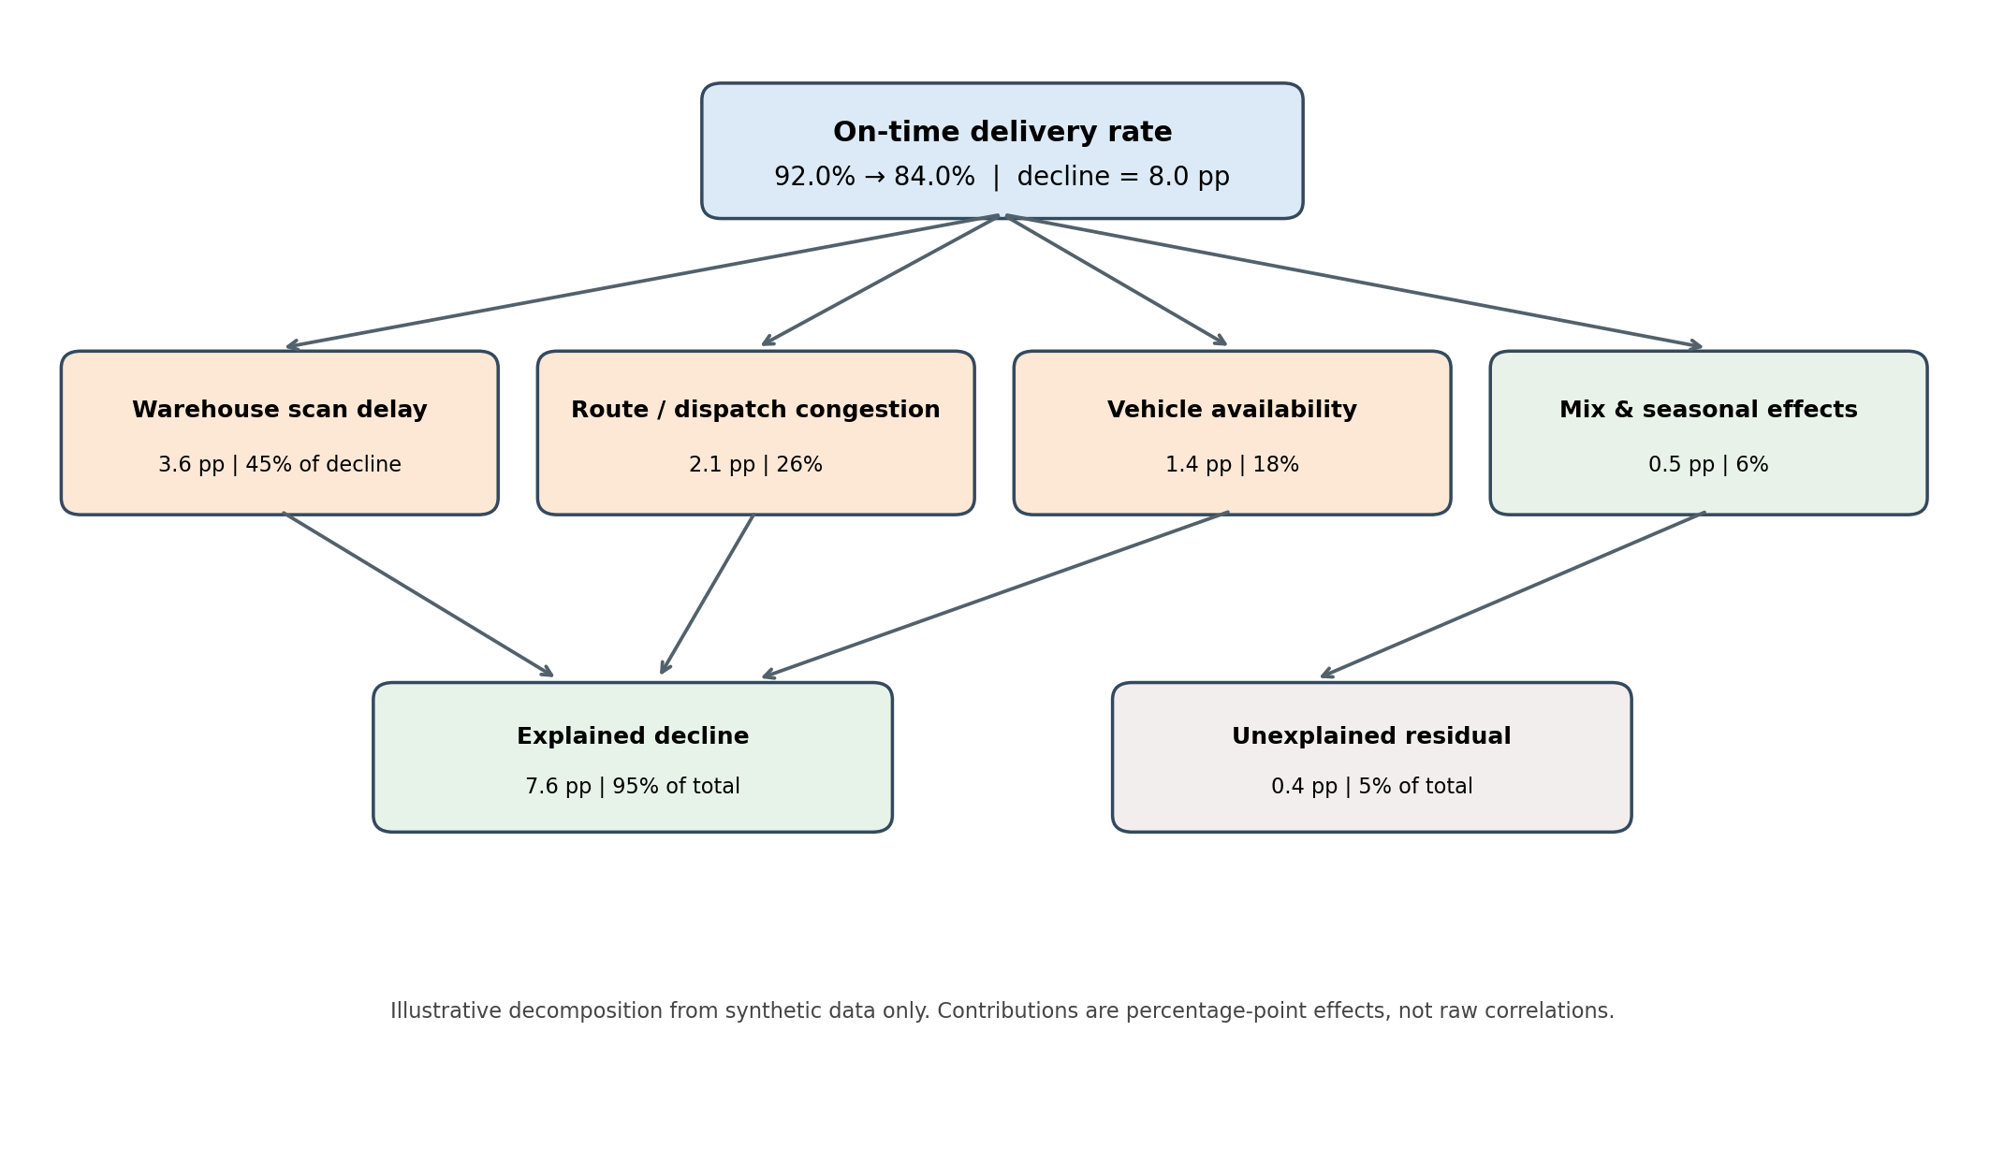
The contribution values are percentage-point effects on the 8.0 pp decline. They are not correlations or shares of all shipments. The synthetic decomposition is illustrative.

2. Hypothesis log and decisions
ID / hypothesis | Test / measure | Decision and illustrative evidence | Owner | Target
H1: Warehouse scan latency increased and pushed dispatch/delivery beyond SLA | Scan-to-dispatch duration; late-scan share  Hub/week comparison; regression with hub and week effects | Supported  Largest estimated contribution: 3.6 pp (45%); p < 0.001 in synthetic demonstration | Hub Operations Lead | Reduce 90th percentile scan-to-dispatch time by 30% within 8 weeks
H2: Route congestion / longer route distance increased transit time | Route distance, planned vs actual transit, departure time  Matched route-period comparison; multivariable regression | Supported  Estimated contribution: 2.1 pp (26%); p < 0.001 | Linehaul Planning Lead | Reduce late departures on high-risk lanes by 25% in 8 weeks
H3: Vehicle unavailability and breakdowns reduced on-time performance | Available fleet %, breakdown and substitute-vehicle events  Hub-week comparison; logistic regression | Supported  Estimated contribution: 1.4 pp (18%); p < 0.01 | Fleet Maintenance Manager | Raise pre-trip vehicle availability to at least 97%
H4: Festive-season volume spikes explain most of the decline | Weekly volume, festive calendar, service mix  Seasonal decomposition; event vs non-event comparison | Partially supported / not primary  Seasonality and mix account for about 0.5 pp (6%); non-festive deterioration remains | Demand Planning Manager | Publish weekly capacity forecast with forecast error below 10%
H5: A few hubs or customer segments account for the decline | Hub, customer tier, service type and region  Hub/segment fixed effects; chi-square for late-rate differences | Partially supported  Concentration is present in affected hubs but hub label changes do not explain the operational effect | Regional Operations Director | Close the gap in the bottom 3 hubs by 2 pp within 10 weeks
H6: Out-of-order scans and timezone errors created a reporting artefact | Raw scan timestamps, event sequence, source timezone  Reconstruct event chronology; compare raw vs corrected metric | Rejected as primary driver  Corrections alter the measured decline by less than 0.2 pp in the synthetic example | Data Engineering Lead | Achieve 99.5% valid event chronology and timezone completeness

3. Analysis workflow and reproducibility notes

Problem definition and metric
Primary metric: on-time delivery rate = shipments delivered within the contractual SLA / eligible delivered shipments. Freeze the SLA definition and denominator across periods, deduplicate shipment IDs, and preserve late, cancelled and excluded statuses separately.

Data cleaning and joining
- Create a shipment-level fact table with one canonical shipment_id and validated one-to-one or many-to-one joins.
- Map old and new hub labels to stable hub_id values using an effective-dated crosswalk; retain raw labels for audit.
- Parse timestamps using the source timezone or explicit UTC offset, convert to UTC, and order scans by event timestamp rather than file-arrival time.
- Check duplicate events, impossible event sequences, missing IDs, negative durations, invalid SLA timestamps and out-of-range values.
- Join route/lane, vehicle, warehouse scan and customer/service dimensions with documented join cardinality and row-count reconciliation.
- Retain missingness flags; impute only model features and never overwrite the raw source fields.

Metric breakdown and statistical tests
Compare weekly and quarterly performance by hub, route, service type and customer segment. Use Welch's t-test for continuous measures such as scan-to-dispatch hours, chi-square tests for categorical late/on-time rates, and multivariable logistic regression for adjusted associations. Include hub, service, customer, distance, volume and calendar controls. Report effect sizes and confidence intervals alongside p-values because large samples can make tiny effects statistically significant.

Driver attribution and seasonality
Estimate each driver's contribution with counterfactual predictions: replace a recent-period driver distribution with its baseline distribution while holding other conditions fixed. Because drivers can interact, use Shapley-style averaging across driver orderings or state the chosen decomposition order. Compare festive and non-festive periods and retain a residual. Do not force the tree to explain 100%.

Weekly early-warning view
Track weekly on-time rate, four-week rolling average, shipment volume, scan-time P90, fleet availability, lane congestion and data-quality exceptions. Trigger an alert when the four-week rate is more than 2 percentage points below target or when two consecutive weeks decline by more than 1 percentage point, subject to a minimum shipment count. Back-test the alert to verify at least four weeks of warning lead time and report false-alert rate.

4. Causal defence and management recommendations
Scan latency is a plausible causal driver because it occurs before dispatch and before the delivery outcome. Adjusted models control for hub, route distance, service, customer segment, volume, calendar and vehicle availability; within-hub comparisons reduce stable location bias. However, observational regression does not by itself prove causality. Validate the mechanism with a staggered pilot across matched hubs and difference-in-differences analysis, or randomize the rollout where operationally feasible.
- Hub Operations Lead — within 8 weeks, reduce 90th-percentile scan-to-dispatch time by 30%; review scan-aging queues daily.
- Linehaul Planning Lead — within 8 weeks, reduce late departures on the highest-risk lanes by 25%; track lane departure adherence.
- Fleet Maintenance Manager — within 10 weeks, raise pre-trip vehicle availability to at least 97%; track breakdowns and missed dispatches.
- Regional Operations Director — within 10 weeks, improve on-time performance in the bottom three hubs by 2 percentage points.
- Data Engineering Lead — within 4 weeks, achieve 99.5% valid event chronology and timezone completeness; enforce canonical hub IDs.

5. Technical appendix: notebook outline and core code
The following code is a compact reproducibility reference. The companion analysis workflow generates a synthetic 1.5-million-row dataset, performs hub and timestamp normalization, runs statistical comparisons and regression, plots weekly performance, and builds the alert view. For a real investigation, replace the synthetic generator with approved source extracts.
import numpy as np
import pandas as pd
from scipy import stats
import statsmodels.formula.api as smf
SEED = 20261106
rng = np.random.default_rng(SEED)
N = 1_500_000
period = rng.integers(0, 2, N, dtype=np.int8)
hub_id = rng.integers(1, 13, N)
service = rng.choice(["Standard", "Express", "Economy"], N)
customer = rng.choice(["SMB", "Enterprise", "Marketplace"], N)
distance_km = np.clip(rng.gamma(2.2, 75, N), 8, 900)
scan_hours = rng.gamma(2.0, 1.8, N) + period * 1.0
congestion = rng.normal(0, 1, N) + period * .65
vehicle_available = rng.binomial(1, np.where(period == 0, .975, .945), N)
festive_flag = rng.binomial(1, np.where(period == 0, .08, .16), N)
logit = (-2.35 + .22*period + .25*(scan_hours > 5)
+ .18*congestion + .52*(vehicle_available == 0)
+ .18*festive_flag + .12*(service == "Economy"))
p_late = 1 / (1 + np.exp(-logit))
late = rng.binomial(1, p_late, N)
df = pd.DataFrame({
"period": period, "hub_id": hub_id, "service_type": service,
"customer_segment": customer, "distance_km": distance_km,
"scan_to_dispatch_hours": scan_hours, "route_congestion_index": congestion,
"vehicle_available": vehicle_available, "festive_flag": festive_flag,
"late": late
})
df["on_time"] = 1 - df["late"]
# Continuous comparison and categorical test
baseline = df.loc[df.period == 0, "scan_to_dispatch_hours"]
recent = df.loc[df.period == 1, "scan_to_dispatch_hours"]
print(stats.ttest_ind(recent, baseline, equal_var=False))
print(stats.chi2_contingency(pd.crosstab(df.vehicle_available, df.late)))
# Adjusted association model; sample shown for practical runtime.
sample = df.sample(200_000, random_state=SEED)
fit = smf.logit(
"late ~ period + scan_to_dispatch_hours + route_congestion_index "
"+ vehicle_available + festive_flag + distance_km "
"+ C(hub_id) + C(service_type) + C(customer_segment)",
data=sample
).fit(disp=False)
print(fit.summary())
# Weekly early-warning view
# In production, group by ISO week and include volume, scan P90,
# fleet availability, route congestion and data-quality checks.
weekly = df.groupby("period").agg(
on_time_rate=("on_time", "mean"),
shipment_count=("on_time", "size")
)
print(weekly)

6. Limitations and final decision requested
The case uses synthetic data and designed driver contributions. The two-quarter window also limits robust year-over-year seasonal inference. Management should approve an 8-week scan-process pilot in matched hubs, assign the named owners, and require weekly review of leading indicators. Recalculate the driver tree on validated production records before making network-wide investment or claiming that any driver has been proven in the real business.

