Java Execution, Class Loading, and JVM Memory
Day 1 Knowledge Chapter — book edition

java-learning / 12-jvm

Chapter orientation
Java looks simple at source-code level, but a production JVM performs several distinct steps before a line of application logic executes: compilation, class discovery, verification, linking, initialization, bytecode execution, memory management, and interaction with native runtime services. This chapter builds that pipeline from first principles instead of treating the JVM as a black box.
Why this matters: When a backend service fails with ClassNotFoundException, NoClassDefFoundError, StackOverflowError, Metaspace pressure, slow startup, or confusing bytecode behavior, the fix depends on understanding which runtime stage is actually responsible.

What you will be able to explain
- Trace a Java program from .java source to native execution
- Explain Bootstrap, Platform, and Application class loaders without confusing loader with storage
- Distinguish Loading, Verification, Preparation, Resolution, and Initialization
- Explain JDK vs runtime vs JVM and modern java.base storage
- Draw JVM runtime memory areas and classify shared vs per-thread memory
- Explain stack frames, local-variable slots, operand stack, PC register, and native methods
- Reason precisely about object references, static fields, Method Area, PermGen, and Metaspace
- Use javap and class-loading logs to verify the theory

1. Why Java uses bytecode
A CPU understands machine instructions for a particular architecture. Java source code is designed to be portable and developer-friendly, so javac does not normally compile an ordinary .java file directly into final CPU instructions. It produces JVM bytecode: an intermediate instruction set defined for the Java Virtual Machine.
public class Hello {
public static void main(String[] args) {
int a = 10;
int b = 20;
int c = a + b;
System.out.println(c);
}
}
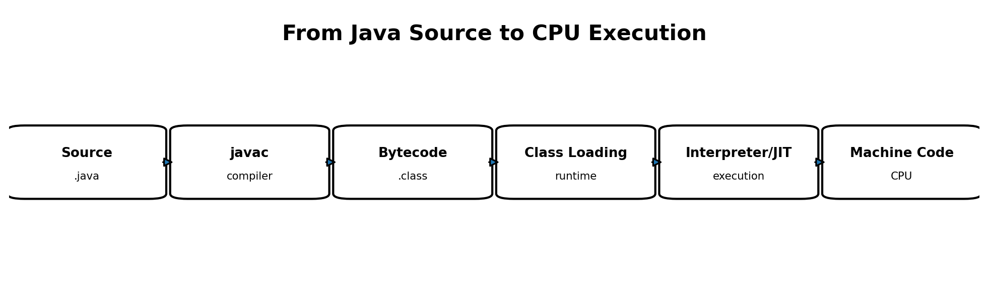
The complete source-to-execution pipeline
The .class file is a structured binary, not a text file containing “compiled Java.” It contains bytecode for methods plus structural information such as the class name, superclass, field and method descriptions, constant-pool entries, version information, and other metadata.
Key idea: Source code, bytecode, and native machine code are different representations. javac produces bytecode; the JVM later interprets and/or JIT-compiles frequently executed bytecode into native code.

2. Reading real bytecode with javap
The fastest way to make the JVM concrete is to inspect what javac produced. Compile the Hello class and disassemble it:
javac Hello.java
javap -c Hello
A representative main method contains instructions like these:
0: bipush 10
2: istore_1
3: bipush 20
5: istore_2
6: iload_1
7: iload_2
8: iadd
9: istore_3
10: getstatic #7 // System.out
13: iload_3
14: invokevirtual #13 // PrintStream.println:(I)V
17: return
The instruction names expose an important JVM design choice: bytecode execution is stack-oriented. Values are loaded from local-variable slots onto an operand stack, operations consume values from that stack, and results are pushed back.
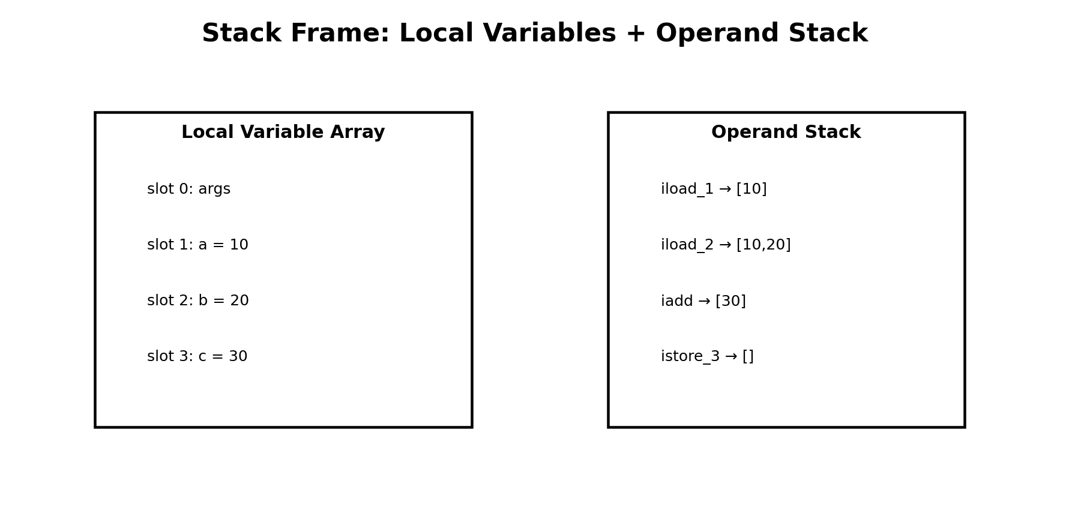
Instruction | What it does in this example
bipush 10 | Push integer 10 on the operand stack
istore_1 | Pop that integer and store it in local slot 1
iload_1 | Push the integer from slot 1
iadd | Pop two integers, add them, push the result
istore_3 | Store the result in slot 3
invokevirtual | Invoke println on a PrintStream instance
return | Return from main

The disassembly also shows a constructor even when the source did not declare one. javac supplies a default constructor that loads this, invokes Object.<init>(), and returns. This is a useful reminder that source code and bytecode are not one-to-one textual equivalents.

3. JVM startup and class loading
When you execute java Hello, the operating system starts a native launcher. That launcher initializes a JVM. The JVM is itself native software; it does not require java.lang.Object in order to “exist.” Once the runtime is established, it begins loading classes needed to execute the program.
The JVM does not eagerly load every Java platform class when the process starts. Startup establishes the runtime, module configuration, bootstrap mechanisms, and the classes immediately required to begin execution. Additional classes are loaded when execution, linking, reflection, framework behavior, or other runtime activity first requires them. For example, java.lang.Object and other foundational classes are needed very early, while an unrelated class such as java.sql.DriverManager need not be loaded merely because it exists in the runtime image. This is why class-loading logs show classes appearing progressively as the program executes.
java Hello

3.1 The class-loader delegation model
Bootstrap Class Loader
↑
Platform Class Loader
↑
Application Class Loader
This diagram is a responsibility/delegation model. It must not be interpreted as a set of directories. A class loader is a mechanism that defines classes; the class bytes come from runtime modules, class-path entries, module-path entries, JARs, generated byte arrays, or other configured sources.
Loader | Typical responsibility | Example
Bootstrap | Fundamental runtime classes, especially java.base | java.lang.Object, java.lang.String, java.util.ArrayList
Platform | Other Java platform modules/classes | java.sql.DriverManager
Application | Application classes and ordinary third-party libraries | Hello, Employee, Jackson ObjectMapper

Parent-first delegation means a loader normally asks its parent to try first. This helps preserve the integrity of platform classes and prevents an application class path from casually replacing java.lang.String with a user-defined class of the same binary name.
Key idea: Delegation answers “who gets the first chance to load this class?” Search configuration answers “where does that loader obtain bytes from?” Those are different questions.

3.2 Class names and class-path lookup
A binary class name maps to a resource path. com.myapp.Employee corresponds to com/myapp/Employee.class. If the class path contains a directory named classes, the Application ClassLoader searches under that directory for the resource path.
java -cp classes Main
The operating-system PATH is unrelated to the Java class path. PATH helps the shell find the java executable. JAVA_HOME identifies a JDK installation. The class path/module path identifies application classes and dependencies.

3.3 Delegation answers “who gets a chance”; search configuration answers “where bytes are found”
This distinction is central to understanding class loading. The delegation hierarchy does not itself describe folders. When the Application ClassLoader is asked to load com.myapp.Employee, it normally delegates upward first. If a parent can define the class, that parent wins. If the parents cannot find it, control returns to the Application ClassLoader, which then searches the sources configured for application classes. In a class-path application those sources are class-path entries; in a modular application they may involve named modules on the module path. Core runtime classes come from the runtime image rather than from your application class path.
Request: com.myapp.Employee
Application ClassLoader
|
| asks parent first
v
Platform ClassLoader
|
| asks parent first
v
Bootstrap loading mechanism
|
| core/platform class found? -> define and return
|
+-- not found -> return to child
|
v
Application ClassLoader
|
v
search configured app sources
This is why two questions must always be separated in interviews and debugging: (1) which loader is responsible for defining the class, and (2) from which physical or logical source are its bytes obtained? Saying “Bootstrap ClassLoader searches the bootstrap folder” is an outdated and misleading mental model for modern Java.

3.4 What exactly happens when you run java Hello?
Assume Hello.class is in the current directory. First, your shell must locate the java launcher executable. That step is controlled by the operating-system PATH, not by the Java class path. The native launcher starts the JVM, builds the initial runtime and module configuration, creates the initial application class-loading environment, and asks the JVM to locate the main class named Hello.
Command shell
|
| PATH locates java.exe / java
v
Native Java launcher
|
v
JVM starts
|
+--> runtime modules available (for example java.base)
|
+--> application class path/module path configured
|
v
load main class "Hello"
|
v
parent-first delegation
|
v
Application ClassLoader searches app sources
|
v
Hello.class found -> load/link/init -> invoke main
If Hello is in the default package and no explicit -cp or -classpath is supplied, the launcher commonly uses the current directory as the default application class path. If you explicitly provide -cp, that command-line value becomes the application class path for that launch and takes precedence over the CLASSPATH environment variable.

3.5 Fully qualified class name to resource path
The JVM works with binary class names such as com.myapp.Employee. A class-path loader translates that binary name into a resource-style path by replacing dots with slashes and appending .class.
Binary name:
com.myapp.Employee
Resource path:
com/myapp/Employee.class
That mapping explains why package structure and directory structure must agree for ordinary class-path loading. If classes is a class-path root, the loader does not search for classes/com.myapp.Employee.class. It looks underneath the root using the package path.
Class-path root:
C:\training\classes
Required file:
C:\training\classes\com\myapp\Employee.class
Launch:
java -cp C:\training\classes com.myapp.Main

3.6 How directory class-path entries are searched
A directory on the class path is a root, not the package directory itself. Suppose the class path contains C:\app\out and the requested binary name is com.acme.payments.PaymentService. The Application ClassLoader forms com/acme/payments/PaymentService.class and checks beneath that class-path root.
-cp C:\app\out
Requested:
com.acme.payments.PaymentService
Lookup:
C:\app\out\com\acme\payments\PaymentService.class
A frequent error is placing C:\app\out\com\acme on the class path and then launching com.acme.payments.PaymentService. That shifts the root too far down. The class-path entry should normally be the directory immediately above the top-level package directory.

3.7 How JAR class-path entries are searched
A JAR can also be a class-path entry. The class loader looks for the same resource path inside the archive. The fact that classes are packaged in a JAR changes the container, not the binary-name-to-resource-path mapping.
Class path:
lib\employee-app.jar
Requested:
com.myapp.Employee
Entry searched inside JAR:
com/myapp/Employee.class
Conceptual location:
employee-app.jar!/com/myapp/Employee.class
A typical Windows launch with an application directory plus libraries might look like this:
java -cp "classes;lib\dependency-a.jar;lib\dependency-b.jar" com.myapp.Main
On Linux and macOS, class-path entries are separated with a colon instead of a semicolon:
java -cp "classes:lib/dependency-a.jar:lib/dependency-b.jar" com.myapp.Main

3.8 Class-path ordering and duplicate classes
Class-path entries are ordered. A class-path loader searches them in class-path order and the first suitable definition it finds can determine which class bytes are used. This becomes important when two JARs accidentally contain the same binary class name or when multiple versions of a dependency are present.
java -cp "old-lib.jar;new-lib.jar;classes" com.myapp.Main
If both JARs contain:
com/vendor/Util.class
the earlier class-path entry can shadow the later one.
This is one source of “works on my machine” dependency problems: the code may compile against one version but run with another version earlier on the runtime class path, producing errors such as NoSuchMethodError or incompatible behavior. Modern build tools reduce this risk by constructing a controlled runtime class path, but the JVM still ultimately receives an ordered set of runtime sources.
The wildcard form lib/* is convenient for launching all JARs in a directory. Applications should not rely on a particular wildcard expansion order for correctness; dependency resolution should be deterministic at the build and packaging level.

3.9 PATH, JAVA_HOME, CLASSPATH, -cp, and module path are different
Setting / option | What it controls | Example
PATH | Lets the operating-system shell locate commands such as java and javac | C:\Program Files\Java\jdk-21\bin
JAVA_HOME | Identifies the JDK installation for tools and scripts; it is not the application class path | C:\Program Files\Java\jdk-21
CLASSPATH | Environment-level default application class path when no command-line class path overrides it | .;lib\app.jar
-cp / -classpath | Per-launch application class path; usually clearer than relying on a global CLASSPATH | java -cp classes;lib\x.jar com.app.Main
--module-path / -p | Locations of named modules for modular launches | java -p mods -m com.app/com.app.Main
A good debugging habit is to ask which layer failed. “java is not recognized” is usually PATH-related. “Could not find or load main class” is usually a class-name, class-path, or module-path problem. A missing dependency may show as ClassNotFoundException or NoClassDefFoundError depending on when and how the JVM attempts to resolve and use it.

3.10 Where Bootstrap and Platform classes come from in modern Java
Before Java 9, many explanations pointed to rt.jar. Modern JDKs use the module system and a runtime image. Fundamental classes in java.base, such as java.lang.Object and java.lang.String, are supplied by the runtime image. The Bootstrap loading mechanism is responsible for foundational runtime classes; the Platform ClassLoader handles additional platform classes and modules assigned to it. Exact implementation details are JVM-version specific, but these classes are not discovered by walking your application class path.
Modern JDK (conceptual)
<JAVA_HOME>
|
+-- bin/
| +-- java
| +-- javac
|
+-- lib/
+-- modules <- runtime image containing named runtime modules
Logical modules include:
java.base
java.sql
java.xml
...
You can inspect the runtime image with jimage. For example, on Windows:
jimage list "%JAVA_HOME%\lib\modules" | findstr "java/lang/String.class"
jimage list "%JAVA_HOME%\lib\modules" | findstr "java/sql/DriverManager.class"
This demonstrates the storage/source side of the model. Class.getClassLoader() demonstrates the defining-loader side. For a bootstrap-defined class, getClassLoader() commonly returns null because the bootstrap loader is represented specially rather than as an ordinary Java ClassLoader object.

3.11 Class path vs module path
The class path belongs to Java’s traditional unnamed-module model. The module path is used for named modules introduced with Java 9. In a simple class-path application, the Application ClassLoader searches class-path entries. In a modular application, module resolution first establishes which named modules are observable and where they come from; classes are then loaded within that resolved module configuration.
Traditional class-path launch:
java -cp "classes;lib/*" com.app.Main
Named-module launch:
java --module-path mods --module com.app/com.app.Main
Short forms:
-p == --module-path
-m == --module
Do not combine the mental models into “the class loader scans every class-path and module-path location.” Module resolution, readability, exports, and loader assignment add another layer in modular applications. For Day 1, retain this rule: class path supplies ordinary application classes and dependencies in the unnamed-module model; module path supplies named modules in the modular model.

3.12 Parent-first delegation: step-by-step example
Assume your code references java.lang.String and com.myapp.Employee. For String, the Application ClassLoader delegates upward. The request eventually reaches the bootstrap mechanism, which can define String from the runtime. Because the parent succeeded, the Application ClassLoader does not define a competing java.lang.String from your class path. For Employee, bootstrap and platform parents do not define it, so control returns to the Application ClassLoader, which searches the configured application sources.
Request 1: java.lang.String
Application
-> Platform
-> Bootstrap
-> FOUND in runtime image
<- returns Class<String>
<- same Class returned
<- application receives bootstrap-defined String
Request 2: com.myapp.Employee
Application
-> Platform
-> Bootstrap
-> not found
<- not found
<- not found
-> search application class path
-> classes/com/myapp/Employee.class FOUND
-> define Employee
This is why parent-first delegation is partly a safety and consistency mechanism: application code normally cannot replace foundational platform definitions merely by placing a same-named class in an application JAR.

3.13 What if the class cannot be found?
The error depends on the context. If the launcher cannot locate the requested main class, you commonly see “Could not find or load main class.” If application code explicitly asks a ClassLoader to load a missing class, ClassNotFoundException is common. If a class was available when another class was compiled or initially linked but is unavailable when the JVM later needs it, NoClassDefFoundError may appear. These are related symptoms but not interchangeable terms.
# Compile
javac Hello.java
# Move or rename Hello.class so it is no longer under the class-path root
java Hello
# Typical launcher message:
Error: Could not find or load main class Hello
Caused by: java.lang.ClassNotFoundException: Hello
For a packaged class, another common mistake is launching it from the wrong directory or omitting the package name. If the source declares package com.myapp;, you normally launch com.myapp.Main with a class-path root above the com directory, not java Main from inside com/myapp.

3.14 Diagnosing where a class came from
Do not guess when debugging class-loading issues. Ask the JVM to report what it loads. On modern HotSpot, unified logging can print class-loading events:
java -Xlog:class+load=info Hello
# More detail when needed
java -Xlog:class+load=debug Hello
Older JDKs commonly used -verbose:class. The log can show class names and sources, which helps diagnose duplicate dependencies, unexpected JAR versions, or whether a class came from the runtime image versus application code.
java -verbose:class Hello
You can also print defining loaders in code:
System.out.println(String.class.getClassLoader()); // typically null: bootstrap
System.out.println(java.sql.DriverManager.class.getClassLoader());
System.out.println(Hello.class.getClassLoader()); // typically application loader

3.15 A complete class-loading search scenario
Consider this launch on Windows:
java -cp "out;lib\jackson-databind.jar;lib\my-utils.jar" com.acme.Main
Suppose Main executes new com.acme.Employee() and later references com.fasterxml.jackson.databind.ObjectMapper. The JVM already has access to core runtime modules. For com.acme.Main and Employee, parent loaders cannot define those application classes, so the Application ClassLoader searches the ordered application class path. It first examines out using the resource paths com/acme/Main.class and com/acme/Employee.class. For ObjectMapper, it eventually searches the JAR entries and finds com/fasterxml/jackson/databind/ObjectMapper.class inside jackson-databind.jar. ObjectMapper itself may trigger loading of more Jackson classes, each following the same delegation and source-search rules.
Configured application class path
1. out
2. lib\jackson-databind.jar
3. lib\my-utils.jar
com.acme.Employee
-> parent delegation fails
-> out/com/acme/Employee.class
-> FOUND
com.fasterxml.jackson.databind.ObjectMapper
-> parent delegation fails
-> out/... not found
-> jackson-databind.jar!/com/fasterxml/jackson/databind/ObjectMapper.class
-> FOUND
This is the mental model to use when production reports “class not found”: start with the binary class name, convert it to the resource path, identify the expected defining loader, inspect the actual runtime class path or module configuration, and verify that the resource exists in one of the sources that loader can see.

3.16 Framework note: Spring Boot executable JARs
A Spring Boot executable JAR adds another layer. Dependencies are commonly nested under BOOT-INF/lib and application classes under BOOT-INF/classes rather than being laid out as ordinary top-level class-path entries. Spring Boot launches with its own loader infrastructure capable of reading those nested locations. The parent-first principle for core and platform classes still matters, but the application-side loader and search mechanics differ from a plain java -cp launch.
Typical Spring Boot executable JAR layout
app.jar
|
+-- BOOT-INF/
+-- classes/
| +-- com/acme/...
|
+-- lib/
+-- dependency-1.jar
+-- dependency-2.jar
Therefore, when debugging a Boot application, do not assume the ordinary application loader is directly scanning nested JAR files in exactly the same way as a plain class path. Framework launchers can introduce custom class-loading behavior. We will study custom class loaders and framework loaders in a later advanced section.

3.17 Class-loader rules to retain
- Loader hierarchy describes delegation and responsibility; it is not a directory tree.
- Parent-first means a child normally asks its parent before trying to define the class itself.
- Binary name com.foo.Bar maps to resource path com/foo/Bar.class.
- A directory class-path entry is a root above the package tree.
- A JAR class-path entry is searched for the same resource path inside the archive.
- PATH finds the java executable; JAVA_HOME identifies the JDK; class path and module path locate application classes or named modules.
- -cp and -classpath configure the application class path for that launch and normally override CLASSPATH.
- Core runtime classes in modern Java come from the runtime image and modules, not from your application class path.
- Class-path ordering matters when duplicate binary class names exist.
- Use -Xlog:class+load=info, or legacy -verbose:class, to observe real loading rather than guessing.

4. Class lifecycle: Loading → Linking → Initialization
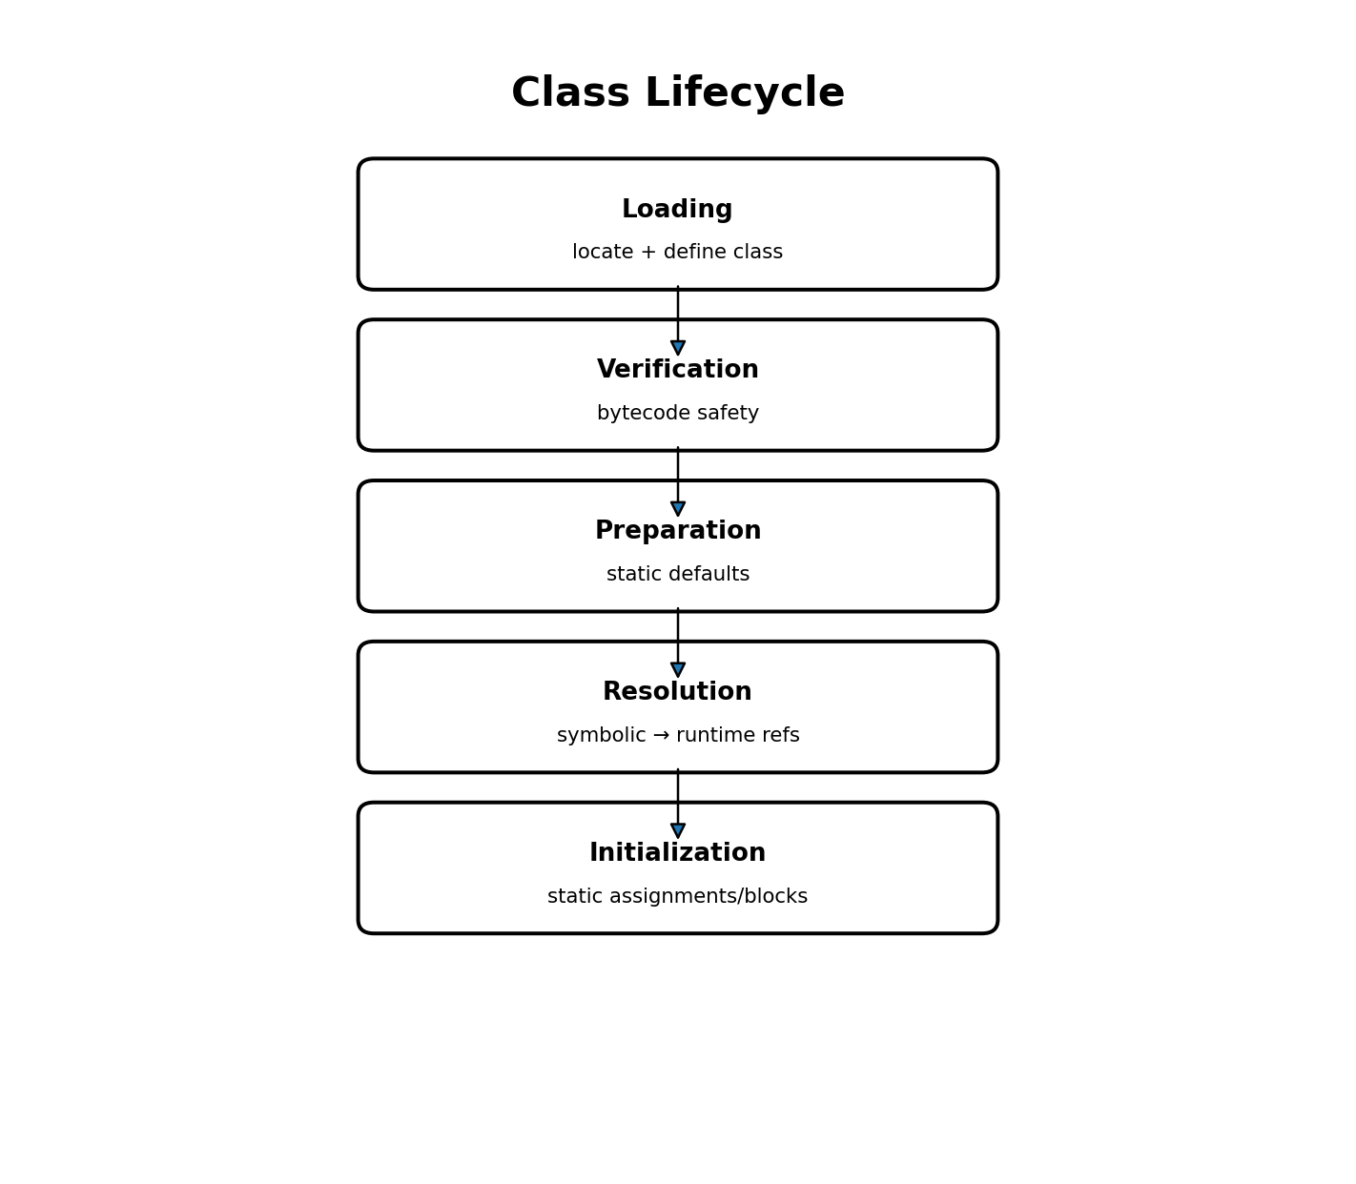

4.1 Loading
Loading locates class bytes, parses the class-file structure, and creates the JVM’s runtime representation of the class. Loading a class does not mean creating an instance of that class. A program can load Employee.class without executing new Employee().

4.2 Verification
Verification protects the JVM from malformed or unsafe bytecode. The verifier checks class-file structure and bytecode constraints so instructions cannot arbitrarily violate JVM type and execution rules.

4.3 Preparation
Preparation establishes class-level static state with default values. Consider:
class Employee {
static int count = 100;
}
During preparation, count has the default int value 0. The explicit assignment to 100 has not executed yet.

4.4 Resolution
A class file does not embed final runtime addresses for every referenced class, method, and field. It contains symbolic references in its constant pool. Resolution converts these symbolic references into runtime-resolvable entities. Resolution may be eager or lazy depending on the JVM and the reference.
class Employee {
Department department;
String departmentName() {
return department.getName();
}
}
The class file records symbolic information for Department and getName. javac cannot know the runtime memory address of a Department class that will be loaded later in a different JVM process.

4.5 Initialization
Initialization finally executes explicit static field initializers and static blocks in the order defined by Java initialization rules.
static int count = 100;
static {
System.out.println("Employee initialized");
}
Key idea: Preparation gives count = 0. Initialization executes the assignment and produces count = 100. This distinction is a common interview point and also explains subtle initialization behavior.

5. JDK, runtime environment, JVM, and java.base
Older explanations often draw a JDK containing a separately installed JRE directory. That picture is historically useful for Java 8, but modern Java should be understood conceptually rather than by expecting a jre folder.
JDK
├── Development tools
│ ├── javac
│ ├── javap
│ ├── jcmd
│ └── ...
└── Runtime environment
├── JVM
├── Java runtime modules
│ ├── java.base
│ ├── java.sql
│ └── ...
└── supporting native/runtime libraries
Since Java 9, the platform is modular. A standard JDK stores runtime modules in a runtime image, commonly under <JAVA_HOME>/lib/modules. java.base logically contains fundamental classes including java.lang.Object and java.lang.String.
java -XshowSettings:properties -version
# Windows examples
dir "%JAVA_HOME%\lib\modules"
jimage list "%JAVA_HOME%\lib\modules" | findstr "java/lang/String.class"
In Java 8, many core classes were packaged in rt.jar under the JRE. Modern custom runtime images can also be produced with jlink.
Key idea: Bootstrap ClassLoader is the loading mechanism. The runtime image is where the platform class bytes are stored. Do not say “String.class is stored inside the Bootstrap ClassLoader.”

6. JVM runtime memory areas
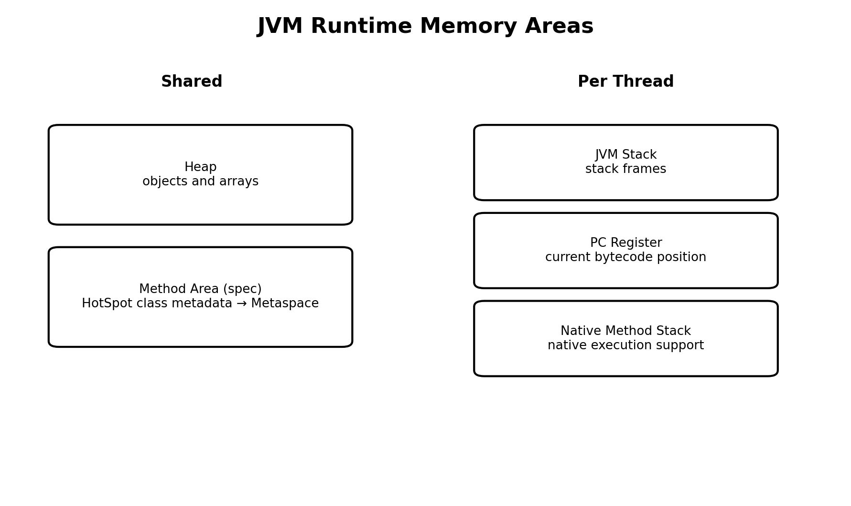
The JVM specification defines runtime data areas. Some are shared by all threads; others are created per thread. The implementation can optimize their physical representation, but the conceptual model is essential for debugging.
Area | Shared/per-thread | What to remember
Heap | Shared | Objects and arrays normally live here conceptually
Method Area | Shared | Specification concept for class-related runtime information
JVM Stack | Per thread | Contains a stack frame for each active Java method invocation
PC Register | Per thread | Tracks the current JVM instruction position/state for non-native methods
Native Method Stack | Per thread conceptually | Supports native method execution; exact physical layout is implementation/OS/ABI dependent

7. Method Area, PermGen, and Metaspace
This topic causes confusion because three terms belong to different abstraction levels and different HotSpot eras.
Term | Meaning
Method Area | A JVM-specification logical concept; it was not removed in Java 8
PermGen | An older HotSpot memory area used for much class-related data before Java 8
Metaspace | The HotSpot native-memory mechanism used for class metadata since Java 8

Before Java 8, HotSpot commonly stored much class-related metadata in PermGen. Java 8 removed PermGen and moved class metadata to Metaspace, which uses native memory. Metaspace can grow until constrained by JVM settings or available native memory; -XX:MaxMetaspaceSize can impose a limit.
# Older HotSpot
-XX:PermSize=...
-XX:MaxPermSize=...
# possible failure: OutOfMemoryError: PermGen space
# Modern HotSpot
-XX:MaxMetaspaceSize=...
# possible failure: OutOfMemoryError: Metaspace

7.1 What is class metadata?
For Employee, class metadata describes the type itself: its name, superclass, interfaces, fields, methods, access modifiers, method descriptors and execution metadata, constant-pool information, and other VM structures. One loaded Employee class representation can describe many Employee instances.
Employee e1 = new Employee();
Employee e2 = new Employee();
Employee e3 = new Employee();
Conceptually there are three Employee objects but one Employee class metadata set for that particular class-loader definition. Later we will study the important nuance that the same binary class name loaded by two different class loaders represents two distinct runtime classes.

7.2 Static fields: do not equate “static” with Metaspace
A simplified old explanation says “static variables live in Method Area/Metaspace.” That is not a safe modern HotSpot statement. Metaspace is primarily class metadata. Static field state is associated with the runtime class representation; in modern HotSpot, the java.lang.Class mirror is heap-resident and static field storage is associated with that class state. Exact physical details are implementation-specific.
class Employee {
static int count = 100;
}
All Employee instances observe one shared class-level field, so Employee.count is preferred over e1.count even though Java permits access through an instance expression.
Key idea: The portable rule is “static field = one class-level storage per loaded class definition.” Avoid making JVM-spec claims about an exact physical address.

8. Heap, objects, and references
The heap is a JVM-managed memory area used primarily for objects and arrays. It is not itself a Java array. Diagrams that draw [A][B][C] are teaching aids for memory layout, not a claim that every object occupies an equal-size cell.
Employee emp = new Employee();
Item | Conceptual location
Employee class metadata | Metaspace in modern HotSpot
local reference emp in main() | main() stack frame
Employee instance | heap

8.1 Multiple references and object identity
Employee e1 = new Employee();
Employee e2 = e1;
e1.name = "A";
System.out.println(e2.name); // A
e1 and e2 are two reference variables pointing to the same object. Setting e1 = null removes only one path. The object remains live while another path such as e2 remains reachable.

8.2 Reference fields can live inside heap objects
class Employee {
Address address = new Address();
}
Employee emp = new Employee();
emp is a local reference in a stack frame. The Employee object is on the heap. The address field is part of that heap object, and it points to another heap object. Therefore “references are stored on the stack” is false as a universal rule.

8.3 Contiguous allocation and fragmentation
An individual object normally requires a suitable contiguous allocation range in ordinary HotSpot layouts. That is why fragmentation matters: three separated 10-byte holes are not equivalent to one 30-byte allocation range when an object needs 30 contiguous bytes.
Before compaction:
[Used][10 free][Used][10 free][Used][10 free]
After compaction:
[Used][Used][Used][ 30 free ]
Moving collectors can relocate live objects and update managed references so Java code continues to observe the same logical objects. A Java reference should not be treated as a raw address controlled by application code.

9. JVM stacks and stack frames
Each Java thread owns its own JVM stack. Every active Java method invocation contributes a stack frame. When a method returns, its frame is popped. This is why deep recursion consumes stack space even when it allocates almost no heap data.
static int add(int a, int b) {
int sum = a + b;
return sum;
}
A frame contains an array of local-variable slots, an operand stack used by bytecode instructions, and additional method execution/frame data. The exact internal representation is a JVM implementation concern, but the JVM class-file format specifies the required max locals and max operand-stack depth for methods.

9.1 Local-variable array
Method parameters and local variables occupy local slots. The slots are not “one Java object per slot”; they are execution storage used according to bytecode type rules. Reference values can occupy local slots just as primitive values can.

9.2 Operand stack
The operand stack is temporary computation workspace inside a frame. iload pushes a local integer value; iadd pops operands and pushes their sum; istore pops the result into a local slot. Do not confuse the operand stack with the thread’s JVM stack: the operand stack lives inside one stack frame, while the JVM stack holds many frames.

10. PC Register and native methods
Each Java thread has its own Program Counter register concept. For a thread executing a non-native method, it identifies the current JVM instruction position/state. For a native method, the JVM specification treats the PC value as undefined.

10.1 Native Method Stack
A native method is declared in Java but implemented outside normal Java bytecode, commonly through JNI or JVM-internal native interfaces. Native execution follows the operating system and CPU ABI, so arguments may travel through CPU registers and/or native stack locations. There is no portable JVM rule saying native arguments must all be placed on a physically separate “native stack.”
public native int readNative(...);
Passing a Java object to native code does not move that Java object out of the heap. Native code interacts through JVM-managed references/handles according to JNI rules. This is important because a moving GC may relocate Java objects.

11. End-to-end execution example
class Employee {
static int count = 0;
String name;
Employee(String name) {
this.name = name;
count++;
}
}
public class App {
public static void main(String[] args) {
Employee e = create("Asha");
System.out.println(Employee.count);
}
static Employee create(String name) {
return new Employee(name);
}
}
- The JVM starts and loads App and required platform classes.
- Employee is loaded when required; verification/linking occur, and its static count gets a default value during preparation.
- Employee initialization executes count = 0 (which is already the default, but the explicit initializer belongs to initialization).
- main receives a stack frame on the main thread. Calling create pushes another frame.
- new Employee allocates an Employee object on the heap and invokes its constructor.
- The constructor writes the instance field name into the heap object and increments the shared static count.
- create returns the reference. Its frame is popped, but the Employee object remains live because main now holds e.
- When main finishes and no other root reaches the object, it may become eligible for garbage collection.

12. Common misconceptions corrected
Misconception | Correct model
javac generates machine code | javac normally generates JVM bytecode; native code is produced/interpreted later by the runtime
Loading a class creates an object | Class loading defines the runtime class; object creation is a separate new operation
Bootstrap loader stores Object.class | The loader is a mechanism; class bytes come from the runtime image
Method Area was removed in Java 8 | Method Area is a JVM-spec concept; PermGen was removed
Metaspace contains every static value | Metaspace primarily contains class metadata; static state is implementation-associated with the class representation
All references live on the stack | Reference fields can be inside heap objects; locals can be in stack frames conceptually
JVM Stack = Operand Stack | A thread JVM stack contains frames; each frame contains its own operand stack
Native stack layout is standardized like JVM frames | Native layout depends on JVM, OS, CPU, compiler, and ABI

13. Five-minute revision
.java → javac → .class bytecode → JVM startup → class loading → linking → initialization → bytecode execution → interpreter/JIT → native execution
- Bootstrap / Platform / Application is a simplified delegation hierarchy.
- Linking = verification + preparation + resolution.
- Preparation gives static fields default values; initialization executes explicit assignments/static blocks.
- Heap and Method Area are shared; JVM Stack, PC Register, and Native Method Stack are per-thread concepts.
- Method Area is specification terminology; PermGen was an old HotSpot mechanism; Metaspace is modern HotSpot class-metadata storage in native memory.
- Each method call creates a stack frame with local-variable slots and an operand stack.
- Objects are heap-resident conceptually; references live wherever their variables/fields live.

Practical Lab

Lab goals
- Compile and inspect bytecode
- Observe class loading
- Prove local-variable and operand-stack behavior from javap output
- Trigger StackOverflowError deliberately
- Inspect runtime/JDK module information

Lab 1 — Compile and inspect bytecode
public class Hello {
public static void main(String[] args) {
int a = 10;
int b = 20;
int c = a + b;
System.out.println(c);
}
}
javac Hello.java
javap -c Hello
Trace bipush → istore → iload → iadd → istore. Write the local-variable slots and operand-stack contents after each instruction. Do not memorize opcode numbers; explain the data movement.

Lab 2 — Observe class loading
java -Xlog:class+load=info Hello
Find entries for java.lang.Object, java.lang.String, java.lang.System, and Hello. Compare their reported source/loader context and explain why application classes are different from platform runtime classes.

Lab 3 — Break class lookup
# compile first
javac Hello.java
# rename/move Hello.class, then
java Hello
Observe the “Could not find or load main class” failure. Restore the file and try a class-path directory with java -cp.

Lab 4 — Inspect the modern runtime image
java -XshowSettings:properties -version
# Windows
jimage list "%JAVA_HOME%\lib\modules" | findstr "java/lang/String.class"

Lab 5 — Trigger StackOverflowError
public class StackOverflowDemo {
static int count;
static void recurse() {
count++;
recurse();
}
public static void main(String[] args) {
try { recurse(); }
catch (StackOverflowError e) {
System.out.println("Calls: " + count);
}
}
}
javac StackOverflowDemo.java
java StackOverflowDemo
java -Xss256k StackOverflowDemo
java -Xss1m StackOverflowDemo
Compare the approximate recursion depth. The exact count is not a contract; frame size, JIT compilation, platform, and JVM version can change it.

Lab 4A — Prove package-to-path mapping
Create this source layout and compile into a separate output root:
src/
com/
myapp/
Employee.java
Main.java
// Employee.java
package com.myapp;
public class Employee {
public String name() {
return "Ada";
}
}
// Main.java
package com.myapp;
public class Main {
public static void main(String[] args) {
System.out.println(new Employee().name());
}
}
javac -d out src\com\myapp\Employee.java src\com\myapp\Main.java
# Result:
out\com\myapp\Employee.class
out\com\myapp\Main.class
java -cp out com.myapp.Main
Now intentionally use the wrong root, such as -cp out\com\myapp, and explain why it fails. The correct class-path root is out because the JVM appends com/myapp/Main.class beneath that root.

Lab 4B — Observe directory and JAR lookup
Package one of your classes into a JAR, then inspect the archive path and load it through -cp.
jar tf my-library.jar
# If the binary name is:
com.myapp.Employee
# the JAR entry should be:
com/myapp/Employee.class
Run with -Xlog:class+load=info and identify which source supplied the class.

Lab 4C — Prove class-path order
Create two JARs containing the same binary class name but different return values. Reverse their order on the class path and observe which definition wins.
java -cp "version1.jar;version2.jar;." Main
java -cp "version2.jar;version1.jar;." Main
Repeat with class-loading logging enabled and identify the source JAR. Record why duplicate runtime versions are dangerous.

Lab 4D — Distinguish PATH, JAVA_HOME, and -cp
where java
java -XshowSettings:properties -version
java -cp out com.myapp.Main
Write one sentence for each: what PATH controls, what java.home tells you, and what -cp controls.

Lab 4E — Inspect defining class loaders
public class LoaderDemo {
public static void main(String[] args) {
System.out.println("String: " + String.class.getClassLoader());
System.out.println("DriverManager: " +
java.sql.DriverManager.class.getClassLoader());
System.out.println("LoaderDemo: " + LoaderDemo.class.getClassLoader());
}
}
Explain why String commonly prints null, why platform classes may show a platform loader, and why LoaderDemo is normally defined by the application loader.

Lab report template
Experiment | Observation | Explanation
javap
class loading log
broken class lookup
runtime image
StackOverflowError

Interview Questions & Revision

Core interview questions

1. What does javac produce?
JVM bytecode in .class files, not ordinary CPU-native machine code.

2. What is in a .class file besides bytecode?
Class/method/field structure, constant pool, version and other metadata.

3. Loading vs object creation?
Loading defines the runtime class; new allocates an instance.

4. Class-loader hierarchy?
Bootstrap → Platform → Application in the simplified parent-first model.

4A. Delegation vs search path?
Delegation answers which loader gets the opportunity to define a class. Search configuration answers where that loader obtains the bytes, such as runtime modules, class-path directories, JARs, or module-path modules.

4B. How does com.myapp.Employee map to disk or JAR layout?
The binary name maps to com/myapp/Employee.class beneath a class-path root or as the same entry path inside a JAR.

4C. If -cp classes is used, where is com.myapp.Employee expected?
Under classes/com/myapp/Employee.class. The class-path entry is the root above the package tree.

4D. PATH vs JAVA_HOME vs class path?
PATH helps the OS locate java and javac; JAVA_HOME identifies the JDK installation for tools and scripts; the class path provides application classes and dependencies.

4E. Does Bootstrap ClassLoader mean a bootstrap directory?
No. Bootstrap is a loading mechanism and responsibility. In modern Java, foundational runtime classes are obtained from the runtime image and modules, not from an application-visible bootstrap folder.

4F. What happens if the same class exists in two runtime JARs?
For ordinary class-path loading, class-path ordering can determine which matching definition is found first. Duplicate versions can cause linkage errors or unexpected behavior.

4G. How do you diagnose where a class was loaded from?
Use -Xlog:class+load=info on modern HotSpot and inspect Class.getClassLoader() when useful. Older JDKs commonly use -verbose:class.

4H. Why can java.lang.String not normally be replaced by a class-path class with the same name?
Parent-first delegation gives the bootstrap and platform side the first opportunity to define core classes, preserving runtime consistency.

4I. Class path vs module path?
Class path supplies ordinary unnamed-module application classes and dependencies; module path supplies named modules and participates in module resolution.

4J. Why is Spring Boot executable-JAR loading different from plain -cp?
Boot commonly stores app classes and nested dependencies under BOOT-INF and uses launcher and custom loader infrastructure to make those nested locations loadable.

5. What does Preparation do?
Allocates/establishes static class state and assigns default values.

6. When does static int count=100 become 100?
During initialization; preparation gives the default 0 first.

7. What is Resolution?
Converting symbolic class/field/method references into runtime-resolvable entities.

8. JVM vs JRE/runtime vs JDK?
JVM executes bytecode; runtime also includes platform modules/native support; JDK adds development tools.

9. Method Area vs PermGen vs Metaspace?
Method Area is spec concept; PermGen old HotSpot implementation; Metaspace modern HotSpot native-memory class metadata.

10. Where is a local reference?
Conceptually in the current method stack frame; reference fields can instead be inside heap objects.

11. What is inside a stack frame?
Local-variable array, operand stack, and frame/method execution data.

12. PC register scope?
Per thread; current bytecode position/state for non-native execution.

13. Why can native code not keep arbitrary raw pointers to Java objects?
Moving GC can relocate objects; JNI/JVM-managed handles and rules preserve safety.

14. Can the same class name be loaded twice?
Yes, by different class loaders; runtime type identity includes the defining loader. This is a later advanced topic.

Whiteboard prompt
Draw and explain: .java → javac → .class → class loader → Loading/Linking/Initialization → main stack frame → heap object. Then place class metadata, a local reference, and the object in the correct runtime areas.

Rapid-fire traps
- “PermGen = Method Area” is an oversimplification.
- “Static values are stored in Metaspace” is not a portable modern rule.
- “References are on stack, objects are on heap” is only safe for local references in the simple case; reference fields live inside objects.
- “Bootstrap ClassLoader is a directory/JAR” is wrong: loader vs source/storage are different concepts.
Does the JVM load every core Java class during startup?
No. The JVM loads the classes required to establish and run the program, and additional runtime/application classes are loaded as they become needed. The runtime image contains many classes that may never be loaded by a particular process.

