Garbage Collection: Reachability, Generations, and Collectors
Day 1 Knowledge Chapter — book edition

java-learning / 13-gc

Chapter orientation
Garbage collection is automatic memory management, but “automatic” does not mean “mysterious.” A collector must answer two fundamental questions: which heap objects are still live, and how can memory occupied by dead objects be safely reused? Everything from GC roots to G1 regions follows from those questions.
Why this matters: Backend latency spikes, Java heap OOMs, memory leaks, humongous allocations, promotion pressure, and GC tuning decisions become much easier to diagnose when you can reason from object reachability and collector mechanics rather than from memorized JVM flags.

What you will be able to explain
- Explain GC in terms of reachability rather than reference counting
- Identify GC-root paths and reason about object graphs/cycles
- Explain mark, sweep, compact, and copying collection
- Explain Eden, Survivor spaces, aging, promotion, and Old Generation
- Explain why old-to-young references require write barriers and remembered information
- Distinguish Young/Major/Full GC terminology carefully
- Explain Stop-The-World, parallel GC work, and concurrent GC work
- Compare Serial, Parallel, G1, ZGC, and Shenandoah at the correct conceptual level
- Explain G1 regions, evacuation, mixed collections, and humongous objects
- Distinguish heap OOME, Metaspace OOME, and StackOverflowError

1. Why garbage collection exists
Heap memory is finite. Applications continuously allocate objects: request DTOs, Strings, collections, buffers, framework objects, messages, caches, and domain models. If memory from objects that are no longer needed were never reused, every long-running service would eventually exhaust its heap.
Java therefore lets the runtime automatically identify objects that are no longer reachable and reclaim their memory. Application code normally does not call free() for ordinary Java objects.
Key idea: GC primarily manages heap object memory. Native resources such as file descriptors and sockets have their own lifecycle rules and must not be treated as “GC will close everything for me.”

2. Reachability: the real definition of liveness
Java garbage collection is based on reachability from a set of root references, not on simple reference counting. An object is live if the collector can find a reference path from a GC Root to that object.
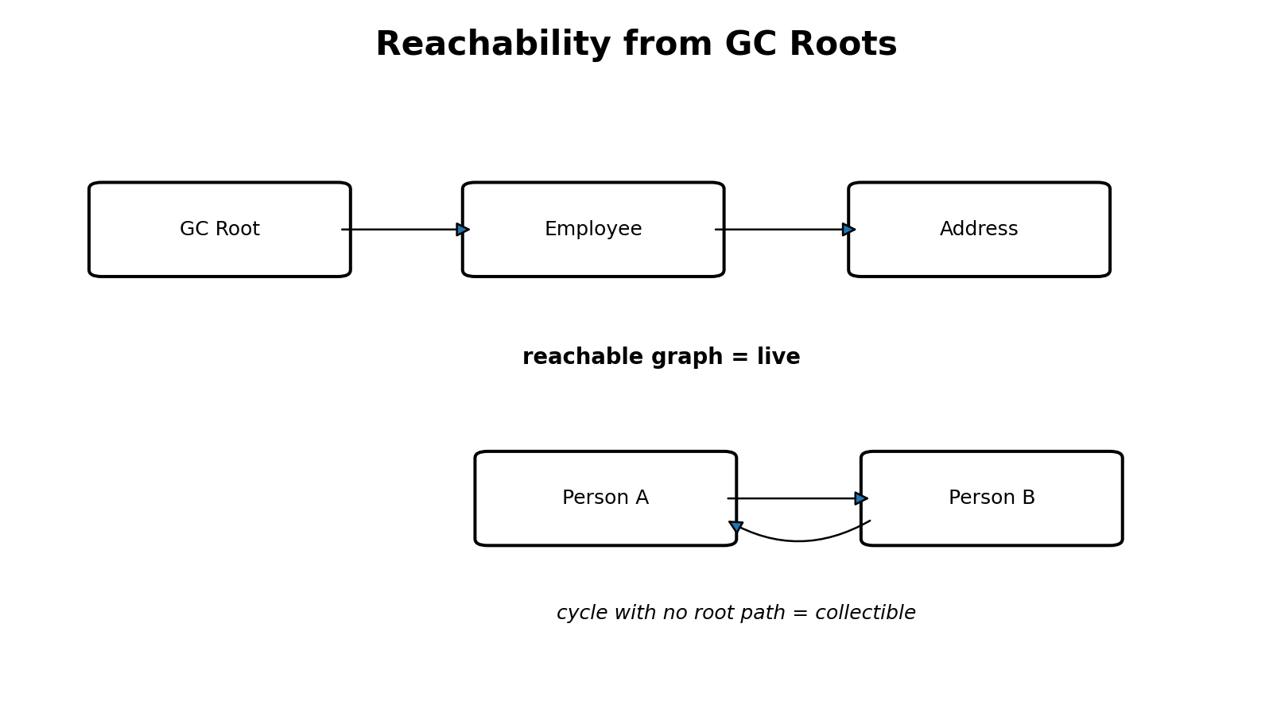

2.1 Common GC Root categories
- References associated with active Java thread execution, including live stack-frame references
- Static/class-related references maintained through loaded runtime class state
- JNI/native references registered with the JVM
- Certain JVM-internal references and runtime structures

2.2 A cycle can still be garbage
Person a = new Person();
Person b = new Person();
a.friend = b;
b.friend = a;
a = null;
b = null;
The two Person objects still reference each other, but if no GC Root reaches either object, the entire cycle is unreachable and collectible. This is exactly where reference-counting intuition fails.

3. “Eligible for GC” is not “deleted now”
Employee e1 = new Employee();
Employee e2 = e1;
e1 = null;
The Employee is still live through e2. Only after all root-reachable paths disappear does it become eligible for collection. Eligibility does not guarantee immediate reclamation; the collector decides when collection work is needed.
e2 = null; // assuming no other path exists, the object becomes unreachable

3.1 Entire subgraphs can become unreachable
class Employee {
Address address = new Address();
}
Employee e = new Employee();
e = null;
If nothing else reaches either object, Employee and its Address subgraph can both become collectible. The collector reasons over the graph, not one variable at a time.

4. Mark, sweep, compact, and copy
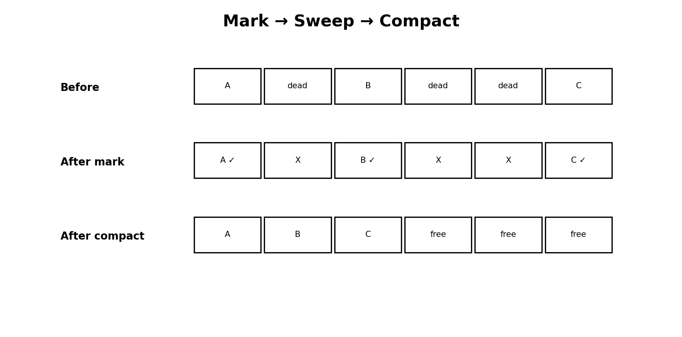

4.1 Mark
Starting from GC Roots, identify the objects that remain reachable/live.

4.2 Sweep
Reclaim memory occupied by objects that were not marked live. A pure mark-sweep organization can leave free holes between surviving objects.

4.3 Compact
Move survivors together to reduce fragmentation and create larger contiguous free ranges. Because the JVM owns reference representation, a moving collector can update references to relocated objects.

4.4 Copy
Copying collection moves only live objects from one area to another and then reclaims the source area wholesale. This is very attractive when most objects in the source area are dead.
From space before: [A][B][C][D][E]
Live objects: A, C, E
To space after: [A][C][E][ free ]
Key idea: These are algorithmic building blocks. Real collectors combine and adapt them rather than behaving like one simplistic textbook algorithm everywhere.

5. Fragmentation and contiguous allocation
Suppose a new object requires a 30-byte contiguous allocation range but the heap contains three isolated 10-byte holes. Total free memory is 30 bytes, yet there is no single 30-byte range. That is external fragmentation.
Need: [ 30 bytes ]
Have: [10 free] ... [10 free] ... [10 free]
Compaction or evacuation can create larger contiguous free areas. This explains why moving collectors do more than merely “delete garbage.”

6. Generational garbage collection
A powerful empirical observation behind many collectors is that most newly allocated objects die young. Temporary Strings, request-scoped DTOs, iterators, intermediate collections, and calculation objects often become unreachable quickly. Some objects—caches, shared state, long-lived graphs—survive much longer.
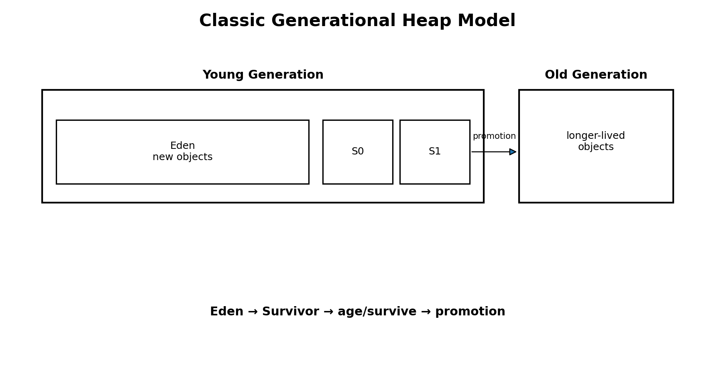

6.1 Eden
In the classic generational model, most ordinary new objects are allocated in Eden. Exact allocation behavior is collector-specific and large objects can follow special paths, but Eden is the correct first mental model.

6.2 Young GC and survivor spaces
When young allocation space fills, a Young GC identifies live young objects. In copying-style young collection, survivors are copied out of Eden/from-survivor into the other survivor space or promoted to Old Generation.
After GC #1: S0 contains survivors, S1 empty
After GC #2: S1 contains survivors, S0 empty
After GC #3: S0 contains survivors, S1 empty
S0 and S1 are better thought of as From and To roles that alternate. At the completion of a classic copying young collection, one survivor space is normally empty and ready to become the destination in a later cycle.

6.3 Object age and promotion
Each time an object survives an appropriate young collection, the collector can increase its age. After sufficient survival, or because of survivor-space pressure/adaptive policy, it can be promoted (tenured) into Old Generation.
Eden → Survivor (age 1) → Survivor (age 2) → ... → Old Generation
Do not memorize “exactly 15 collections” as a universal truth. HotSpot exposes concepts such as -XX:MaxTenuringThreshold for applicable collectors, but actual promotion decisions depend on collector policy, survivor pressure, adaptive thresholds, size, and configuration.

7. Young GC, old collection, and Full GC terminology
“Young GC” is relatively clear: a collection primarily of young-generation regions/space. “Major GC” is less standardized; different collectors and tools use it differently. “Full GC” generally refers to a broad, expensive collection involving most or all of the heap and often additional cleanup, but exact semantics remain collector-specific.
Key idea: In production discussions, name the collector and the actual event shown in GC logs instead of relying only on ambiguous terms like “Major GC.”

8. Stop-The-World
Application threads continuously mutate the object graph. Certain GC phases require the JVM to bring those application/mutator threads to safe states and pause them. This is a Stop-The-World (STW) pause.
T1 ───────│ PAUSED │────────►
T2 ───────│ PAUSED │────────►
T3 ───────│ PAUSED │────────►
GC phase
STW does not mean the JVM process is frozen. GC/JVM threads are actively performing required work. Young collections can include STW phases too, so “only Full GC pauses the application” is incorrect.

9. Old-to-young references: why barriers exist
class Employee {
Address address;
}
// Employee already old; new Address is young
employee.address = new Address();
A Young GC cannot assume that young objects are referenced only by young objects or thread stacks. An old Employee can keep a young Address alive. Scanning the entire Old Generation on every Young GC would undermine the performance benefit of generations.

9.1 Write barrier
When reference fields are written, JVM-generated/runtime barrier code can perform GC bookkeeping. A write barrier is the mechanism around the reference store; it is not a Java source-level if statement that you write manually.

9.2 Card table
A classic technique divides heap memory into small logical cards. A reference write can mark a card dirty, telling the collector that this area may contain references needing attention.
Card: 0 1 2 3 4
State: clean clean clean DIRTY clean

9.3 Remembered Set
A remembered set is the remembered information that helps a collector discover references entering a collection area/region from outside it. Card tables can support remembered-set maintenance, but “write barrier,” “card table,” and “remembered set” are not synonyms.

10. Serial GC
Serial GC performs its principal collection work with a single GC worker thread. Your application can still have many Java threads; “serial” refers to GC worker parallelism, not to the application becoming single-threaded.
Application T1 ───│ paused │───►
Application T2 ───│ paused │───►
│
GC Worker 1
In the traditional model, young collection copies survivors and the old-generation collector uses mark-compact style processing. Serial GC can be suitable for small heaps, constrained environments, or simple workloads where GC parallelism overhead is not beneficial.
java -XX:+UseSerialGC MyApplication

11. Parallel GC
Parallel GC attacks the obvious limitation of Serial GC: on a multicore machine, why should one worker perform all collection work? It uses multiple GC worker threads so STW collection work can be divided across CPU cores.
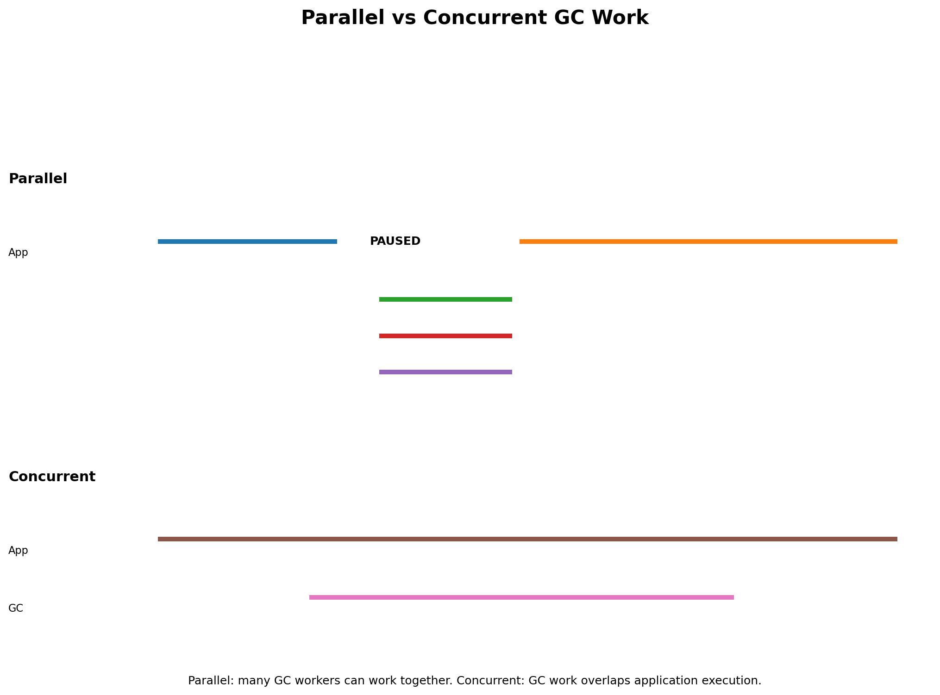
Its traditional design emphasis is throughput: maximize the fraction of total time spent doing application work. A batch job may tolerate occasional pauses if total job completion time is excellent.
java -XX:+UseParallelGC MyApplication
Key idea: Parallel and concurrent are different. Parallel means multiple GC workers work at the same time. Concurrent means GC work overlaps application execution.

12. G1: region-based generational collection
G1 keeps generational concepts but changes the physical heap organization. Instead of one permanently contiguous Young block followed by one contiguous Old block, the heap is divided into equal-sized regions that can take roles such as Eden, Survivor, Old, Free, or Humongous.
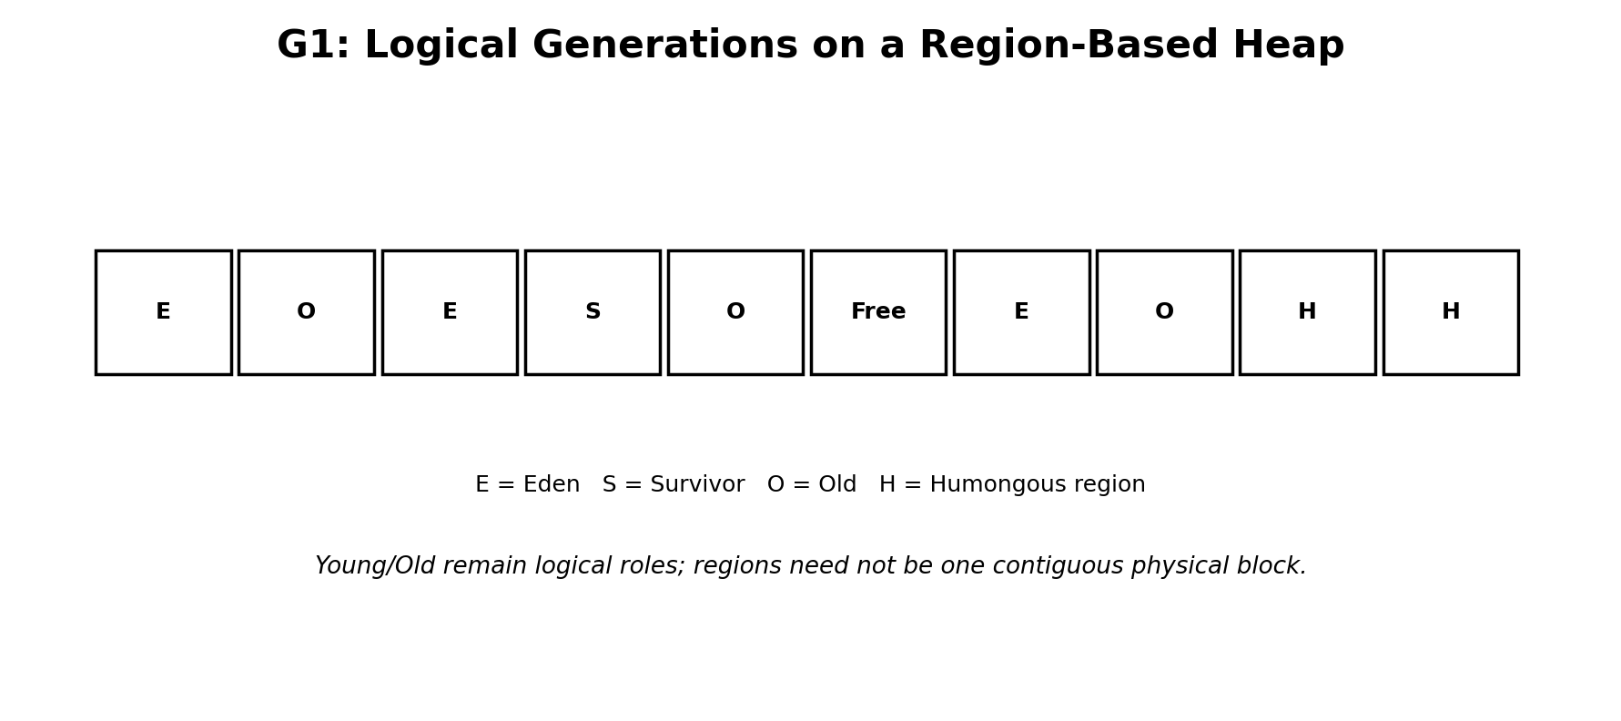

12.1 Evacuation
When selected regions are collected, G1 can evacuate live objects into destination regions and reclaim the source regions. This is a copying/moving idea applied at region scale.
Eden region before: [A][B][C][D][E][F]
Live: B, D, F
Destination region: [B][D][F]
Old Eden region: fully reusable

12.2 Collection Set (CSet)
A G1 pause collects a chosen set of regions rather than blindly treating every old region identically. The chosen regions form the Collection Set. G1 uses predicted cost and reclaimable space, among other heuristics, while working toward a pause-time goal.

12.3 Concurrent marking and mixed collections
As old occupancy grows, G1 can perform marking work concurrently with the application to learn which old regions contain significant garbage. Later mixed collections can collect young regions plus selected old regions with good reclamation potential.
Mixed collection ≈ young regions + selected old regions

12.4 Why Remembered Sets matter even more in G1
Any region can reference objects in many other regions. If Region 7 is collected, G1 needs efficient knowledge of incoming references from outside the collection set. Remembered information maintained through barriers/card mechanisms helps avoid scanning the entire heap.

12.5 Pause-time target
-XX:MaxGCPauseMillis=200
This is a goal used by G1 heuristics, not a hard promise that every pause will be under 200 ms.

13. G1 Humongous Objects
In G1, an object whose size is greater than half a region is treated as humongous. Such an object occupies a contiguous sequence of humongous regions, starting with a Humongous Start region and continuing as needed.
// Example of a potentially humongous allocation depending on region size
byte[] data = new byte[20_000_000];
If the region size were 4 MB, an object larger than roughly 2 MB would be humongous. A 10 MB object would require several contiguous regions. Large temporary arrays, full-file buffering, and giant payload materialization can therefore create special pressure in G1.

13.1 Backend design implication
Bad for large data when avoidable:
wholeFile = readAllBytes(...)
Prefer when appropriate:
read chunk → process → release → read next chunk
Streaming/chunking is not “because GC cannot handle arrays”; it is an architectural technique that controls peak live-set size and allocation pressure.

14. ZGC and Shenandoah
Both collectors pursue very low pause times by moving substantially more GC work into concurrent phases. Low-pause does not mean zero-pause: short synchronization/STW phases still exist.
Collector | Day 1 mental model
ZGC | Very low pause focus, highly concurrent work, designed to scale to large heaps; modern ZGC is generational in current JDKs
Shenandoah | Very low pause focus with concurrent evacuation/compaction techniques; availability depends on JDK distribution/build

Do not dive into colored pointers, load barriers, forwarding protocols, SATB details, or collector-specific heuristics on Day 1. First master the problem they solve: doing relocation/marking while application threads continue changing the object graph requires sophisticated barrier protocols.

15. Collector comparison
Collector | GC worker/concurrency idea | Primary conceptual emphasis
Serial | Single principal GC worker; STW collection | Simplicity / small workloads
Parallel | Multiple GC workers during STW phases | Throughput
G1 | Regions + parallel evacuation + concurrent marking | Balanced throughput and pause-time goals
ZGC | Highly concurrent | Very low pauses / scalability
Shenandoah | Highly concurrent, including relocation techniques | Very low pauses

16. Heap OOME vs Metaspace OOME vs StackOverflowError

16.1 Java heap space
List<byte[]> data = new ArrayList<>();
while (true) {
data.add(new byte[10 * 1024 * 1024]);
}
The list retains every array, so they remain reachable and GC cannot reclaim them. Eventually the heap may fail with OutOfMemoryError: Java heap space.

16.2 Allocation is not automatically a leak
while (true) {
new byte[10 * 1024 * 1024];
}
Those arrays become unreachable quickly because no long-lived reference retains them. This loop creates extreme allocation pressure, but the liveness story differs from a retained-object leak.

16.3 Metaspace OOME
If an application repeatedly creates class loaders/classes and prevents the defining loaders from becoming unloadable, class metadata can accumulate until Metaspace memory is exhausted or a configured limit is reached.

16.4 StackOverflowError
static void recurse() {
recurse();
}
Every recursive invocation creates another frame on the same thread’s JVM stack. Eventually the thread stack cannot accommodate another frame and StackOverflowError occurs. This is a stack-capacity failure, not a heap-retention problem.

17. Production reasoning examples

17.1 Latency spike during GC
If an API normally completes in 50 ms but overlaps a 250 ms STW pause, the observed request latency can jump dramatically even though application code itself did not become slower. GC logs and APM timelines are therefore useful together.

17.2 Large file service
A service that repeatedly creates 100 MB byte arrays may trigger humongous allocations, high allocation rate, and a larger live set. Stream processing can reduce peak memory pressure. The correct diagnosis requires checking whether those arrays are short-lived, retained, duplicated, or referenced by caches/futures.

17.3 Memory leak mental model
A Java “memory leak” usually means objects are still reachable even though the business logic no longer needs them. GC cannot read developer intent. If a static map, cache, listener registry, ThreadLocal, queue, or class loader retains an object graph, the collector correctly treats it as live.

18. Common misconceptions corrected
Misconception | Correct model
e = null deletes the object | It removes one reference path; collection depends on reachability from all GC Roots
Cycles cannot be collected | Cycles are collectible when no root reaches them
Young GC has no STW pause | Young collections can have STW phases
Full GC is the only expensive event | Collector-specific pauses and evacuation failures can also be expensive
Parallel GC means application and GC run together | Parallel means multiple GC workers; concurrency is the overlap concept
G1 has no Young/Old generations | G1 uses logical generational roles on regions
S0 always means “from” and S1 always “to” | The survivor roles alternate
Every object promotes after exactly 15 GCs | Promotion thresholds and policy are collector/configuration dependent
Write barrier = remembered set | Barrier is the update mechanism; remembered set is stored reference information
Low-pause collector = no pauses | Low-pause collectors still require some synchronization/STW phases

19. Five-minute revision
GC Roots → reachability → live/dead decision
Most objects die young → Eden → Survivor → promotion → Old
Moving/copying collection → references adjusted by JVM
Old→Young / cross-region references → barriers + remembered information
STW = application/mutator threads paused for required GC phases
- Mark finds live objects; sweep reclaims dead memory; compact moves survivors; copying moves live objects to another area.
- Serial = one main GC worker. Parallel = many GC workers and throughput emphasis.
- G1 = region-based generational collector using evacuation, remembered sets, concurrent marking, and mixed collections.
- ZGC/Shenandoah = very-low-pause families using extensive concurrent work.
- Heap OOME is about unsatisfied heap allocation/live set; Metaspace OOME concerns class metadata/native memory limits; StackOverflowError concerns a thread stack.

Practical Lab

Lab 1 — Prove heap OOME with retained objects
import java.util.*;
public class HeapOomDemo {
public static void main(String[] args) {
List<byte[]> data = new ArrayList<>();
while (true) data.add(new byte[10 * 1024 * 1024]);
}
}
javac HeapOomDemo.java
java -Xmx128m HeapOomDemo
Expected eventual failure: OutOfMemoryError: Java heap space. Explain the root path: main thread → local data → ArrayList → retained byte arrays.

Lab 2 — Compare with short-lived allocations
public class AllocationPressureDemo {
public static void main(String[] args) {
while (true) {
byte[] temp = new byte[10 * 1024 * 1024];
}
}
}
Run only in a disposable lab environment with a small heap. Compare behavior with the retained-list program. This is allocation pressure, but objects are not intentionally retained.

Lab 3 — Observe G1 Young GC
import java.util.*;
public class GcLogDemo {
public static void main(String[] args) throws Exception {
List<byte[]> retained = new ArrayList<>();
for (int i = 0; i < 500; i++) {
byte[] temp = new byte[1024 * 1024];
if (i % 20 == 0) retained.add(temp);
Thread.sleep(10);
}
System.out.println("Retained: " + retained.size());
}
}
javac GcLogDemo.java
java -Xms64m -Xmx64m -XX:+UseG1GC -Xlog:gc GcLogDemo
# more detail
java -Xms64m -Xmx64m -XX:+UseG1GC -Xlog:gc* GcLogDemo
For Day 1, identify only: GC event number, event type, pause wording, heap before → after, and duration. Save advanced log interpretation for the diagnostics module.

Lab 4 — Compare collectors
java -Xms64m -Xmx64m -XX:+UseSerialGC -Xlog:gc GcLogDemo
java -Xms64m -Xmx64m -XX:+UseParallelGC -Xlog:gc GcLogDemo
java -Xms64m -Xmx64m -XX:+UseG1GC -Xlog:gc GcLogDemo
Do not rank collectors from this tiny benchmark. Instead, compare the vocabulary and event patterns in their logs and connect them to the architecture learned in the chapter.

Lab 5 — Reason about object graphs
static Employee shared = new Employee();
public static void main(String[] args) {
Employee local = shared;
local = null;
}
Question: is the object eligible for GC? No: shared remains a root-reachable path. Now set shared = null and assume no other references; explain the state again.

Lab report template
Experiment | What stayed reachable? | GC/error observed | Explanation
Retained heap OOME
Short-lived allocations
G1 logs
Collector comparison
Reachability reasoning

Interview Questions & Revision

Core interview questions

1. What makes an object eligible for GC?
No path from any GC Root reaches it.

2. Does e = null immediately free the object?
No. It removes one reference; liveness depends on all root paths and collection timing.

3. Can a cycle be collected?
Yes, if the entire cycle is unreachable from GC Roots.

4. Mark vs sweep vs compact?
Mark identifies live; sweep reclaims dead; compact relocates survivors to reduce fragmentation.

5. Why is copying collection good for young objects?
When most objects die, only the small survivor set needs copying.

6. Why Eden + Survivor spaces?
Most allocations start young; survivors are copied/aged efficiently before promotion.

7. Are S0 and S1 both normally full?
In the classic copying model, one is typically the destination/current survivor set and the other is empty after a collection; roles alternate.

8. What is promotion?
Moving/placing sufficiently long-lived young objects into Old Generation.

9. Why not scan all Old Generation on every Young GC?
It would be expensive; barriers/card/remembered information tracks relevant incoming references.

10. Write barrier vs card table vs remembered set?
Barrier performs bookkeeping on writes; card table is a coarse structure; remembered set stores relevant cross-area reference information.

11. What is STW?
Application/mutator threads are paused for phases requiring a safe/stable JVM state; the JVM/GC itself is still working.

12. Serial vs Parallel GC?
Serial uses one main GC worker; Parallel uses multiple workers and emphasizes throughput.

13. Parallel vs concurrent?
Parallel = many GC workers simultaneously; concurrent = GC work overlaps application execution.

14. What is G1’s key structural idea?
Equal-sized heap regions with logical Eden/Survivor/Old roles and region-based collection sets.

15. What is G1 evacuation?
Copy/move live objects out of selected source regions so those regions can be reclaimed.

16. What is a mixed collection?
A G1 collection including young regions plus selected old regions.

17. What is a humongous object in G1?
An object larger than half a G1 region; it occupies contiguous humongous regions.

18. Does MaxGCPauseMillis guarantee the pause?
No, it is a heuristic goal.

19. Why ZGC/Shenandoah?
To achieve very low pauses by performing substantially more GC work concurrently.

20. Heap OOME vs StackOverflowError?
Heap OOME means heap allocation cannot be satisfied; StackOverflowError means a thread stack cannot accommodate another frame.

Scenario questions

A static Map keeps growing. GC runs frequently but memory never drops much. Why?
Objects remain root-reachable through static state; GC correctly treats them as live.

Old object points to a new Address object. How can Young GC find it efficiently?
Write barrier/remembered information records relevant old-to-young or cross-region references.

API p99 latency spikes during a GC pause. CPU is otherwise fine. What is the connection?
The request thread can be suspended during STW time, adding pause duration to observed request latency.

Why can moving GC relocate an object without Java code noticing?
The JVM controls managed references and updates/forwards them according to the collector’s protocol.

A 100 MB file is repeatedly read into byte[]. What GC concern appears under G1?
Potential humongous allocations, high peak live set, and allocation/collection pressure; streaming may reduce peak memory.

Rapid revision
GC Roots → reachable = live
Unreachable → eligible
Young: Eden → Survivor → Old
STW ≠ JVM stopped
Parallel ≠ Concurrent
G1 = regions + evacuation + remembered sets + concurrent marking + mixed collections

