

Adithya Varman N CH.SC.U4CSE24257
Week – 4 Date - 26/12/2025
Design and Analysis of Algorithm(23CSE211)

PRIM’S ALGORITHM
Code:
#include <stdio.h> #include <limits.h>

#define INF 9999 int n;

int minKey(int key[], int mstSet[]) { int min = INF, min_index, v;
for (v = 0; v < n; v++)
if (mstSet[v] == 0 && key[v] < min) min = key[v], min_index = v;
return min_index;
}

void printMST(int parent[], int graph[20][20]) { printf("Edge \tWeight\n");
for (int i = 1; i < n; i++)
printf("%d - %d \t%d \n", parent[i], i, graph[i][parent[i]]);
}

void primMST(int graph[20][20]) { int parent[20];
int key[20]; int mstSet[20];

for (int i = 0; i < n; i++) key[i] = INF, mstSet[i] = 0;

key[0] = 0;
parent[0] = -1;

for (int count = 0; count < n - 1; count++) { int u = minKey(key, mstSet);
mstSet[u] = 1;

for (int v = 0; v < n; v++)
if (graph[u][v] && mstSet[v] == 0 && graph[u][v] < key[v]) parent[v] = u, key[v] = graph[u][v];
}
printMST(parent, graph);
}

int main() {
int graph[20][20]; printf("Name:Adithya Varman N\n");
printf("Roll No: CH.SC.U4CSE24257\n\n"); printf("Enter number of vertices: "); scanf("%d", &n);
printf("Enter adjacency matrix:\n"); for(int i = 0; i < n; i++)
for(int j = 0; j < n; j++) scanf("%d", &graph[i][j]);

primMST(graph); return 0;
}

Output:
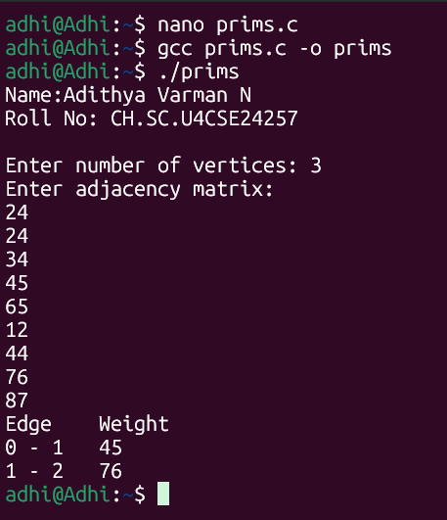


Time Complexity: O(N^2)

Since the graph is represented using an Adjacency Matrix, we use two nested loops. The outer loop runs N times to include every vertex in the MST. The inner loop (searching for the minimum key and updating neighbors) iterates through all N vertices. This results in N * N operations.


Space Complexity: O(N)

I used three auxiliary arrays (key, parent, and mstSet), each of size N. Therefore, the space required is proportional to the number of vertices N.

KRUSKAL’S ALGORITHM

Code:
#include <stdio.h> #include <stdlib.h>

struct Edge {
int src, dest, weight;
};

struct Edge edges[100]; int parent[20];
int n, e_cnt = 0;

int find(int i) {
if (parent[i] == -1) return i;
return find(parent[i]);
}

void Union(int x, int y) { int xset = find(x); int yset = find(y); if(xset != yset)
parent[xset] = yset;
}

int compare(const void* a, const void* b) { struct Edge* a1 = (struct Edge*)a; struct Edge* b1 = (struct Edge*)b; return a1->weight - b1->weight;
}

void kruskalMST() { int mst_weight = 0;
qsort(edges, e_cnt, sizeof(edges[0]), compare);

for (int i = 0; i < n; i++) parent[i] = -1;

printf("Edge \tWeight\n");
for (int i = 0; i < e_cnt; i++) { int x = find(edges[i].src); int y = find(edges[i].dest);

if (x != y) {
printf("%d - %d \t%d \n", edges[i].src, edges[i].dest, edges[i].weight);
mst_weight += edges[i].weight; Union(x, y);
}
}

printf("Total Cost: %d\n", mst_weight);
}

int main() {
int weight;
printf("Name: Adithya Varman N\n"); printf("Roll No: CH.SC.U4CSE24257\n\n"); printf("Enter number of vertices: "); scanf("%d", &n);
printf("Enter number of edges: "); scanf("%d", &e_cnt);

for(int i = 0; i < e_cnt; i++) {
printf("Enter src, dest, weight for edge %d: ", i+1); scanf("%d %d %d", &edges[i].src, &edges[i].dest,
&edges[i].weight);
}

kruskalMST(); return 0;
}

Output:

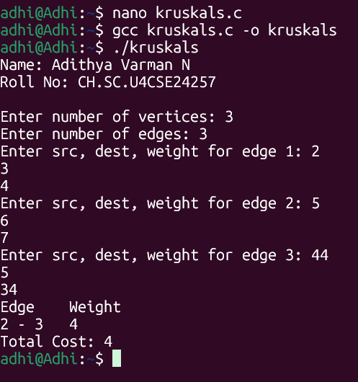


Time Complexity: O(E log E) or O(E log N)

The most time-consuming step is sorting all the edges by weight, which takes O(E log E). The Union-Find operations take nearly constant time on average (O(alpha(N))), so the sorting dominates the complexity.


Space Complexity: O(E + N)

I used an array to store all E edges and a parent array of size N for the Union- Find structure. Thus, the space complexity depends on both the number of edges and vertices.

