

Adithya Varman N CH.SC.U4CSE24257
Week – 6 Date - 09/01/2026
Design and Analysis of Algorithm(23CSE211)

1. ADELSON – VELSKY AND LANDIS TREE (AVL)
Code:
#include <stdio.h> #include <stdlib.h> typedef struct Node {
int key;
struct Node *left; struct Node *right; int height;
} Node;

int getHeight(Node *n) {
return (n == NULL) ? 0 : n->height;
}

int max(int a, int b) { return (a > b) ? a : b;
}
Node* newNode(int key) {
Node* node = (Node*)malloc(sizeof(Node)); node->key = key;
node->left = node->right = NULL;
node->height = 1; // New node is initially added at leaf return node;
}

Node* rightRotate(Node *y) { Node *x = y->left;
Node *T2 = x->right; x->right = y;
y->left = T2;
y->height = max(getHeight(y->left), getHeight(y->right)) + 1;

x->height = max(getHeight(x->left), getHeight(x->right)) + 1;

return x;
}
Node* leftRotate(Node *x) { Node *y = x->right; Node *T2 = y->left;
y->left = x; x->right = T2;
x->height = max(getHeight(x->left), getHeight(x->right)) + 1; y->height = max(getHeight(y->left), getHeight(y->right)) + 1;

return y;
}
int getBalance(Node *N) {

return (N == NULL) ? 0 : getHeight(N->left) - getHeight(N->right);
}
Node* insert(Node* node, int key) {

if (node == NULL) return newNode(key);

if (key < node->key)
node->left = insert(node->left, key); else if (key > node->key)
node->right = insert(node->right, key); else
return node;
node->height = 1 + max(getHeight(node->left), getHeight(node-
>right));
int balance = getBalance(node);

if (balance > 1 && key < node->left->key) return rightRotate(node);

if (balance < -1 && key > node->right->key) return leftRotate(node);
if (balance > 1 && key > node->left->key) { node->left = leftRotate(node->left);

return rightRotate(node);

}
if (balance < -1 && key < node->right->key) { node->right = rightRotate(node->right); return leftRotate(node);
}

return node;
}
void inOrder(Node *root) { if (root != NULL) {
inOrder(root->left); printf("%d ", root->key); inOrder(root->right);
}
}

int main() {
printf("Name: Adithya Varman N \n");

printf("Roll No: CH.SC.U4CSE24257\n\n");

Node *root = NULL;
root = insert(root, 10); root = insert(root, 20);
root = insert(root, 30); root = insert(root, 40); root = insert(root, 50); root = insert(root, 25);

printf("In-order traversal of the constructed AVL tree is: \n"); inOrder(root);
printf("\n");

return 0;
}

Output:
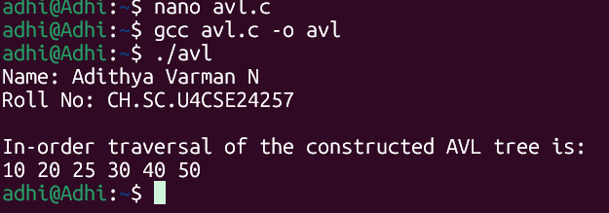


Time Complexity: O(log N)

Because the tree is strictly balanced, the height is guaranteed to be O(log N). Operations like insertion, deletion, and search take time proportional to the height. Unlike a standard BST, which can degrade to O(N) in the worst case (skewed tree), AVL trees ensure O(log N) even in the worst case.


Space Complexity: O(N)

I used malloc to allocate memory for each of the N nodes. Additionally, each node stores an integer height variable to track balance, which adds a small constant overhead per node compared to a standard BST.

