

Adithya Varman N CH.SC.U4CSE24257
Week – 8
Design and Analysis of Algorithm(23CSE211)

JOB SEQUENCING
Code:
#include <stdio.h> #include <stdlib.h> #include <stdbool.h>

struct Job {
char id; int dead; int profit;
};

int compare(const void* a, const void* b) { struct Job* temp1 = (struct Job*)a; struct Job* temp2 = (struct Job*)b;
return (temp2->profit - temp1->profit); // Sort descending by profit
}

int min(int num1, int num2) {
return (num1 > num2) ? num2 : num1;
}

void printJobScheduling(struct Job arr[], int n) { qsort(arr, n, sizeof(struct Job), compare);

int result[n]; bool slot[n];

for (int i = 0; i < n; i++) slot[i] = false;

for (int i = 0; i < n; i++) {

for (int j = min(n, arr[i].dead) - 1; j >= 0; j--) { if (slot[j] == false) {
result[j] = i; slot[j] = true; break;
}
}
}

printf("Following is maximum profit sequence of jobs: \n"); int totalProfit = 0;
for (int i = 0; i < n; i++) { if (slot[i]) {
printf("%c ", arr[result[i]].id); totalProfit += arr[result[i]].profit;
}
}
printf("\nTotal Profit: %d\n", totalProfit);
}

int main() {
struct Job arr[] = { {'a', 2, 100}, {'b', 1, 19}, {'c', 2, 27},
{'d', 1, 25}, {'e', 3, 15} };
int n = sizeof(arr) / sizeof(arr[0]);

printf("Name: Adithya Varman N \n");
printf("Roll No: CH.SC.U4CSE24257\n\n"); printJobScheduling(arr, n);
return 0;
}

Output:
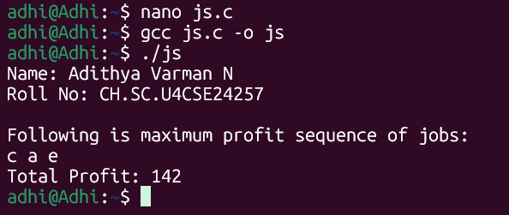


Time Complexity: O(N^2)

Sorting the jobs takes O(N log N). Then, iterating through the jobs and finding a free slot takes O(N^2) in the worst case. This can be optimized to O(N log N) using Disjoint Sets.


Space Complexity: O(N)

Arrays result and slot take linear memory space to track the schedule.

HUFFMAN CODING

Code:
#include <stdio.h> #include <stdlib.h>

#define MAX_TREE_HT 100

struct MinHeapNode { char data; unsigned freq;
struct MinHeapNode *left, *right;
};

struct MinHeap { unsigned size; unsigned capacity;
struct MinHeapNode** array;
};

struct MinHeapNode* newNode(char data, unsigned freq) { struct MinHeapNode* temp = (struct
MinHeapNode*)malloc(sizeof(struct MinHeapNode)); temp->left = temp->right = NULL;
temp->data = data; temp->freq = freq; return temp;

}

struct MinHeap* createMinHeap(unsigned capacity) {
struct MinHeap* minHeap = (struct MinHeap*)malloc(sizeof(struct MinHeap));
minHeap->size = 0;
minHeap->capacity = capacity;
minHeap->array = (struct MinHeapNode**)malloc(minHeap->capacity * sizeof(struct MinHeapNode*));
return minHeap;
}

void swapMinHeapNode(struct MinHeapNode** a, struct MinHeapNode** b) { struct MinHeapNode* t = *a;
*a = *b;
*b = t;
}

void minHeapify(struct MinHeap* minHeap, int idx) { int smallest = idx;
int left = 2 * idx + 1; int right = 2 * idx + 2;

if (left < minHeap->size && minHeap->array[left]->freq < minHeap-
>array[smallest]->freq)
smallest = left;

if (right < minHeap->size && minHeap->array[right]->freq < minHeap->array[smallest]->freq)

smallest = right;

if (smallest != idx) {
swapMinHeapNode(&minHeap->array[smallest], &minHeap-
>array[idx]);
minHeapify(minHeap, smallest);
}
}

int isSizeOne(struct MinHeap* minHeap) { return (minHeap->size == 1);
}

struct MinHeapNode* extractMin(struct MinHeap* minHeap) { struct MinHeapNode* temp = minHeap->array[0];
minHeap->array[0] = minHeap->array[minHeap->size - 1];
--minHeap->size; minHeapify(minHeap, 0); return temp;
}

void insertMinHeap(struct MinHeap* minHeap, struct MinHeapNode* minHeapNode) {

++minHeap->size;
int i = minHeap->size - 1;
while (i && minHeapNode->freq < minHeap->array[(i - 1) / 2]->freq)
{

minHeap->array[i] = minHeap->array[(i - 1) / 2]; i = (i - 1) / 2;
}
minHeap->array[i] = minHeapNode;
}

void buildMinHeap(struct MinHeap* minHeap) { int n = minHeap->size - 1;
for (int i = (n - 1) / 2; i >= 0; --i) minHeapify(minHeap, i);
}

void printArr(int arr[], int n) { for (int i = 0; i < n; ++i)
printf("%d", arr[i]); printf("\n");
}

int isLeaf(struct MinHeapNode* root) {

return !(root->left) && !(root->right);
}

struct MinHeap* createAndBuildMinHeap(char data[], int freq[], int size) {
struct MinHeap* minHeap = createMinHeap(size); for (int i = 0; i < size; ++i)
minHeap->array[i] = newNode(data[i], freq[i]);

minHeap->size = size; buildMinHeap(minHeap); return minHeap;
}

struct MinHeapNode* buildHuffmanTree(char data[], int freq[], int size) {
struct MinHeapNode *left, *right, *top;
struct MinHeap* minHeap = createAndBuildMinHeap(data, freq, size);

while (!isSizeOne(minHeap)) { left = extractMin(minHeap); right = extractMin(minHeap);
top = newNode('$', left->freq + right->freq); top->left = left;
top->right = right;

insertMinHeap(minHeap, top);
}
return extractMin(minHeap);
}

void printCodes(struct MinHeapNode* root, int arr[], int top) { if (root->left) {
arr[top] = 0;
printCodes(root->left, arr, top + 1);
}
if (root->right) {

arr[top] = 1;
printCodes(root->right, arr, top + 1);
}
if (isLeaf(root)) {
printf("%c: ", root->data); printArr(arr, top);
}
}

void HuffmanCodes(char data[], int freq[], int size) {
struct MinHeapNode* root = buildHuffmanTree(data, freq, size); int arr[MAX_TREE_HT], top = 0;

printCodes(root, arr, top);
}

int main() {
char arr[] = { 'a', 'b', 'c', 'd', 'e', 'f' }; int freq[] = { 5, 9, 12, 13, 16, 45 };
int size = sizeof(arr) / sizeof(arr[0]);

printf("Name: Adithya Varman N\n"); printf("Roll No: CH.SC.U4CSE24257\n\n"); printf("Huffman Codes generated:\n"); HuffmanCodes(arr, freq, size);
return 0;
}

Output:
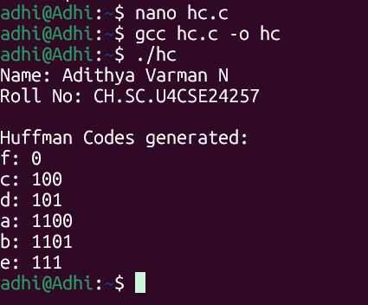


Time Complexity: O(N log N)

Extracting the minimum from the heap and inserting the new combined node back into the heap takes O(log N) time. Since we do this for N characters, the total time is N log N.


Space Complexity: O(N)

The Min-Heap array and the Huffman Tree require memory proportional to the number of distinct characters N.

