

ADITHYA VARMAN NANDHIVARMAN

CH.SC.U4SCE24257

Week – 2 Date - 04/12/2025
Design and Analysis of Algorithm(23CSE211)

Bubble Sort

Code:
#include<stdio.h> int arr[100]; int n;
void swap(int *a,int *b){ int temp=*a;
*a=*b;
*b=temp;
}
void Sort(int arr[]){ for(int i=0;i<n;i++){
for(int j=0;j<n-i-1;j++){ if(arr[j]>arr[j+1]){
swap(&arr[j],&arr[j+1]);
}
}
}
}
int main(){ printf("CH.SC.U4CSE24257\n");
printf("Enter no. of elements to insert:"); scanf("%d",&n);
printf("Enter elements followed by a space"); for(int i=0;i<n;i++){
scanf("%d",&arr[i]);
}
Sort(arr);
printf("Sorted array is:"); for(int i=0;i<n;i++){
printf("\t%d",arr[i]);
}
}

Output:

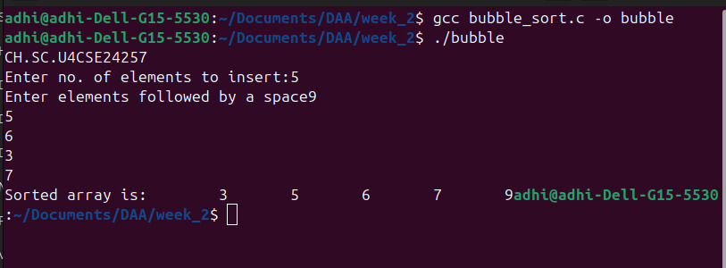

Space Complexity: O(1)
Justification: The sorting happens in-place within the original array. You only use a single temporary variable (temp) for swapping, so no extra memory is required relative to the input size.

Time Complexity: O(n2)
Justification: We have two nested loops. The outer loop runs n times, and for every iteration of the outer loop, the inner loop also runs roughly n times. This results in n x n operations.

Insertion Sort

Code:
#include<stdio.h> int arr[100]; int n;
void Sort(int arr[]){ for(int i=1;i<n;i++){
int j=i-1;
int temp=arr[i];
while(j>=0 && temp<arr[j]){ arr[j+1]=arr[j];
j--;
}
arr[j+1]=temp;
}
}
int main(){ printf("CH.SC.U4CSE24257\n");
printf("Enter no. of elements to insert:"); scanf("%d",&n);
printf("Enter elements followed by a space"); for(int i=0;i<n;i++){
scanf("%d",&arr[i]);
}
Sort(arr);
printf("Sorted array is:"); for(int i=0;i<n;i++){
printf("\t%d",arr[i]);
}
}

Output:
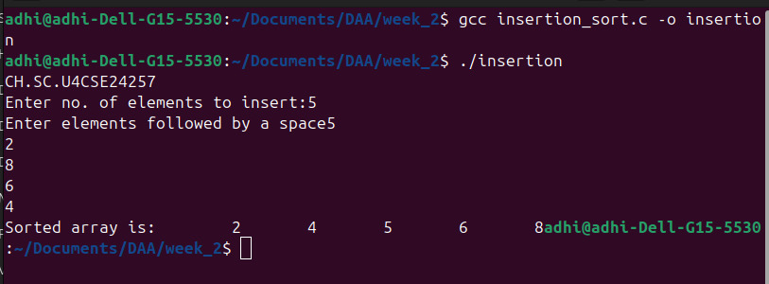

Space Complexity: O(1)
Justification: The sorting is performed in-place using the same array. Only one temporary variable (temp) is used, so no extra memory is needed.

Time Complexity: O(n2)
Justification: For every element i, the inner while loop runs i times to shift elements. This results in n x n operations.

Selection Sort

Code:
#include<stdio.h> int arr[100];
int n;
void swap(int *a,int *b){ int temp=*a;
*a=*b;
*b=temp;
}
void Sort(int arr[]){ for(int i=0;i<n;i++){
int min=i;
for(int j=i+1;j<n;j++){ if(arr[min]>arr[j]){
min=j;
}
}
if(min!=i){ swap(&arr[min],&arr[i]);
}
}
}
int main(){ printf("CH.SC.U4CSE24257\n");
printf("Enter no. of elements to insert:"); scanf("%d",&n);
printf("Enter elements followed by a space"); for(int i=0;i<n;i++){
scanf("%d",&arr[i]);
}
Sort(arr);
printf("Sorted array is:"); for(int i=0;i<n;i++){
printf("\t%d",arr[i]);
}
}

Output:

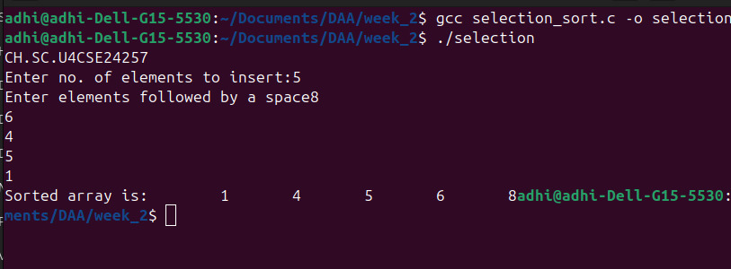

Time Complexity: O(n2)
Justification: There are two nested loops. Regardless of the data order, the inner loop iterates through the remaining unsorted elements to find the minimum. This always
results in roughly ^{n(n–1)} comparisons, or n x n operations.
2

Space Complexity: O(1)
Justification: The algorithm sorts the array in-place. It uses only a few variables (min, i, j, temp) for bookkeeping, requiring no extra memory proportional to the input size.

Bucket Sort

Code:
#include <stdio.h> #define MAX 100 int arr[MAX];
int size = 0;
void readArray(int n) { size = n;
printf("Enter the elements:"); for (int i = 0; i < n; i++) { scanf("%d", &arr[i]);
}
}
void display(int n) {
for (int i = 0; i < n; i++) { printf("%d ", arr[i]);
}
printf("\n");
}
void bucketSort() {
int buckets[10][MAX]; int count[10];
int i, j, k, max = 0;
for (i = 0; i < 10; i++) count[i] = 0; for (i = 0; i < size; i++) {
if (arr[i] > max) max = arr[i];
}
for (i = 0; i < size; i++) {
int idx = (arr[i] * 10) / (max + 1); buckets[idx][count[idx]++] = arr[i];
}
for (i = 0; i < 10; i++) {
for (j = 1; j < count[i]; j++) { int key = buckets[i][j];
k = j - 1;
while (k >= 0 && buckets[i][k] > key) { buckets[i][k + 1] = buckets[i][k]; k--;
}
buckets[i][k + 1] = key;
}
}
k = 0;
for (i = 0; i < 10; i++) {
for (j = 0; j < count[i]; j++) { arr[k++] = buckets[i][j];
}
}
}
int main() {
int n; printf("CH.SC.U4CSE24257\n");
printf("Enter number of elements:");

scanf("%d", &n); readArray(n); printf("\nOriginal array: "); display(size);
bucketSort();
printf("\nSorted array (Ascending Order): "); display(size);
return 0;
}

Output:

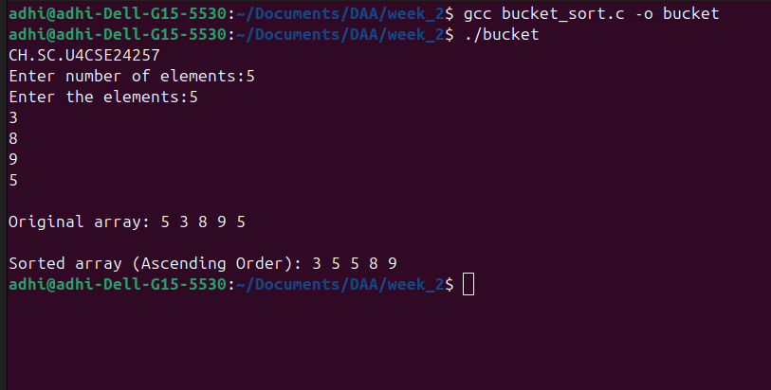

Time Complexity: O(n2)
Justification: In the worst case, if the data is not uniformly distributed (e.g., all elements fall into the same bucket), the algorithm relies on the inner loop which performs Insertion Sort. Since Insertion Sort has a worst-case time of O(n2), the total time becomes quadratic.

Space Complexity: O(n)
Justification: The algorithm uses an auxiliary 2D array buckets[10][MAX] to temporarily store and sort the elements. This requires extra memory proportional to the size of the input data (n).

Heap Sort

Code:

#include <stdio.h>

void hf(int a[], int n, int i) {

int m = i;

int l = 2 * i + 1;

int r = 2 * i + 2;

int t;

if (l < n && a[l] > a[m])

m = l;

if (r < n && a[r] > a[m])

m = r;

if (m != i) {

t = a[i];

a[i] = a[m];

a[m] = t;

hf(a, n, m);

}

}

void hS(int a[], int n) {

int i, t;

for (i = n / 2 - 1; i >= 0; i--)

hf(a, n, i);

for (i = n - 1; i > 0; i--) {

t = a[0];

a[0] = a[i];

a[i] = t;

hf(a, i, 0);

}

}

void pA(int a[], int n) {

int i;

for (i = 0; i < n; ++i)

printf("%d ", a[i]);

printf("\n");

}

int main() {

printf("CH.SC.U4CSE24257\n");

int a[] = {4, 10, 3, 5, 1};

int n = sizeof(a) / sizeof(a[0]);

hS(a, n);

printf("Sorted array: \n");

pA(a, n);

return 0;

}

Output:

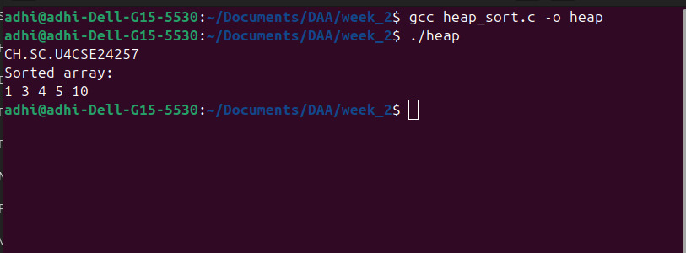
Time Complexity: O(n log n)
Justification: The algorithm first builds a heap in O(n). Then, it performs a loop n times to extract elements. In each iteration, it calls min_heapify, which traverses the height of the tree (log n) to restore the heap property. Therefore, the total time is n log n.

Space Complexity: O(1)
Justification: The sorting is performed in-place. While the recursive min_heapify uses stack space proportional to the tree height (O(log n)), the algorithm does not allocate any new arrays or data structures to hold the elements.

