Quantum AI-based Electricity
Demand Forecasting System
Hybrid Variational Quantum Circuit (VQC) vs Linear Regression

Adithya Varman Nandhivarman
Course: 23CSE304 — Quantum Computing
Capstone Project Report

Abstract
This report presents a hybrid quantum-classical machine learning approach to short-term electricity demand forecasting. A Variational Quantum Circuit (VQC) with 4 qubits and 2 StronglyEntanglingLayers (24 trainable parameters) is implemented using PennyLane's default.qubit simulator with backpropagation-based gradient computation. The model is trained on 1,500 hourly demand readings from the AEP (American Electric Power) dataset obtained from Kaggle. Performance is compared against a classical Linear Regression baseline. The Linear Regression model achieves an R² of 0.9697 with MAE of 226.1469 MW, significantly outperforming the VQC (R² = 0.6224, MAE = 696.9230 MW). This result is expected given the small circuit size, limited expressivity of 4 qubits, and the predominantly linear nature of the lag-based features. No quantum advantage is claimed. The project demonstrates a complete, working hybrid quantum-classical pipeline including model training, evaluation, and an interactive Streamlit web application for live predictions.

Problem Statement

Problem
Electricity demand forecasting is essential for power grid operators to balance supply and demand, minimize costs, and prevent blackouts. Short-term (hourly) forecasting is particularly challenging due to rapid fluctuations driven by weather, time of day, and human behaviour. While classical statistical and machine learning methods perform well, quantum computing promises potential advantages for certain optimization and learning tasks. This project investigates whether a hybrid Variational Quantum Circuit can provide competitive forecasting performance.

Input
The input is the AEP_hourly.csv dataset from the PJM Interconnection energy market on Kaggle. It contains hourly electricity consumption in megawatts (MW) with columns: Datetime and AEP_MW. The first 1,500 rows (sorted chronologically) are used. Four lag features are constructed: the demand values at hours t-4, t-3, t-2, and t-1, used to predict the demand at hour t.

Expected Output
The system outputs a predicted electricity demand value (in MW) for the next hour, given the previous four hours' demand. Both the VQC and Linear Regression models produce these predictions, which are compared against actual values using MAE, RMSE, and R² metrics.

Limitations
1. The VQC uses only 4 qubits and 24 parameters, severely limiting its expressivity compared to classical models.
2. The default.qubit simulator runs on a classical computer, offering no actual quantum speedup.
3. Only 4 lag features are used; richer feature engineering (weather, calendar features) would improve both models.
4. On real quantum hardware, gate noise and decoherence would further degrade VQC performance.
5. The dataset is limited to 1,500 rows for computational feasibility on the simulator.

Objectives
- Implement a hybrid Variational Quantum Circuit (VQC) regressor using PennyLane.
- Train the VQC on real-world hourly electricity demand data from the AEP dataset.
- Compare VQC performance against a classical Linear Regression baseline using MAE, RMSE, and R².
- Deploy an interactive Streamlit web application for live demand predictions.
- Provide an honest, evidence-based analysis of quantum vs. classical performance at this scale.

Proposed Algorithm

Algorithm Explanation
The proposed algorithm is a Hybrid Variational Quantum Circuit (VQC) Regressor. It combines a parameterized quantum circuit with classical optimization to perform regression. The quantum circuit acts as a trainable function: input features are encoded into qubit rotations (AngleEmbedding with RX gates), a parameterized ansatz (StronglyEntanglingLayers) creates entanglement and applies learnable rotations, and the expectation value of the Pauli-Z operator on qubit 0 serves as the scalar output. A classical optimizer (Adam) minimizes the mean squared error between the circuit output and the scaled target values.

Flowchart
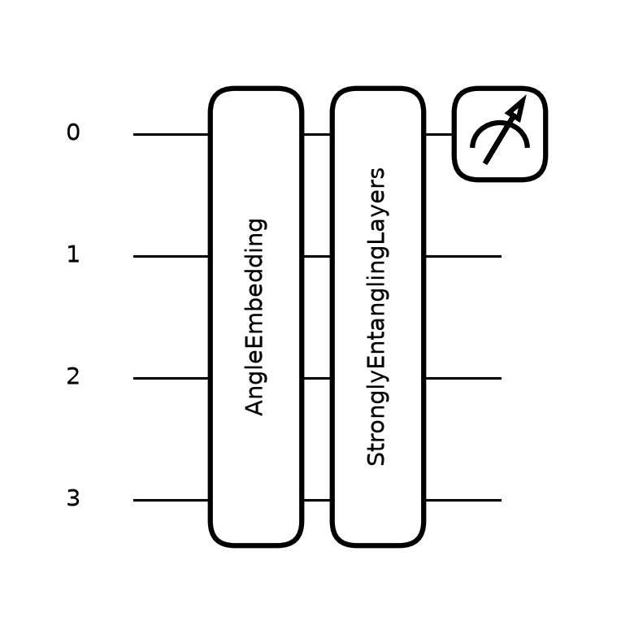
Figure: 4-qubit Variational Quantum Circuit with AngleEmbedding and 2 StronglyEntanglingLayers.

Step-by-Step Process
- Step 1: Load the AEP_hourly.csv dataset and sort by Datetime. Use the first 1,500 rows.
- Step 2: Construct 4 lag features: X[i] = [demand[i-4], demand[i-3], demand[i-2], demand[i-1]], y[i] = demand[i].
- Step 3: Split data 80/20 chronologically (no shuffling): 1,196 training samples, 300 test samples.
- Step 4: Fit MinMaxScaler on training data: features scaled to [0, 1], target scaled to [-1, 1].
- Step 5: Initialize VQC weights θ randomly from Uniform(0, 2π) with shape (2, 4, 3) = 24 parameters.
- Step 6: For each of 80 epochs: compute VQC predictions via parameter broadcasting, calculate MSE loss, update θ with Adam (lr = 0.05).
- Step 7: Train Linear Regression baseline on the same scaled training data.
- Step 8: Evaluate both models on the test set, inverse-transforming predictions to original MW units.
- Step 9: Compute MAE, RMSE, and R² for both models and generate comparison plots.

Applications
Hybrid quantum-classical models have potential applications in: (1) energy grid demand forecasting and load balancing, (2) financial time-series prediction, (3) supply chain demand planning, and (4) any regression task where quantum feature spaces might capture complex correlations. However, current NISQ-era devices are limited in qubit count and coherence time, making practical advantage unlikely for problems where classical models already perform well.

Pseudocode
ALGORITHM: Hybrid VQC Demand Forecasting
INPUT: Hourly demand series D[1..1500]
OUTPUT: Predicted demand for next hour
1. FOR i = 5 TO 1500:
X[i] ← [D[i-4], D[i-3], D[i-2], D[i-1]]
y[i] ← D[i]
2. split ← 0.8 × |X|
X_train, y_train ← X[1..split], y[1..split]
X_test, y_test ← X[split+1..|X|], y[split+1..|y|]
3. x_scaler ← fit MinMaxScaler(0,1) on X_train
y_scaler ← fit MinMaxScaler(-1,1) on y_train
X_train ← x_scaler.transform(X_train)
X_test ← clip(x_scaler.transform(X_test), 0, 1)
y_train ← y_scaler.transform(y_train)
4. θ ← Random(0, 2π, shape=(2, 4, 3)) // 24 parameters
5. FOR epoch = 1 TO 80:
// Quantum circuit with parameter broadcasting
ŷ ← VQC(X_train, θ) // AngleEmbedding + StronglyEntanglingLayers + ⟨Z₀⟩
loss ← MSE(ŷ, y_train)
θ ← Adam_update(θ, ∇loss, lr=0.05)
6. pred_vqc ← y_scaler.inverse(VQC(X_test, θ))
pred_lr ← y_scaler.inverse(LinearRegression.predict(X_test))
7. RETURN MAE, RMSE, R² for both models

Implementation

Language and Tools
The project is implemented in Python 3.14. The quantum circuit is built using PennyLane 0.45, an open-source quantum machine learning framework by Xanadu. The classical baseline uses scikit-learn's LinearRegression. Data processing uses NumPy and Pandas. Visualization uses Matplotlib. The web application is built with Streamlit. Model artifacts are serialized with Joblib.

Code Explanation
The core quantum circuit is defined as a PennyLane QNode with the default.qubit device (statevector simulator). The diff_method='backprop' flag enables efficient gradient computation by backpropagating through the simulated quantum circuit — this is faster than the parameter-shift rule but only works on simulators. On real quantum hardware, the parameter-shift rule would be used, requiring 2 circuit evaluations per parameter per gradient step.
AngleEmbedding encodes each of the 4 input features as an RX rotation (angle = π × x) on one qubit. StronglyEntanglingLayers applies 2 layers of parameterized Rot gates followed by CNOT entanglement, creating a 24-parameter trainable ansatz. The circuit output is the expectation value ⟨Z₀⟩ ∈ [-1, 1], which is mapped back to MW units via inverse scaling.
Parameter broadcasting allows the entire training batch to be processed in a single circuit call, significantly improving performance on the simulator.
@qml.qnode(dev, interface="autograd", diff_method="backprop")
def vqc(x, weights):
qml.AngleEmbedding(np.pi * x, wires=range(4), rotation="X")
qml.StronglyEntanglingLayers(weights, wires=range(4))
return qml.expval(qml.PauliZ(0))

Website (Streamlit Application)

Technologies and Tools
The web application is built with Streamlit 1.65, a Python framework for creating interactive data applications. It requires no frontend JavaScript code — the entire app is written in Python. The app loads pre-trained model artifacts (weights, scalers, Linear Regression model) from artifacts.joblib and recreates the quantum circuit at inference time using PennyLane.

Design and Features
The application features a dark-themed UI with glassmorphism-styled metric cards and three tabs:
1. Predict Tab: Users enter four hourly demand values (MW) as lag features. Clicking 'Predict Next Hour' runs both the VQC and Linear Regression models, displaying predictions in styled metric cards.
2. Results Tab: Displays a comparison table of MAE, RMSE, R², training time, and parameter count for both models, along with the generated results plots (actual vs. predicted, loss curve, model comparison).
3. Circuit Tab: Shows the quantum circuit diagram generated by qml.draw_mpl, with an explanation of the architecture.

Screenshots
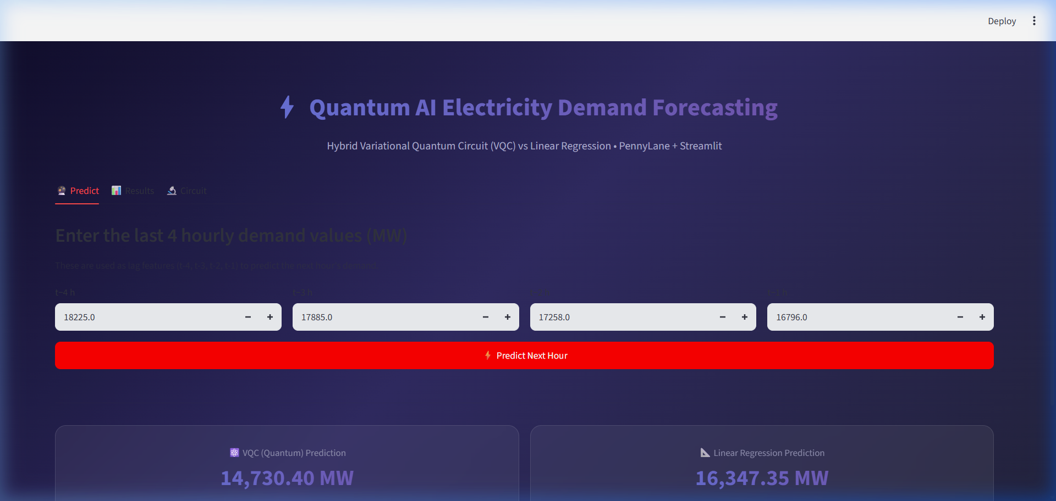
Figure: Predict Tab — Enter 4 lag values and get predictions from both models.

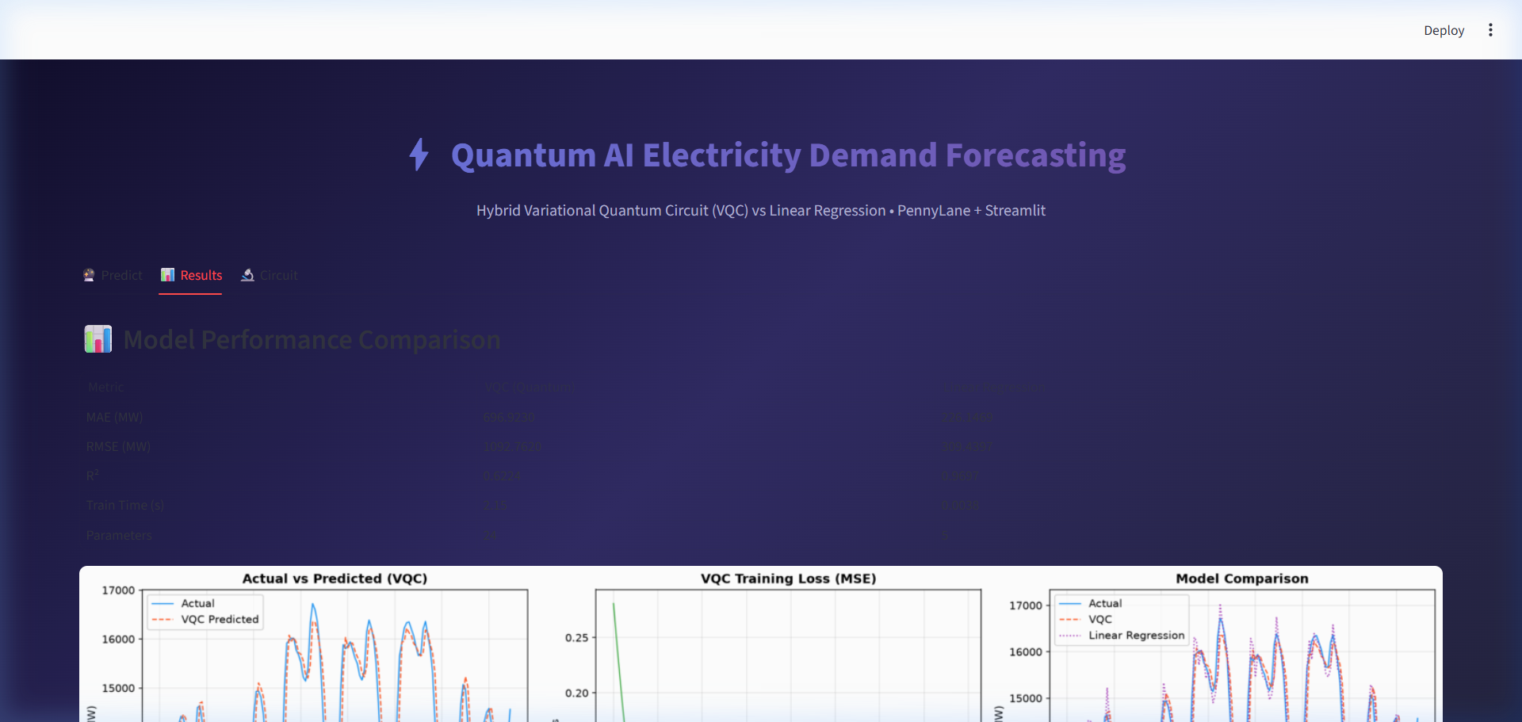
Figure: Results Tab — Performance comparison table and visualization plots.

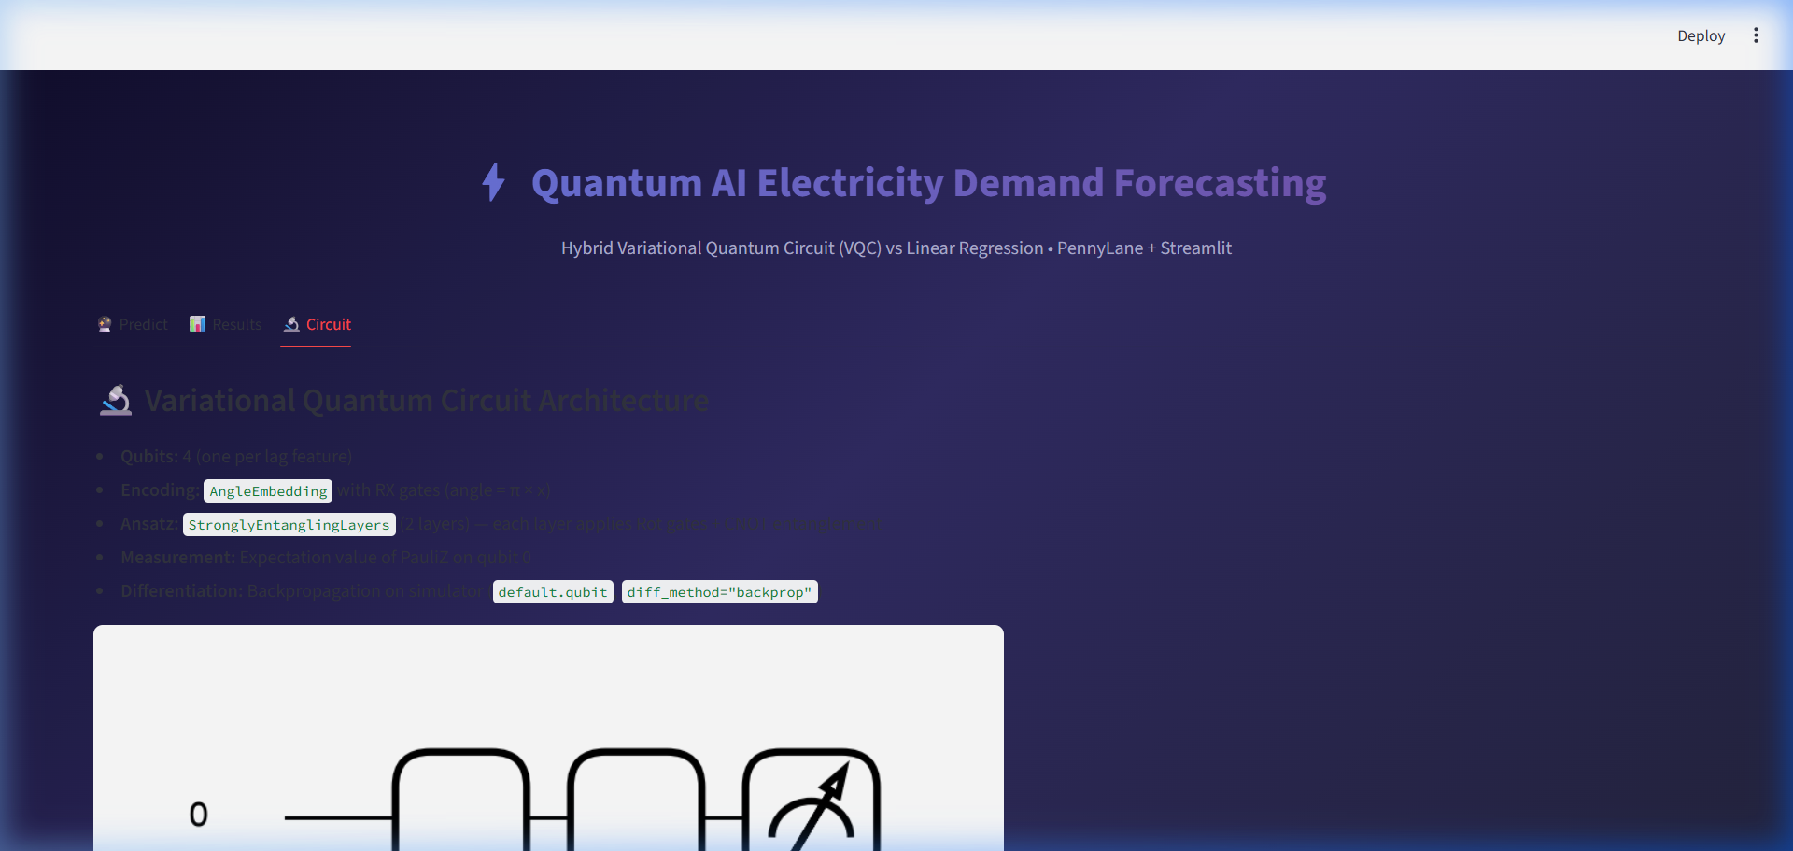
Figure: Circuit Tab — Quantum circuit architecture diagram.

Results

Input
The input dataset consists of 1,500 hourly electricity demand readings from the AEP region, sorted chronologically. Four lag features are constructed from each consecutive window of 4 hours, producing 1,496 samples. These are split 80/20 into 1,196 training and 300 test samples. Features are scaled to [0, 1] and targets to [-1, 1].

Output and Performance
Metric | VQC (Quantum) | Linear Regression
MAE (MW) | 696.9230 | 226.1469
RMSE (MW) | 1092.7620 | 309.4397
R² | 0.6224 | 0.9697
Train Time (s) | 2.15 | 0.0038
Parameters | 24 | 5

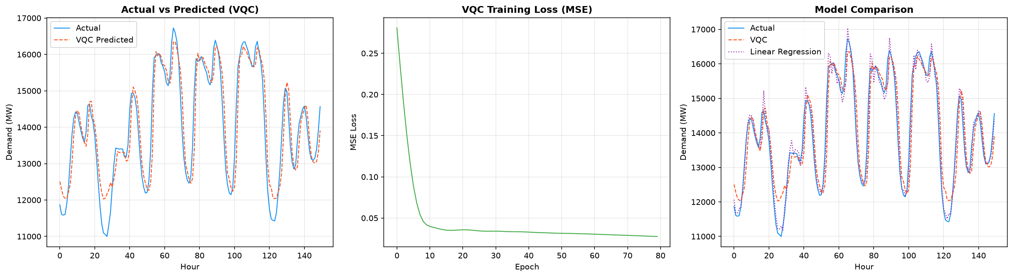
Figure: (Left) Actual vs. VQC Predicted, (Center) Training Loss Curve, (Right) Model Comparison.

Analysis
Linear Regression decisively outperforms the VQC across all metrics. With an R² of 0.9697 vs. 0.6224, the classical model explains 97.0% of the variance compared to 62.2% for the VQC. The VQC's MAE (696.9 MW) is 3.1× worse than Linear Regression (226.1 MW).
This outcome is expected for several reasons:
1. The 4-qubit circuit operates in a 16-dimensional Hilbert space with only 24 parameters — insufficient to capture the full complexity of the demand signal.
2. Lag-based demand features are predominantly linear (autocorrelated), favouring Linear Regression.
3. The VQC output is bounded to [-1, 1] (single Pauli-Z expectation), requiring the entire demand range to be compressed into this interval, which can lose resolution.
4. Despite 80 epochs of training (2.15s), the VQC loss plateaus at 0.027585, suggesting the circuit has reached its representational capacity.
No quantum advantage or 'exponential speedup' is observed or claimed. The simulator runs on classical hardware, and the VQC's computational cost exceeds that of Linear Regression by orders of magnitude.

Time and Space Complexity
Time Complexity on Simulator: O(E × n × L × N × 2ⁿ)
Where E = 80 (epochs), n = 4 (qubits), L = 2 (layers), N = 1196 (training samples), 2ⁿ = 16 (statevector dimension).
Space Complexity: O(2ⁿ + N×n + n×L)
= O(16 + 1196×4 + 4×2) = O(4808)
On real quantum hardware, the parameter-shift rule requires 2 circuit evaluations per parameter per gradient step, giving O(E × P × N) circuit executions where P = 24 parameters. This project uses backpropagation on the simulator for computational efficiency.

Conclusion
This project implemented a complete hybrid quantum-classical machine learning pipeline for electricity demand forecasting. A 4-qubit Variational Quantum Circuit with StronglyEntanglingLayers was trained using PennyLane's default.qubit simulator and compared against a classical Linear Regression baseline.
The experimental results clearly show that Linear Regression (R² = 0.9697) significantly outperforms the VQC (R² = 0.6224) on this task. This is attributable to the limited expressivity of a 4-qubit circuit (24 parameters in a 16-dimensional Hilbert space), the predominantly linear nature of autocorrelated lag features, and the single-qubit measurement bottleneck.
The project demonstrates that quantum machine learning is not a universal improvement over classical methods, particularly at the current NISQ (Noisy Intermediate-Scale Quantum) era. The value of this work lies in establishing a reproducible, end-to-end hybrid quantum-classical ML pipeline — including data processing, quantum circuit design, training, evaluation, and web deployment — that can be scaled up as quantum hardware matures.
Future work could explore: (1) more qubits and layers as hardware allows, (2) data re-uploading circuits for increased expressivity, (3) quantum kernel methods, and (4) problems with inherently non-classical structure where quantum advantage is more plausible.

References
[1] PennyLane Documentation. Xanadu. https://docs.pennylane.ai
[2] AEP Hourly Energy Consumption Dataset. Kaggle (PJM Interconnection). https://www.kaggle.com/datasets/robikscube/hourly-energy-consumption

