## M.Sc. Business Analytics

## MIS41430 – Mastering Big Data

The Advantages and Disadvantages of a Master's Degree in a Hybrid Learning Environment

Professor: Dr Martin Perry

|  |  |  |
| --- | --- | --- |
| **Name of Student** | **Student ID** | **Email ID** |
| Abhinav Ram Seetharaman P | 22200201 | [abhinav.seetharamanp@ucdconnect.ie](mailto:abhinav.seetharamanp@ucdconnect.ie) |
| Adithya Vivek | 22200615 | [adithya.vivek@ucdconnect.ie](mailto:adithya.vivek@ucdconnect.ie) |
| Anish Joseph Vijaykumar | 22203566 | [anish.vijaykumar@ucdconnect.ie](mailto:anish.vijaykumar@ucdconnect.ie) |
| Caroline Maria Joseph | 22200927 | [caroline.joseph@ucdconnect.ie](mailto:caroline.joseph@ucdconnect.ie) |
| Prashanthi Balachander | 22200632 | [prashanthi.balachander@ucdconnect.ie](mailto:prashanthi.balachander@ucdconnect.ie) |

Table of Content

**1. INTRODUCTION .............................................................................................................. 3**

**2. METHODOLOGY ............................................................................................................. 3**

**3. FINDINGS AND INSIGHTS.............................................................................................. 6**

**3.a. ADVANTAGES OF MASTERS DEGREE IN A HYBRID**

**LEARNING ENVIRONMENT.............................................................................................. 7**

**3.b. DISADVANTAGES OF MASTERS DEGREE IN A HYBRID**

**LEARNING ENVIRONMENT............................................................................................. 12**

**4. CONCLUSION .................................................................................................................. 17**

**1. Introduction:**

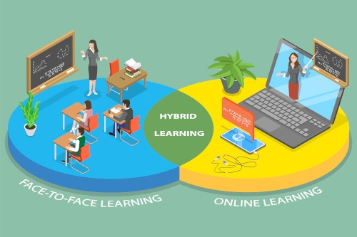

**Figure 1. Hybrid Learning**

With the introduction of hybrid learning, a new strategy that combines the advantages of traditional in-person instruction with the flexibility and accessibility of online learning, the educational landscape has seen a tremendous transition recently. Hybrid learning has become a popular option for Master's degrees as the world embraces technological breakthroughs and new educational paradigms, promising a transformative experience for students wishing to further their knowledge and careers.

This comprehensive survey seeks to delve into the advantages and disadvantages of pursuing a Master's program through hybrid learning. The study gathered valuable insights from a diverse group of students who have experienced hybrid learning firsthand. Participants were asked to provide their perspectives on various aspects of hybrid learning, shedding light on critical factors such as flexibility, academic performance, networking opportunities, course engagement, interaction with peers and professors, study schedule maintenance, and coordination within groups or teams.

**2. Methodology:**

A survey was designed using Microsoft Forms to gather valuable feedback and insights. The survey targeted students who had either completed their master's degree or were currently pursuing it. After the survey was submitted, Power Automate was deployed to trigger an automatic reply to notification via email, acknowledging the submission. The responses collected through Microsoft Forms were then fed into Power BI for data visualization and analysis. Finally, SharePoint was utilized as a collaborative platform where team members could access and share files efficiently.

**Microsoft Forms: Facilitating Data Collection:**

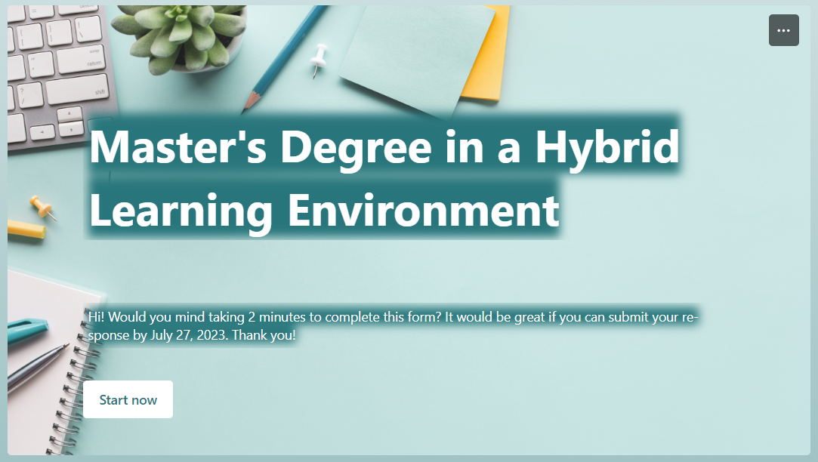

**Figure 2. Microsoft Forms - Survey**

Microsoft Forms offered a user-friendly interface, enabling the creation of a comprehensive survey that covered various aspects of the master's degree experience. The survey explores various aspects of pursuing a master's degree in a hybrid learning environment. It commences with general inquiries, such as age group and email identification for communication purposes.

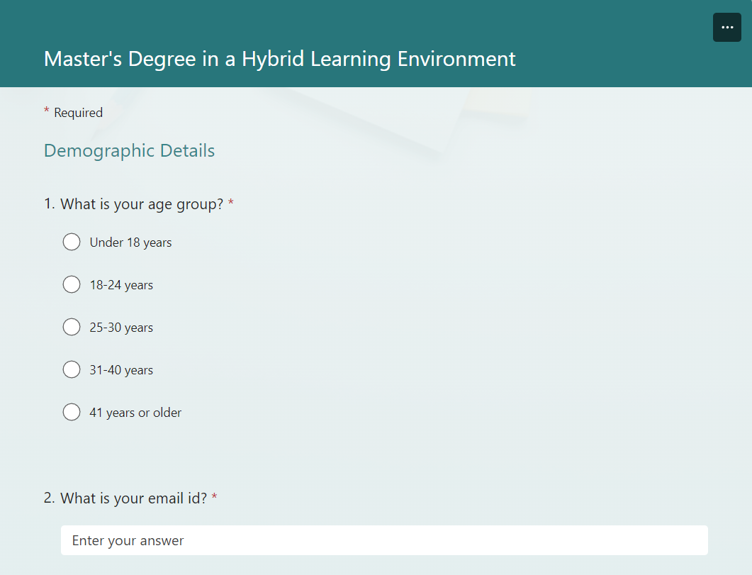

**Figure 3. Microsoft Forms - Survey**

Participants are then asked about their prior experience with hybrid learning during their master's degree program, distinguishing between respondents who have encountered it and those who have not. The survey further delves into exploring the primary benefits and drawbacks associated with hybrid learning for master's degree programs.

The survey received an impressive response of 47 submissions, reflecting students' willingness to contribute to enhancing their educational journey.

**Survey Link-** <https://forms.office.com/e/wYr2qgsRVH>

**Power Automate: Automating Communication:**

Upon submission of the survey form, Power Automate swiftly triggered an automatic reply notification to each respondent via email. This automated communication provided immediate acknowledgement and fostered a sense of engagement and appreciation among the participants.

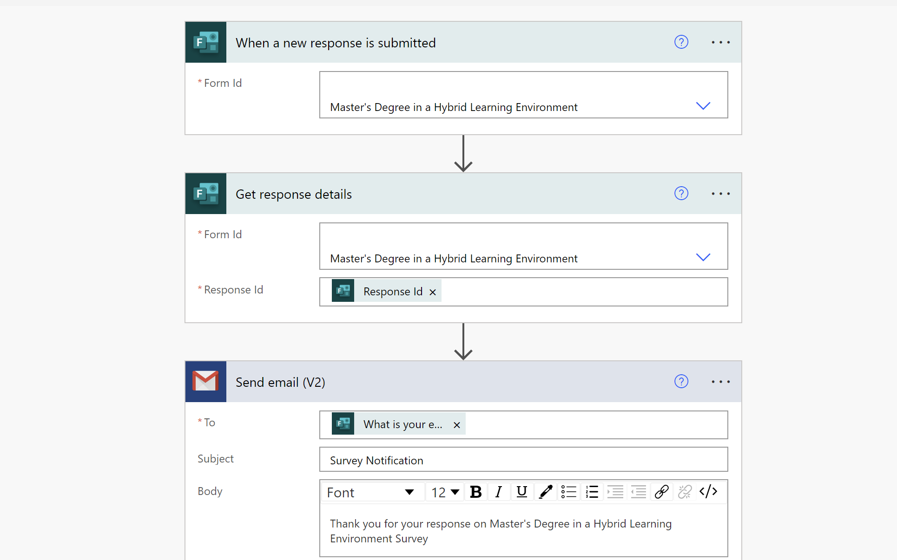

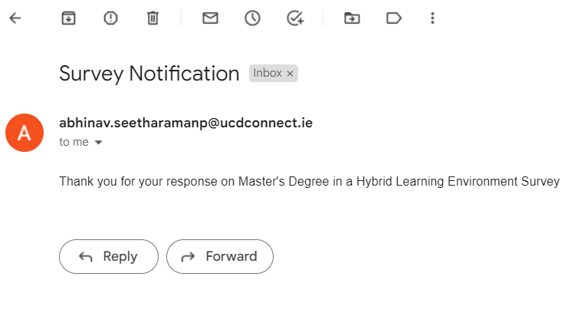 **Figure 4. Power Automate Flow to generate an automated email**

**Figure 5. Survey Notifications using Power Automate**

**Power BI: Visualizing Insights:**

The data collected through Microsoft Forms was integrated into Power BI, a robust business intelligence tool. Power BI efficiently transformed the raw data into visually appealing and insightful charts, graphs, and reports. These visualizations offered a comprehensive view of student opinions, preferences, and experiences related to their master's degree, empowering educational stakeholders to make informed decisions based on data-driven insights.

**SharePoint: Enabling Seamless Collaboration:**

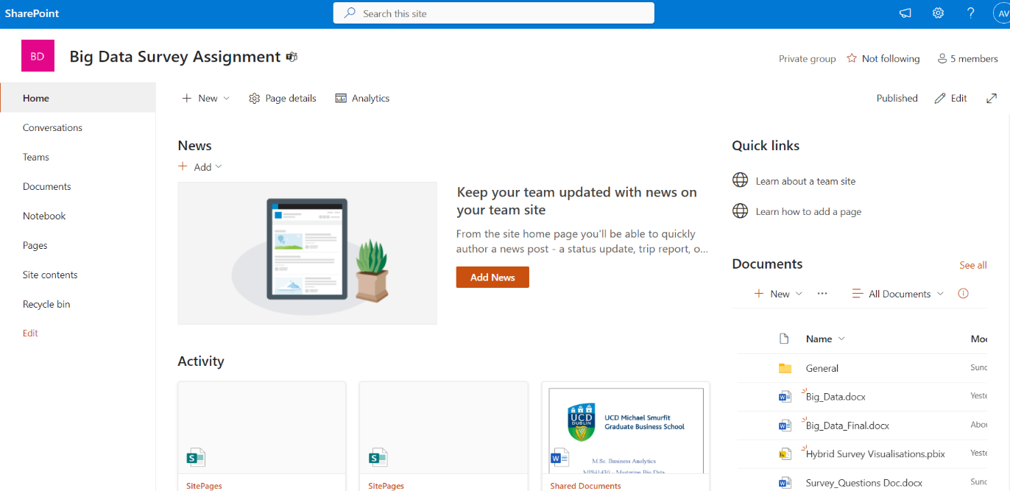 Efficient file sharing and team collaboration are pivotal in a collaborative educational environment. SharePoint served as the ideal platform for this purpose. Team members could easily access and collaborate on shared files, enabling efficient communication and constructive collaboration in decision-making.

# 

**Figure 6. Sharepoint for Team Collaboration**

**3. Findings and Insights:**

The survey analysis yielded intriguing revelations from 47 respondents, comprising individuals who had either completed their master's course or were actively pursuing it. This comprehensive report delves into the visualization and assessment of the survey's Key Performance Indicators (KPIs) based on gender and age groups, elucidating the advantages, academic performance, interaction and communication dynamics, technological aspects, and challenges associated with the hybrid learning environment. In conclusion, the report draws key insights to gauge overall satisfaction with hybrid learning and assess key benefits and drawbacks it brings to the academic world.

**Key Performance Indicators (KPIs):**

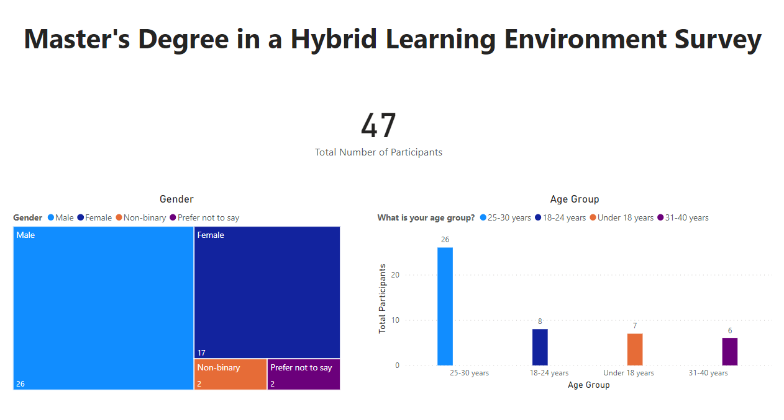

**Figure 7. Key Performance Indicators**

The survey responses indicated slightly higher participation of males, with 26 male and 17 female respondents. Additionally, 2 individuals identified as non-binary, and 2 preferred to remain anonymous. Notably, a significant majority of respondents belonged to the age category of 25-30 years.

**3.a. Advantages of a Master’s Degree in a Hybrid Learning Environment:**

**Primary Advantages:**

A staggering 25 individuals recognized flexibility as the foremost advantage of a hybrid learning setup, while 10 respondents supported individualized learning pace as a key benefit. In contrast, only 4 respondents selected improved engagement and interaction as a notable advantage. Flexibility enables students to modify their schedules, pursue their education at their speed, and transcend geographical boundaries, according to 25 respondents, who also recognize its importance. By meeting individual requirements and juggling work and school, this strategy promotes a variety of learning experiences. It also improves engagement and outcomes. Flexibility in hybrid learning, as a transforming instrument, symbolizes the inclusive and successful methodology of modern teaching, making education available to everyone.

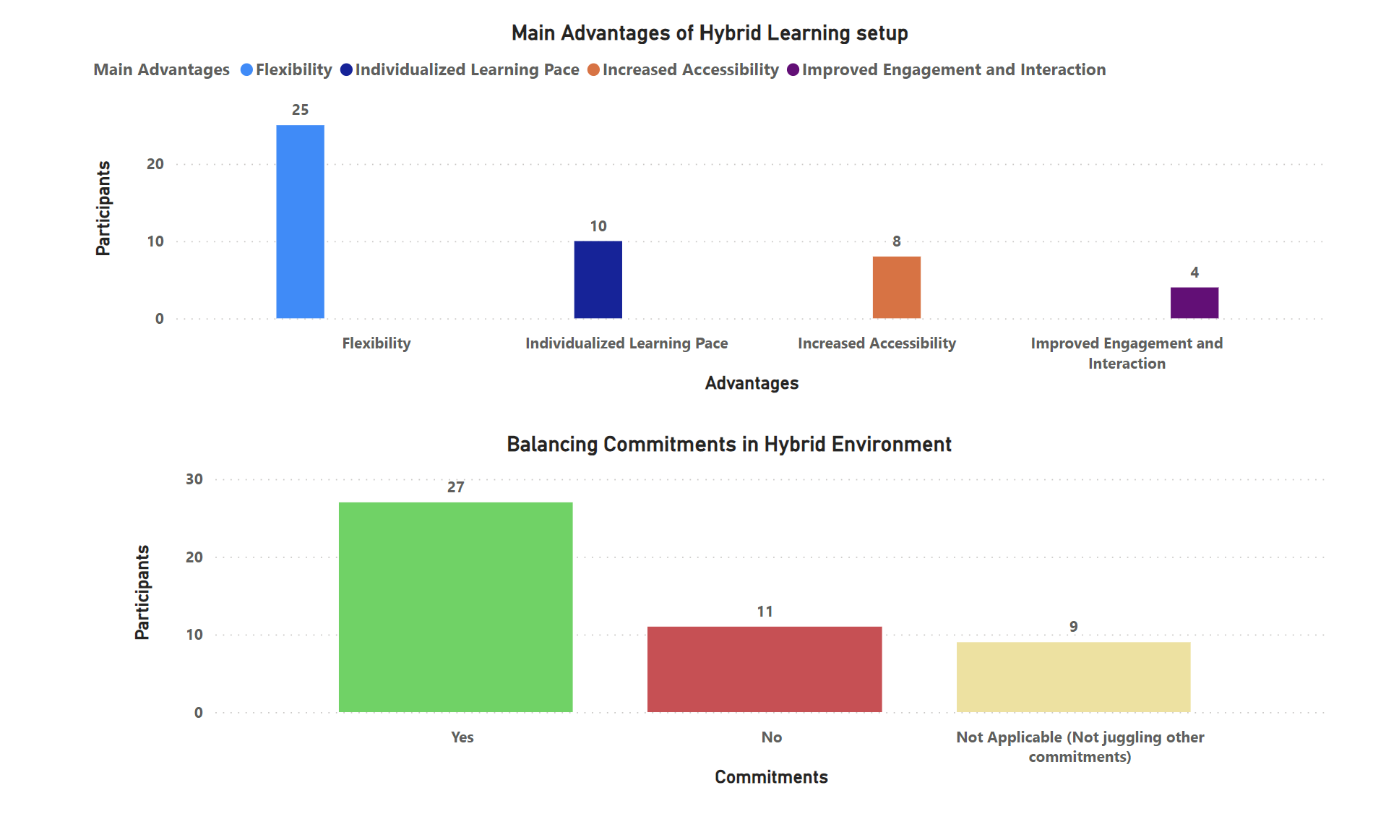

**Figure 8. Primary Advantages of Hybrid Learning Setup**

Moreover, 27 respondents affirmed that balancing commitments within a hybrid environment is significantly more manageable than in a traditional in-person setting. It can be inferred that Students can organize their study time around personal and professional commitments because of this approach's flexibility. People who have the option to access course materials remotely can easily incorporate learning into their busy lives, striking a healthy balance between their academic, professional, and familial obligations.

**Academic Performance in Hybrid Learning:**

According to the survey analysis on academic achievement in hybrid learning, 20 respondents saw an improvement, 15 saw a decline in performance, and 12 saw no appreciable difference from in-person learning. An upbeat viewpoint, however, emphasizes that the majority of people saw an improvement. This encouraging trend was probably influenced by hybrid learning's adaptable and personalized character. While those struggling might need more assistance, students who excelled with a tailored pace and remote access to resources could achieve success. Hybrid learning offers the ability to improve overall academic performance and accommodate to a wider spectrum of learners thanks to evolving teaching methods, targeted support, and inclusive approaches, making it a promising benefit for contemporary education.

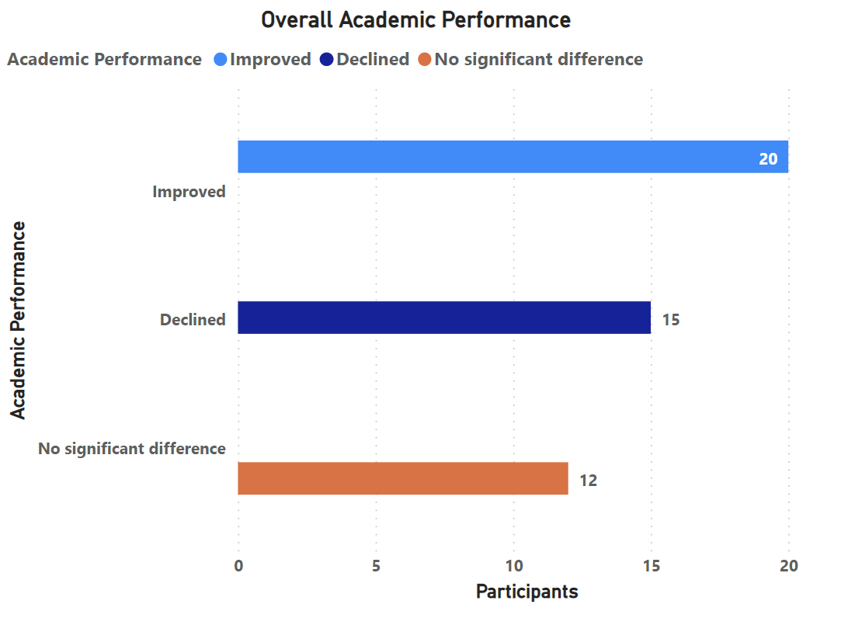

**Figure 9. Overall Academic Performance**

**Technological Aspects / Support Provided in Hybrid Learning:**

The survey's findings on students' use of online resources and technologies in a hybrid learning environment point to a positive development. While 17 students displayed a moderate level of comfort, 13 of them displayed an extremely high level of assurance when utilizing digital resources. This technological proficiency gives students the ability to access a multitude of online resources, collaborate efficiently, and interact with interactive content, which is a critical advantage for hybrid learning. The combination of face-to-face and online learning experiences improves academic performance while also giving students the fundamental digital skills they need to meet the expectations of a technologically advanced society. A positive outlook for the effective integration of online technologies in hybrid learning, which provides a well-rounded educational experience, may be seen in the mix of confidence levels.

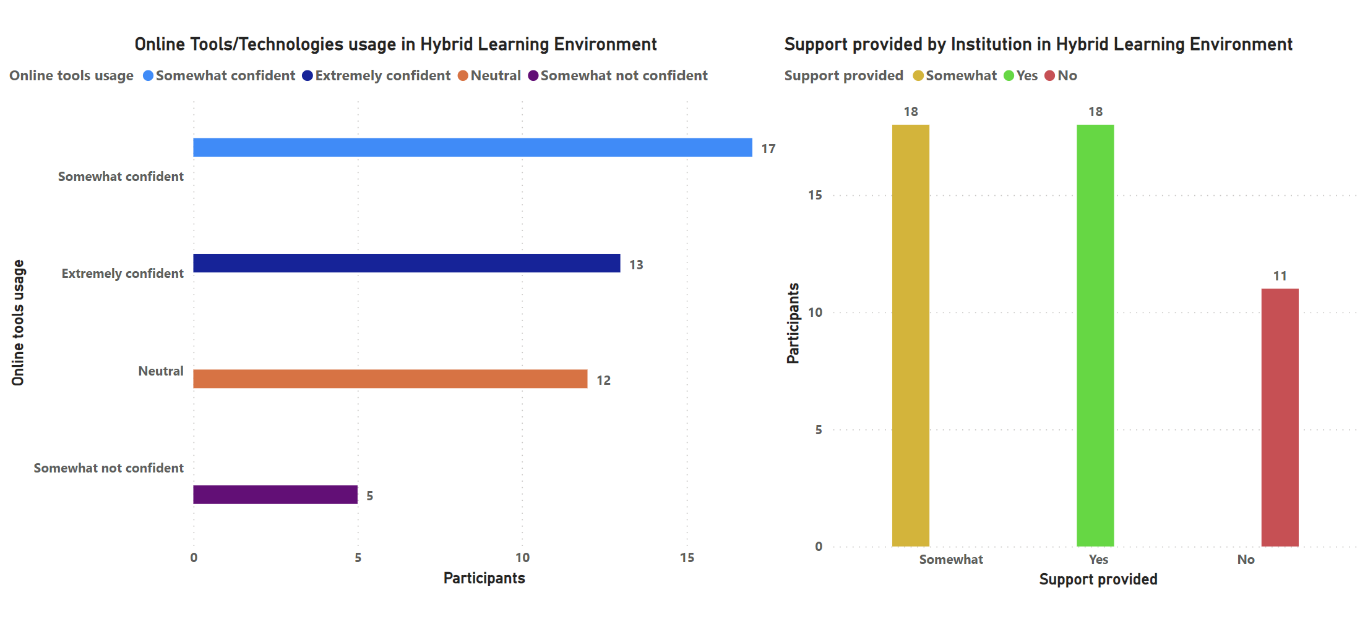

**Figure 10. Technological Aspects / Support provided**

Responses to the survey's questions about institutional support in a hybrid learning environment show a range of opinions. A 50-50 division resulted from an equal proportion of students who acknowledged receiving appropriate support and an equal number who remained ambivalent. Despite this, the potential benefit of hybrid learning is found in the room for development. Institutions can address issues and improve their assistance programs to better serve the requirements of students. Hybrid learning provides universities with the chance to improve student aid, individualized counselling, and technical support through a dynamic blend of in-person and online resources. Institutions can use hybrid learning to establish a more supportive academic atmosphere, thereby improving student performance and success, by actively responding to feedback and modifying their support mechanisms.

**Workload Maintenance in Hybrid Learning:**

About 57% of people believe that the hybrid and in-person learning settings are consistent, according to the survey's findings on workload maintenance in hybrid learning. An important benefit of hybrid learning can be seen in the striking similarities in workload management. It illustrates that regardless of the learning modality, pupils are capable of managing their academic commitments. Hybrid learning's flexibility and adaptation are probably responsible for this successful outcome. Hybrid learning equips students to keep a balanced workload by enabling them to access materials remotely and choose their timetables. This benefit demonstrates how hybrid learning enhances the educational process by supporting smooth changes between learning modalities and encouraging student achievement.

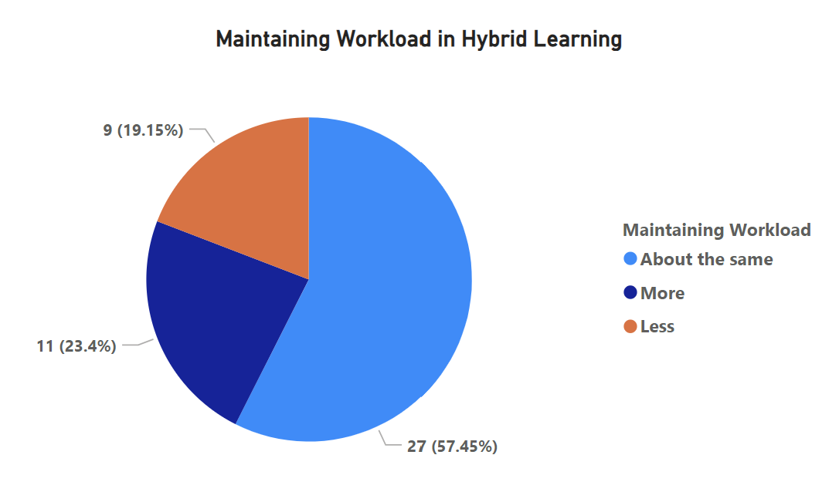

**Figure 11. Maintaining Workload in Hybrid Learning**

**Networking in Hybrid Learning:**

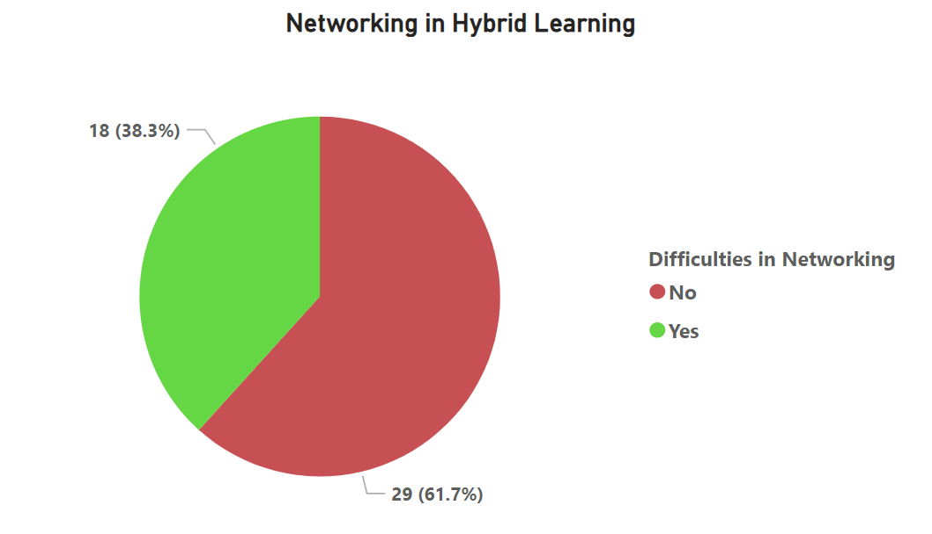 The survey's findings on networking in hybrid learning reveal a significant benefit, with about 62% of participants reporting no problems making relationships. This research emphasizes how, despite being blended, hybrid learning can help to enhance networking opportunities. Hybrid learning gives students a variety of ways to connect with peers, teachers, and professionals by fusing in-person encounters with online collaborations. Students can participate in debates, group projects, and virtual events thanks to the integration of online platforms, which promotes simple communication. Therefore, hybrid learning gives students the freedom to widen their networks, develop their interpersonal abilities, and create meaningful relationships that can have a favourable effect on their academic and professional careers.

**Figure 12. Networking in Hybrid Learning**

**3.b. Disadvantages of a Master’s Degree in a Hybrid Learning Environment:**

**Primary Disadvantages:**

According to the survey results, there are several major drawbacks to hybrid learning, with "Technology Dependence and Technical Issues" standing out as the biggest issue, reflecting a reliance on digital resources and probable connectivity issues. Following closely is "Limited Face-to-Face Interaction," which raises questions about the diminished one-on-one interaction with peers and teachers. Participants also voiced concerns about "Reduced Social and Networking Opportunities" and the "Potential for Isolation and Decreased Engagement," though to a lesser amount, highlighting the difficulties in forming social bonds and staying motivated in a hybrid environment. These results highlight how crucial it is to address technology assistance, improve in-person contacts, and put mechanisms in place to promote a feeling of community and active engagement to ensure a successful hybrid learning experience.

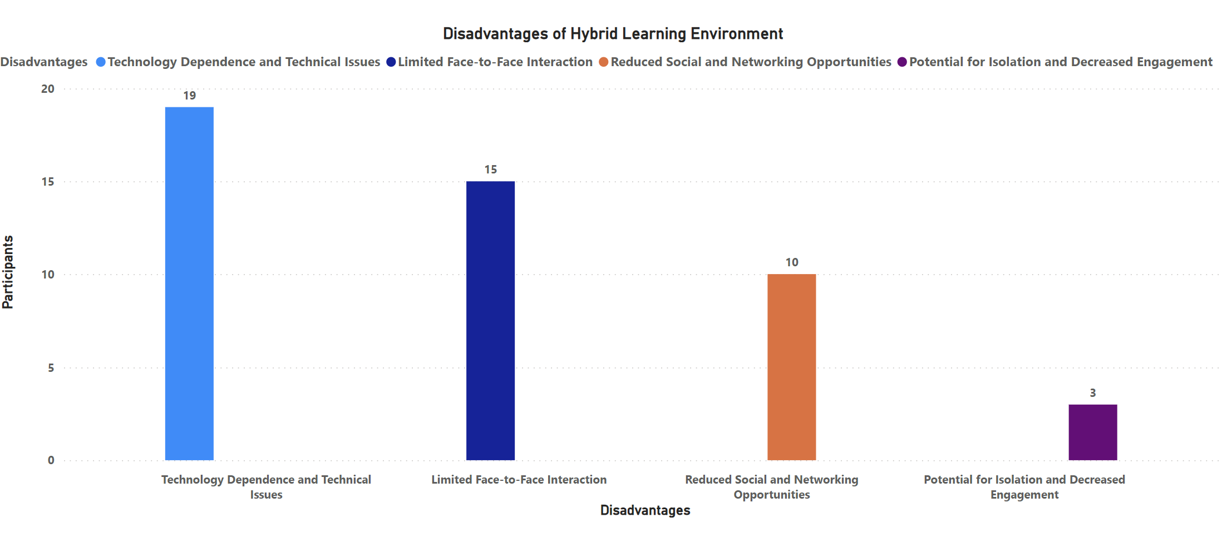

**Figure 13. Key Disadvantages in Hybrid Learning**

**Course Engagement in Hybrid Learning:**

Insights from the survey on course participation in hybrid learning revealed a hotly contested point of view, with a slight deficit of four support votes favouring those who thought it was more difficult in a hybrid configuration. This finding points out a possible disadvantage of hybrid learning, where certain students can struggle to sustain active participation in their courses. Students may need to adjust to different learning environments due to the combination of in-person and online components, which could make it difficult for them to maintain constant engagement. To overcome this issue, educators and institutions should concentrate on integrating interactive online technologies, encouraging regular communication, and offering more assistance to promote sustained course participation and guarantee students' success in a hybrid learning environment.

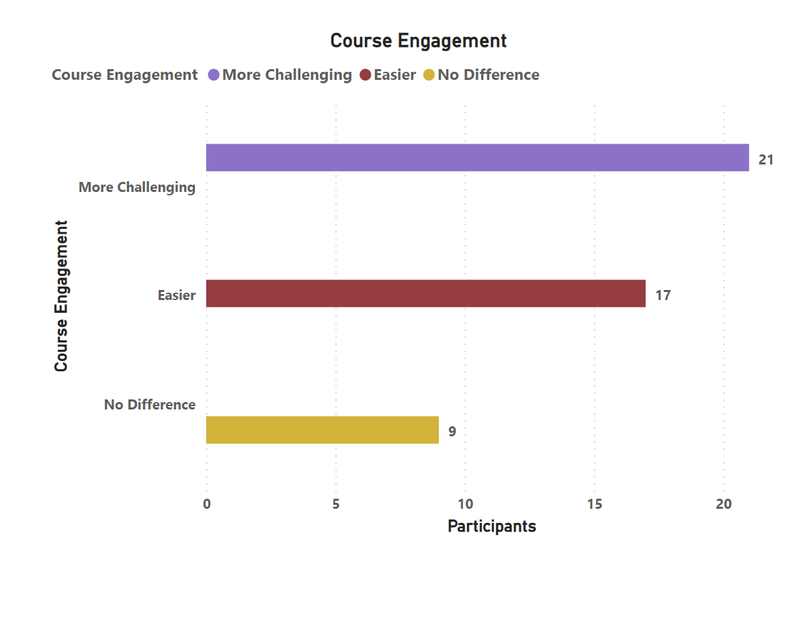

**Figure 14. Course Engagement in Hybrid Learning**

**Interaction with Peers/Professors in Hybrid Learning:**

About 23 respondents indicated moderate levels of involvement in this learning environment, according to the survey's findings on interactions with peers and instructors in hybrid learning. This research highlights a potential drawback of hybrid learning, as the form of education may affect how deeply students interact with their teachers and peers. Finding the ideal mix between in-person and online interactions can be difficult, which might limit opportunities for impromptu conversations, collaborative projects, and real-time feedback. To address this issue, educators can come up with novel ways to encourage lively online discussions, plan frequent virtual gatherings, and offer plenty of opportunities for both in-person and virtual interactions. By doing this, they can make sure that students have meaningful interactions with both their peers and professors throughout their hybrid learning journey.

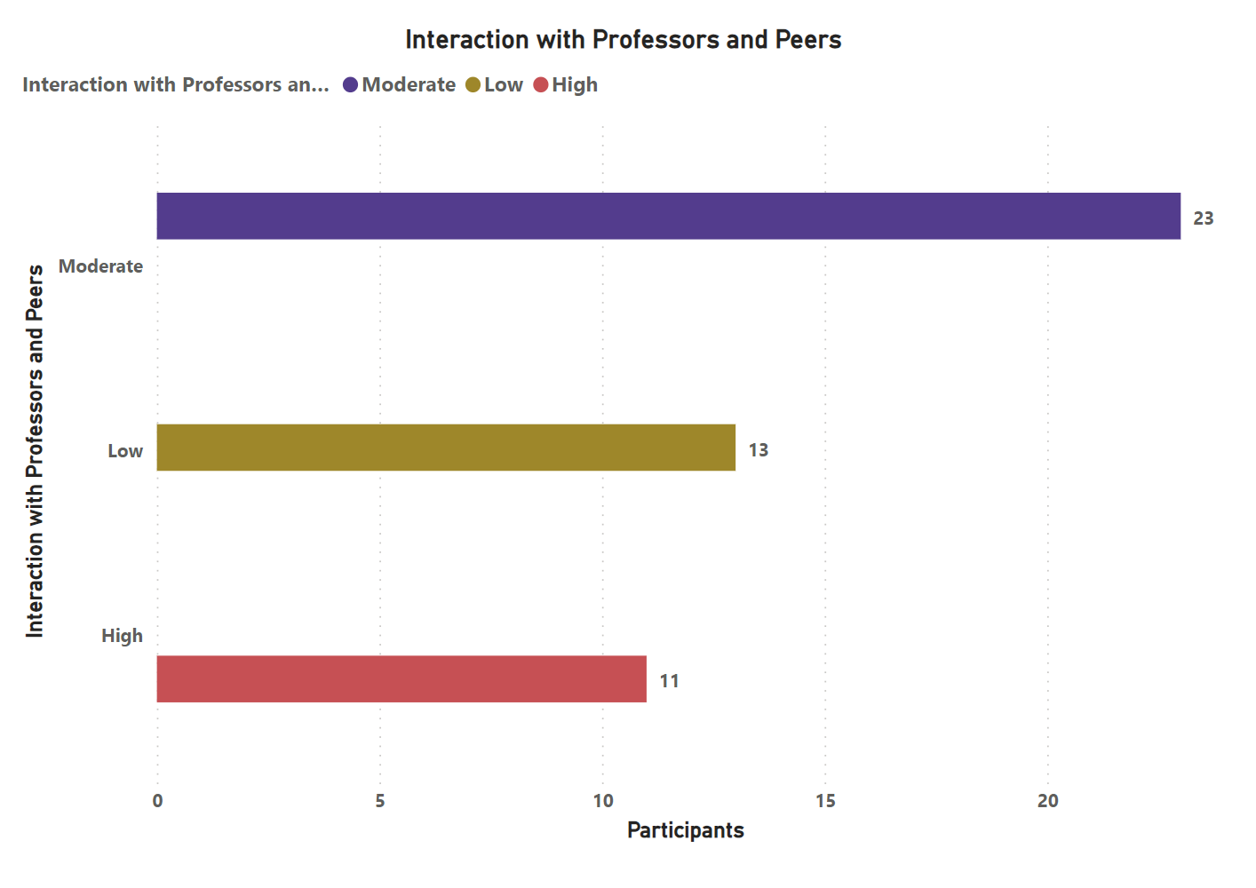

**Figure 15. Interaction with Peers/ Professors in Hybrid Learning**

**Seeking Clarifications/Questions in Hybrid Learning:**

Insights from the poll on asking for clarifications or questions during hybrid learning point to a potential drawback. 15 respondents were at ease with both in-person and online interactions, while 18 respondents preferred in-person settings for their interactions with academics. According to this research, some students could find it difficult to ask questions and get prompt answers while using a hybrid learning method. The potential impediment to real-time communication during online encounters may prevent students from answering questions right away or from developing deeper ideas. To address this issue, educators must set up virtual office hours, encourage active involvement in online forums, and use effective communication channels to make sure that students receive the help and direction they need throughout their hybrid learning experience.

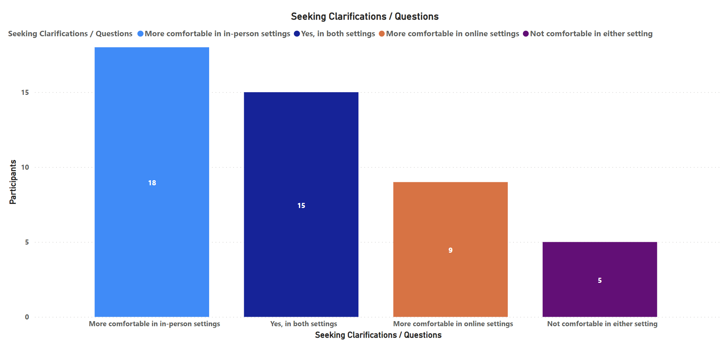

**Figure 16. Seeking Clarifications/Questions in Hybrid Learning**

**Maintaining Study Schedule in Hybrid Learning:**

Insights from the survey on keeping to a study schedule in hybrid learning point to a serious drawback, with about 55% of respondents admitting the challenge. Hybrid learning's flexibility, while advantageous in many ways, can present difficulties with time management and study discipline. It may be challenging for students to develop a regular study schedule due to the combination of in-person and online components, which may require them to adjust to various learning settings. Teachers and institutions can help students with this problem by offering advice on time management, offering structured study plans, and implementing routine check-ins to keep them organized and motivated. Hybrid learning may enhance academic success and guarantee that students can successfully manage their study schedules by acknowledging and actively addressing this concern.

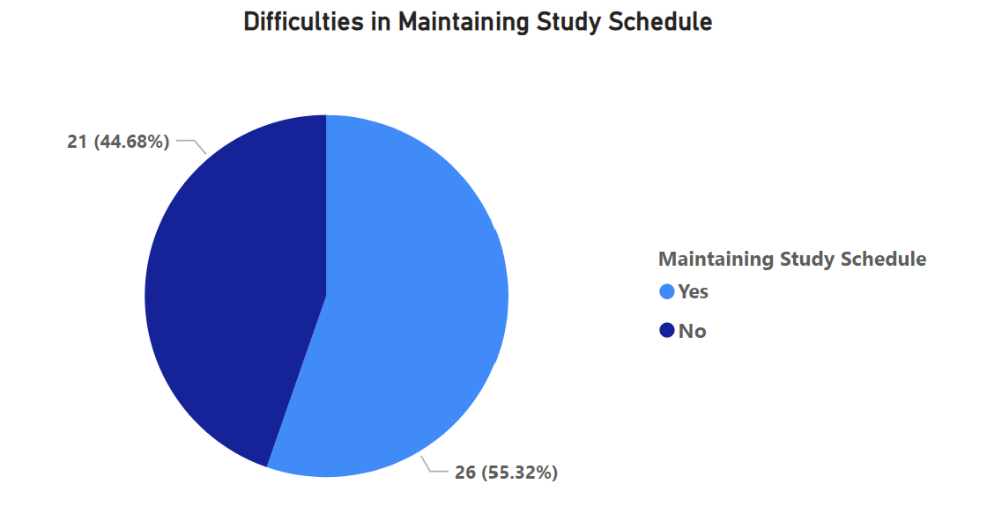

**Figure 17. Maintaining Study Schedule in Hybrid Learning**

**Group/Team Coordination in Hybrid Learning:**

With 53% of respondents expressing difficulties, the survey's findings on group or team coordination in hybrid learning revealed a considerable disadvantage. Due to the mix of in-person and online interactions, the hybrid learning environment may complicate group collaboration. Finding mutually convenient meeting times, dealing with potential technology-related obstacles, and handling communication efficiently may be challenging for students. Professors can lessen these difficulties by outlining clear rules for online cooperation, facilitating online conferences on user-friendly platforms, and encouraging good group communication. By solving these issues, hybrid learning can enhance the learning process overall by better-assisting students in their group projects and encouraging effective teamwork.

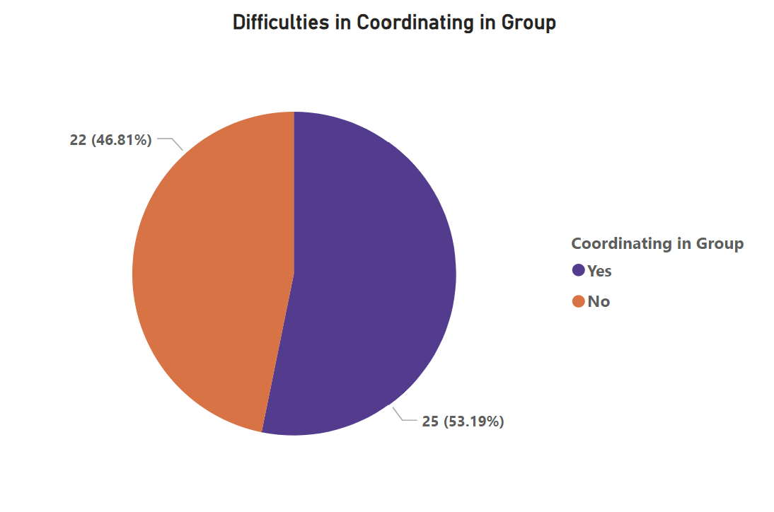

**Figure 18. Team/Group Coordination in Hybrid Learning**

**Overall Satisfaction with Hybrid Learning:**

The study results show that respondents have an overall favourable opinion of hybrid learning, with nine people giving it a satisfaction rating of 10. This shows that a sizeable percentage of respondents thought hybrid learning was very beneficial and successful. The next two most popular scores, a 9 and a 7, which were each given by four respondents, underscore the generally optimistic outlook. The high satisfaction scores indicate the flexibility, personalized pacing, and variety of learning experiences as possible benefits of hybrid learning. To further improve the general pleasure and success of students in hybrid learning environments, educators and institutions must address issues linked to technology dependence and interaction.

**Figure 19. Overall Satisfaction Ratings in Hybrid Learning**

**4. Conclusion:**

In conclusion, hybrid learning for Master's degrees offers an innovative and dynamic educational strategy that combines the benefits of conventional in-person instruction with the adaptability of online learning. While the study reveals many advantages, such as adaptability, personalized learning paths, and networking opportunities, it also uncovers significant drawbacks, such as dependence on technology, a lack of in-person connections, and potential feelings of isolation. Institutions may develop a strong and efficient hybrid learning environment that caters to students' different requirements and equips them to succeed in the ever-changing higher education landscape by addressing these challenges and utilizing the benefits. Hybrid learning has the power to significantly influence the future of Master's programs by making learning accessible, interesting, and transformative for all students. It does so by committing to continual development and innovative teaching methods.