**Ultrasonic Proximity Sensor**

A

Minor Project (IS2170)

Report

Submitted in the partial fulfillment of the requirement for the award of

Bachelor of Technology

in

Computer Science and Engineering IoT & IS

By:

**Adithyan S**

**229311105**

Under the guidance of:

**Prof. Siddhanta Kumar Singh**



November 2023

Department of Computer Science and Engineering IoT & IS

School of Computer and Communication Engineering

Manipal University Jaipur

VPO. Dehmi Kalan, Jaipur, Rajasthan, India – 303007

Department of Computer Science and Engineering IoT & IS

School of Computer and Communication Engineering, Manipal University Jaipur,

Dehmi Kalan, Jaipur, Rajasthan, India- 303007

**STUDENT DECLARATION**

*I hereby declare that this project* ***Ultrasonic Proximity Sensor*** *is my own work and that, to the best of my knowledge and belief, it contains no material previously published or written by another person nor material which has been accepted for the award of any other degree or diploma of the University or other Institute, except where due acknowledgements has been made in the text.*

Place: Manipal University Jaipur

Date: 11th November 2023

**Adithyan S**

229311105

B.Tech CSE(Iot & IS) 3rd Semester

**ABSTRACT**

The Ultrasonic Proximity Sensor project utilizes an Arduino Uno microcontroller and an ultrasonic sensor to detect the distance between the sensor and an object. The project aims to demonstrate the practical application of ultrasonic technology in proximity sensing, with potential applications in robotics, automation, and security systems.

**TABLE OF CONTENTS**

|  |  |  |
| --- | --- | --- |
| **Serial no.** | **Contents** | **Page no.** |
| 1. | Introduction | 1 |
| 2. | Components Used | 1 |
| 3. | Methodology | 2 |
| 4. | Results | 2 |
| 5. | Conclusion | 6 |
| 6. | Bibliography | 8 |

1. **INTRODUCTION**

**1.1 Background**

Ultrasonic sensors are widely used in various applications for distance measurement. They work on the principle of sending ultrasonic waves and measuring the time it takes for the waves to bounce back after hitting an object. This project focuses on implementing an ultrasonic proximity sensor using Arduino Uno to measure and display the distance between the sensor and an object.

**1.2 Objectives**

* Design and implement an ultrasonic proximity sensor system.
* Interface the sensor with Arduino Uno for data processing.
* Display real-time distance measurements.
* Provide a user-friendly interface for distance monitoring.

1. **Components Used**
2. Arduino Uno
3. Ultrasonic Sensor (HC-SR04)
4. Breadboard and jumper wires
5. 16x2 LCD Display
6. Resistor (2x 220Ω for LCD backlight)
7. Potentiometer (for LCD contrast adjustment)
8. **METHODOLGY**

**3.1 Hardware Setup**

Connect the VCC and GND pins of the ultrasonic sensor to the +5V and GND pins on the Arduino Uno.

Connect the Trig pin of the sensor to digital pin 9 on the Arduino.

Connect the Echo pin of the sensor to digital pin 10 on the Arduino.

Connect the VCC and GND pins of the LCD display to +5V and GND on the Arduino.

Connect the SDA and SCL pins of the LCD display to A4 and A5 on the Arduino.

Connect the backlight of the LCD through two 220Ω resistors to digital pin 7 and GND on the Arduino.

Adjust the contrast of the LCD using the potentiometer.

**3.2 Software Implementation**

Write a program in the Arduino IDE to read data from the ultrasonic sensor.

Calculate the distance based on the time taken for the ultrasonic waves to return.

Display the distance on the LCD screen.

Implement a user-friendly interface for real-time monitoring.

1. **RESULTS**

The Project successfully measures and displays the distance between the ultrasonic sensor and an object on the LCD screen. The system provides accurate and real-time distance information, demonstrating the functionality of the ultrasonic proximity sensor.

**Code:**

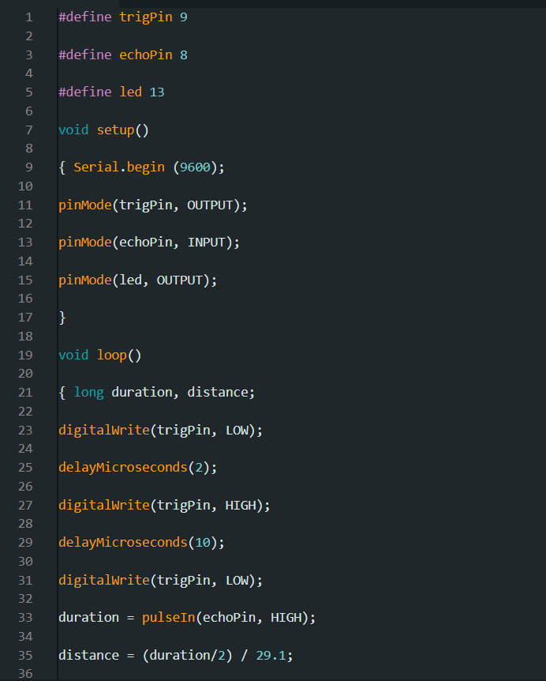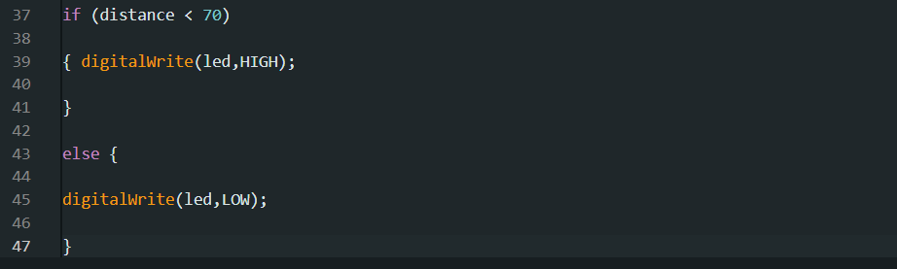

1. **CONCLUSION**

In conclusion, the Ultrasonic Proximity Sensor project showcases the practical application of ultrasonic technology in distance measurement. The integration with Arduino Uno allows for a versatile and programmable platform, making it suitable for a wide range of applications. Further improvements and extensions to the project could include data logging, wireless communication, or integration with other sensors for enhanced functionality.

**BIBLIOGRAPHY**

1. Arduino Official Website: <https://www.arduino.cc/>
2. HC-SR04 Ultrasonic Sensor Datasheet: [Link to Datasheet]