Tampa Bay Rental Affordability
Examining the Gap Between Household Income, Official Rent Benchmarks, and Market-Rate Rents in Hillsborough, Pinellas, Pasco, and Hernando Counties
ISM 6419 Data Visualization

Introduction
Rents across the Tampa Bay metro area have climbed sharply since 2015. Population growth, tight housing supply, and a wave of remote workers and out-of-state movers after the COVID-19 pandemic all played a part. Zillow named Tampa the nation's hottest housing market heading into 2022, and the University of South Florida's 2025 State of the Region report found that Zillow's Observed Rent Index for the metro rose roughly 81 percent between 2015 and 2023, a faster pace than most comparable Florida metros. The Tampa-St. Petersburg-Clearwater Metropolitan Statistical Area, as HUD defines it, covers Hillsborough, Pinellas, Pasco, and Hernando counties. Wage growth in the region hasn't obviously kept pace with rent growth, which raises a basic question: are local incomes still enough to cover a typical rental unit?
This project looks at rental affordability across all four counties, drawing on publicly available government and private-sector data. It combines county-level rent and income figures, census-tract-level cost-burden data, and zip-code-level market rents three different levels of geographic detail that, together, give a fuller picture than any single source could on its own. Two research questions guide the analysis:
- Research Question 1: Who can afford to rent in the Tampa Bay area and which counties, and which neighborhoods within them, are furthest from being able to afford a standard two-bedroom apartment?
- Research Question 2: How does HUD's official Fair Market Rent benchmark compare to Zillow's independently observed market rent, and has the gap between these two measures changed since 2015?
To answer the first question, I compare county-level median household income against the income needed to afford the area's Fair Market Rent under the standard 30-percent-of-income threshold, then supplement that with tract-level data on renter households already carrying a cost burden. For the second question, I compare HUD's Fair Market Rent, the figure used to set federal housing-assistance payment standards, directly against Zillow's Observed Rent Index, which reflects actual rents from active listings.

Methodology
This project draws on six datasets from three sources, two federal agencies and one commercial provider, covering all four counties in the Tampa-St. Petersburg-Clearwater HUD Metro FMR Area: Hillsborough, Pinellas, Pasco, and Hernando. I downloaded each dataset directly from its source, cleaned it, and reshaped it into a tidy format before loading it into Tableau. Rather than using traditional joins, I linked the six tables using Tableau's relationship model, which let each one stay at its own native level of geographic and temporal detail.

Data Sources
- HUD Fair Market Rents (FY2015-FY2025), by county and bedroom size. Source: https://www.huduser.gov/portal/datasets/fmr.html
- U.S. Census Bureau, American Community Survey, Table S1903 (Median Household Income), 2015-2024 (2020 unavailable see Limitations). Source: https://data.census.gov/
- U.S. Census Bureau, Population Estimates Program, county population totals, 2015-2025. Source: https://www.census.gov/programs-surveys/popest.html
- HUD-USPS ZIP Code Crosswalk Files (ZIP-County and ZIP-Tract, 2026 Q1), used to link zip-code-level and tract-level data to counties. Source: https://www.huduser.gov/portal/datasets/usps_crosswalk.html
- HUD Comprehensive Housing Affordability Strategy (CHAS) data, 2018-2022 5-year estimates, Table 8, census-tract level. Source: https://www.huduser.gov/portal/datasets/cp.html
- Zillow Observed Rent Index (ZORI), smoothed, all homes plus multifamily, zip-code level, January 2015-June 2026. Source: https://www.zillow.com/research/data/

Data Preparation and Linkage
I related the six datasets in Tableau as follows: the county-level Fair Market Rent table serves as the base table and is related to county median income and county population on County and Year; a HUD zip-to-county-to-tract crosswalk table serves as a hub connecting county-level data to zip-level and tract-level data, related to the base table on County; the HUD CHAS tract-level cost-burden table is related to the crosswalk on Census Tract GEOID; and the Zillow zip-level rent table is related both to the crosswalk on Zip Code and directly to the base FMR table on County and Year, the latter relationship using a calculated field to extract the year from each monthly observation so that annual comparisons could be made correctly.

Limitations
A few limitations are worth flagging. Census Bureau 1-year ACS income estimates weren't published for 2020 because of pandemic-related data-collection disruptions, leaving a one-year gap in the income series for all four counties. County population figures combine two separate Census Bureau estimate "vintages" (a pre-2020 series and a post-2020 series) that meet at 2020 without sharing an identical estimation methodology. Fourteen zip codes span more than one county; I assigned each to its dominant county by residential address share rather than splitting it proportionally. Finally, Tableau Desktop doesn't include a built-in geographic role for census tracts, so the tract-level cost-burden map I'd originally planned ended up built at the county level instead; tract-level detail is still present in the underlying data and could be mapped with additional geocoding tools in future work.

Analysis

Research Question 1: Who can afford to rent in Tampa Bay?
Figure 1 tracks median two-bedroom Fair Market Rent against median household income for each county from 2015 through 2025. Rent and income both climbed steadily through 2019 in every county, but rent took off starting around 2021 while income growth stayed roughly linear. In Hillsborough and Pinellas, the rent line visibly overtakes the income trajectory in the early 2020s, a sign that rent has been eating up a growing share of the typical household's paycheck.
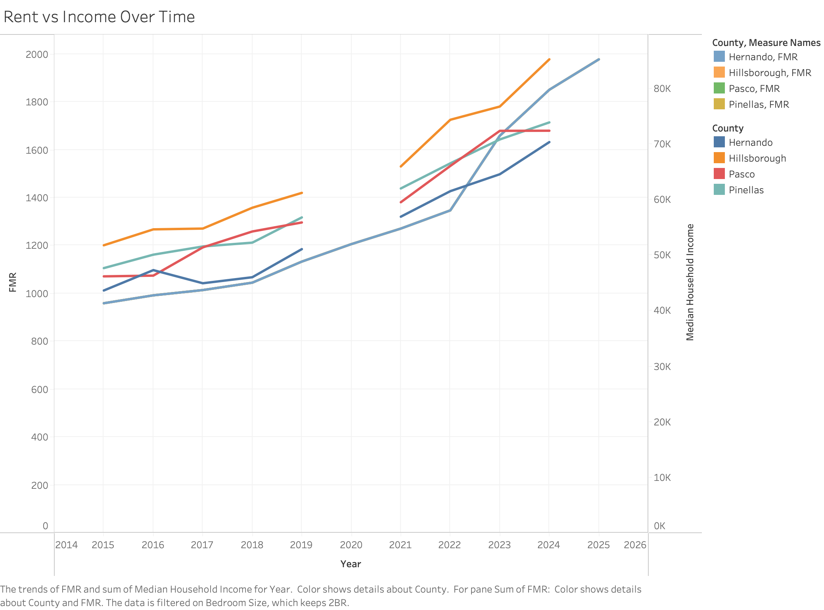
Figure 1. Median 2-Bedroom Fair Market Rent vs. Median Household Income by County, 2015-2025.
Figure 2 boils this down to a single number for 2024, the most recent year with complete data: the gap between each county's actual median household income and the income a household would need to spend no more than 30 percent on the area's Fair Market Rent. Hillsborough is the only county where median income clears that bar, by $11,143. Pinellas comes close, falling short by just $208. Pasco and Hernando fall further behind, at $1,705 and $3,749 short respectively, with Hernando the furthest from affordability of the four.
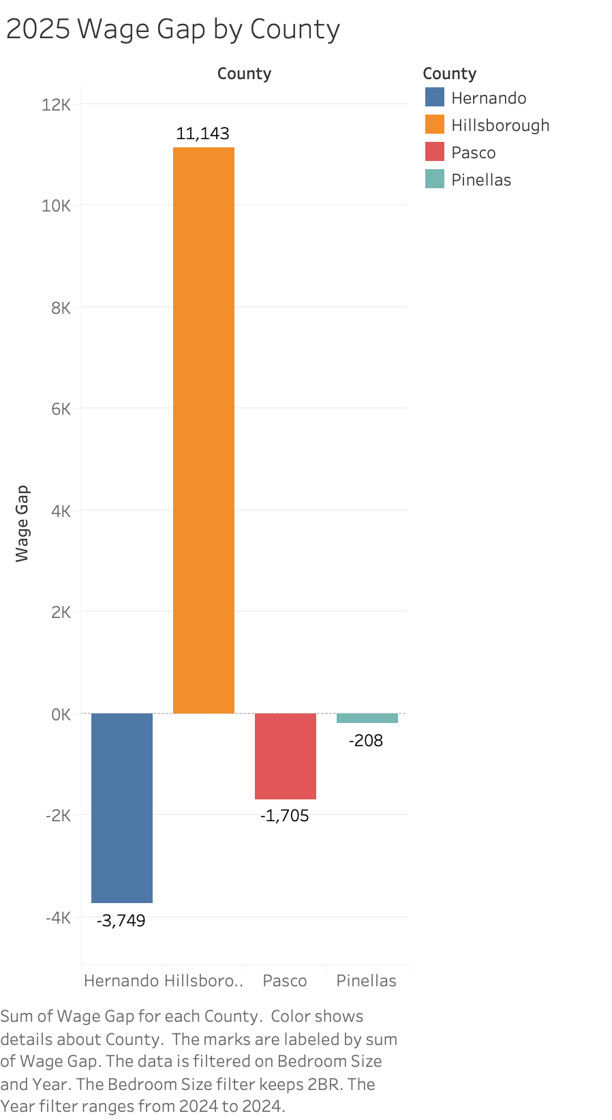
Figure 2. Gap Between Median Household Income and Income Required for 2-Bedroom Rent Affordability, by County (2024).
Figure 3 pushes this analysis down to the tract level, using HUD's Comprehensive Housing Affordability Strategy data on the share of renter households in each census tract already paying more than 30 percent of income toward rent. Averaged across tracts, cost-burdened renter households range from 41.4 percent in Hernando County to 49.2 percent in Pasco and Hillsborough. That's a notable reversal from Figure 2: Hillsborough looked comparatively affordable at the county-median level, yet it and Pasco actually have the highest shares of renter households under cost burden. The explanation comes down to income distribution, a county can clear the affordability threshold on paper while still containing plenty of lower-income renters who don't.
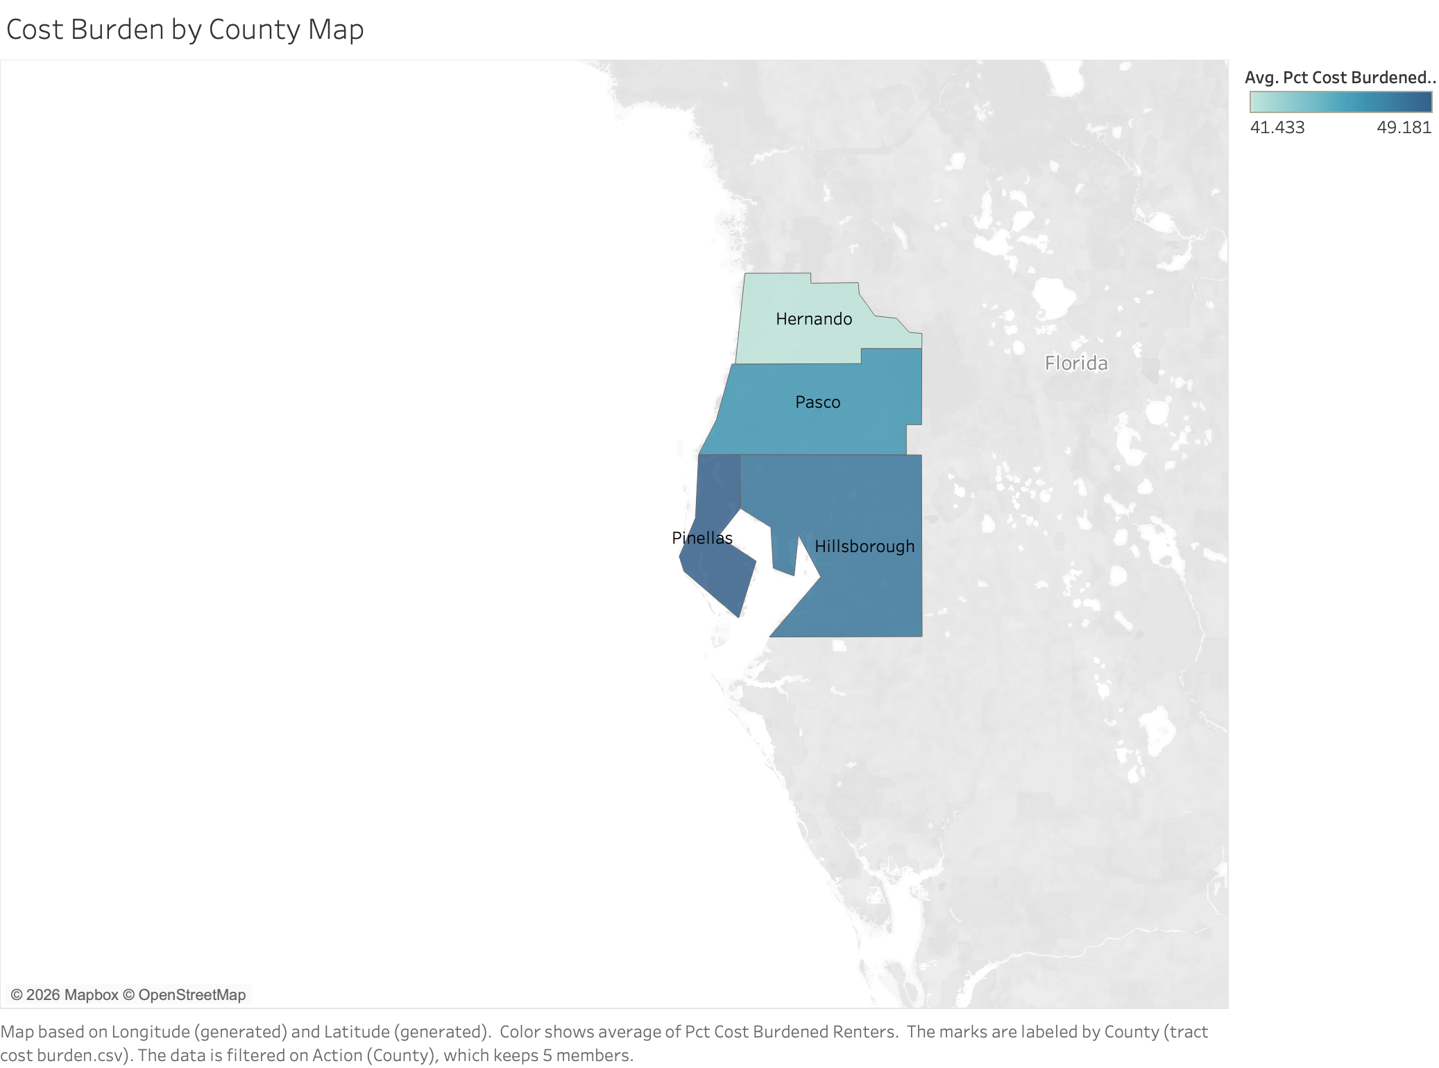
Figure 3. Average Share of Cost-Burdened Renter Households by County, Census Tract Data (2018-2022).
Taken together, these three charts point to something more nuanced than one affordable county and three unaffordable ones. Cost burden is elevated across all four counties somewhere between four and five in ten renter households are paying more than they can comfortably afford, regardless of where the county median income lands.

Research Question 2: HUD Fair Market Rent vs. Zillow Observed Market Rent
Figure 4 compares the two rent benchmarks directly, using an interactive parameter that toggles between HUD's Fair Market Rent and Zillow's Observed Rent Index for the same four counties. Zillow's series runs about six months longer than HUD's here, since ZORI data was available through June 2026 while FY2025 is the most recent complete Fair Market Rent year (see Methodology); the extra half-year on the Zillow chart reflects that difference rather than any inconsistency in the underlying data. Under the HUD benchmark, Hillsborough County's rent trajectory separates clearly from the other three counties beginning in 2020, ending 2025 well above Hernando, Pasco, and Pinellas. Under the Zillow benchmark, however, the four counties track much more closely together across the full period, with Pasco and Pinellas trending marginally above Hillsborough for much of 2015-2022 before Hillsborough and Pinellas pull slightly ahead near the end of the series.
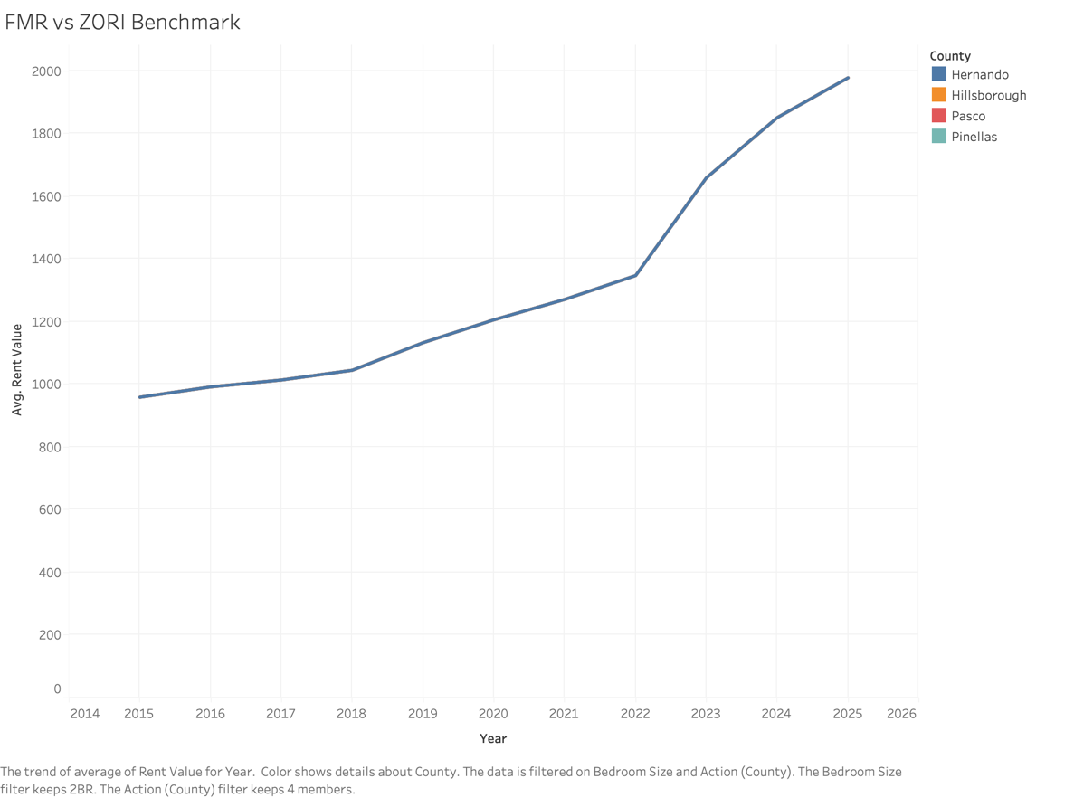
Figure 4a. County Rent Trends Under the HUD Fair Market Rent Benchmark, 2015-2025.
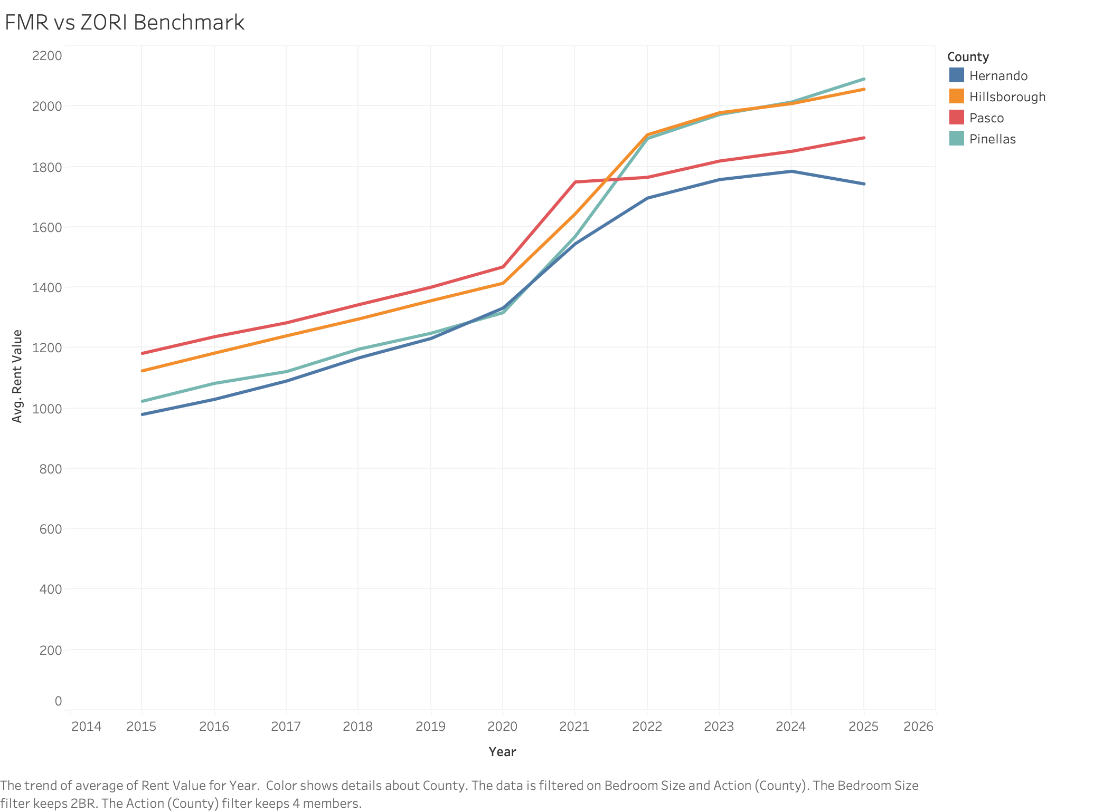
Figure 4b. County Rent Trends Under the Zillow Observed Rent Index Benchmark, 2015-2026.
That divergence is itself a finding. HUD sets Fair Market Rents once a year at the metro level rather than observing each county independently, so the benchmark can understate how closely, or how differently, rents across neighboring counties actually move in the private market. Zillow's index, built from real listings, picks up those county-to-county differences more directly. This isn't just an academic distinction: Fair Market Rents set payment standards for the Housing Choice Voucher program, so if the official benchmark drifts from what the private market is actually charging in a given county, voucher holders there may have a harder time finding landlords willing to accept the federally set rate.

Conclusion
This project set out to answer two questions about rental affordability in Tampa Bay. On who can afford to rent: Hillsborough is the only county where 2024 median household income exceeds what's needed to affordably rent a standard two-bedroom unit at HUD's Fair Market Rent, while Hernando falls furthest short. But the tract-level cost-burden data tells a more sobering story between roughly 41 and 49 percent of renter households across all four counties are already paying more than 30 percent of their income toward rent, and Pasco and Hillsborough actually have the highest shares despite Hillsborough's stronger median-income position. Affordability in Tampa Bay, in other words, isn't a problem confined to one weaker county; it's a regional issue touching a large minority of renters everywhere.
On how HUD's official benchmark compares to Zillow's market-observed rent: the two measures tell noticeably different stories about which counties are getting relatively more or less expensive. HUD's Fair Market Rent shows Hillsborough pulling clearly ahead of the other three counties in recent years; Zillow's Observed Rent Index instead shows all four counties converging over the same period. Since Fair Market Rent is set at the metro level while Zillow's index tracks each county's market directly, this gap suggests the official federal benchmark may not fully capture how much rents actually vary county to county within a single metro area.
These conclusions come directly from patterns in the data. Beyond that, I'd guess a few factors are contributing to what we're seeing here: differences in new housing construction across the four counties, the geography of post-pandemic in-migration into Tampa Bay, and differences in local zoning and land-use policy all seem plausible. But the data can't tell us which of these, if any, is actually driving the trends, so take that as speculation on my part rather than something the analysis itself demonstrates.

Additional Research Questions
A few questions came up along the way that this project doesn't answer but that seem worth chasing down:
- Has new multifamily housing construction in Hillsborough County outpaced construction in the other three counties over the 2015-2025 period, and does this help explain the divergence between the HUD and Zillow rent benchmarks?
- How has renter cost burden changed over time at the census-tract level within each county, rather than being observed only as a single-period average?
- To what extent does the gap between HUD Fair Market Rent and Zillow's Observed Rent Index affect the ability of Housing Choice Voucher holders to find willing landlords in each of the four counties?
- How does renter cost burden in Tampa Bay compare to other fast-growing Florida metropolitan areas, such as Orlando or Sarasota-Bradenton, over the same time period?

Dashboard
The three county-level visualizations above, the wage-gap comparison, the cost-burden map, and the HUD/Zillow rent-benchmark comparison, come together in a single interactive dashboard, shown in Figure 5. Selecting a county in the wage-gap chart filters both the map and the rent-benchmark chart to that county, so a reader can move between the region-wide patterns discussed in this report and the detail for any one county.
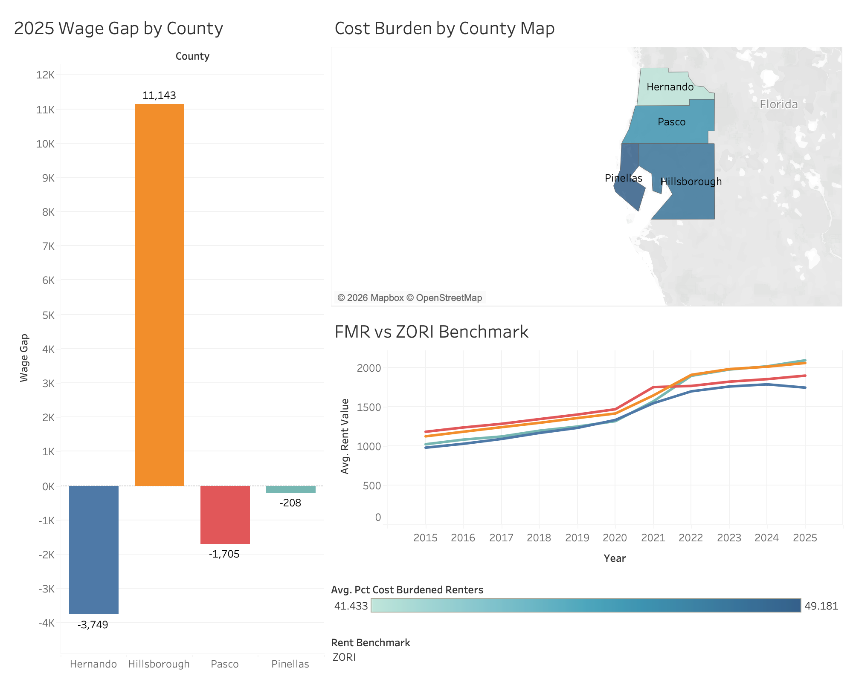
Figure 5. Tampa Bay Rental Affordability Dashboard, combining county-level wage gap, cost burden, and rent-benchmark comparisons.
Appendix A: Data Source URLs
- HUD Fair Market Rents: https://www.huduser.gov/portal/datasets/fmr.html
- U.S. Census Bureau American Community Survey: https://data.census.gov/
- U.S. Census Bureau Population Estimates Program: https://www.census.gov/programs-surveys/popest.html
- HUD-USPS ZIP Code Crosswalk Files: https://www.huduser.gov/portal/datasets/usps_crosswalk.html
- HUD Comprehensive Housing Affordability Strategy (CHAS) Data: https://www.huduser.gov/portal/datasets/cp.html
- Zillow Research Data (Observed Rent Index): https://www.zillow.com/research/data/

