Friend Error : values not passing in database for accept and delete (On accepting request : console.log(pendingRequest.status) gives undefined values .)

Soln. : check html page and controller for values and object passed

==========================================================================================================================================================================

Use commons-dbcp-1.2.2 jar instead of commons-dbcp-1.4 jar along with commons-pool-1.5.4(1.6).jar - for basicDataSource

Alternate way : use commons-dbcp2 - keeping rest dependencies same

==========================================================================================================================================================================

Aug 01, 2017 5:27:38 PM org.apache.tomcat.util.digester.SetPropertiesRule begin

WARNING: [SetPropertiesRule]{Server/Service/Engine/Host/Context} Setting property 'source' to 'org.eclipse.jst.jee.server:backendCrudDemo' did not find a matching property.

Aug 01, 2017 5:27:38 PM org.apache.catalina.startup.VersionLoggerListener log

INFO: Server version: Apache Tomcat/8.5.16

Aug 01, 2017 5:27:38 PM org.apache.catalina.startup.VersionLoggerListener log

INFO: Server built: Jun 21 2017 17:01:09 UTC

Aug 01, 2017 5:27:38 PM org.apache.catalina.startup.VersionLoggerListener log

INFO: Server number: 8.5.16.0

Aug 01, 2017 5:27:38 PM org.apache.catalina.startup.VersionLoggerListener log

INFO: OS Name: Windows 7

Aug 01, 2017 5:27:38 PM org.apache.catalina.startup.VersionLoggerListener log

INFO: OS Version: 6.1

Aug 01, 2017 5:27:38 PM org.apache.catalina.startup.VersionLoggerListener log

INFO: Architecture: amd64

Aug 01, 2017 5:27:38 PM org.apache.catalina.startup.VersionLoggerListener log

INFO: Java Home: C:\Program Files\Java\jdk1.8.0_131\jre

Aug 01, 2017 5:27:38 PM org.apache.catalina.startup.VersionLoggerListener log

INFO: JVM Version: 1.8.0_131-b11

Aug 01, 2017 5:27:38 PM org.apache.catalina.startup.VersionLoggerListener log

INFO: JVM Vendor: Oracle Corporation

Aug 01, 2017 5:27:38 PM org.apache.catalina.startup.VersionLoggerListener log

INFO: CATALINA_BASE: E:\NIIT\Programs\Angular_JS_CRUD_Demo\.metadata\.plugins\org.eclipse.wst.server.core\tmp0

Aug 01, 2017 5:27:38 PM org.apache.catalina.startup.VersionLoggerListener log

INFO: CATALINA_HOME: D:\apache-tomcat-8.5.16

Aug 01, 2017 5:27:38 PM org.apache.catalina.startup.VersionLoggerListener log

INFO: Command line argument: -Dcatalina.base=E:\NIIT\Programs\Angular_JS_CRUD_Demo\.metadata\.plugins\org.eclipse.wst.server.core\tmp0

Aug 01, 2017 5:27:38 PM org.apache.catalina.startup.VersionLoggerListener log

INFO: Command line argument: -Dcatalina.home=D:\apache-tomcat-8.5.16

Aug 01, 2017 5:27:38 PM org.apache.catalina.startup.VersionLoggerListener log

INFO: Command line argument: -Dwtp.deploy=E:\NIIT\Programs\Angular_JS_CRUD_Demo\.metadata\.plugins\org.eclipse.wst.server.core\tmp0\wtpwebapps

Aug 01, 2017 5:27:38 PM org.apache.catalina.startup.VersionLoggerListener log

INFO: Command line argument: -Djava.endorsed.dirs=D:\apache-tomcat-8.5.16\endorsed

Aug 01, 2017 5:27:38 PM org.apache.catalina.startup.VersionLoggerListener log

INFO: Command line argument: -Dfile.encoding=Cp1252

Aug 01, 2017 5:27:38 PM org.apache.catalina.core.AprLifecycleListener lifecycleEvent

INFO: The APR based Apache Tomcat Native library which allows optimal performance in production environments was not found on the java.library.path: [C:\Program Files\Java\jdk1.8.0_131\bin;C:\Windows\Sun\Java\bin;C:\Windows\system32;C:\Windows;C:/Program Files/Java/jre1.8.0_131/bin/server;C:/Program Files/Java/jre1.8.0_131/bin;C:/Program Files/Java/jre1.8.0_131/lib/amd64;D:\oracle\app\oracle\product\11.2.0\server\bin;;C:\ProgramData\Oracle\Java\javapath;C:\Windows\system32;C:\Windows;C:\Windows\System32\Wbem;C:\Windows\System32\WindowsPowerShell\v1.0\;C:\Program Files\Lenovo\Bluetooth Software\;C:\Program Files\Lenovo\Bluetooth Software\syswow64;C:\Program Files (x86)\Skype\Phone\;D:\NodeJs\;C:\Program Files\PuTTY\;C:\Program Files\MongoDB\Server\3.4\bin;D:\Mongodb\test\mongodb\data;C:\Program Files\Java\jdk1.8.0_131\bin;C:\Program Files\Maven\apache-maven-3.5.0\bin;C:\Users\Aditi\AppData\Roaming\npm;C:\Users\Aditi\eclipse\jee-neon3\eclipse;;.]

Aug 01, 2017 5:27:38 PM org.apache.coyote.AbstractProtocol init

INFO: Initializing ProtocolHandler ["http-nio-9090"]

Aug 01, 2017 5:27:39 PM org.apache.tomcat.util.net.NioSelectorPool getSharedSelector

INFO: Using a shared selector for servlet write/read

Aug 01, 2017 5:27:39 PM org.apache.coyote.AbstractProtocol init

INFO: Initializing ProtocolHandler ["ajp-nio-8009"]

Aug 01, 2017 5:27:39 PM org.apache.tomcat.util.net.NioSelectorPool getSharedSelector

INFO: Using a shared selector for servlet write/read

Aug 01, 2017 5:27:39 PM org.apache.catalina.startup.Catalina load

INFO: Initialization processed in 860 ms

Aug 01, 2017 5:27:39 PM org.apache.catalina.core.StandardService startInternal

INFO: Starting service [Catalina]

Aug 01, 2017 5:27:39 PM org.apache.catalina.core.StandardEngine startInternal

INFO: Starting Servlet Engine: Apache Tomcat/8.5.16

Aug 01, 2017 5:27:41 PM org.apache.jasper.servlet.TldScanner scanJars

INFO: At least one JAR was scanned for TLDs yet contained no TLDs. Enable debug logging for this logger for a complete list of JARs that were scanned but no TLDs were found in them. Skipping unneeded JARs during scanning can improve startup time and JSP compilation time.

SLF4J: Failed to load class "org.slf4j.impl.StaticLoggerBinder".

SLF4J: Defaulting to no-operation (NOP) logger implementation

SLF4J: See http://www.slf4j.org/codes.html#StaticLoggerBinder for further details.

Aug 01, 2017 5:27:41 PM org.apache.catalina.core.ApplicationContext log

INFO: 1 Spring WebApplicationInitializers detected on classpath

Aug 01, 2017 5:27:41 PM org.apache.catalina.core.ApplicationContext log

INFO: Initializing Spring root WebApplicationContext

Aug 01, 2017 5:27:43 PM org.hibernate.Version logVersion

INFO: HHH000412: Hibernate Core {5.2.10.Final}

Aug 01, 2017 5:27:43 PM org.hibernate.cfg.Environment <clinit>

INFO: HHH000206: hibernate.properties not found

Aug 01, 2017 5:27:43 PM org.hibernate.annotations.common.reflection.java.JavaReflectionManager <clinit>

INFO: HCANN000001: Hibernate Commons Annotations {5.0.1.Final}

Aug 01, 2017 5:27:43 PM org.hibernate.engine.jdbc.env.internal.JdbcEnvironmentInitiator initiateService

WARN: HHH000342: Could not obtain connection to query metadata : Cannot create PoolableConnectionFactory (ORA-01017: invalid username/password; logon denied

)

Aug 01, 2017 5:27:43 PM org.hibernate.dialect.Dialect <init>

INFO: HHH000400: Using dialect: org.hibernate.dialect.Oracle10gDialect

Aug 01, 2017 5:27:43 PM org.hibernate.engine.jdbc.env.internal.LobCreatorBuilderImpl makeLobCreatorBuilder

INFO: HHH000422: Disabling contextual LOB creation as connection was null

Aug 01, 2017 5:27:44 PM org.hibernate.hql.spi.id.IdTableHelper executeIdTableCreationStatements

ERROR: Unable obtain JDBC Connection

org.apache.commons.dbcp.SQLNestedException: Cannot create PoolableConnectionFactory (ORA-01017: invalid username/password; logon denied

)

at org.apache.commons.dbcp.BasicDataSource.createDataSource(BasicDataSource.java:1225)

at org.apache.commons.dbcp.BasicDataSource.getConnection(BasicDataSource.java:880)

at org.hibernate.engine.jdbc.connections.internal.DatasourceConnectionProviderImpl.getConnection(DatasourceConnectionProviderImpl.java:122)

at org.hibernate.internal.SessionFactoryImpl$1.obtainConnection(SessionFactoryImpl.java:419)

at org.hibernate.hql.spi.id.IdTableHelper.executeIdTableCreationStatements(IdTableHelper.java:67)

at org.hibernate.hql.spi.id.global.GlobalTemporaryTableBulkIdStrategy.finishPreparation(GlobalTemporaryTableBulkIdStrategy.java:125)

at org.hibernate.hql.spi.id.global.GlobalTemporaryTableBulkIdStrategy.finishPreparation(GlobalTemporaryTableBulkIdStrategy.java:42)

at org.hibernate.hql.spi.id.AbstractMultiTableBulkIdStrategyImpl.prepare(AbstractMultiTableBulkIdStrategyImpl.java:88)

at org.hibernate.internal.SessionFactoryImpl.<init>(SessionFactoryImpl.java:302)

at org.hibernate.boot.internal.SessionFactoryBuilderImpl.build(SessionFactoryBuilderImpl.java:452)

at org.hibernate.cfg.Configuration.buildSessionFactory(Configuration.java:710)

at org.hibernate.cfg.Configuration.buildSessionFactory(Configuration.java:726)

at com.niit.configuration.DBConfig.sessionFactory(DBConfig.java:43)

at com.niit.configuration.DBConfig$$EnhancerBySpringCGLIB$$8e9c929c.CGLIB$sessionFactory$2(<generated>)

at com.niit.configuration.DBConfig$$EnhancerBySpringCGLIB$$8e9c929c$$FastClassBySpringCGLIB$$d1333f40.invoke(<generated>)

at org.springframework.cglib.proxy.MethodProxy.invokeSuper(MethodProxy.java:228)

at org.springframework.context.annotation.ConfigurationClassEnhancer$BeanMethodInterceptor.intercept(ConfigurationClassEnhancer.java:358)

at com.niit.configuration.DBConfig$$EnhancerBySpringCGLIB$$8e9c929c.sessionFactory(<generated>)

at sun.reflect.NativeMethodAccessorImpl.invoke0(Native Method)

at sun.reflect.NativeMethodAccessorImpl.invoke(NativeMethodAccessorImpl.java:62)

at sun.reflect.DelegatingMethodAccessorImpl.invoke(DelegatingMethodAccessorImpl.java:43)

at java.lang.reflect.Method.invoke(Method.java:498)

at org.springframework.beans.factory.support.SimpleInstantiationStrategy.instantiate(SimpleInstantiationStrategy.java:162)

at org.springframework.beans.factory.support.ConstructorResolver.instantiateUsingFactoryMethod(ConstructorResolver.java:588)

at org.springframework.beans.factory.support.AbstractAutowireCapableBeanFactory.instantiateUsingFactoryMethod(AbstractAutowireCapableBeanFactory.java:1173)

at org.springframework.beans.factory.support.AbstractAutowireCapableBeanFactory.createBeanInstance(AbstractAutowireCapableBeanFactory.java:1067)

at org.springframework.beans.factory.support.AbstractAutowireCapableBeanFactory.doCreateBean(AbstractAutowireCapableBeanFactory.java:513)

at org.springframework.beans.factory.support.AbstractAutowireCapableBeanFactory.createBean(AbstractAutowireCapableBeanFactory.java:483)

at org.springframework.beans.factory.support.AbstractBeanFactory$1.getObject(AbstractBeanFactory.java:306)

at org.springframework.beans.factory.support.DefaultSingletonBeanRegistry.getSingleton(DefaultSingletonBeanRegistry.java:230)

at org.springframework.beans.factory.support.AbstractBeanFactory.doGetBean(AbstractBeanFactory.java:302)

at org.springframework.beans.factory.support.AbstractBeanFactory.getBean(AbstractBeanFactory.java:197)

at org.springframework.beans.factory.support.DefaultListableBeanFactory.preInstantiateSingletons(DefaultListableBeanFactory.java:761)

at org.springframework.context.support.AbstractApplicationContext.finishBeanFactoryInitialization(AbstractApplicationContext.java:867)

at org.springframework.context.support.AbstractApplicationContext.refresh(AbstractApplicationContext.java:543)

at org.springframework.web.context.ContextLoader.configureAndRefreshWebApplicationContext(ContextLoader.java:443)

at org.springframework.web.context.ContextLoader.initWebApplicationContext(ContextLoader.java:325)

at org.springframework.web.context.ContextLoaderListener.contextInitialized(ContextLoaderListener.java:107)

at org.apache.catalina.core.StandardContext.listenerStart(StandardContext.java:4743)

at org.apache.catalina.core.StandardContext.startInternal(StandardContext.java:5207)

at org.apache.catalina.util.LifecycleBase.start(LifecycleBase.java:150)

at org.apache.catalina.core.ContainerBase$StartChild.call(ContainerBase.java:1419)

at org.apache.catalina.core.ContainerBase$StartChild.call(ContainerBase.java:1409)

at java.util.concurrent.FutureTask.run(FutureTask.java:266)

at java.util.concurrent.ThreadPoolExecutor.runWorker(ThreadPoolExecutor.java:1142)

at java.util.concurrent.ThreadPoolExecutor$Worker.run(ThreadPoolExecutor.java:617)

at java.lang.Thread.run(Thread.java:748)

Caused by: java.sql.SQLException: ORA-01017: invalid username/password; logon denied

at oracle.jdbc.driver.T4CTTIoer.processError(T4CTTIoer.java:440)

at oracle.jdbc.driver.T4CTTIoer.processError(T4CTTIoer.java:389)

at oracle.jdbc.driver.T4CTTIoer.processError(T4CTTIoer.java:382)

at oracle.jdbc.driver.T4CTTIfun.processError(T4CTTIfun.java:573)

at oracle.jdbc.driver.T4CTTIoauthenticate.processError(T4CTTIoauthenticate.java:431)

at oracle.jdbc.driver.T4CTTIfun.receive(T4CTTIfun.java:445)

at oracle.jdbc.driver.T4CTTIfun.doRPC(T4CTTIfun.java:191)

at oracle.jdbc.driver.T4CTTIoauthenticate.doOAUTH(T4CTTIoauthenticate.java:366)

at oracle.jdbc.driver.T4CTTIoauthenticate.doOAUTH(T4CTTIoauthenticate.java:752)

at oracle.jdbc.driver.T4CConnection.logon(T4CConnection.java:366)

at oracle.jdbc.driver.PhysicalConnection.<init>(PhysicalConnection.java:536)

at oracle.jdbc.driver.T4CConnection.<init>(T4CConnection.java:228)

at oracle.jdbc.driver.T4CDriverExtension.getConnection(T4CDriverExtension.java:32)

at oracle.jdbc.driver.OracleDriver.connect(OracleDriver.java:521)

at org.apache.commons.dbcp.DriverConnectionFactory.createConnection(DriverConnectionFactory.java:38)

at org.apache.commons.dbcp.PoolableConnectionFactory.makeObject(PoolableConnectionFactory.java:294)

at org.apache.commons.dbcp.BasicDataSource.validateConnectionFactory(BasicDataSource.java:1247)

at org.apache.commons.dbcp.BasicDataSource.createDataSource(BasicDataSource.java:1221)

... 46 more

Aug 01, 2017 5:27:44 PM org.hibernate.engine.jdbc.spi.SqlExceptionHelper logExceptions

WARN: SQL Error: 0, SQLState: null

Aug 01, 2017 5:27:44 PM org.hibernate.engine.jdbc.spi.SqlExceptionHelper logExceptions

ERROR: Cannot create PoolableConnectionFactory (ORA-01017: invalid username/password; logon denied

)

Aug 01, 2017 5:27:44 PM org.apache.catalina.core.StandardContext listenerStart

SEVERE: Exception sending context initialized event to listener instance of class [org.springframework.web.context.ContextLoaderListener]

org.springframework.beans.factory.BeanCreationException: Error creating bean with name 'sessionFactory' defined in com.niit.configuration.DBConfig: Bean instantiation via factory method failed; nested exception is org.springframework.beans.BeanInstantiationException: Failed to instantiate [org.hibernate.SessionFactory]: Factory method 'sessionFactory' threw exception; nested exception is org.hibernate.exception.GenericJDBCException: Unable to open JDBC Connection for DDL execution

at org.springframework.beans.factory.support.ConstructorResolver.instantiateUsingFactoryMethod(ConstructorResolver.java:599)

at org.springframework.beans.factory.support.AbstractAutowireCapableBeanFactory.instantiateUsingFactoryMethod(AbstractAutowireCapableBeanFactory.java:1173)

at org.springframework.beans.factory.support.AbstractAutowireCapableBeanFactory.createBeanInstance(AbstractAutowireCapableBeanFactory.java:1067)

at org.springframework.beans.factory.support.AbstractAutowireCapableBeanFactory.doCreateBean(AbstractAutowireCapableBeanFactory.java:513)

at org.springframework.beans.factory.support.AbstractAutowireCapableBeanFactory.createBean(AbstractAutowireCapableBeanFactory.java:483)

at org.springframework.beans.factory.support.AbstractBeanFactory$1.getObject(AbstractBeanFactory.java:306)

at org.springframework.beans.factory.support.DefaultSingletonBeanRegistry.getSingleton(DefaultSingletonBeanRegistry.java:230)

at org.springframework.beans.factory.support.AbstractBeanFactory.doGetBean(AbstractBeanFactory.java:302)

at org.springframework.beans.factory.support.AbstractBeanFactory.getBean(AbstractBeanFactory.java:197)

at org.springframework.beans.factory.support.DefaultListableBeanFactory.preInstantiateSingletons(DefaultListableBeanFactory.java:761)

at org.springframework.context.support.AbstractApplicationContext.finishBeanFactoryInitialization(AbstractApplicationContext.java:867)

at org.springframework.context.support.AbstractApplicationContext.refresh(AbstractApplicationContext.java:543)

at org.springframework.web.context.ContextLoader.configureAndRefreshWebApplicationContext(ContextLoader.java:443)

at org.springframework.web.context.ContextLoader.initWebApplicationContext(ContextLoader.java:325)

at org.springframework.web.context.ContextLoaderListener.contextInitialized(ContextLoaderListener.java:107)

at org.apache.catalina.core.StandardContext.listenerStart(StandardContext.java:4743)

at org.apache.catalina.core.StandardContext.startInternal(StandardContext.java:5207)

at org.apache.catalina.util.LifecycleBase.start(LifecycleBase.java:150)

at org.apache.catalina.core.ContainerBase$StartChild.call(ContainerBase.java:1419)

at org.apache.catalina.core.ContainerBase$StartChild.call(ContainerBase.java:1409)

at java.util.concurrent.FutureTask.run(FutureTask.java:266)

at java.util.concurrent.ThreadPoolExecutor.runWorker(ThreadPoolExecutor.java:1142)

at java.util.concurrent.ThreadPoolExecutor$Worker.run(ThreadPoolExecutor.java:617)

at java.lang.Thread.run(Thread.java:748)

Caused by: org.springframework.beans.BeanInstantiationException: Failed to instantiate [org.hibernate.SessionFactory]: Factory method 'sessionFactory' threw exception; nested exception is org.hibernate.exception.GenericJDBCException: Unable to open JDBC Connection for DDL execution

at org.springframework.beans.factory.support.SimpleInstantiationStrategy.instantiate(SimpleInstantiationStrategy.java:189)

at org.springframework.beans.factory.support.ConstructorResolver.instantiateUsingFactoryMethod(ConstructorResolver.java:588)

... 23 more

Caused by: org.hibernate.exception.GenericJDBCException: Unable to open JDBC Connection for DDL execution

at org.hibernate.exception.internal.StandardSQLExceptionConverter.convert(StandardSQLExceptionConverter.java:47)

at org.hibernate.engine.jdbc.spi.SqlExceptionHelper.convert(SqlExceptionHelper.java:111)

at org.hibernate.engine.jdbc.spi.SqlExceptionHelper.convert(SqlExceptionHelper.java:97)

at org.hibernate.resource.transaction.backend.jdbc.internal.DdlTransactionIsolatorNonJtaImpl.getIsolatedConnection(DdlTransactionIsolatorNonJtaImpl.java:69)

at org.hibernate.tool.schema.internal.exec.ImprovedExtractionContextImpl.getJdbcConnection(ImprovedExtractionContextImpl.java:60)

at org.hibernate.tool.schema.extract.internal.SequenceInformationExtractorLegacyImpl.extractMetadata(SequenceInformationExtractorLegacyImpl.java:40)

at org.hibernate.tool.schema.extract.internal.DatabaseInformationImpl.initializeSequences(DatabaseInformationImpl.java:65)

at org.hibernate.tool.schema.extract.internal.DatabaseInformationImpl.<init>(DatabaseInformationImpl.java:59)

at org.hibernate.tool.schema.internal.Helper.buildDatabaseInformation(Helper.java:132)

at org.hibernate.tool.schema.internal.AbstractSchemaMigrator.doMigration(AbstractSchemaMigrator.java:92)

at org.hibernate.tool.schema.spi.SchemaManagementToolCoordinator.performDatabaseAction(SchemaManagementToolCoordinator.java:183)

at org.hibernate.tool.schema.spi.SchemaManagementToolCoordinator.process(SchemaManagementToolCoordinator.java:72)

at org.hibernate.internal.SessionFactoryImpl.<init>(SessionFactoryImpl.java:309)

at org.hibernate.boot.internal.SessionFactoryBuilderImpl.build(SessionFactoryBuilderImpl.java:452)

at org.hibernate.cfg.Configuration.buildSessionFactory(Configuration.java:710)

at org.hibernate.cfg.Configuration.buildSessionFactory(Configuration.java:726)

at com.niit.configuration.DBConfig.sessionFactory(DBConfig.java:43)

at com.niit.configuration.DBConfig$$EnhancerBySpringCGLIB$$8e9c929c.CGLIB$sessionFactory$2(<generated>)

at com.niit.configuration.DBConfig$$EnhancerBySpringCGLIB$$8e9c929c$$FastClassBySpringCGLIB$$d1333f40.invoke(<generated>)

at org.springframework.cglib.proxy.MethodProxy.invokeSuper(MethodProxy.java:228)

at org.springframework.context.annotation.ConfigurationClassEnhancer$BeanMethodInterceptor.intercept(ConfigurationClassEnhancer.java:358)

at com.niit.configuration.DBConfig$$EnhancerBySpringCGLIB$$8e9c929c.sessionFactory(<generated>)

at sun.reflect.NativeMethodAccessorImpl.invoke0(Native Method)

at sun.reflect.NativeMethodAccessorImpl.invoke(NativeMethodAccessorImpl.java:62)

at sun.reflect.DelegatingMethodAccessorImpl.invoke(DelegatingMethodAccessorImpl.java:43)

at java.lang.reflect.Method.invoke(Method.java:498)

at org.springframework.beans.factory.support.SimpleInstantiationStrategy.instantiate(SimpleInstantiationStrategy.java:162)

... 24 more

Caused by: org.apache.commons.dbcp.SQLNestedException: Cannot create PoolableConnectionFactory (ORA-01017: invalid username/password; logon denied

)

at org.apache.commons.dbcp.BasicDataSource.createDataSource(BasicDataSource.java:1225)

at org.apache.commons.dbcp.BasicDataSource.getConnection(BasicDataSource.java:880)

at org.hibernate.engine.jdbc.connections.internal.DatasourceConnectionProviderImpl.getConnection(DatasourceConnectionProviderImpl.java:122)

at org.hibernate.engine.jdbc.env.internal.JdbcEnvironmentInitiator$ConnectionProviderJdbcConnectionAccess.obtainConnection(JdbcEnvironmentInitiator.java:180)

at org.hibernate.resource.transaction.backend.jdbc.internal.DdlTransactionIsolatorNonJtaImpl.getIsolatedConnection(DdlTransactionIsolatorNonJtaImpl.java:43)

... 47 more

Caused by: java.sql.SQLException: ORA-01017: invalid username/password; logon denied

at oracle.jdbc.driver.T4CTTIoer.processError(T4CTTIoer.java:440)

at oracle.jdbc.driver.T4CTTIoer.processError(T4CTTIoer.java:389)

at oracle.jdbc.driver.T4CTTIoer.processError(T4CTTIoer.java:382)

at oracle.jdbc.driver.T4CTTIfun.processError(T4CTTIfun.java:573)

at oracle.jdbc.driver.T4CTTIoauthenticate.processError(T4CTTIoauthenticate.java:431)

at oracle.jdbc.driver.T4CTTIfun.receive(T4CTTIfun.java:445)

at oracle.jdbc.driver.T4CTTIfun.doRPC(T4CTTIfun.java:191)

at oracle.jdbc.driver.T4CTTIoauthenticate.doOAUTH(T4CTTIoauthenticate.java:366)

at oracle.jdbc.driver.T4CTTIoauthenticate.doOAUTH(T4CTTIoauthenticate.java:752)

at oracle.jdbc.driver.T4CConnection.logon(T4CConnection.java:366)

at oracle.jdbc.driver.PhysicalConnection.<init>(PhysicalConnection.java:536)

at oracle.jdbc.driver.T4CConnection.<init>(T4CConnection.java:228)

at oracle.jdbc.driver.T4CDriverExtension.getConnection(T4CDriverExtension.java:32)

at oracle.jdbc.driver.OracleDriver.connect(OracleDriver.java:521)

at org.apache.commons.dbcp.DriverConnectionFactory.createConnection(DriverConnectionFactory.java:38)

at org.apache.commons.dbcp.PoolableConnectionFactory.makeObject(PoolableConnectionFactory.java:294)

at org.apache.commons.dbcp.BasicDataSource.validateConnectionFactory(BasicDataSource.java:1247)

at org.apache.commons.dbcp.BasicDataSource.createDataSource(BasicDataSource.java:1221)

... 51 more

Aug 01, 2017 5:27:44 PM org.apache.catalina.core.StandardContext startInternal

SEVERE: One or more listeners failed to start. Full details will be found in the appropriate container log file

Aug 01, 2017 5:27:44 PM org.apache.catalina.core.StandardContext startInternal

SEVERE: Context [/backendCrudDemo] startup failed due to previous errors

Aug 01, 2017 5:27:44 PM org.apache.catalina.core.ApplicationContext log

INFO: Closing Spring root WebApplicationContext

Aug 01, 2017 5:27:44 PM org.apache.catalina.loader.WebappClassLoaderBase clearReferencesJdbc

WARNING: The web application [backendCrudDemo] registered the JDBC driver [oracle.jdbc.OracleDriver] but failed to unregister it when the web application was stopped. To prevent a memory leak, the JDBC Driver has been forcibly unregistered.

Aug 01, 2017 5:27:44 PM org.apache.catalina.loader.WebappClassLoaderBase checkThreadLocalMapForLeaks

SEVERE: The web application [backendCrudDemo] created a ThreadLocal with key of type [java.lang.ThreadLocal] (value [java.lang.ThreadLocal@43848e30]) and a value of type [java.lang.Class] (value [class oracle.sql.AnyDataFactory]) but failed to remove it when the web application was stopped. Threads are going to be renewed over time to try and avoid a probable memory leak.

Aug 01, 2017 5:27:44 PM org.apache.catalina.loader.WebappClassLoaderBase checkThreadLocalMapForLeaks

SEVERE: The web application [backendCrudDemo] created a ThreadLocal with key of type [java.lang.ThreadLocal] (value [java.lang.ThreadLocal@656718b4]) and a value of type [java.lang.Class] (value [class oracle.sql.TypeDescriptorFactory]) but failed to remove it when the web application was stopped. Threads are going to be renewed over time to try and avoid a probable memory leak.

Aug 01, 2017 5:27:44 PM org.apache.coyote.AbstractProtocol start

INFO: Starting ProtocolHandler ["http-nio-9090"]

Aug 01, 2017 5:27:44 PM org.apache.coyote.AbstractProtocol start

INFO: Starting ProtocolHandler ["ajp-nio-8009"]

Aug 01, 2017 5:27:45 PM org.apache.catalina.startup.Catalina start

INFO: Server startup in 5954 ms

Solution : check internet connection + check database_name ( my case - system )

// no internet connection required to connect to database . It is required only to run frontend part .....

==========================================================================================================================================================================

Aug 01, 2017 6:27:44 PM org.apache.tomcat.util.digester.SetPropertiesRule begin

WARNING: [SetPropertiesRule]{Server/Service/Engine/Host/Context} Setting property 'source' to 'org.eclipse.jst.jee.server:backendCrudDemo' did not find a matching property.

Aug 01, 2017 6:27:44 PM org.apache.catalina.startup.VersionLoggerListener log

INFO: Server version: Apache Tomcat/8.5.16

Aug 01, 2017 6:27:44 PM org.apache.catalina.startup.VersionLoggerListener log

INFO: Server built: Jun 21 2017 17:01:09 UTC

Aug 01, 2017 6:27:44 PM org.apache.catalina.startup.VersionLoggerListener log

INFO: Server number: 8.5.16.0

Aug 01, 2017 6:27:44 PM org.apache.catalina.startup.VersionLoggerListener log

INFO: OS Name: Windows 7

Aug 01, 2017 6:27:44 PM org.apache.catalina.startup.VersionLoggerListener log

INFO: OS Version: 6.1

Aug 01, 2017 6:27:44 PM org.apache.catalina.startup.VersionLoggerListener log

INFO: Architecture: amd64

Aug 01, 2017 6:27:44 PM org.apache.catalina.startup.VersionLoggerListener log

INFO: Java Home: C:\Program Files\Java\jdk1.8.0_131\jre

Aug 01, 2017 6:27:44 PM org.apache.catalina.startup.VersionLoggerListener log

INFO: JVM Version: 1.8.0_131-b11

Aug 01, 2017 6:27:44 PM org.apache.catalina.startup.VersionLoggerListener log

INFO: JVM Vendor: Oracle Corporation

Aug 01, 2017 6:27:44 PM org.apache.catalina.startup.VersionLoggerListener log

INFO: CATALINA_BASE: E:\NIIT\Programs\Angular_JS_CRUD_Demo\.metadata\.plugins\org.eclipse.wst.server.core\tmp0

Aug 01, 2017 6:27:44 PM org.apache.catalina.startup.VersionLoggerListener log

INFO: CATALINA_HOME: D:\apache-tomcat-8.5.16

Aug 01, 2017 6:27:44 PM org.apache.catalina.startup.VersionLoggerListener log

INFO: Command line argument: -Dcatalina.base=E:\NIIT\Programs\Angular_JS_CRUD_Demo\.metadata\.plugins\org.eclipse.wst.server.core\tmp0

Aug 01, 2017 6:27:44 PM org.apache.catalina.startup.VersionLoggerListener log

INFO: Command line argument: -Dcatalina.home=D:\apache-tomcat-8.5.16

Aug 01, 2017 6:27:44 PM org.apache.catalina.startup.VersionLoggerListener log

INFO: Command line argument: -Dwtp.deploy=E:\NIIT\Programs\Angular_JS_CRUD_Demo\.metadata\.plugins\org.eclipse.wst.server.core\tmp0\wtpwebapps

Aug 01, 2017 6:27:44 PM org.apache.catalina.startup.VersionLoggerListener log

INFO: Command line argument: -Djava.endorsed.dirs=D:\apache-tomcat-8.5.16\endorsed

Aug 01, 2017 6:27:44 PM org.apache.catalina.startup.VersionLoggerListener log

INFO: Command line argument: -Dfile.encoding=Cp1252

Aug 01, 2017 6:27:44 PM org.apache.catalina.core.AprLifecycleListener lifecycleEvent

INFO: The APR based Apache Tomcat Native library which allows optimal performance in production environments was not found on the java.library.path: [C:\Program Files\Java\jdk1.8.0_131\bin;C:\Windows\Sun\Java\bin;C:\Windows\system32;C:\Windows;C:/Program Files/Java/jre1.8.0_131/bin/server;C:/Program Files/Java/jre1.8.0_131/bin;C:/Program Files/Java/jre1.8.0_131/lib/amd64;D:\oracle\app\oracle\product\11.2.0\server\bin;;C:\ProgramData\Oracle\Java\javapath;C:\Windows\system32;C:\Windows;C:\Windows\System32\Wbem;C:\Windows\System32\WindowsPowerShell\v1.0\;C:\Program Files\Lenovo\Bluetooth Software\;C:\Program Files\Lenovo\Bluetooth Software\syswow64;C:\Program Files (x86)\Skype\Phone\;D:\NodeJs\;C:\Program Files\PuTTY\;C:\Program Files\MongoDB\Server\3.4\bin;D:\Mongodb\test\mongodb\data;C:\Program Files\Java\jdk1.8.0_131\bin;C:\Program Files\Maven\apache-maven-3.5.0\bin;C:\Users\Aditi\AppData\Roaming\npm;C:\Users\Aditi\eclipse\jee-neon3\eclipse;;.]

Aug 01, 2017 6:27:44 PM org.apache.coyote.AbstractProtocol init

INFO: Initializing ProtocolHandler ["http-nio-9090"]

Aug 01, 2017 6:27:44 PM org.apache.tomcat.util.net.NioSelectorPool getSharedSelector

INFO: Using a shared selector for servlet write/read

Aug 01, 2017 6:27:44 PM org.apache.coyote.AbstractProtocol init

INFO: Initializing ProtocolHandler ["ajp-nio-8009"]

Aug 01, 2017 6:27:44 PM org.apache.tomcat.util.net.NioSelectorPool getSharedSelector

INFO: Using a shared selector for servlet write/read

Aug 01, 2017 6:27:44 PM org.apache.catalina.startup.Catalina load

INFO: Initialization processed in 929 ms

Aug 01, 2017 6:27:44 PM org.apache.catalina.core.StandardService startInternal

INFO: Starting service [Catalina]

Aug 01, 2017 6:27:44 PM org.apache.catalina.core.StandardEngine startInternal

INFO: Starting Servlet Engine: Apache Tomcat/8.5.16

Aug 01, 2017 6:27:47 PM org.apache.jasper.servlet.TldScanner scanJars

INFO: At least one JAR was scanned for TLDs yet contained no TLDs. Enable debug logging for this logger for a complete list of JARs that were scanned but no TLDs were found in them. Skipping unneeded JARs during scanning can improve startup time and JSP compilation time.

SLF4J: Failed to load class "org.slf4j.impl.StaticLoggerBinder".

SLF4J: Defaulting to no-operation (NOP) logger implementation

SLF4J: See http://www.slf4j.org/codes.html#StaticLoggerBinder for further details.

Aug 01, 2017 6:27:47 PM org.apache.catalina.core.ApplicationContext log

INFO: 1 Spring WebApplicationInitializers detected on classpath

Aug 01, 2017 6:27:47 PM org.apache.catalina.core.ApplicationContext log

INFO: Initializing Spring root WebApplicationContext

Aug 01, 2017 6:27:48 PM org.hibernate.Version logVersion

INFO: HHH000412: Hibernate Core {5.2.10.Final}

Aug 01, 2017 6:27:48 PM org.hibernate.cfg.Environment <clinit>

INFO: HHH000206: hibernate.properties not found

Aug 01, 2017 6:27:48 PM org.hibernate.annotations.common.reflection.java.JavaReflectionManager <clinit>

INFO: HCANN000001: Hibernate Commons Annotations {5.0.1.Final}

Aug 01, 2017 6:27:49 PM org.hibernate.dialect.Dialect <init>

INFO: HHH000400: Using dialect: org.hibernate.dialect.Oracle10gDialect

Hibernate: create table Person_Batch_1 (id number(10,0) not null, email_id varchar2(255 char), first_name varchar2(255 char), last_name varchar2(255 char), phone_number varchar2(255 char), primary key (id))

Hibernate: create sequence hibernate_sequence start with 1 increment by 1

Aug 01, 2017 6:27:51 PM org.apache.catalina.core.ApplicationContext log

INFO: Initializing Spring FrameworkServlet 'dispatcher'

Aug 01, 2017 6:27:51 PM org.hibernate.dialect.Dialect <init>

INFO: HHH000400: Using dialect: org.hibernate.dialect.Oracle10gDialect

Hibernate: create table Person_Batch_1 (id number(10,0) not null, email_id varchar2(255 char), first_name varchar2(255 char), last_name varchar2(255 char), phone_number varchar2(255 char), primary key (id))

Aug 01, 2017 6:27:51 PM org.hibernate.tool.schema.internal.ExceptionHandlerLoggedImpl handleException

WARN: GenerationTarget encountered exception accepting command : Error executing DDL via JDBC Statement

org.hibernate.tool.schema.spi.CommandAcceptanceException: Error executing DDL via JDBC Statement

at org.hibernate.tool.schema.internal.exec.GenerationTargetToDatabase.accept(GenerationTargetToDatabase.java:67)

at org.hibernate.tool.schema.internal.AbstractSchemaMigrator.applySqlString(AbstractSchemaMigrator.java:525)

at org.hibernate.tool.schema.internal.AbstractSchemaMigrator.applySqlStrings(AbstractSchemaMigrator.java:470)

at org.hibernate.tool.schema.internal.AbstractSchemaMigrator.createTable(AbstractSchemaMigrator.java:273)

at org.hibernate.tool.schema.internal.GroupedSchemaMigratorImpl.performTablesMigration(GroupedSchemaMigratorImpl.java:71)

at org.hibernate.tool.schema.internal.AbstractSchemaMigrator.performMigration(AbstractSchemaMigrator.java:203)

at org.hibernate.tool.schema.internal.AbstractSchemaMigrator.doMigration(AbstractSchemaMigrator.java:110)

at org.hibernate.tool.schema.spi.SchemaManagementToolCoordinator.performDatabaseAction(SchemaManagementToolCoordinator.java:183)

at org.hibernate.tool.schema.spi.SchemaManagementToolCoordinator.process(SchemaManagementToolCoordinator.java:72)

at org.hibernate.internal.SessionFactoryImpl.<init>(SessionFactoryImpl.java:309)

at org.hibernate.boot.internal.SessionFactoryBuilderImpl.build(SessionFactoryBuilderImpl.java:452)

at org.hibernate.cfg.Configuration.buildSessionFactory(Configuration.java:710)

at org.hibernate.cfg.Configuration.buildSessionFactory(Configuration.java:726)

at com.niit.configuration.DBConfig.sessionFactory(DBConfig.java:43)

at com.niit.configuration.DBConfig$$EnhancerBySpringCGLIB$$10872a87.CGLIB$sessionFactory$1(<generated>)

at com.niit.configuration.DBConfig$$EnhancerBySpringCGLIB$$10872a87$$FastClassBySpringCGLIB$$23d5f72.invoke(<generated>)

at org.springframework.cglib.proxy.MethodProxy.invokeSuper(MethodProxy.java:228)

at org.springframework.context.annotation.ConfigurationClassEnhancer$BeanMethodInterceptor.intercept(ConfigurationClassEnhancer.java:358)

at com.niit.configuration.DBConfig$$EnhancerBySpringCGLIB$$10872a87.sessionFactory(<generated>)

at sun.reflect.NativeMethodAccessorImpl.invoke0(Native Method)

at sun.reflect.NativeMethodAccessorImpl.invoke(NativeMethodAccessorImpl.java:62)

at sun.reflect.DelegatingMethodAccessorImpl.invoke(DelegatingMethodAccessorImpl.java:43)

at java.lang.reflect.Method.invoke(Method.java:498)

at org.springframework.beans.factory.support.SimpleInstantiationStrategy.instantiate(SimpleInstantiationStrategy.java:162)

at org.springframework.beans.factory.support.ConstructorResolver.instantiateUsingFactoryMethod(ConstructorResolver.java:588)

at org.springframework.beans.factory.support.AbstractAutowireCapableBeanFactory.instantiateUsingFactoryMethod(AbstractAutowireCapableBeanFactory.java:1173)

at org.springframework.beans.factory.support.AbstractAutowireCapableBeanFactory.createBeanInstance(AbstractAutowireCapableBeanFactory.java:1067)

at org.springframework.beans.factory.support.AbstractAutowireCapableBeanFactory.doCreateBean(AbstractAutowireCapableBeanFactory.java:513)

at org.springframework.beans.factory.support.AbstractAutowireCapableBeanFactory.createBean(AbstractAutowireCapableBeanFactory.java:483)

at org.springframework.beans.factory.support.AbstractBeanFactory$1.getObject(AbstractBeanFactory.java:306)

at org.springframework.beans.factory.support.DefaultSingletonBeanRegistry.getSingleton(DefaultSingletonBeanRegistry.java:230)

at org.springframework.beans.factory.support.AbstractBeanFactory.doGetBean(AbstractBeanFactory.java:302)

at org.springframework.beans.factory.support.AbstractBeanFactory.getBean(AbstractBeanFactory.java:202)

at org.springframework.beans.factory.config.DependencyDescriptor.resolveCandidate(DependencyDescriptor.java:208)

at org.springframework.beans.factory.support.DefaultListableBeanFactory.doResolveDependency(DefaultListableBeanFactory.java:1138)

at org.springframework.beans.factory.support.DefaultListableBeanFactory.resolveDependency(DefaultListableBeanFactory.java:1066)

at org.springframework.beans.factory.annotation.AutowiredAnnotationBeanPostProcessor$AutowiredFieldElement.inject(AutowiredAnnotationBeanPostProcessor.java:585)

at org.springframework.beans.factory.annotation.InjectionMetadata.inject(InjectionMetadata.java:88)

at org.springframework.beans.factory.annotation.AutowiredAnnotationBeanPostProcessor.postProcessPropertyValues(AutowiredAnnotationBeanPostProcessor.java:366)

at org.springframework.beans.factory.support.AbstractAutowireCapableBeanFactory.populateBean(AbstractAutowireCapableBeanFactory.java:1264)

at org.springframework.beans.factory.support.AbstractAutowireCapableBeanFactory.doCreateBean(AbstractAutowireCapableBeanFactory.java:553)

at org.springframework.beans.factory.support.AbstractAutowireCapableBeanFactory.createBean(AbstractAutowireCapableBeanFactory.java:483)

at org.springframework.beans.factory.support.AbstractBeanFactory$1.getObject(AbstractBeanFactory.java:306)

at org.springframework.beans.factory.support.DefaultSingletonBeanRegistry.getSingleton(DefaultSingletonBeanRegistry.java:230)

at org.springframework.beans.factory.support.AbstractBeanFactory.doGetBean(AbstractBeanFactory.java:302)

at org.springframework.beans.factory.support.AbstractBeanFactory.getBean(AbstractBeanFactory.java:202)

at org.springframework.beans.factory.config.DependencyDescriptor.resolveCandidate(DependencyDescriptor.java:208)

at org.springframework.beans.factory.support.DefaultListableBeanFactory.doResolveDependency(DefaultListableBeanFactory.java:1138)

at org.springframework.beans.factory.support.DefaultListableBeanFactory.resolveDependency(DefaultListableBeanFactory.java:1066)

at org.springframework.beans.factory.annotation.AutowiredAnnotationBeanPostProcessor$AutowiredFieldElement.inject(AutowiredAnnotationBeanPostProcessor.java:585)

at org.springframework.beans.factory.annotation.InjectionMetadata.inject(InjectionMetadata.java:88)

at org.springframework.beans.factory.annotation.AutowiredAnnotationBeanPostProcessor.postProcessPropertyValues(AutowiredAnnotationBeanPostProcessor.java:366)

at org.springframework.beans.factory.support.AbstractAutowireCapableBeanFactory.populateBean(AbstractAutowireCapableBeanFactory.java:1264)

at org.springframework.beans.factory.support.AbstractAutowireCapableBeanFactory.doCreateBean(AbstractAutowireCapableBeanFactory.java:553)

at org.springframework.beans.factory.support.AbstractAutowireCapableBeanFactory.createBean(AbstractAutowireCapableBeanFactory.java:483)

at org.springframework.beans.factory.support.AbstractBeanFactory$1.getObject(AbstractBeanFactory.java:306)

at org.springframework.beans.factory.support.DefaultSingletonBeanRegistry.getSingleton(DefaultSingletonBeanRegistry.java:230)

at org.springframework.beans.factory.support.AbstractBeanFactory.doGetBean(AbstractBeanFactory.java:302)

at org.springframework.beans.factory.support.AbstractBeanFactory.getBean(AbstractBeanFactory.java:197)

at org.springframework.beans.factory.support.DefaultListableBeanFactory.preInstantiateSingletons(DefaultListableBeanFactory.java:761)

at org.springframework.context.support.AbstractApplicationContext.finishBeanFactoryInitialization(AbstractApplicationContext.java:867)

at org.springframework.context.support.AbstractApplicationContext.refresh(AbstractApplicationContext.java:543)

at org.springframework.web.servlet.FrameworkServlet.configureAndRefreshWebApplicationContext(FrameworkServlet.java:668)

at org.springframework.web.servlet.FrameworkServlet.initWebApplicationContext(FrameworkServlet.java:540)

at org.springframework.web.servlet.FrameworkServlet.initServletBean(FrameworkServlet.java:494)

at org.springframework.web.servlet.HttpServletBean.init(HttpServletBean.java:171)

at javax.servlet.GenericServlet.init(GenericServlet.java:158)

at org.apache.catalina.core.StandardWrapper.initServlet(StandardWrapper.java:1183)

at org.apache.catalina.core.StandardWrapper.load(StandardWrapper.java:992)

at org.apache.catalina.core.StandardContext.loadOnStartup(StandardContext.java:4931)

at org.apache.catalina.core.StandardContext.startInternal(StandardContext.java:5241)

at org.apache.catalina.util.LifecycleBase.start(LifecycleBase.java:150)

at org.apache.catalina.core.ContainerBase$StartChild.call(ContainerBase.java:1419)

at org.apache.catalina.core.ContainerBase$StartChild.call(ContainerBase.java:1409)

at java.util.concurrent.FutureTask.run(FutureTask.java:266)

at java.util.concurrent.ThreadPoolExecutor.runWorker(ThreadPoolExecutor.java:1142)

at java.util.concurrent.ThreadPoolExecutor$Worker.run(ThreadPoolExecutor.java:617)

at java.lang.Thread.run(Thread.java:748)

Caused by: java.sql.SQLSyntaxErrorException: ORA-00955: name is already used by an existing object

at oracle.jdbc.driver.T4CTTIoer.processError(T4CTTIoer.java:440)

at oracle.jdbc.driver.T4CTTIoer.processError(T4CTTIoer.java:396)

at oracle.jdbc.driver.T4C8Oall.processError(T4C8Oall.java:837)

at oracle.jdbc.driver.T4CTTIfun.receive(T4CTTIfun.java:445)

at oracle.jdbc.driver.T4CTTIfun.doRPC(T4CTTIfun.java:191)

at oracle.jdbc.driver.T4C8Oall.doOALL(T4C8Oall.java:523)

at oracle.jdbc.driver.T4CStatement.doOall8(T4CStatement.java:193)

at oracle.jdbc.driver.T4CStatement.executeForRows(T4CStatement.java:999)

at oracle.jdbc.driver.OracleStatement.doExecuteWithTimeout(OracleStatement.java:1315)

at oracle.jdbc.driver.OracleStatement.executeInternal(OracleStatement.java:1890)

at oracle.jdbc.driver.OracleStatement.execute(OracleStatement.java:1855)

at oracle.jdbc.driver.OracleStatementWrapper.execute(OracleStatementWrapper.java:304)

at org.apache.commons.dbcp.DelegatingStatement.execute(DelegatingStatement.java:264)

at org.hibernate.tool.schema.internal.exec.GenerationTargetToDatabase.accept(GenerationTargetToDatabase.java:54)

... 77 more

Aug 01, 2017 6:27:52 PM org.apache.coyote.AbstractProtocol start

INFO: Starting ProtocolHandler ["http-nio-9090"]

Aug 01, 2017 6:27:52 PM org.apache.coyote.AbstractProtocol start

INFO: Starting ProtocolHandler ["ajp-nio-8009"]

Aug 01, 2017 6:27:52 PM org.apache.catalina.startup.Catalina start

INFO: Server startup in 8437 ms

Aug 01, 2017 6:29:01 PM org.apache.catalina.core.StandardContext reload

INFO: Reloading Context with name [/backendCrudDemo] has started

Aug 01, 2017 6:29:01 PM org.apache.catalina.core.ApplicationContext log

INFO: Destroying Spring FrameworkServlet 'dispatcher'

Aug 01, 2017 6:29:01 PM org.apache.catalina.core.ApplicationContext log

INFO: Closing Spring root WebApplicationContext

Aug 01, 2017 6:29:01 PM org.apache.catalina.loader.WebappClassLoaderBase clearReferencesJdbc

WARNING: The web application [backendCrudDemo] registered the JDBC driver [oracle.jdbc.OracleDriver] but failed to unregister it when the web application was stopped. To prevent a memory leak, the JDBC Driver has been forcibly unregistered.

Aug 01, 2017 6:29:02 PM org.apache.jasper.servlet.TldScanner scanJars

INFO: At least one JAR was scanned for TLDs yet contained no TLDs. Enable debug logging for this logger for a complete list of JARs that were scanned but no TLDs were found in them. Skipping unneeded JARs during scanning can improve startup time and JSP compilation time.

SLF4J: Failed to load class "org.slf4j.impl.StaticLoggerBinder".

SLF4J: Defaulting to no-operation (NOP) logger implementation

SLF4J: See http://www.slf4j.org/codes.html#StaticLoggerBinder for further details.

Aug 01, 2017 6:29:03 PM org.apache.catalina.core.ApplicationContext log

INFO: 1 Spring WebApplicationInitializers detected on classpath

Aug 01, 2017 6:29:03 PM org.apache.catalina.core.ApplicationContext log

INFO: Initializing Spring root WebApplicationContext

Aug 01, 2017 6:29:04 PM org.hibernate.Version logVersion

INFO: HHH000412: Hibernate Core {5.2.10.Final}

Aug 01, 2017 6:29:04 PM org.hibernate.cfg.Environment <clinit>

INFO: HHH000206: hibernate.properties not found

Aug 01, 2017 6:29:04 PM org.hibernate.annotations.common.reflection.java.JavaReflectionManager <clinit>

INFO: HCANN000001: Hibernate Commons Annotations {5.0.1.Final}

Aug 01, 2017 6:29:04 PM org.hibernate.dialect.Dialect <init>

INFO: HHH000400: Using dialect: org.hibernate.dialect.Oracle10gDialect

Hibernate: create table Person_Batch_1 (id number(10,0) not null, email_id varchar2(255 char), first_name varchar2(255 char), last_name varchar2(255 char), phone_number varchar2(255 char), primary key (id))

Aug 01, 2017 6:29:05 PM org.hibernate.tool.schema.internal.ExceptionHandlerLoggedImpl handleException

WARN: GenerationTarget encountered exception accepting command : Error executing DDL via JDBC Statement

org.hibernate.tool.schema.spi.CommandAcceptanceException: Error executing DDL via JDBC Statement

at org.hibernate.tool.schema.internal.exec.GenerationTargetToDatabase.accept(GenerationTargetToDatabase.java:67)

at org.hibernate.tool.schema.internal.AbstractSchemaMigrator.applySqlString(AbstractSchemaMigrator.java:525)

at org.hibernate.tool.schema.internal.AbstractSchemaMigrator.applySqlStrings(AbstractSchemaMigrator.java:470)

at org.hibernate.tool.schema.internal.AbstractSchemaMigrator.createTable(AbstractSchemaMigrator.java:273)

at org.hibernate.tool.schema.internal.GroupedSchemaMigratorImpl.performTablesMigration(GroupedSchemaMigratorImpl.java:71)

at org.hibernate.tool.schema.internal.AbstractSchemaMigrator.performMigration(AbstractSchemaMigrator.java:203)

at org.hibernate.tool.schema.internal.AbstractSchemaMigrator.doMigration(AbstractSchemaMigrator.java:110)

at org.hibernate.tool.schema.spi.SchemaManagementToolCoordinator.performDatabaseAction(SchemaManagementToolCoordinator.java:183)

at org.hibernate.tool.schema.spi.SchemaManagementToolCoordinator.process(SchemaManagementToolCoordinator.java:72)

at org.hibernate.internal.SessionFactoryImpl.<init>(SessionFactoryImpl.java:309)

at org.hibernate.boot.internal.SessionFactoryBuilderImpl.build(SessionFactoryBuilderImpl.java:452)

at org.hibernate.cfg.Configuration.buildSessionFactory(Configuration.java:710)

at org.hibernate.cfg.Configuration.buildSessionFactory(Configuration.java:726)

at com.niit.configuration.DBConfig.sessionFactory(DBConfig.java:43)

at com.niit.configuration.DBConfig$$EnhancerBySpringCGLIB$$75207652.CGLIB$sessionFactory$1(<generated>)

at com.niit.configuration.DBConfig$$EnhancerBySpringCGLIB$$75207652$$FastClassBySpringCGLIB$$6f6580be.invoke(<generated>)

at org.springframework.cglib.proxy.MethodProxy.invokeSuper(MethodProxy.java:228)

at org.springframework.context.annotation.ConfigurationClassEnhancer$BeanMethodInterceptor.intercept(ConfigurationClassEnhancer.java:358)

at com.niit.configuration.DBConfig$$EnhancerBySpringCGLIB$$75207652.sessionFactory(<generated>)

at sun.reflect.NativeMethodAccessorImpl.invoke0(Native Method)

at sun.reflect.NativeMethodAccessorImpl.invoke(NativeMethodAccessorImpl.java:62)

at sun.reflect.DelegatingMethodAccessorImpl.invoke(DelegatingMethodAccessorImpl.java:43)

at java.lang.reflect.Method.invoke(Method.java:498)

at org.springframework.beans.factory.support.SimpleInstantiationStrategy.instantiate(SimpleInstantiationStrategy.java:162)

at org.springframework.beans.factory.support.ConstructorResolver.instantiateUsingFactoryMethod(ConstructorResolver.java:588)

at org.springframework.beans.factory.support.AbstractAutowireCapableBeanFactory.instantiateUsingFactoryMethod(AbstractAutowireCapableBeanFactory.java:1173)

at org.springframework.beans.factory.support.AbstractAutowireCapableBeanFactory.createBeanInstance(AbstractAutowireCapableBeanFactory.java:1067)

at org.springframework.beans.factory.support.AbstractAutowireCapableBeanFactory.doCreateBean(AbstractAutowireCapableBeanFactory.java:513)

at org.springframework.beans.factory.support.AbstractAutowireCapableBeanFactory.createBean(AbstractAutowireCapableBeanFactory.java:483)

at org.springframework.beans.factory.support.AbstractBeanFactory$1.getObject(AbstractBeanFactory.java:306)

at org.springframework.beans.factory.support.DefaultSingletonBeanRegistry.getSingleton(DefaultSingletonBeanRegistry.java:230)

at org.springframework.beans.factory.support.AbstractBeanFactory.doGetBean(AbstractBeanFactory.java:302)

at org.springframework.beans.factory.support.AbstractBeanFactory.getBean(AbstractBeanFactory.java:197)

at org.springframework.beans.factory.support.DefaultListableBeanFactory.preInstantiateSingletons(DefaultListableBeanFactory.java:761)

at org.springframework.context.support.AbstractApplicationContext.finishBeanFactoryInitialization(AbstractApplicationContext.java:867)

at org.springframework.context.support.AbstractApplicationContext.refresh(AbstractApplicationContext.java:543)

at org.springframework.web.context.ContextLoader.configureAndRefreshWebApplicationContext(ContextLoader.java:443)

at org.springframework.web.context.ContextLoader.initWebApplicationContext(ContextLoader.java:325)

at org.springframework.web.context.ContextLoaderListener.contextInitialized(ContextLoaderListener.java:107)

at org.apache.catalina.core.StandardContext.listenerStart(StandardContext.java:4743)

at org.apache.catalina.core.StandardContext.startInternal(StandardContext.java:5207)

at org.apache.catalina.util.LifecycleBase.start(LifecycleBase.java:150)

at org.apache.catalina.core.StandardContext.reload(StandardContext.java:3800)

at org.apache.catalina.loader.WebappLoader.backgroundProcess(WebappLoader.java:292)

at org.apache.catalina.core.StandardContext.backgroundProcess(StandardContext.java:5563)

at org.apache.catalina.core.ContainerBase$ContainerBackgroundProcessor.processChildren(ContainerBase.java:1388)

at org.apache.catalina.core.ContainerBase$ContainerBackgroundProcessor.processChildren(ContainerBase.java:1392)

at org.apache.catalina.core.ContainerBase$ContainerBackgroundProcessor.processChildren(ContainerBase.java:1392)

at org.apache.catalina.core.ContainerBase$ContainerBackgroundProcessor.run(ContainerBase.java:1360)

at java.lang.Thread.run(Thread.java:748)

Caused by: java.sql.SQLSyntaxErrorException: ORA-00955: name is already used by an existing object

at oracle.jdbc.driver.T4CTTIoer.processError(T4CTTIoer.java:440)

at oracle.jdbc.driver.T4CTTIoer.processError(T4CTTIoer.java:396)

at oracle.jdbc.driver.T4C8Oall.processError(T4C8Oall.java:837)

at oracle.jdbc.driver.T4CTTIfun.receive(T4CTTIfun.java:445)

at oracle.jdbc.driver.T4CTTIfun.doRPC(T4CTTIfun.java:191)

at oracle.jdbc.driver.T4C8Oall.doOALL(T4C8Oall.java:523)

at oracle.jdbc.driver.T4CStatement.doOall8(T4CStatement.java:193)

at oracle.jdbc.driver.T4CStatement.executeForRows(T4CStatement.java:999)

at oracle.jdbc.driver.OracleStatement.doExecuteWithTimeout(OracleStatement.java:1315)

at oracle.jdbc.driver.OracleStatement.executeInternal(OracleStatement.java:1890)

at oracle.jdbc.driver.OracleStatement.execute(OracleStatement.java:1855)

at oracle.jdbc.driver.OracleStatementWrapper.execute(OracleStatementWrapper.java:304)

at org.apache.commons.dbcp.DelegatingStatement.execute(DelegatingStatement.java:264)

at org.hibernate.tool.schema.internal.exec.GenerationTargetToDatabase.accept(GenerationTargetToDatabase.java:54)

... 49 more

Aug 01, 2017 6:29:06 PM org.apache.catalina.core.ApplicationContext log

INFO: Initializing Spring FrameworkServlet 'dispatcher'

Aug 01, 2017 6:29:06 PM org.hibernate.dialect.Dialect <init>

INFO: HHH000400: Using dialect: org.hibernate.dialect.Oracle10gDialect

Hibernate: create table Person_Batch_1 (id number(10,0) not null, email_id varchar2(255 char), first_name varchar2(255 char), last_name varchar2(255 char), phone_number varchar2(255 char), primary key (id))

Aug 01, 2017 6:29:06 PM org.hibernate.tool.schema.internal.ExceptionHandlerLoggedImpl handleException

WARN: GenerationTarget encountered exception accepting command : Error executing DDL via JDBC Statement

org.hibernate.tool.schema.spi.CommandAcceptanceException: Error executing DDL via JDBC Statement

at org.hibernate.tool.schema.internal.exec.GenerationTargetToDatabase.accept(GenerationTargetToDatabase.java:67)

at org.hibernate.tool.schema.internal.AbstractSchemaMigrator.applySqlString(AbstractSchemaMigrator.java:525)

at org.hibernate.tool.schema.internal.AbstractSchemaMigrator.applySqlStrings(AbstractSchemaMigrator.java:470)

at org.hibernate.tool.schema.internal.AbstractSchemaMigrator.createTable(AbstractSchemaMigrator.java:273)

at org.hibernate.tool.schema.internal.GroupedSchemaMigratorImpl.performTablesMigration(GroupedSchemaMigratorImpl.java:71)

at org.hibernate.tool.schema.internal.AbstractSchemaMigrator.performMigration(AbstractSchemaMigrator.java:203)

at org.hibernate.tool.schema.internal.AbstractSchemaMigrator.doMigration(AbstractSchemaMigrator.java:110)

at org.hibernate.tool.schema.spi.SchemaManagementToolCoordinator.performDatabaseAction(SchemaManagementToolCoordinator.java:183)

at org.hibernate.tool.schema.spi.SchemaManagementToolCoordinator.process(SchemaManagementToolCoordinator.java:72)

at org.hibernate.internal.SessionFactoryImpl.<init>(SessionFactoryImpl.java:309)

at org.hibernate.boot.internal.SessionFactoryBuilderImpl.build(SessionFactoryBuilderImpl.java:452)

at org.hibernate.cfg.Configuration.buildSessionFactory(Configuration.java:710)

at org.hibernate.cfg.Configuration.buildSessionFactory(Configuration.java:726)

at com.niit.configuration.DBConfig.sessionFactory(DBConfig.java:43)

at com.niit.configuration.DBConfig$$EnhancerBySpringCGLIB$$75207652.CGLIB$sessionFactory$1(<generated>)

at com.niit.configuration.DBConfig$$EnhancerBySpringCGLIB$$75207652$$FastClassBySpringCGLIB$$6f6580be.invoke(<generated>)

at org.springframework.cglib.proxy.MethodProxy.invokeSuper(MethodProxy.java:228)

at org.springframework.context.annotation.ConfigurationClassEnhancer$BeanMethodInterceptor.intercept(ConfigurationClassEnhancer.java:358)

at com.niit.configuration.DBConfig$$EnhancerBySpringCGLIB$$75207652.sessionFactory(<generated>)

at sun.reflect.NativeMethodAccessorImpl.invoke0(Native Method)

at sun.reflect.NativeMethodAccessorImpl.invoke(NativeMethodAccessorImpl.java:62)

at sun.reflect.DelegatingMethodAccessorImpl.invoke(DelegatingMethodAccessorImpl.java:43)

at java.lang.reflect.Method.invoke(Method.java:498)

at org.springframework.beans.factory.support.SimpleInstantiationStrategy.instantiate(SimpleInstantiationStrategy.java:162)

at org.springframework.beans.factory.support.ConstructorResolver.instantiateUsingFactoryMethod(ConstructorResolver.java:588)

at org.springframework.beans.factory.support.AbstractAutowireCapableBeanFactory.instantiateUsingFactoryMethod(AbstractAutowireCapableBeanFactory.java:1173)

at org.springframework.beans.factory.support.AbstractAutowireCapableBeanFactory.createBeanInstance(AbstractAutowireCapableBeanFactory.java:1067)

at org.springframework.beans.factory.support.AbstractAutowireCapableBeanFactory.doCreateBean(AbstractAutowireCapableBeanFactory.java:513)

at org.springframework.beans.factory.support.AbstractAutowireCapableBeanFactory.createBean(AbstractAutowireCapableBeanFactory.java:483)

at org.springframework.beans.factory.support.AbstractBeanFactory$1.getObject(AbstractBeanFactory.java:306)

at org.springframework.beans.factory.support.DefaultSingletonBeanRegistry.getSingleton(DefaultSingletonBeanRegistry.java:230)

at org.springframework.beans.factory.support.AbstractBeanFactory.doGetBean(AbstractBeanFactory.java:302)

at org.springframework.beans.factory.support.AbstractBeanFactory.getBean(AbstractBeanFactory.java:202)

at org.springframework.beans.factory.config.DependencyDescriptor.resolveCandidate(DependencyDescriptor.java:208)

at org.springframework.beans.factory.support.DefaultListableBeanFactory.doResolveDependency(DefaultListableBeanFactory.java:1138)

at org.springframework.beans.factory.support.DefaultListableBeanFactory.resolveDependency(DefaultListableBeanFactory.java:1066)

at org.springframework.beans.factory.annotation.AutowiredAnnotationBeanPostProcessor$AutowiredFieldElement.inject(AutowiredAnnotationBeanPostProcessor.java:585)

at org.springframework.beans.factory.annotation.InjectionMetadata.inject(InjectionMetadata.java:88)

at org.springframework.beans.factory.annotation.AutowiredAnnotationBeanPostProcessor.postProcessPropertyValues(AutowiredAnnotationBeanPostProcessor.java:366)

at org.springframework.beans.factory.support.AbstractAutowireCapableBeanFactory.populateBean(AbstractAutowireCapableBeanFactory.java:1264)

at org.springframework.beans.factory.support.AbstractAutowireCapableBeanFactory.doCreateBean(AbstractAutowireCapableBeanFactory.java:553)

at org.springframework.beans.factory.support.AbstractAutowireCapableBeanFactory.createBean(AbstractAutowireCapableBeanFactory.java:483)

at org.springframework.beans.factory.support.AbstractBeanFactory$1.getObject(AbstractBeanFactory.java:306)

at org.springframework.beans.factory.support.DefaultSingletonBeanRegistry.getSingleton(DefaultSingletonBeanRegistry.java:230)

at org.springframework.beans.factory.support.AbstractBeanFactory.doGetBean(AbstractBeanFactory.java:302)

at org.springframework.beans.factory.support.AbstractBeanFactory.getBean(AbstractBeanFactory.java:202)

at org.springframework.beans.factory.config.DependencyDescriptor.resolveCandidate(DependencyDescriptor.java:208)

at org.springframework.beans.factory.support.DefaultListableBeanFactory.doResolveDependency(DefaultListableBeanFactory.java:1138)

at org.springframework.beans.factory.support.DefaultListableBeanFactory.resolveDependency(DefaultListableBeanFactory.java:1066)

at org.springframework.beans.factory.annotation.AutowiredAnnotationBeanPostProcessor$AutowiredFieldElement.inject(AutowiredAnnotationBeanPostProcessor.java:585)

at org.springframework.beans.factory.annotation.InjectionMetadata.inject(InjectionMetadata.java:88)

at org.springframework.beans.factory.annotation.AutowiredAnnotationBeanPostProcessor.postProcessPropertyValues(AutowiredAnnotationBeanPostProcessor.java:366)

at org.springframework.beans.factory.support.AbstractAutowireCapableBeanFactory.populateBean(AbstractAutowireCapableBeanFactory.java:1264)

at org.springframework.beans.factory.support.AbstractAutowireCapableBeanFactory.doCreateBean(AbstractAutowireCapableBeanFactory.java:553)

at org.springframework.beans.factory.support.AbstractAutowireCapableBeanFactory.createBean(AbstractAutowireCapableBeanFactory.java:483)

at org.springframework.beans.factory.support.AbstractBeanFactory$1.getObject(AbstractBeanFactory.java:306)

at org.springframework.beans.factory.support.DefaultSingletonBeanRegistry.getSingleton(DefaultSingletonBeanRegistry.java:230)

at org.springframework.beans.factory.support.AbstractBeanFactory.doGetBean(AbstractBeanFactory.java:302)

at org.springframework.beans.factory.support.AbstractBeanFactory.getBean(AbstractBeanFactory.java:197)

at org.springframework.beans.factory.support.DefaultListableBeanFactory.preInstantiateSingletons(DefaultListableBeanFactory.java:761)

at org.springframework.context.support.AbstractApplicationContext.finishBeanFactoryInitialization(AbstractApplicationContext.java:867)

at org.springframework.context.support.AbstractApplicationContext.refresh(AbstractApplicationContext.java:543)

at org.springframework.web.servlet.FrameworkServlet.configureAndRefreshWebApplicationContext(FrameworkServlet.java:668)

at org.springframework.web.servlet.FrameworkServlet.initWebApplicationContext(FrameworkServlet.java:540)

at org.springframework.web.servlet.FrameworkServlet.initServletBean(FrameworkServlet.java:494)

at org.springframework.web.servlet.HttpServletBean.init(HttpServletBean.java:171)

at javax.servlet.GenericServlet.init(GenericServlet.java:158)

at org.apache.catalina.core.StandardWrapper.initServlet(StandardWrapper.java:1183)

at org.apache.catalina.core.StandardWrapper.load(StandardWrapper.java:992)

at org.apache.catalina.core.StandardContext.loadOnStartup(StandardContext.java:4931)

at org.apache.catalina.core.StandardContext.startInternal(StandardContext.java:5241)

at org.apache.catalina.util.LifecycleBase.start(LifecycleBase.java:150)

at org.apache.catalina.core.StandardContext.reload(StandardContext.java:3800)

at org.apache.catalina.loader.WebappLoader.backgroundProcess(WebappLoader.java:292)

at org.apache.catalina.core.StandardContext.backgroundProcess(StandardContext.java:5563)

at org.apache.catalina.core.ContainerBase$ContainerBackgroundProcessor.processChildren(ContainerBase.java:1388)

at org.apache.catalina.core.ContainerBase$ContainerBackgroundProcessor.processChildren(ContainerBase.java:1392)

at org.apache.catalina.core.ContainerBase$ContainerBackgroundProcessor.processChildren(ContainerBase.java:1392)

at org.apache.catalina.core.ContainerBase$ContainerBackgroundProcessor.run(ContainerBase.java:1360)

at java.lang.Thread.run(Thread.java:748)

Caused by: java.sql.SQLSyntaxErrorException: ORA-00955: name is already used by an existing object

at oracle.jdbc.driver.T4CTTIoer.processError(T4CTTIoer.java:440)

at oracle.jdbc.driver.T4CTTIoer.processError(T4CTTIoer.java:396)

at oracle.jdbc.driver.T4C8Oall.processError(T4C8Oall.java:837)

at oracle.jdbc.driver.T4CTTIfun.receive(T4CTTIfun.java:445)

at oracle.jdbc.driver.T4CTTIfun.doRPC(T4CTTIfun.java:191)

at oracle.jdbc.driver.T4C8Oall.doOALL(T4C8Oall.java:523)

at oracle.jdbc.driver.T4CStatement.doOall8(T4CStatement.java:193)

at oracle.jdbc.driver.T4CStatement.executeForRows(T4CStatement.java:999)

at oracle.jdbc.driver.OracleStatement.doExecuteWithTimeout(OracleStatement.java:1315)

at oracle.jdbc.driver.OracleStatement.executeInternal(OracleStatement.java:1890)

at oracle.jdbc.driver.OracleStatement.execute(OracleStatement.java:1855)

at oracle.jdbc.driver.OracleStatementWrapper.execute(OracleStatementWrapper.java:304)

at org.apache.commons.dbcp.DelegatingStatement.execute(DelegatingStatement.java:264)

at org.hibernate.tool.schema.internal.exec.GenerationTargetToDatabase.accept(GenerationTargetToDatabase.java:54)

... 79 more

Aug 01, 2017 6:29:07 PM org.apache.catalina.core.StandardContext reload

INFO: Reloading Context with name [/backendCrudDemo] is completed

Soln. : table already creaated manually in database /// chk for typo error

==========================================================================================================================================================================

10th Aug :

Aug 10, 2017 3:52:49 PM org.apache.tomcat.util.digester.SetPropertiesRule begin

WARNING: [SetPropertiesRule]{Server/Service/Engine/Host/Context} Setting property 'source' to 'org.eclipse.jst.jee.server:StuforexBackend' did not find a matching property.

Aug 10, 2017 3:52:49 PM org.apache.catalina.startup.VersionLoggerListener log

INFO: Server version: Apache Tomcat/8.5.16

Aug 10, 2017 3:52:49 PM org.apache.catalina.startup.VersionLoggerListener log

INFO: Server built: Jun 21 2017 17:01:09 UTC

Aug 10, 2017 3:52:49 PM org.apache.catalina.startup.VersionLoggerListener log

INFO: Server number: 8.5.16.0

Aug 10, 2017 3:52:49 PM org.apache.catalina.startup.VersionLoggerListener log

INFO: OS Name: Windows 7

Aug 10, 2017 3:52:49 PM org.apache.catalina.startup.VersionLoggerListener log

INFO: OS Version: 6.1

Aug 10, 2017 3:52:49 PM org.apache.catalina.startup.VersionLoggerListener log

INFO: Architecture: amd64

Aug 10, 2017 3:52:49 PM org.apache.catalina.startup.VersionLoggerListener log

INFO: Java Home: C:\Program Files\Java\jdk1.8.0_131\jre

Aug 10, 2017 3:52:49 PM org.apache.catalina.startup.VersionLoggerListener log

INFO: JVM Version: 1.8.0_131-b11

Aug 10, 2017 3:52:49 PM org.apache.catalina.startup.VersionLoggerListener log

INFO: JVM Vendor: Oracle Corporation

Aug 10, 2017 3:52:49 PM org.apache.catalina.startup.VersionLoggerListener log

INFO: CATALINA_BASE: E:\E_Collaboration\.metadata\.plugins\org.eclipse.wst.server.core\tmp0

Aug 10, 2017 3:52:49 PM org.apache.catalina.startup.VersionLoggerListener log

INFO: CATALINA_HOME: D:\apache-tomcat-8.5.16

Aug 10, 2017 3:52:49 PM org.apache.catalina.startup.VersionLoggerListener log

INFO: Command line argument: -Dcatalina.base=E:\E_Collaboration\.metadata\.plugins\org.eclipse.wst.server.core\tmp0

Aug 10, 2017 3:52:49 PM org.apache.catalina.startup.VersionLoggerListener log

INFO: Command line argument: -Dcatalina.home=D:\apache-tomcat-8.5.16

Aug 10, 2017 3:52:49 PM org.apache.catalina.startup.VersionLoggerListener log

INFO: Command line argument: -Dwtp.deploy=E:\E_Collaboration\.metadata\.plugins\org.eclipse.wst.server.core\tmp0\wtpwebapps

Aug 10, 2017 3:52:49 PM org.apache.catalina.startup.VersionLoggerListener log

INFO: Command line argument: -Djava.endorsed.dirs=D:\apache-tomcat-8.5.16\endorsed

Aug 10, 2017 3:52:49 PM org.apache.catalina.startup.VersionLoggerListener log

INFO: Command line argument: -Dfile.encoding=Cp1252

Aug 10, 2017 3:52:49 PM org.apache.catalina.core.AprLifecycleListener lifecycleEvent

INFO: The APR based Apache Tomcat Native library which allows optimal performance in production environments was not found on the java.library.path: [C:\Program Files\Java\jdk1.8.0_131\bin;C:\Windows\Sun\Java\bin;C:\Windows\system32;C:\Windows;C:/Program Files/Java/jre1.8.0_131/bin/server;C:/Program Files/Java/jre1.8.0_131/bin;C:/Program Files/Java/jre1.8.0_131/lib/amd64;D:\oracle\app\oracle\product\11.2.0\server\bin;;C:\ProgramData\Oracle\Java\javapath;C:\Windows\system32;C:\Windows;C:\Windows\System32\Wbem;C:\Windows\System32\WindowsPowerShell\v1.0\;C:\Program Files\Lenovo\Bluetooth Software\;C:\Program Files\Lenovo\Bluetooth Software\syswow64;C:\Program Files (x86)\Skype\Phone\;D:\NodeJs\;C:\Program Files\PuTTY\;C:\Program Files\MongoDB\Server\3.4\bin;D:\Mongodb\test\mongodb\data;C:\Program Files\Java\jdk1.8.0_131\bin;C:\Program Files\Maven\apache-maven-3.5.0\bin;C:\Users\Aditi\AppData\Roaming\npm;C:\Users\Aditi\eclipse\jee-neon3\eclipse;;.]

Aug 10, 2017 3:52:49 PM org.apache.coyote.AbstractProtocol init

INFO: Initializing ProtocolHandler ["http-nio-9090"]

Aug 10, 2017 3:52:49 PM org.apache.tomcat.util.net.NioSelectorPool getSharedSelector

INFO: Using a shared selector for servlet write/read

Aug 10, 2017 3:52:49 PM org.apache.coyote.AbstractProtocol init

INFO: Initializing ProtocolHandler ["ajp-nio-8009"]

Aug 10, 2017 3:52:49 PM org.apache.tomcat.util.net.NioSelectorPool getSharedSelector

INFO: Using a shared selector for servlet write/read

Aug 10, 2017 3:52:49 PM org.apache.catalina.startup.Catalina load

INFO: Initialization processed in 1041 ms

Aug 10, 2017 3:52:49 PM org.apache.catalina.core.StandardService startInternal

INFO: Starting service [Catalina]

Aug 10, 2017 3:52:49 PM org.apache.catalina.core.StandardEngine startInternal

INFO: Starting Servlet Engine: Apache Tomcat/8.5.16

Aug 10, 2017 3:52:52 PM org.apache.jasper.servlet.TldScanner scanJars

INFO: At least one JAR was scanned for TLDs yet contained no TLDs. Enable debug logging for this logger for a complete list of JARs that were scanned but no TLDs were found in them. Skipping unneeded JARs during scanning can improve startup time and JSP compilation time.

SLF4J: Failed to load class "org.slf4j.impl.StaticLoggerBinder".

SLF4J: Defaulting to no-operation (NOP) logger implementation

SLF4J: See http://www.slf4j.org/codes.html#StaticLoggerBinder for further details.

Aug 10, 2017 3:52:52 PM org.apache.catalina.core.ApplicationContext log

INFO: 1 Spring WebApplicationInitializers detected on classpath

Aug 10, 2017 3:52:52 PM org.apache.catalina.core.ApplicationContext log

INFO: Initializing Spring root WebApplicationContext

Aug 10, 2017 3:52:53 PM org.hibernate.Version logVersion

INFO: HHH000412: Hibernate Core {5.2.10.Final}

Aug 10, 2017 3:52:53 PM org.hibernate.cfg.Environment <clinit>

INFO: HHH000206: hibernate.properties not found

Aug 10, 2017 3:52:54 PM org.hibernate.annotations.common.reflection.java.JavaReflectionManager <clinit>

INFO: HCANN000001: Hibernate Commons Annotations {5.0.1.Final}

Aug 10, 2017 3:52:55 PM org.hibernate.dialect.Dialect <init>

INFO: HHH000400: Using dialect: org.hibernate.dialect.Oracle10gDialect

Aug 10, 2017 3:52:55 PM org.hibernate.validator.internal.util.Version <clinit>

INFO: HV000001: Hibernate Validator 5.4.1.Final

Hibernate: create table User_Detail (username varchar2(255 char) not null, email_id varchar2(255 char) not null, first_name varchar2(255 char) not null, last_name varchar2(255 char), online_status number(1,0) not null, password varchar2(255 char) not null, phone_number varchar2(255 char), primary key (username))

Hibernate: alter table User_Detail drop constraint UK_lu89w5mc1294wstdd8hlj35rf

Hibernate: alter table User_Detail add constraint UK_lu89w5mc1294wstdd8hlj35rf unique (email_id)

Aug 10, 2017 3:52:57 PM org.apache.catalina.core.ApplicationContext log

INFO: Initializing Spring FrameworkServlet 'dispatcher'

Aug 10, 2017 3:52:57 PM org.hibernate.dialect.Dialect <init>

INFO: HHH000400: Using dialect: org.hibernate.dialect.Oracle10gDialect

Hibernate: create table User_Detail (username varchar2(255 char) not null, email_id varchar2(255 char) not null, first_name varchar2(255 char) not null, last_name varchar2(255 char), online_status number(1,0) not null, password varchar2(255 char) not null, phone_number varchar2(255 char), primary key (username))

Hibernate: alter table User_Detail drop constraint UK_lu89w5mc1294wstdd8hlj35rf

Aug 10, 2017 3:52:57 PM org.hibernate.tool.schema.internal.ExceptionHandlerLoggedImpl handleException

WARN: GenerationTarget encountered exception accepting command : Error executing DDL via JDBC Statement

org.hibernate.tool.schema.spi.CommandAcceptanceException: Error executing DDL via JDBC Statement

at org.hibernate.tool.schema.internal.exec.GenerationTargetToDatabase.accept(GenerationTargetToDatabase.java:67)

at org.hibernate.tool.schema.internal.AbstractSchemaMigrator.applySqlString(AbstractSchemaMigrator.java:525)

at org.hibernate.tool.schema.internal.AbstractSchemaMigrator.applySqlStrings(AbstractSchemaMigrator.java:470)

at org.hibernate.tool.schema.internal.AbstractSchemaMigrator.createTable(AbstractSchemaMigrator.java:273)

at org.hibernate.tool.schema.internal.GroupedSchemaMigratorImpl.performTablesMigration(GroupedSchemaMigratorImpl.java:71)

at org.hibernate.tool.schema.internal.AbstractSchemaMigrator.performMigration(AbstractSchemaMigrator.java:203)

at org.hibernate.tool.schema.internal.AbstractSchemaMigrator.doMigration(AbstractSchemaMigrator.java:110)

at org.hibernate.tool.schema.spi.SchemaManagementToolCoordinator.performDatabaseAction(SchemaManagementToolCoordinator.java:183)

at org.hibernate.tool.schema.spi.SchemaManagementToolCoordinator.process(SchemaManagementToolCoordinator.java:72)

at org.hibernate.internal.SessionFactoryImpl.<init>(SessionFactoryImpl.java:309)

at org.hibernate.boot.internal.SessionFactoryBuilderImpl.build(SessionFactoryBuilderImpl.java:452)

at org.hibernate.cfg.Configuration.buildSessionFactory(Configuration.java:710)

at org.hibernate.cfg.Configuration.buildSessionFactory(Configuration.java:726)

at com.niit.configuration.DBConfig.sessionFactory(DBConfig.java:41)

at com.niit.configuration.DBConfig$$EnhancerBySpringCGLIB$$40db2ed9.CGLIB$sessionFactory$0(<generated>)

at com.niit.configuration.DBConfig$$EnhancerBySpringCGLIB$$40db2ed9$$FastClassBySpringCGLIB$$87542868.invoke(<generated>)

at org.springframework.cglib.proxy.MethodProxy.invokeSuper(MethodProxy.java:228)

at org.springframework.context.annotation.ConfigurationClassEnhancer$BeanMethodInterceptor.intercept(ConfigurationClassEnhancer.java:358)

at com.niit.configuration.DBConfig$$EnhancerBySpringCGLIB$$40db2ed9.sessionFactory(<generated>)

at sun.reflect.NativeMethodAccessorImpl.invoke0(Native Method)

at sun.reflect.NativeMethodAccessorImpl.invoke(NativeMethodAccessorImpl.java:62)

at sun.reflect.DelegatingMethodAccessorImpl.invoke(DelegatingMethodAccessorImpl.java:43)

at java.lang.reflect.Method.invoke(Method.java:498)

at org.springframework.beans.factory.support.SimpleInstantiationStrategy.instantiate(SimpleInstantiationStrategy.java:162)

at org.springframework.beans.factory.support.ConstructorResolver.instantiateUsingFactoryMethod(ConstructorResolver.java:588)

at org.springframework.beans.factory.support.AbstractAutowireCapableBeanFactory.instantiateUsingFactoryMethod(AbstractAutowireCapableBeanFactory.java:1173)

at org.springframework.beans.factory.support.AbstractAutowireCapableBeanFactory.createBeanInstance(AbstractAutowireCapableBeanFactory.java:1067)

at org.springframework.beans.factory.support.AbstractAutowireCapableBeanFactory.doCreateBean(AbstractAutowireCapableBeanFactory.java:513)

at org.springframework.beans.factory.support.AbstractAutowireCapableBeanFactory.createBean(AbstractAutowireCapableBeanFactory.java:483)

at org.springframework.beans.factory.support.AbstractBeanFactory$1.getObject(AbstractBeanFactory.java:306)

at org.springframework.beans.factory.support.DefaultSingletonBeanRegistry.getSingleton(DefaultSingletonBeanRegistry.java:230)

at org.springframework.beans.factory.support.AbstractBeanFactory.doGetBean(AbstractBeanFactory.java:302)

at org.springframework.beans.factory.support.AbstractBeanFactory.getBean(AbstractBeanFactory.java:197)

at org.springframework.beans.factory.support.DefaultListableBeanFactory.preInstantiateSingletons(DefaultListableBeanFactory.java:761)

at org.springframework.context.support.AbstractApplicationContext.finishBeanFactoryInitialization(AbstractApplicationContext.java:867)

at org.springframework.context.support.AbstractApplicationContext.refresh(AbstractApplicationContext.java:543)

at org.springframework.web.servlet.FrameworkServlet.configureAndRefreshWebApplicationContext(FrameworkServlet.java:668)

at org.springframework.web.servlet.FrameworkServlet.initWebApplicationContext(FrameworkServlet.java:540)

at org.springframework.web.servlet.FrameworkServlet.initServletBean(FrameworkServlet.java:494)

at org.springframework.web.servlet.HttpServletBean.init(HttpServletBean.java:171)

at javax.servlet.GenericServlet.init(GenericServlet.java:158)

at org.apache.catalina.core.StandardWrapper.initServlet(StandardWrapper.java:1183)

at org.apache.catalina.core.StandardWrapper.load(StandardWrapper.java:992)

at org.apache.catalina.core.StandardContext.loadOnStartup(StandardContext.java:4931)

at org.apache.catalina.core.StandardContext.startInternal(StandardContext.java:5241)

at org.apache.catalina.util.LifecycleBase.start(LifecycleBase.java:150)

at org.apache.catalina.core.ContainerBase$StartChild.call(ContainerBase.java:1419)

at org.apache.catalina.core.ContainerBase$StartChild.call(ContainerBase.java:1409)

at java.util.concurrent.FutureTask.run(FutureTask.java:266)

at java.util.concurrent.ThreadPoolExecutor.runWorker(ThreadPoolExecutor.java:1142)

at java.util.concurrent.ThreadPoolExecutor$Worker.run(ThreadPoolExecutor.java:617)

at java.lang.Thread.run(Thread.java:748)

Caused by: java.sql.SQLSyntaxErrorException: ORA-00955: name is already used by an existing object

at oracle.jdbc.driver.T4CTTIoer.processError(T4CTTIoer.java:440)

at oracle.jdbc.driver.T4CTTIoer.processError(T4CTTIoer.java:396)

at oracle.jdbc.driver.T4C8Oall.processError(T4C8Oall.java:837)

at oracle.jdbc.driver.T4CTTIfun.receive(T4CTTIfun.java:445)

at oracle.jdbc.driver.T4CTTIfun.doRPC(T4CTTIfun.java:191)

at oracle.jdbc.driver.T4C8Oall.doOALL(T4C8Oall.java:523)

at oracle.jdbc.driver.T4CStatement.doOall8(T4CStatement.java:193)

at oracle.jdbc.driver.T4CStatement.executeForRows(T4CStatement.java:999)

at oracle.jdbc.driver.OracleStatement.doExecuteWithTimeout(OracleStatement.java:1315)

at oracle.jdbc.driver.OracleStatement.executeInternal(OracleStatement.java:1890)

at oracle.jdbc.driver.OracleStatement.execute(OracleStatement.java:1855)

at oracle.jdbc.driver.OracleStatementWrapper.execute(OracleStatementWrapper.java:304)

at org.apache.commons.dbcp.DelegatingStatement.execute(DelegatingStatement.java:264)

at org.hibernate.tool.schema.internal.exec.GenerationTargetToDatabase.accept(GenerationTargetToDatabase.java:54)

... 51 more

Hibernate: alter table User_Detail add constraint UK_lu89w5mc1294wstdd8hlj35rf unique (email_id)

Aug 10, 2017 3:52:59 PM org.apache.coyote.AbstractProtocol start

INFO: Starting ProtocolHandler ["http-nio-9090"]

Aug 10, 2017 3:52:59 PM org.apache.coyote.AbstractProtocol start

INFO: Starting ProtocolHandler ["ajp-nio-8009"]

Aug 10, 2017 3:52:59 PM org.apache.catalina.startup.Catalina start

INFO: Server startup in 9155 ms

Soln. : table created in oracle database but still it gives ddl error without creating blank entries

***************************************

Unsupported Media Type :

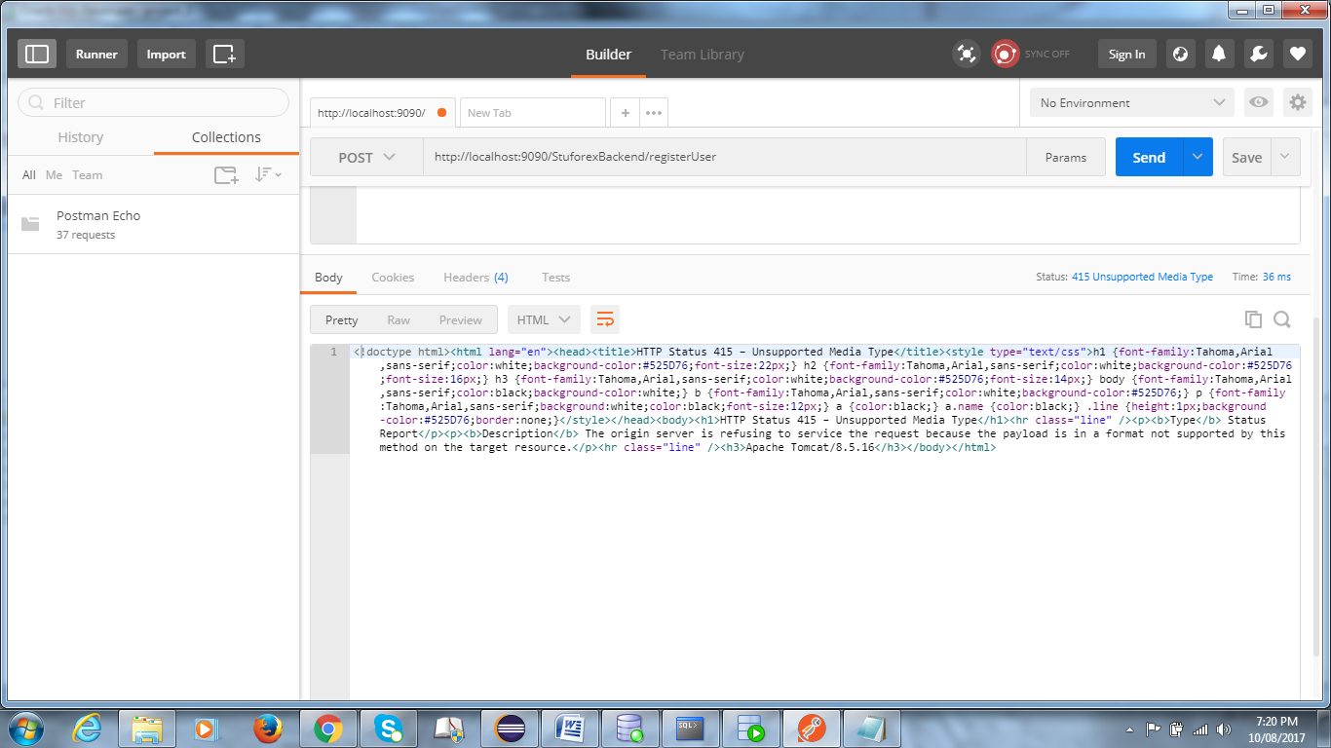

Soln. : change to json/application ( for get method - raw - json)

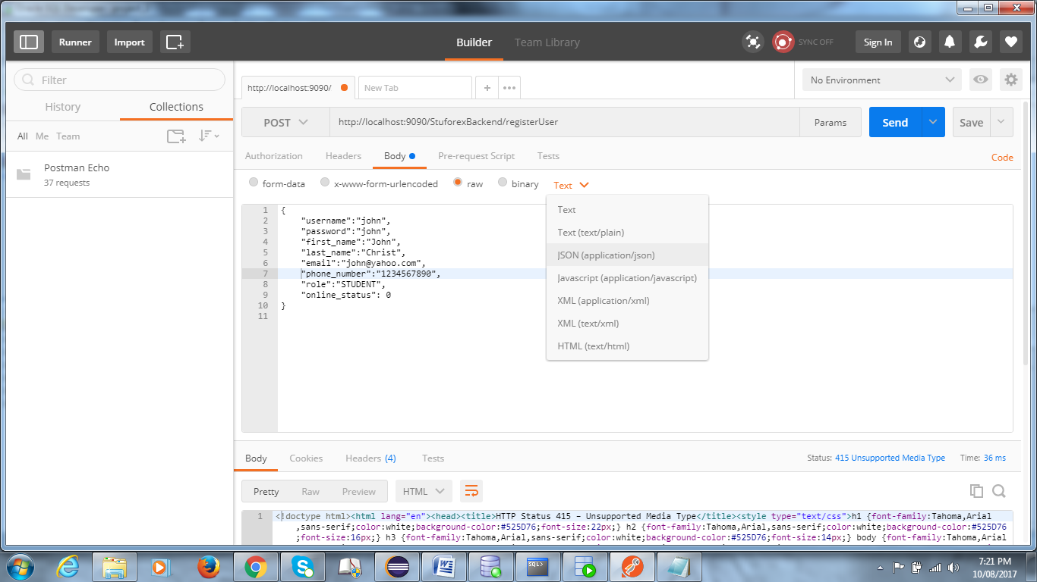

==========================================================================================================================================================================

11TH AUG :

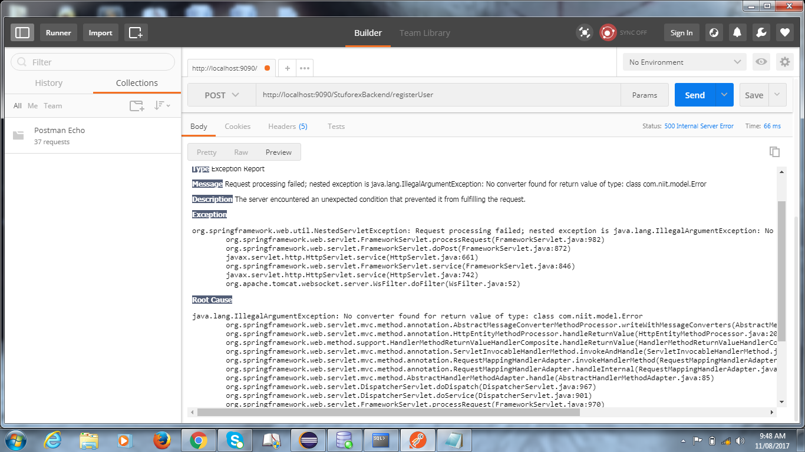

Soln. : generate getter-setter methods in error.java class

*****************

==========================================================================================================================================================================

Error :  Optional int parameter 'id' is present but cannot be translated into a null value due to being declared as a primitive type. Consider declaring it as object wrapper for the corresponding primitive type. (getPersonById)

Soln. : Add @PathVariable in method

==========================================================================================================================================================================

Positional parameter error :

In userDaoImpl.java : User login() ->

Query query = session.createQuery("from User where username = ? and password = ?");

query.setString(0 , user.getUsername());

query.setString(0 , user.getPassword()) ; // it should be query.setString(1 , user.getPassword())

==========================================================================================================================================================================

BadRequest Error ( error 400 ) :

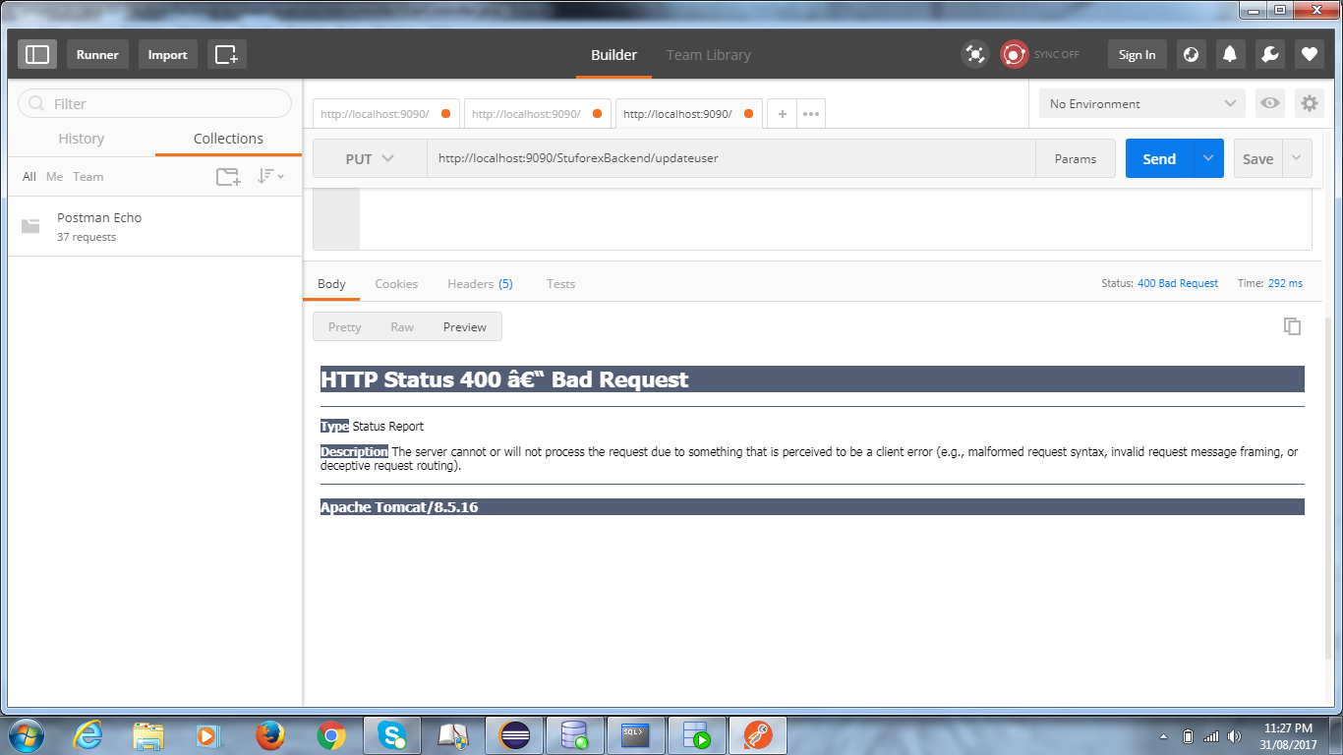

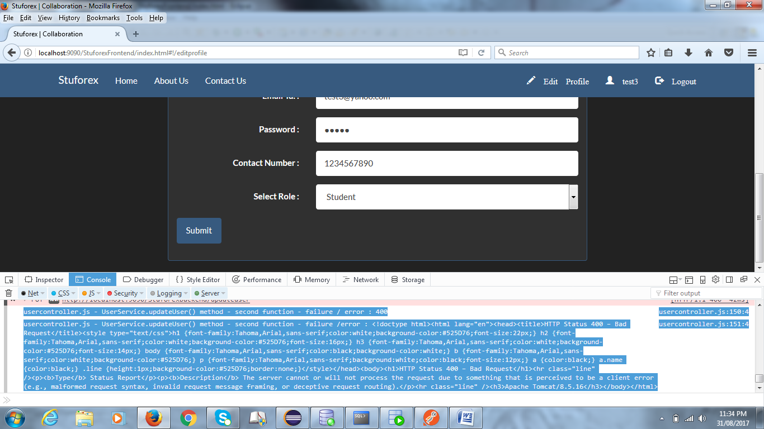

WebConsole Error :

usercontroller.js - UserService.updateUser() method - second function - failure / error : 400 usercontroller.js:150:4

usercontroller.js - UserService.updateUser() method - second function - failure /error : <!doctype html><html lang="en"><head><title>HTTP Status 400 – Bad Request</title><style type="text/css">h1 {font-family:Tahoma,Arial,sans-serif;color:white;background-color:#525D76;font-size:22px;} h2 {font-family:Tahoma,Arial,sans-serif;color:white;background-color:#525D76;font-size:16px;} h3 {font-family:Tahoma,Arial,sans-serif;color:white;background-color:#525D76;font-size:14px;} body {font-family:Tahoma,Arial,sans-serif;color:black;background-color:white;} b {font-family:Tahoma,Arial,sans-serif;color:white;background-color:#525D76;} p {font-family:Tahoma,Arial,sans-serif;background:white;color:black;font-size:12px;} a {color:black;} a.name {color:black;} .line {height:1px;background-color:#525D76;border:none;}</style></head><body><h1>HTTP Status 400 – Bad Request</h1><hr class="line" /><p><b>Type</b> Status Report</p><p><b>Description</b> The server cannot or will not process the request due to something that is perceived to be a client error (e.g., malformed request syntax, invalid request message framing, or deceptive request routing).</p><hr class="line" /><h3>Apache Tomcat/8.5.16</h3></body></html> usercontroller.js:151:4

Soln : check userservice.js - if object is passed or not .

==========================================================================================================================================================================

TypeError : Unable to get .then() property in usercontroller.js (UserService.registerUser($scope).then(....))

usercontroller.js :

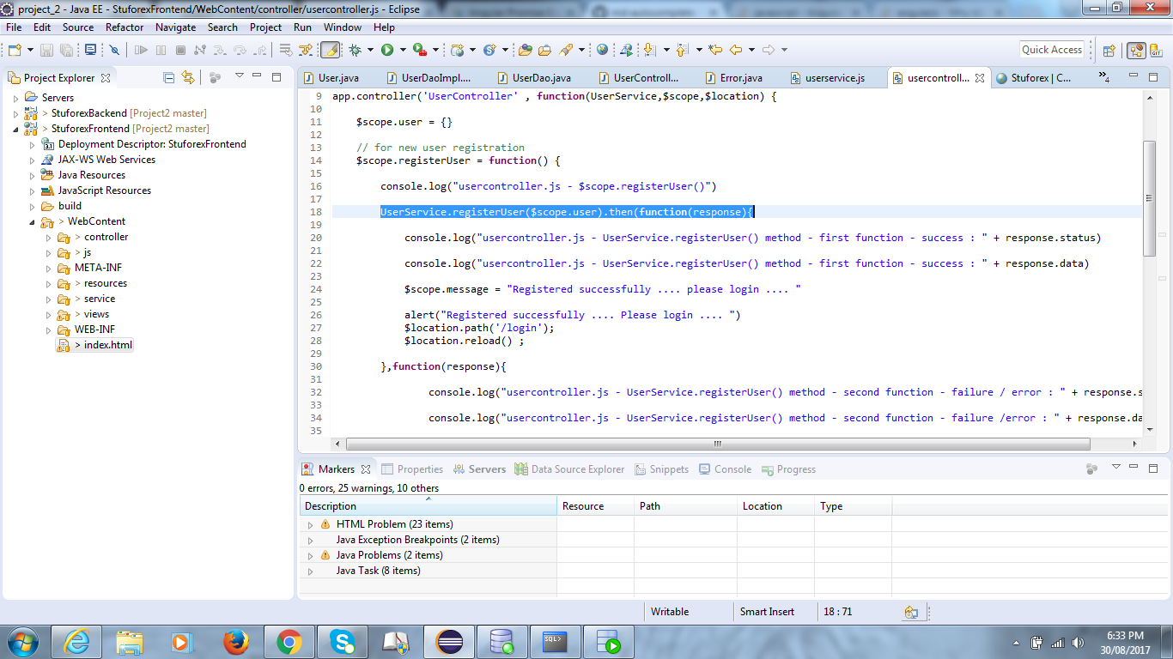

webconsole :

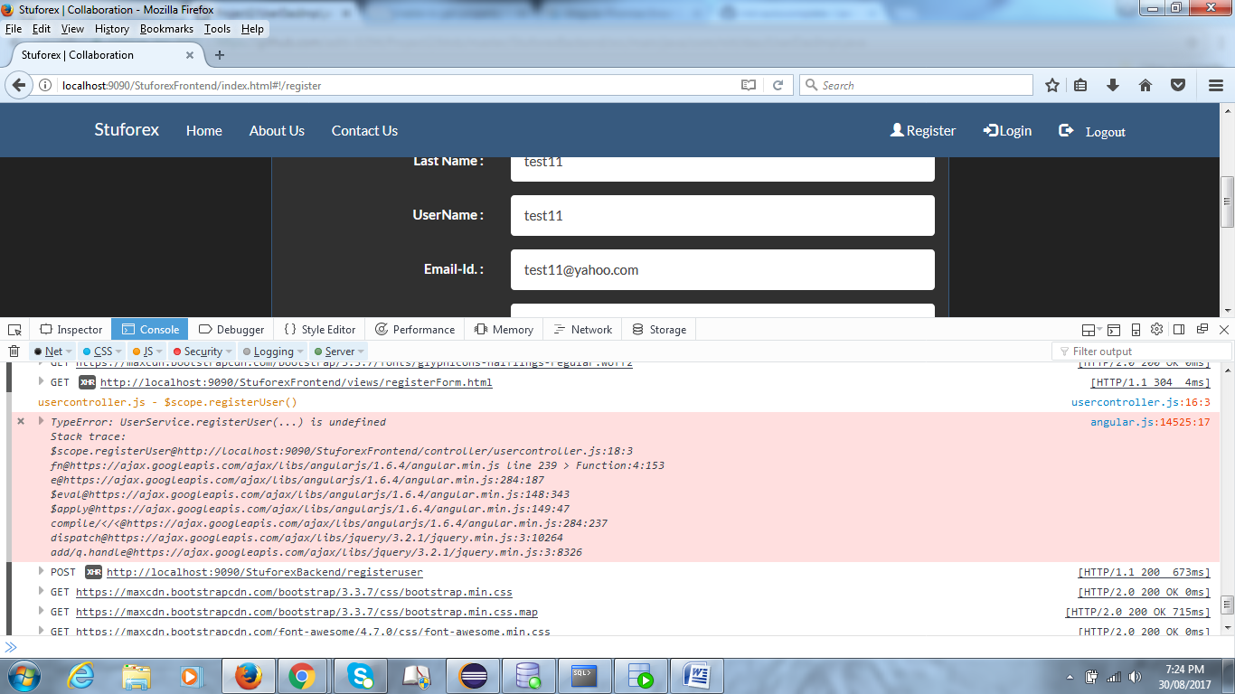

http://localhost:9090/StuforexFrontend/views/registerForm.html [HTTP/1.1 304 4ms]

usercontroller.js - $scope.registerUser() usercontroller.js:16:3

TypeError: UserService.registerUser(...) is undefined

Stack trace:

$scope.registerUser@http://localhost:9090/StuforexFrontend/controller/usercontroller.js:18:3

fn@https://ajax.googleapis.com/ajax/libs/angularjs/1.6.4/angular.min.js line 239 > Function:4:153

e@https://ajax.googleapis.com/ajax/libs/angularjs/1.6.4/angular.min.js:284:187

$eval@https://ajax.googleapis.com/ajax/libs/angularjs/1.6.4/angular.min.js:148:343

$apply@https://ajax.googleapis.com/ajax/libs/angularjs/1.6.4/angular.min.js:149:47

compile/</<@https://ajax.googleapis.com/ajax/libs/angularjs/1.6.4/angular.min.js:284:237

dispatch@https://ajax.googleapis.com/ajax/libs/jquery/3.2.1/jquery.min.js:3:10264

add/q.handle@https://ajax.googleapis.com/ajax/libs/jquery/3.2.1/jquery.min.js:3:8326

angular.js:14525:17

POST

Soln : add 'return' word before $http in userservice.js

==========================================================================================================================================================================

Error : org.hibernate.MappingException: org.hibernate.dialect.Oracle10gDialect does not support identity key generation

Soln. : Use AUTO value .

==========================================================================================================================================================================

Error : Handler processing failed; nested exception is java.lang.AbstractMethodError: Method org/apache/commons/dbcp/DelegatingPreparedStatement.setCharacterStream(ILjava/io/Reader;J)V is abstract

Message : org.springframework.web.util.NestedServletException: Handler processing failed; nested exception is java.lang.AbstractMethodError: Method org/apache/commons/dbcp/DelegatingPreparedStatement.setCharacterStream(ILjava/io/Reader;J)V is abstract

**Root Cause**

java.lang.AbstractMethodError: Method org/apache/commons/dbcp/DelegatingPreparedStatement.setCharacterStream(ILjava/io/Reader;J)V is abstract

Soln : Cannot use @Lob annotation . Use commons-dbcp2 maven dependency .

DBConfig.java Error : cannot take import org.apache.commons.dbcp.BasicDataSource; for BasicDataSource : for commons-dpcp dependency 1.4 version

======================================================================================================================================no need to put id and date

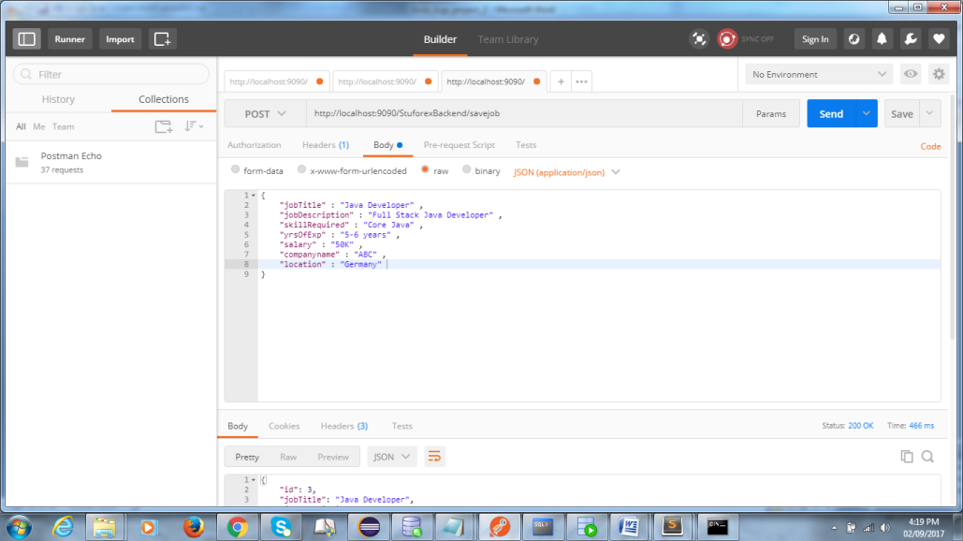

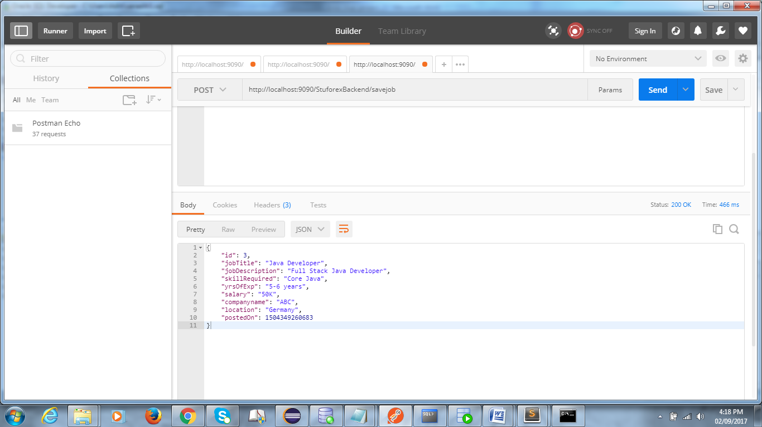

======================================================================================================================================

Error : jobservice.js:5:1

Error: [$injector:unpr] Unknown provider: $scopeProvider <- $scope

http://errors.angularjs.org/1.6.4/$injector/unpr?p0=%24scopeProvider%20%3C-%20%24scope

Soln. : Clear cookies or restart system

======================================================================================================================================

BlogPost_Detail : postman check -

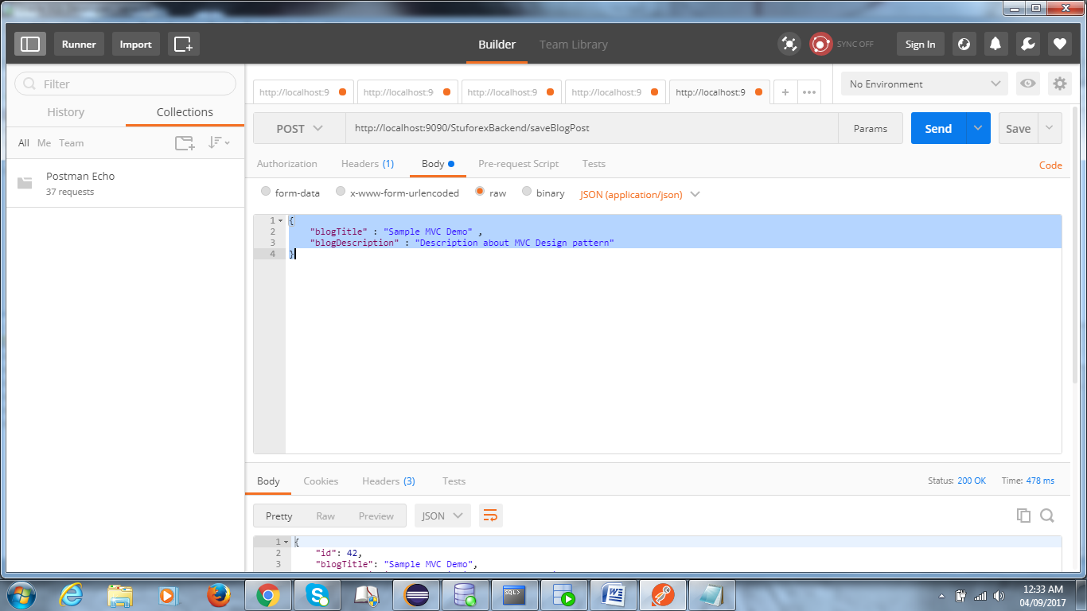

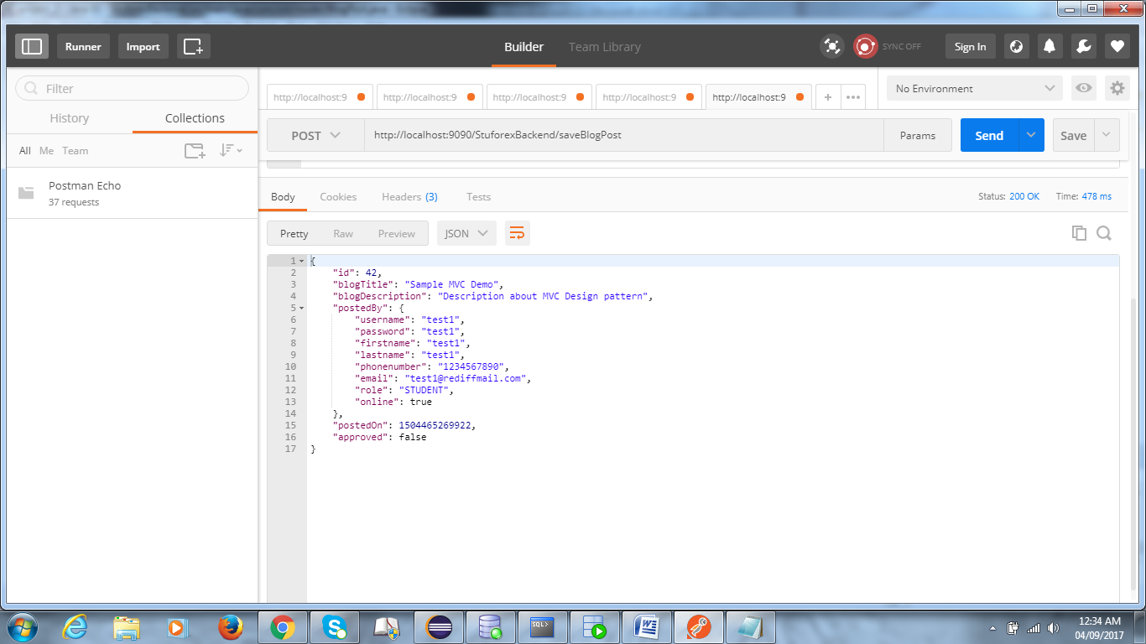

======================================================================================================================================

Error : Error: [$compile:tpload] Failed to load template: views/blogpostForm (HTTP status: 404 )

Soln. : app.js mei .when('/saveBlogPost' , {templateUrl : 'views/____.html'}) == check

======================================================================================================================================

$scope.getBlogPostsWaitingForApproval = response.data

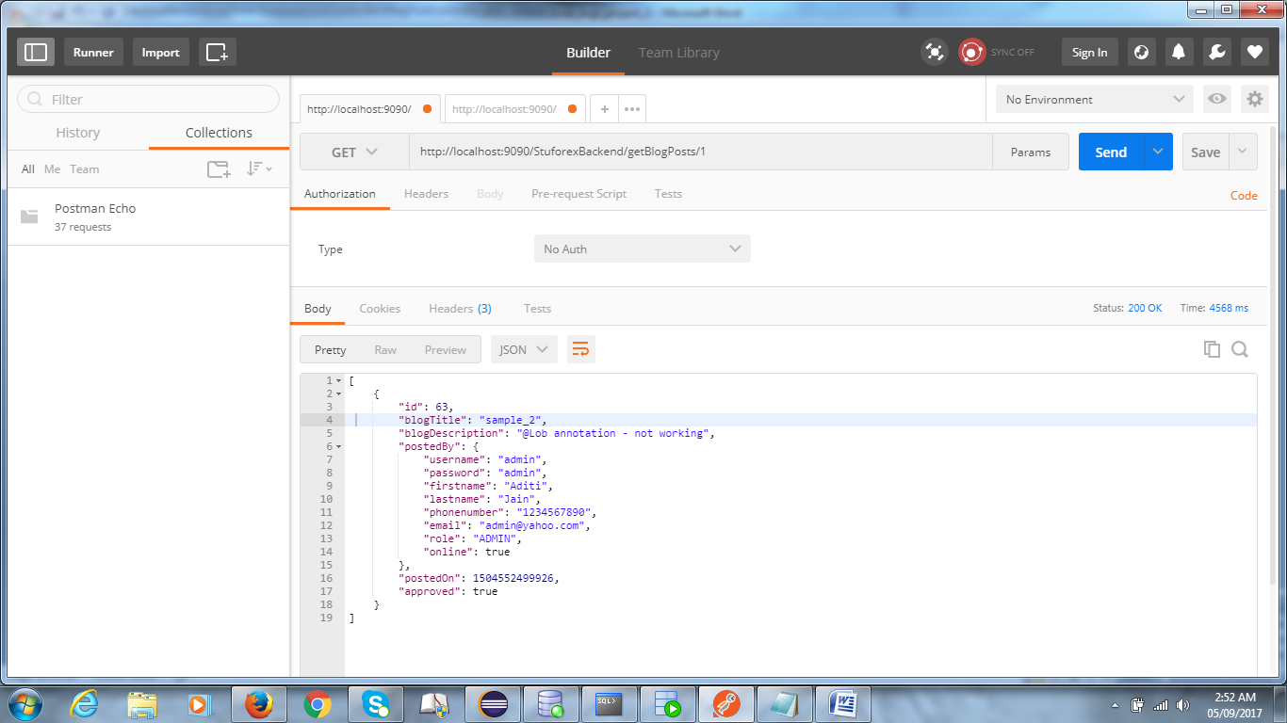

$scope.getApprovedListofBlogPosts = response.data

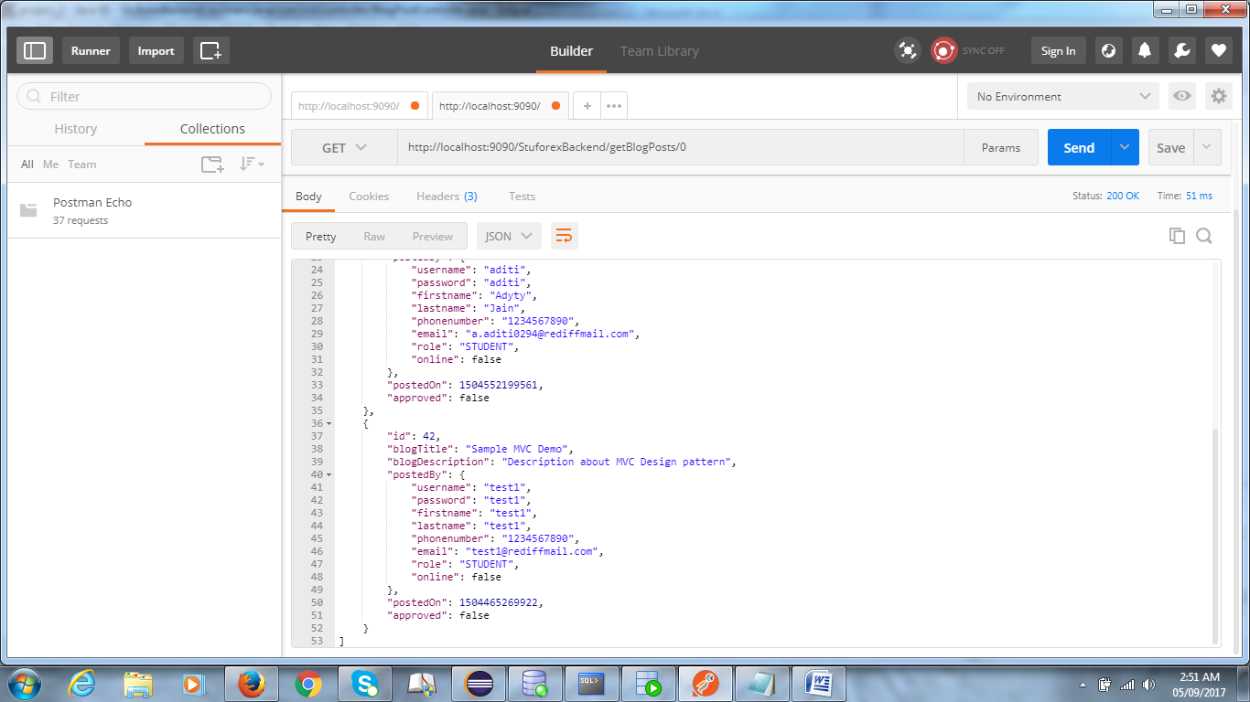

======================================================================================================================================

BlogComment - addBlogComment :

// no need to pass id :

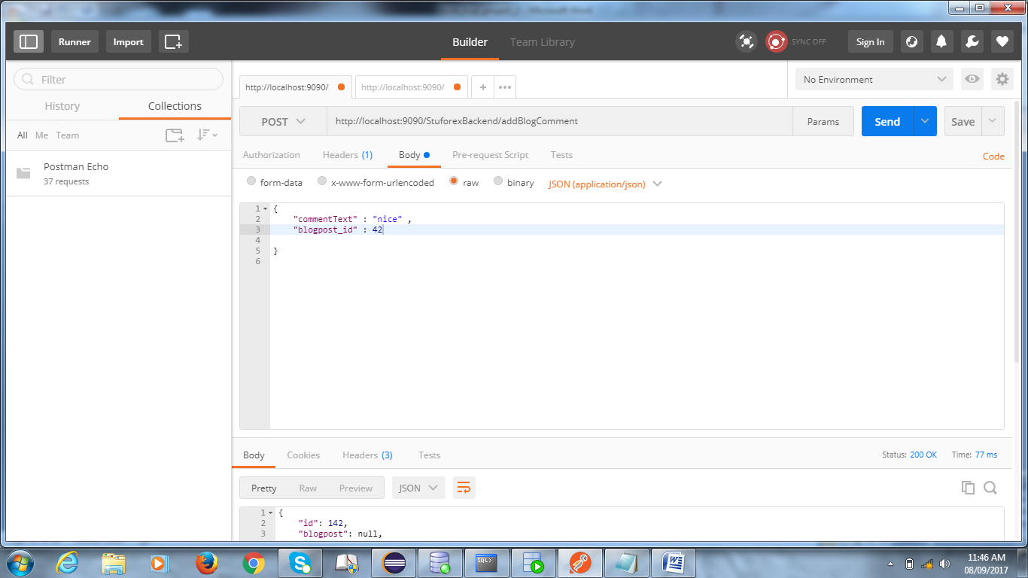

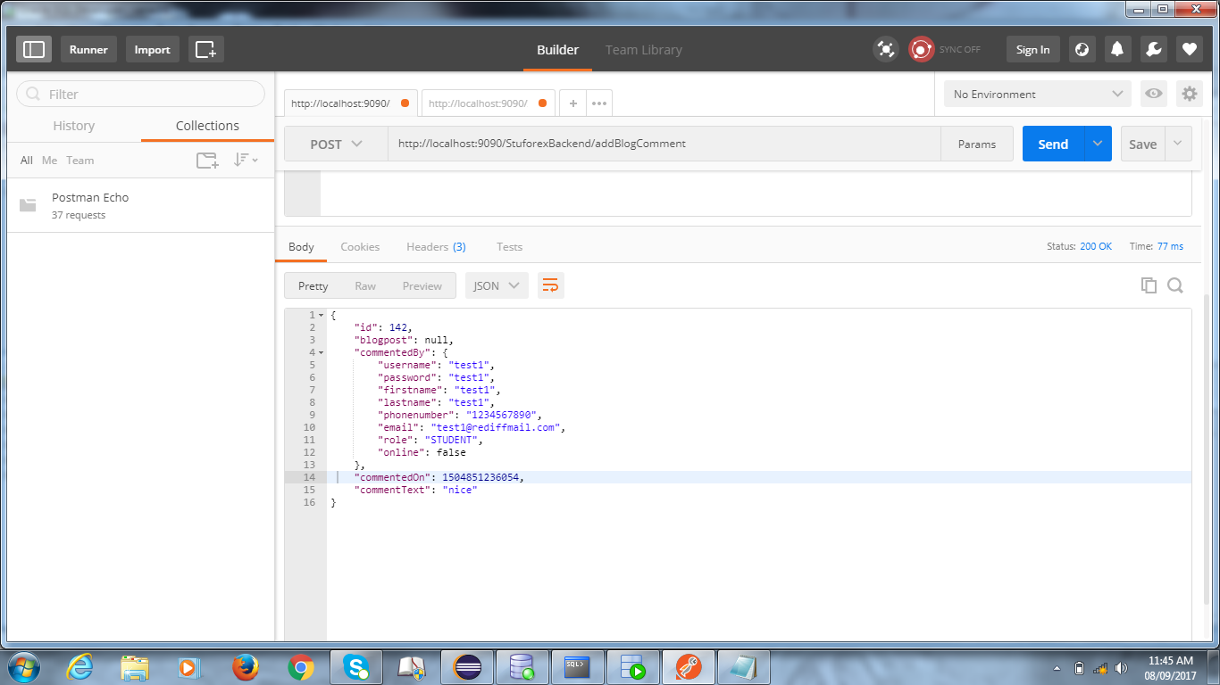

Get All Blog Comments :

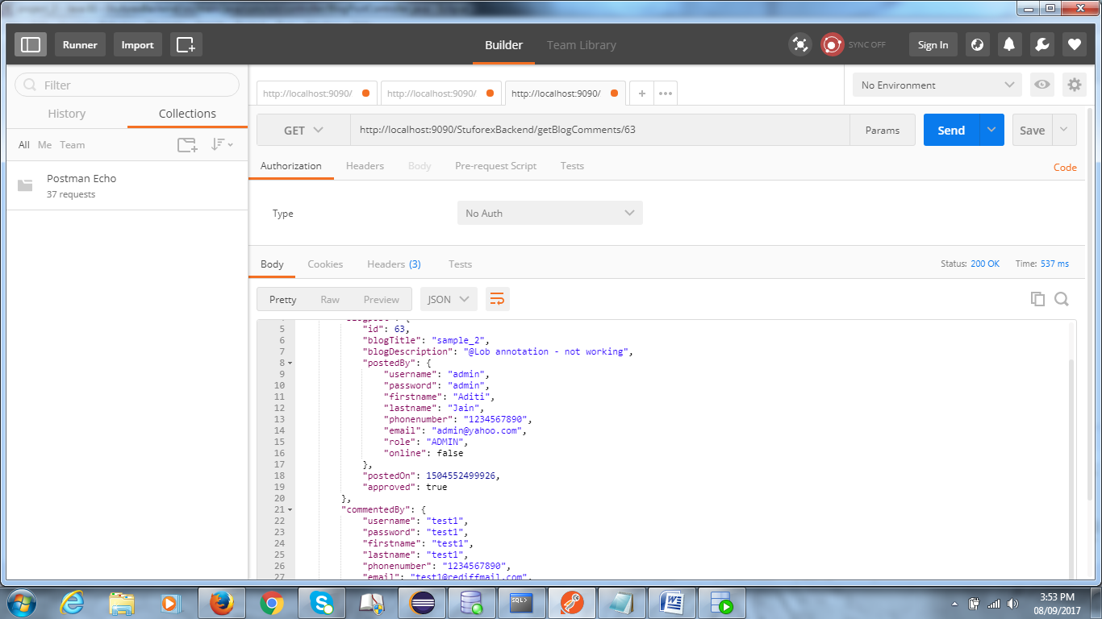

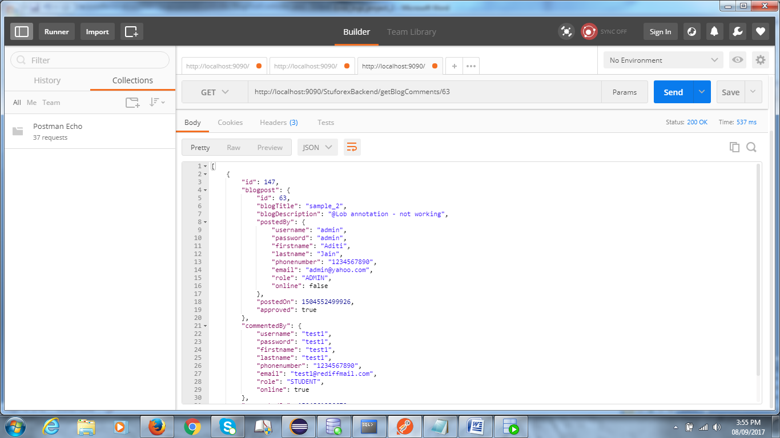

======================================================================================================================================

On running updateprofile.html - 404 error :

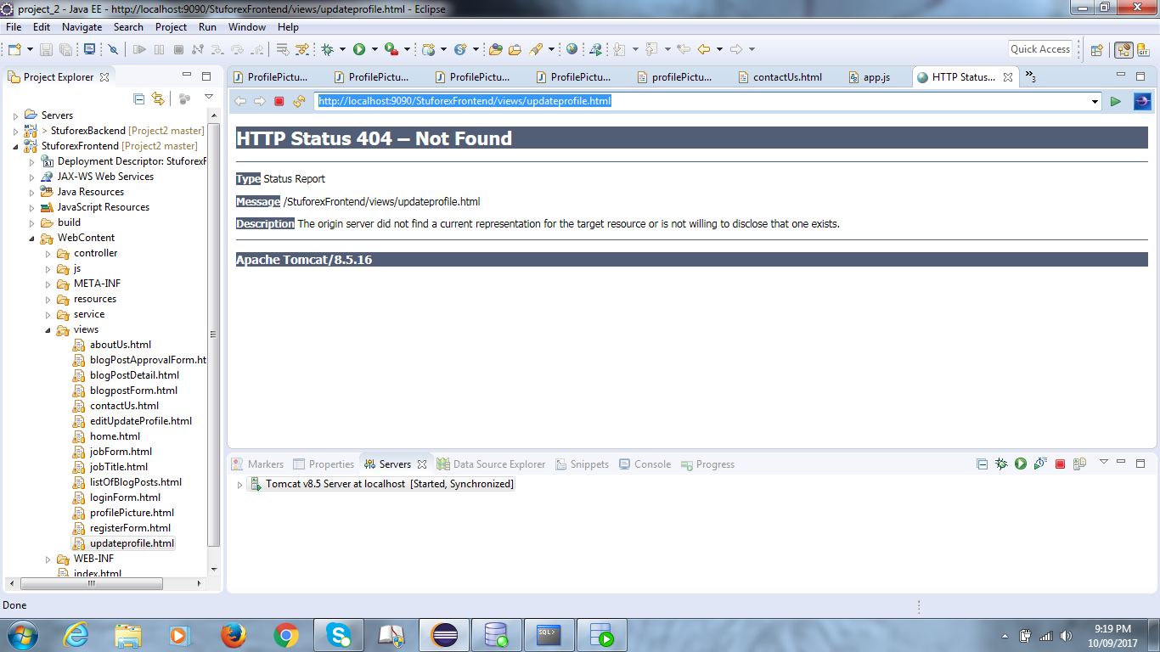

Soln. : Create new html page and copy-paste contents .

change only templateUrl in app.js .....

======================================================================================================================================

Error : could not extract resultset

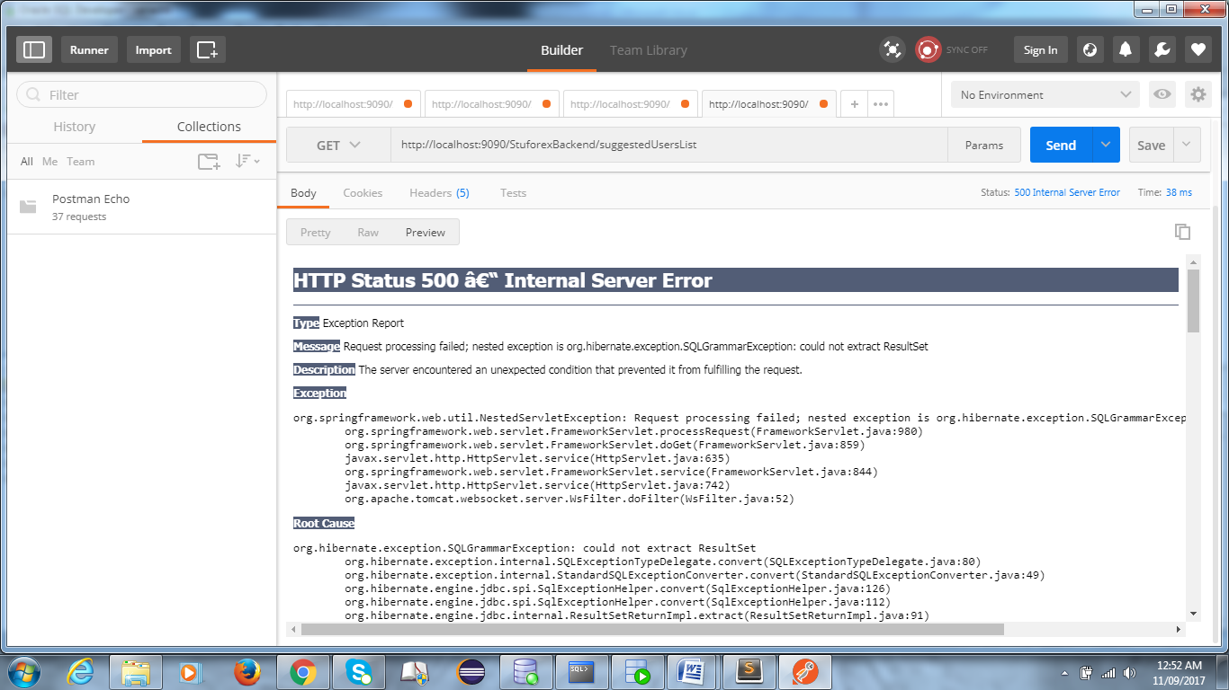

**HTTP Status 500 â€“ Internal Server Error**

**Type** Exception Report

**Message** Request processing failed; nested exception is org.hibernate.exception.SQLGrammarException: could not extract ResultSet

**Description** The server encountered an unexpected condition that prevented it from fulfilling the request.

**Exception**

org.springframework.web.util.NestedServletException: Request processing failed; nested exception is org.hibernate.exception.SQLGrammarException: could not extract ResultSet

org.springframework.web.servlet.FrameworkServlet.processRequest(FrameworkServlet.java:980)

org.springframework.web.servlet.FrameworkServlet.doGet(FrameworkServlet.java:859)

javax.servlet.http.HttpServlet.service(HttpServlet.java:635)

org.springframework.web.servlet.FrameworkServlet.service(FrameworkServlet.java:844)

javax.servlet.http.HttpServlet.service(HttpServlet.java:742)

org.apache.tomcat.websocket.server.WsFilter.doFilter(WsFilter.java:52)

**Root Cause**

org.hibernate.exception.SQLGrammarException: could not extract ResultSet

org.hibernate.exception.internal.SQLExceptionTypeDelegate.convert(SQLExceptionTypeDelegate.java:80)

org.hibernate.exception.internal.StandardSQLExceptionConverter.convert(StandardSQLExceptionConverter.java:49)

org.hibernate.engine.jdbc.spi.SqlExceptionHelper.convert(SqlExceptionHelper.java:126)

org.hibernate.engine.jdbc.spi.SqlExceptionHelper.convert(SqlExceptionHelper.java:112)

org.hibernate.engine.jdbc.internal.ResultSetReturnImpl.extract(ResultSetReturnImpl.java:91)

org.hibernate.loader.Loader.getResultSet(Loader.java:2066)

org.hibernate.loader.Loader.executeQueryStatement(Loader.java:1863)

org.hibernate.loader.Loader.executeQueryStatement(Loader.java:1839)

org.hibernate.loader.Loader.doQuery(Loader.java:910)

org.hibernate.loader.Loader.doQueryAndInitializeNonLazyCollections(Loader.java:355)

org.hibernate.loader.Loader.doList(Loader.java:2554)

org.hibernate.loader.Loader.doList(Loader.java:2540)

org.hibernate.loader.Loader.listIgnoreQueryCache(Loader.java:2370)

org.hibernate.loader.Loader.list(Loader.java:2365)

org.hibernate.loader.custom.CustomLoader.list(CustomLoader.java:353)

org.hibernate.internal.SessionImpl.listCustomQuery(SessionImpl.java:1909)

org.hibernate.internal.AbstractSessionImpl.list(AbstractSessionImpl.java:311)

org.hibernate.internal.SQLQueryImpl.list(SQLQueryImpl.java:141)

com.niit.dao.FriendDaoImpl.getListOfSuggestedUsers(FriendDaoImpl.java:54)

sun.reflect.NativeMethodAccessorImpl.invoke0(Native Method)

sun.reflect.NativeMethodAccessorImpl.invoke(NativeMethodAccessorImpl.java:62)

sun.reflect.DelegatingMethodAccessorImpl.invoke(DelegatingMethodAccessorImpl.java:43)

java.lang.reflect.Method.invoke(Method.java:498)

org.springframework.aop.support.AopUtils.invokeJoinpointUsingReflection(AopUtils.java:302)

org.springframework.aop.framework.ReflectiveMethodInvocation.invokeJoinpoint(ReflectiveMethodInvocation.java:190)

org.springframework.aop.framework.ReflectiveMethodInvocation.proceed(ReflectiveMethodInvocation.java:157)

org.springframework.transaction.interceptor.TransactionInterceptor$1.proceedWithInvocation(TransactionInterceptor.java:99)

org.springframework.transaction.interceptor.TransactionAspectSupport.invokeWithinTransaction(TransactionAspectSupport.java:281)

org.springframework.transaction.interceptor.TransactionInterceptor.invoke(TransactionInterceptor.java:96)

org.springframework.aop.framework.ReflectiveMethodInvocation.proceed(ReflectiveMethodInvocation.java:179)

org.springframework.aop.framework.JdkDynamicAopProxy.invoke(JdkDynamicAopProxy.java:208)

com.sun.proxy.$Proxy40.getListOfSuggestedUsers(Unknown Source)

com.niit.controller.FriendController.getListOfSuggestedUsers(FriendController.java:43)

sun.reflect.NativeMethodAccessorImpl.invoke0(Native Method)

sun.reflect.NativeMethodAccessorImpl.invoke(NativeMethodAccessorImpl.java:62)

sun.reflect.DelegatingMethodAccessorImpl.invoke(DelegatingMethodAccessorImpl.java:43)

java.lang.reflect.Method.invoke(Method.java:498)

org.springframework.web.method.support.InvocableHandlerMethod.doInvoke(InvocableHandlerMethod.java:221)

org.springframework.web.method.support.InvocableHandlerMethod.invokeForRequest(InvocableHandlerMethod.java:136)

org.springframework.web.servlet.mvc.method.annotation.ServletInvocableHandlerMethod.invokeAndHandle(ServletInvocableHandlerMethod.java:110)

org.springframework.web.servlet.mvc.method.annotation.RequestMappingHandlerAdapter.invokeHandlerMethod(RequestMappingHandlerAdapter.java:817)

org.springframework.web.servlet.mvc.method.annotation.RequestMappingHandlerAdapter.handleInternal(RequestMappingHandlerAdapter.java:731)

org.springframework.web.servlet.mvc.method.AbstractHandlerMethodAdapter.handle(AbstractHandlerMethodAdapter.java:85)

org.springframework.web.servlet.DispatcherServlet.doDispatch(DispatcherServlet.java:959)

org.springframework.web.servlet.DispatcherServlet.doService(DispatcherServlet.java:893)

org.springframework.web.servlet.FrameworkServlet.processRequest(FrameworkServlet.java:968)

org.springframework.web.servlet.FrameworkServlet.doGet(FrameworkServlet.java:859)

javax.servlet.http.HttpServlet.service(HttpServlet.java:635)

org.springframework.web.servlet.FrameworkServlet.service(FrameworkServlet.java:844)

javax.servlet.http.HttpServlet.service(HttpServlet.java:742)

org.apache.tomcat.websocket.server.WsFilter.doFilter(WsFilter.java:52)

**Root Cause**

java.sql.SQLSyntaxErrorException: ORA-01789: query block has incorrect number of result columns

oracle.jdbc.driver.T4CTTIoer.processError(T4CTTIoer.java:440)

oracle.jdbc.driver.T4CTTIoer.processError(T4CTTIoer.java:396)

oracle.jdbc.driver.T4C8Oall.processError(T4C8Oall.java:837)

oracle.jdbc.driver.T4CTTIfun.receive(T4CTTIfun.java:445)

oracle.jdbc.driver.T4CTTIfun.doRPC(T4CTTIfun.java:191)

oracle.jdbc.driver.T4C8Oall.doOALL(T4C8Oall.java:523)

oracle.jdbc.driver.T4CPreparedStatement.doOall8(T4CPreparedStatement.java:207)

oracle.jdbc.driver.T4CPreparedStatement.executeForDescribe(T4CPreparedStatement.java:863)

oracle.jdbc.driver.OracleStatement.executeMaybeDescribe(OracleStatement.java:1153)

oracle.jdbc.driver.OracleStatement.doExecuteWithTimeout(OracleStatement.java:1275)

oracle.jdbc.driver.OraclePreparedStatement.executeInternal(OraclePreparedStatement.java:3576)

oracle.jdbc.driver.OraclePreparedStatement.executeQuery(OraclePreparedStatement.java:3620)

oracle.jdbc.driver.OraclePreparedStatementWrapper.executeQuery(OraclePreparedStatementWrapper.java:1491)

org.apache.commons.dbcp2.DelegatingPreparedStatement.executeQuery(DelegatingPreparedStatement.java:83)

org.apache.commons.dbcp2.DelegatingPreparedStatement.executeQuery(DelegatingPreparedStatement.java:83)

org.hibernate.engine.jdbc.internal.ResultSetReturnImpl.extract(ResultSetReturnImpl.java:82)

org.hibernate.loader.Loader.getResultSet(Loader.java:2066)

org.hibernate.loader.Loader.executeQueryStatement(Loader.java:1863)

org.hibernate.loader.Loader.executeQueryStatement(Loader.java:1839)

org.hibernate.loader.Loader.doQuery(Loader.java:910)

org.hibernate.loader.Loader.doQueryAndInitializeNonLazyCollections(Loader.java:355)

org.hibernate.loader.Loader.doList(Loader.java:2554)

org.hibernate.loader.Loader.doList(Loader.java:2540)

org.hibernate.loader.Loader.listIgnoreQueryCache(Loader.java:2370)

org.hibernate.loader.Loader.list(Loader.java:2365)

org.hibernate.loader.custom.CustomLoader.list(CustomLoader.java:353)

org.hibernate.internal.SessionImpl.listCustomQuery(SessionImpl.java:1909)

org.hibernate.internal.AbstractSessionImpl.list(AbstractSessionImpl.java:311)

org.hibernate.internal.SQLQueryImpl.list(SQLQueryImpl.java:141)

com.niit.dao.FriendDaoImpl.getListOfSuggestedUsers(FriendDaoImpl.java:54)

sun.reflect.NativeMethodAccessorImpl.invoke0(Native Method)

sun.reflect.NativeMethodAccessorImpl.invoke(NativeMethodAccessorImpl.java:62)

sun.reflect.DelegatingMethodAccessorImpl.invoke(DelegatingMethodAccessorImpl.java:43)

java.lang.reflect.Method.invoke(Method.java:498)

org.springframework.aop.support.AopUtils.invokeJoinpointUsingReflection(AopUtils.java:302)

org.springframework.aop.framework.ReflectiveMethodInvocation.invokeJoinpoint(ReflectiveMethodInvocation.java:190)

org.springframework.aop.framework.ReflectiveMethodInvocation.proceed(ReflectiveMethodInvocation.java:157)

org.springframework.transaction.interceptor.TransactionInterceptor$1.proceedWithInvocation(TransactionInterceptor.java:99)

org.springframework.transaction.interceptor.TransactionAspectSupport.invokeWithinTransaction(TransactionAspectSupport.java:281)

org.springframework.transaction.interceptor.TransactionInterceptor.invoke(TransactionInterceptor.java:96)

org.springframework.aop.framework.ReflectiveMethodInvocation.proceed(ReflectiveMethodInvocation.java:179)

org.springframework.aop.framework.JdkDynamicAopProxy.invoke(JdkDynamicAopProxy.java:208)

com.sun.proxy.$Proxy40.getListOfSuggestedUsers(Unknown Source)

com.niit.controller.FriendController.getListOfSuggestedUsers(FriendController.java:43)

sun.reflect.NativeMethodAccessorImpl.invoke0(Native Method)

sun.reflect.NativeMethodAccessorImpl.invoke(NativeMethodAccessorImpl.java:62)

sun.reflect.DelegatingMethodAccessorImpl.invoke(DelegatingMethodAccessorImpl.java:43)

java.lang.reflect.Method.invoke(Method.java:498)

org.springframework.web.method.support.InvocableHandlerMethod.doInvoke(InvocableHandlerMethod.java:221)

org.springframework.web.method.support.InvocableHandlerMethod.invokeForRequest(InvocableHandlerMethod.java:136)

org.springframework.web.servlet.mvc.method.annotation.ServletInvocableHandlerMethod.invokeAndHandle(ServletInvocableHandlerMethod.java:110)

org.springframework.web.servlet.mvc.method.annotation.RequestMappingHandlerAdapter.invokeHandlerMethod(RequestMappingHandlerAdapter.java:817)

org.springframework.web.servlet.mvc.method.annotation.RequestMappingHandlerAdapter.handleInternal(RequestMappingHandlerAdapter.java:731)

org.springframework.web.servlet.mvc.method.AbstractHandlerMethodAdapter.handle(AbstractHandlerMethodAdapter.java:85)

org.springframework.web.servlet.DispatcherServlet.doDispatch(DispatcherServlet.java:959)

org.springframework.web.servlet.DispatcherServlet.doService(DispatcherServlet.java:893)

org.springframework.web.servlet.FrameworkServlet.processRequest(FrameworkServlet.java:968)

org.springframework.web.servlet.FrameworkServlet.doGet(FrameworkServlet.java:859)

javax.servlet.http.HttpServlet.service(HttpServlet.java:635)

org.springframework.web.servlet.FrameworkServlet.service(FrameworkServlet.java:844)

javax.servlet.http.HttpServlet.service(HttpServlet.java:742)

org.apache.tomcat.websocket.server.WsFilter.doFilter(WsFilter.java:52)

**Note** The full stack trace of the root cause is available in the server logs.

======================================================================================================================================

If private chat not working : check path :- queue/topic <something similar> in chatcontroller.js

======================================================================================================================================