DBConfig.java :

CategoryDAO object creation -

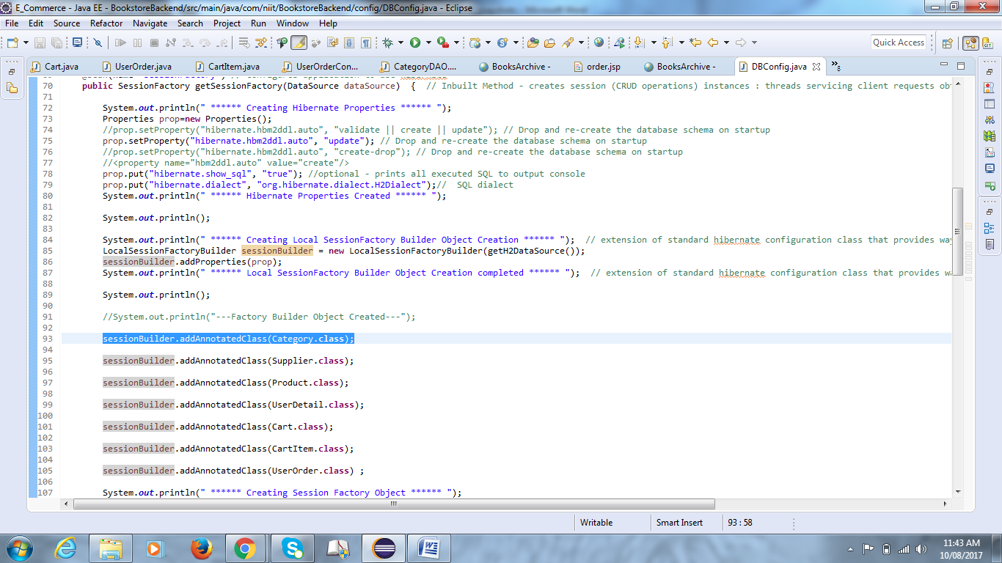

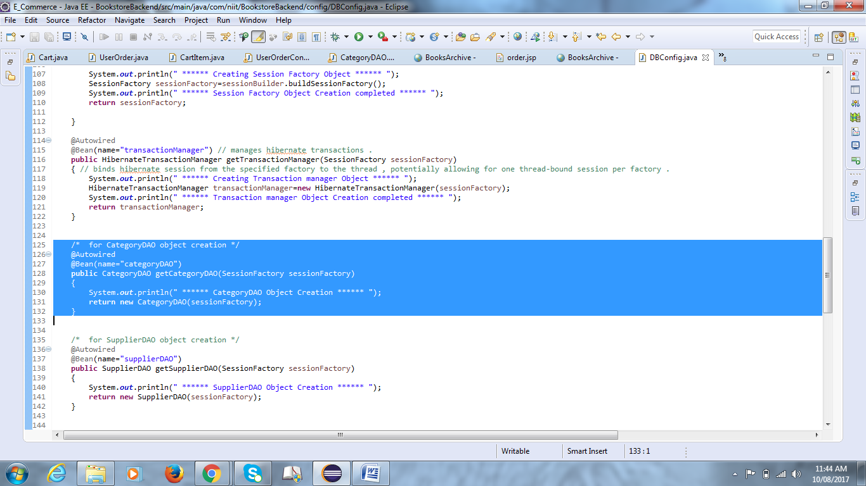

CategoryDAO.java :

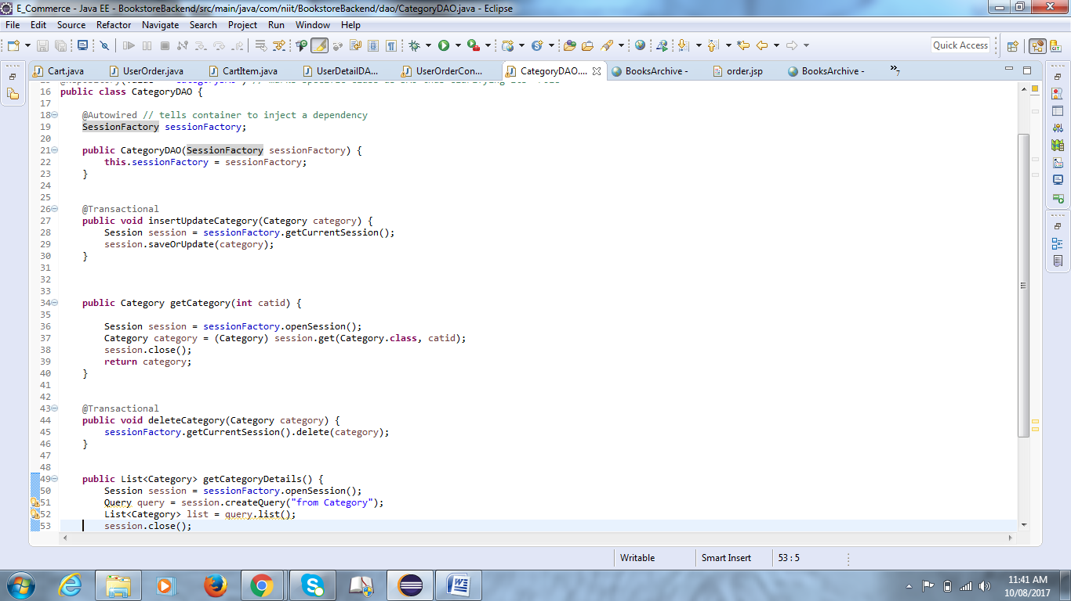

manageCategory.jsp page :

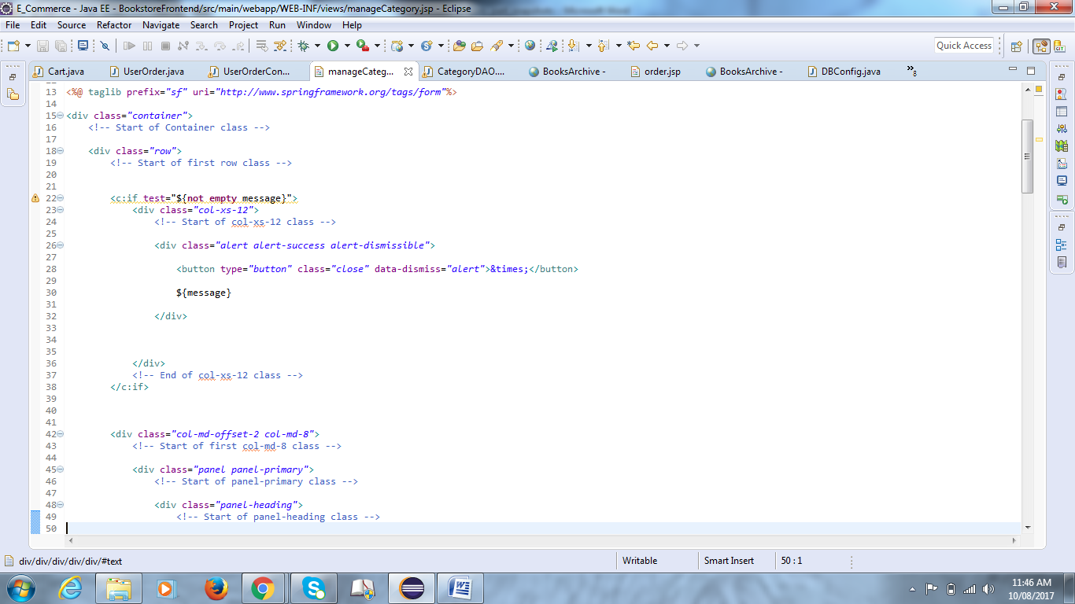

CategoryController.java

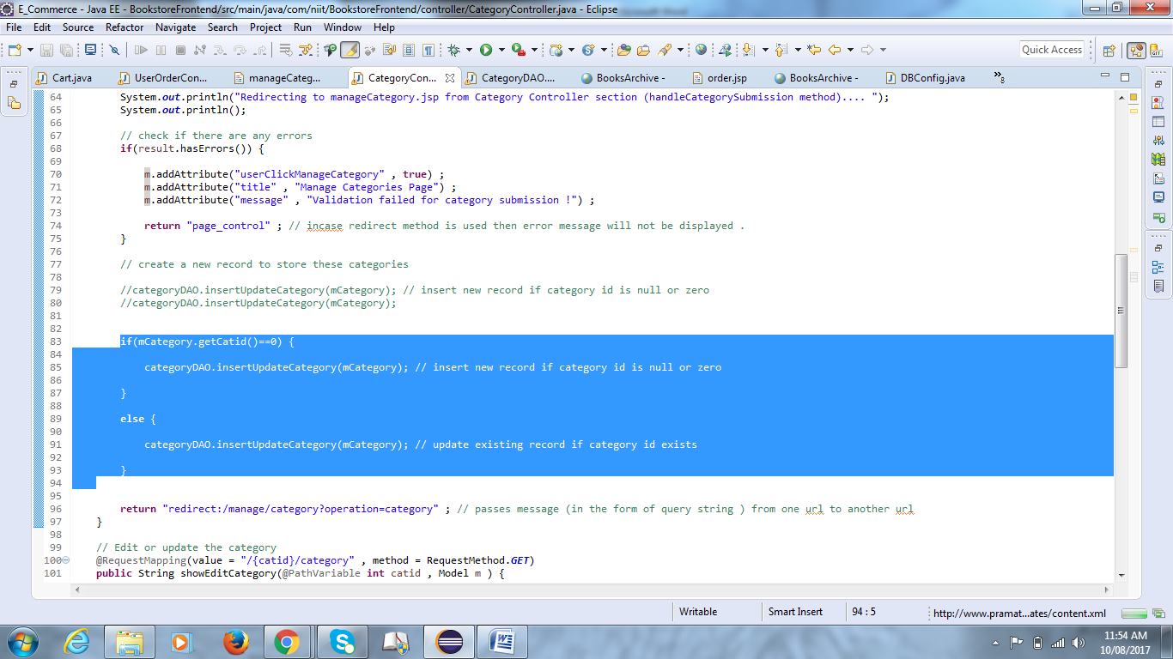

Earlier this code was working but when I tried this week , instead of updating the existing category , a new category is being inserted .

==========================================================================================================================================================================

On running the program : ( console output logs are attached in CRUD_Console_part_CategoryUpdateError.docx file )

Category Part :

Existing Database :

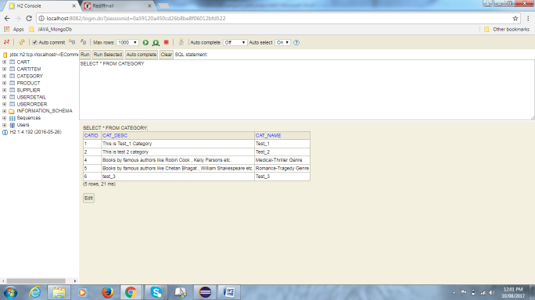

Step - 1 : On clicking manageCategory :

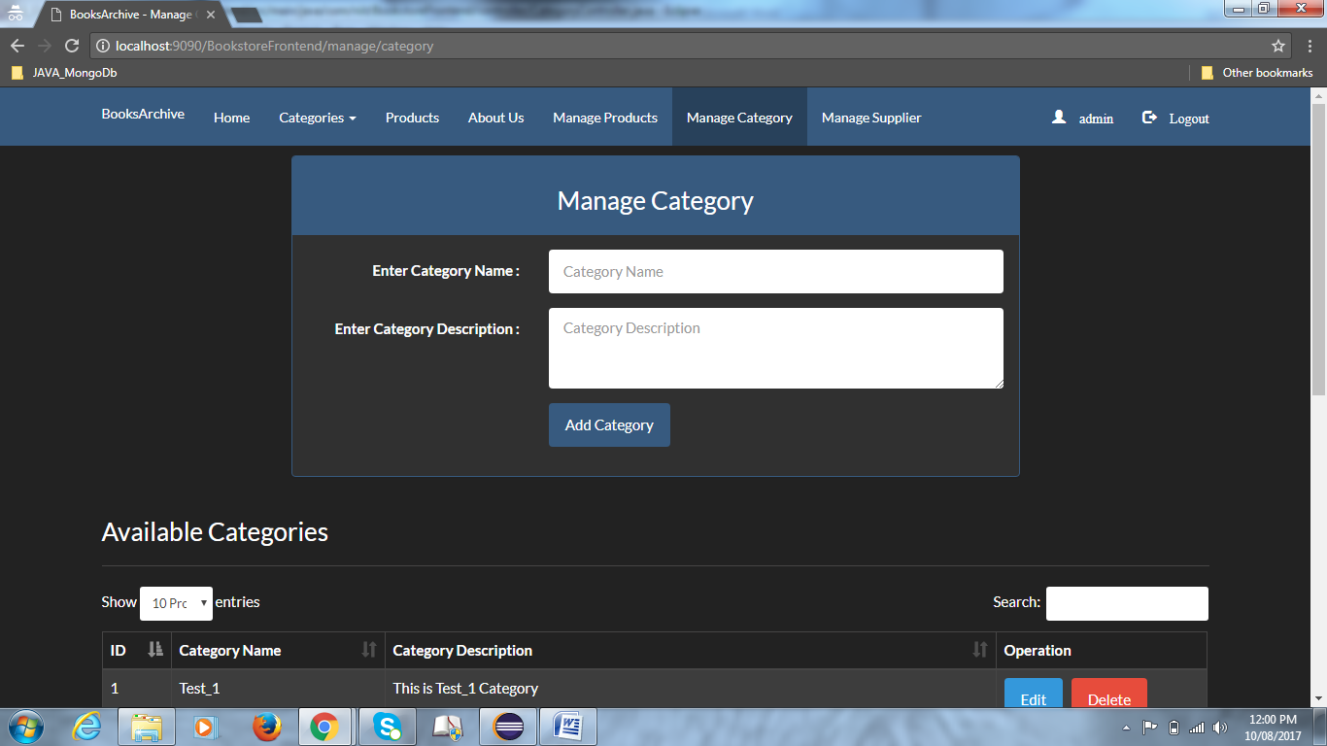

Step - 2 : On clicking Edit button :

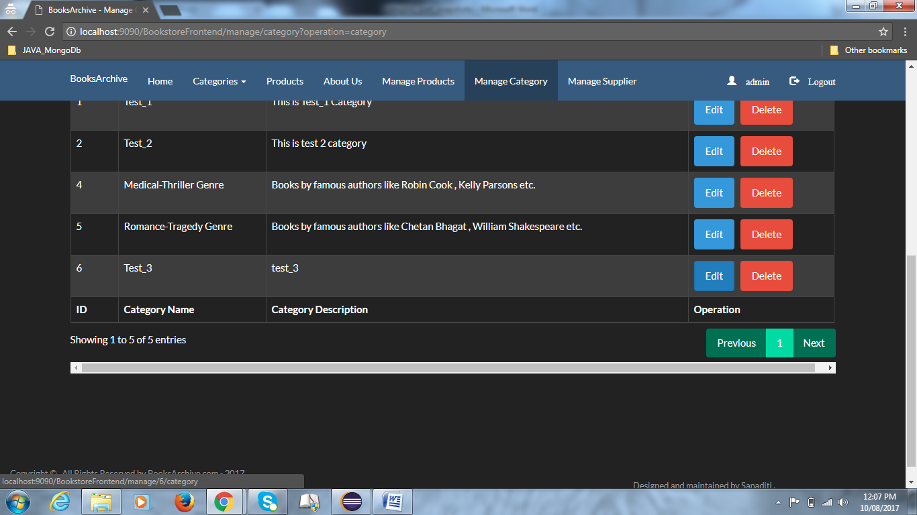

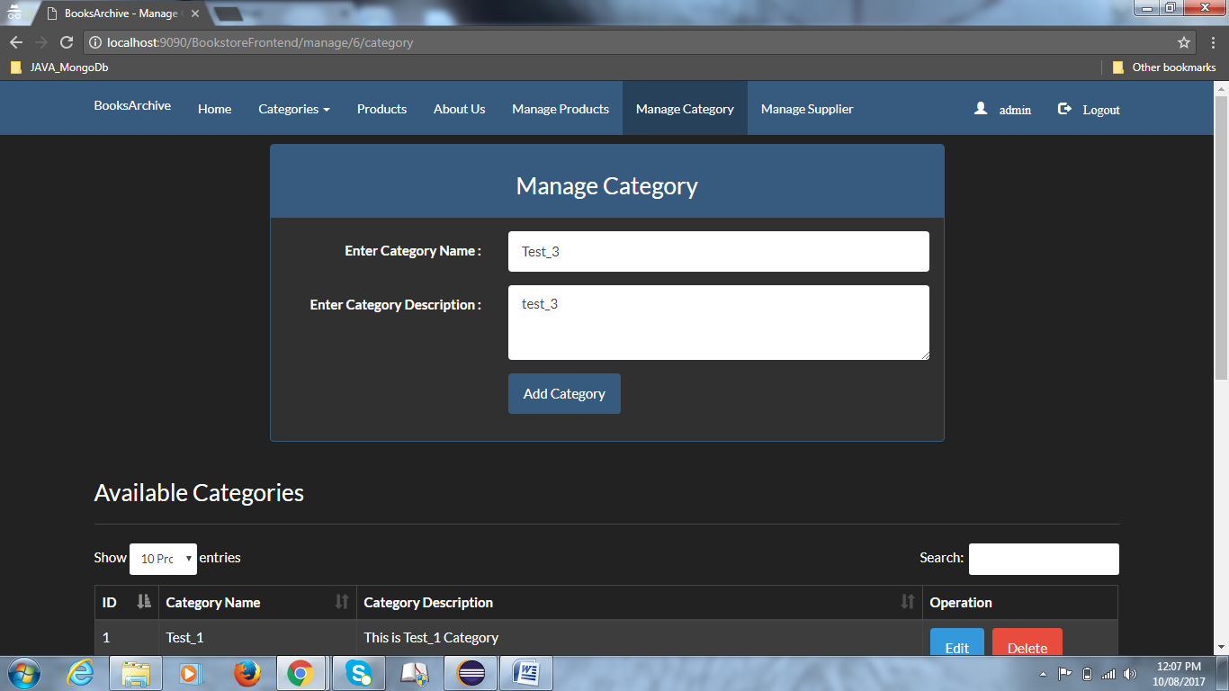

Step - 3 : On editing and clicking Add Category method :

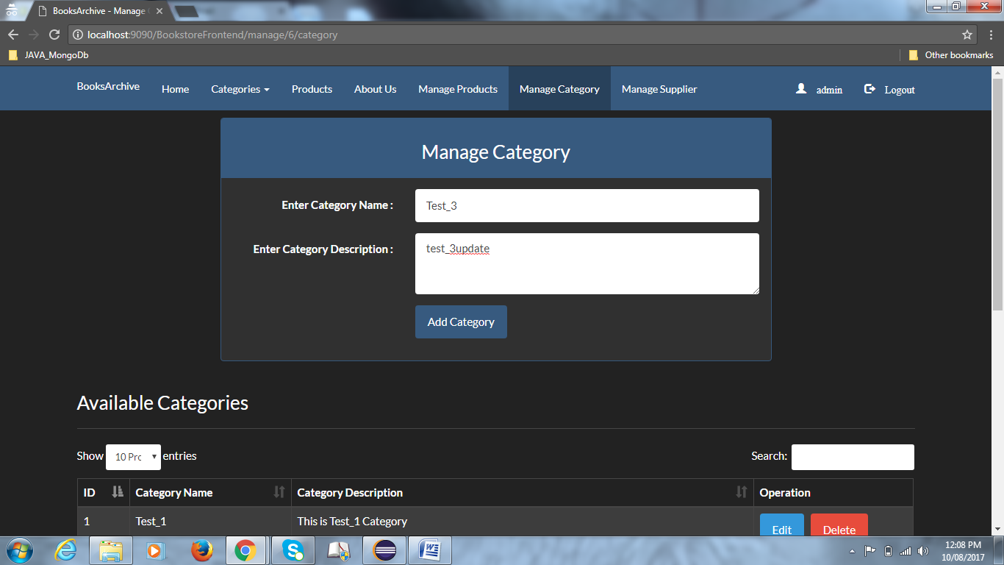

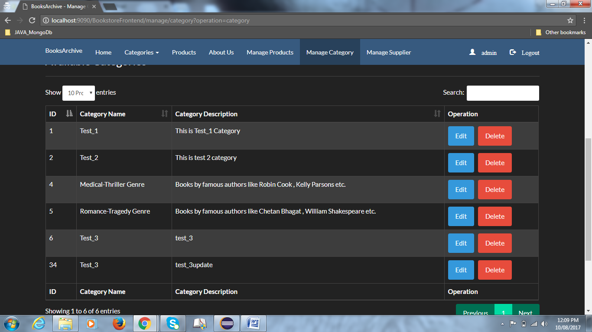

In database : (new category inserted instead of updating that category )

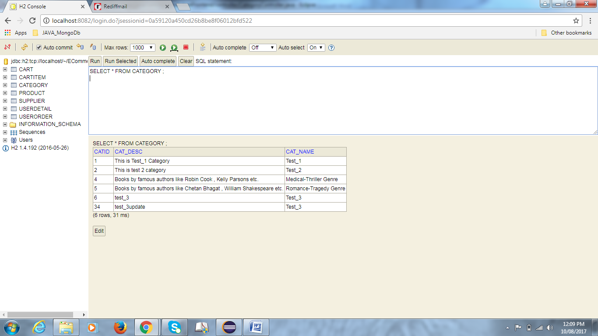

**********

Supplier Part :

Existing Database :

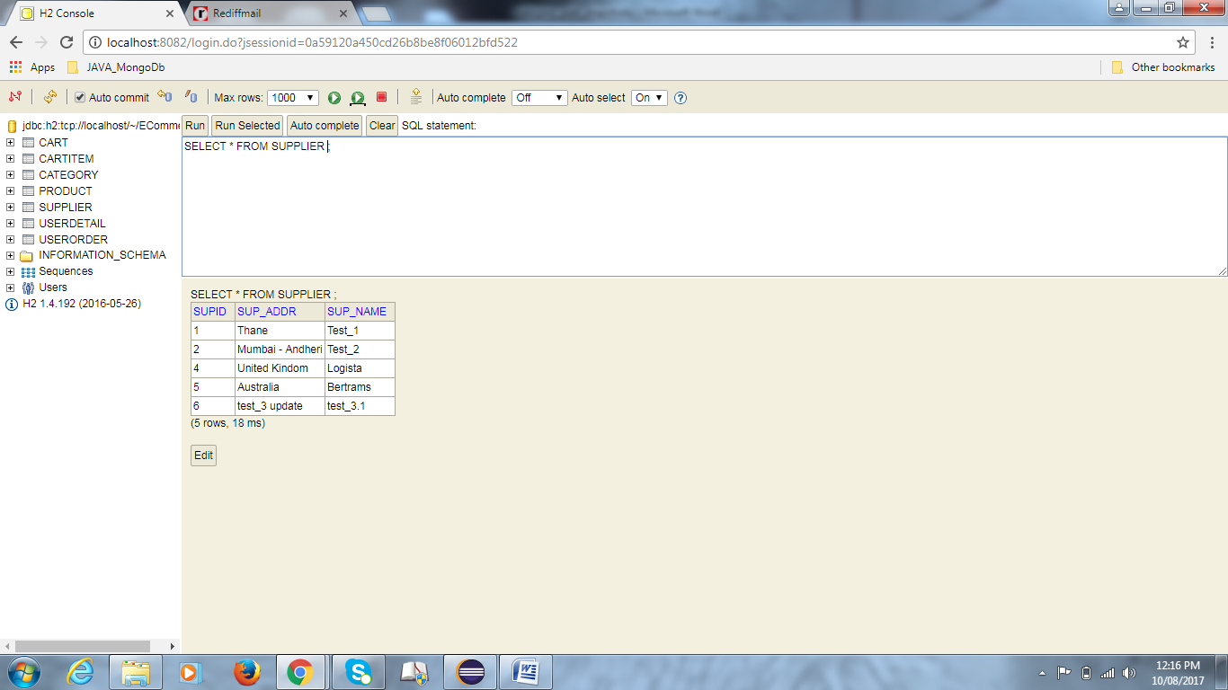

Step - 1 : On clicking manageSupplier:

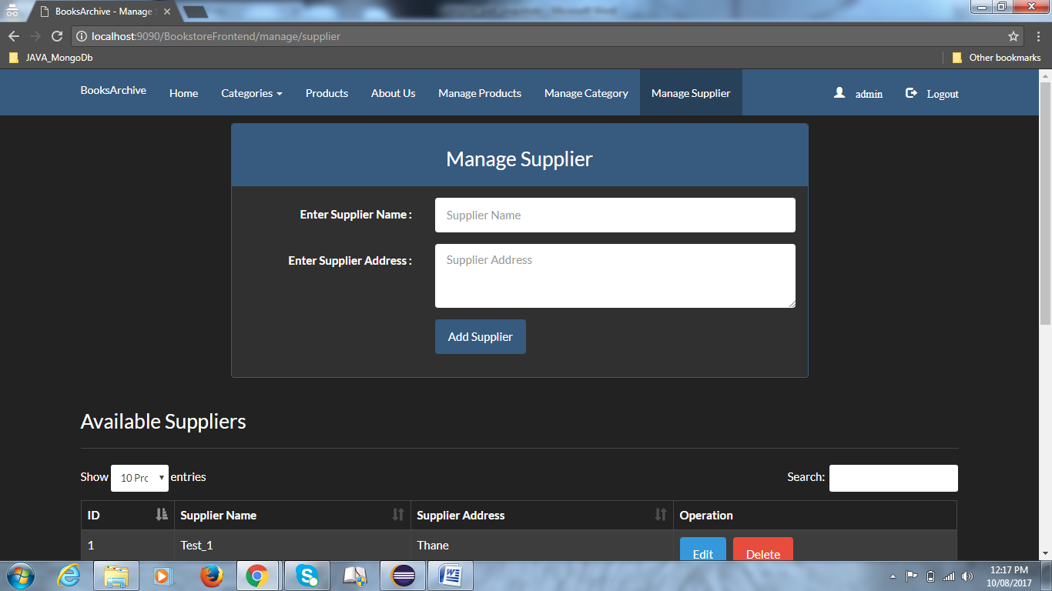

Step - 2 : On clicking Edit button :

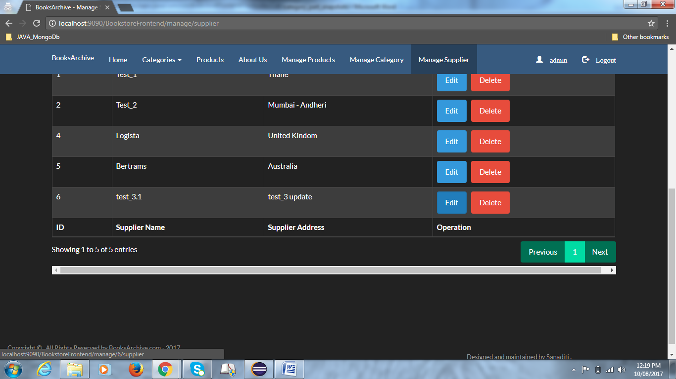

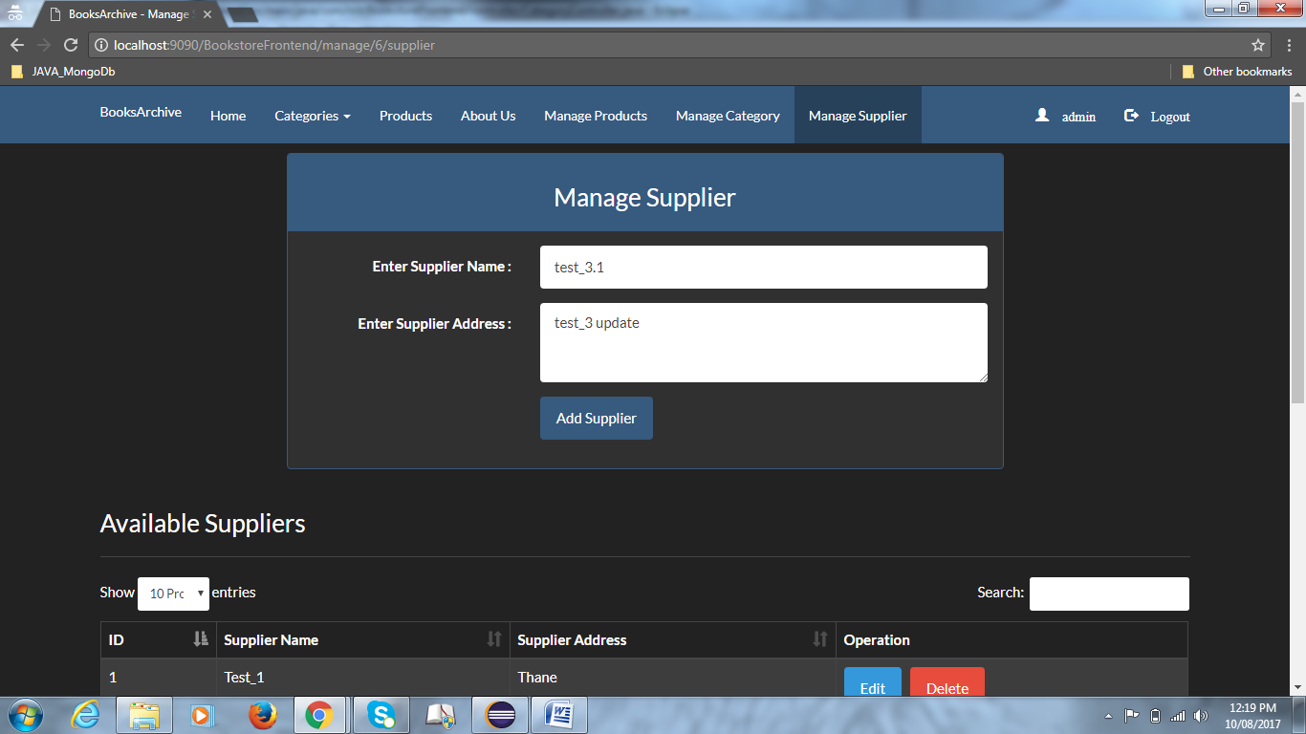

Step - 3 : On editing and clicking Add Supplier method :

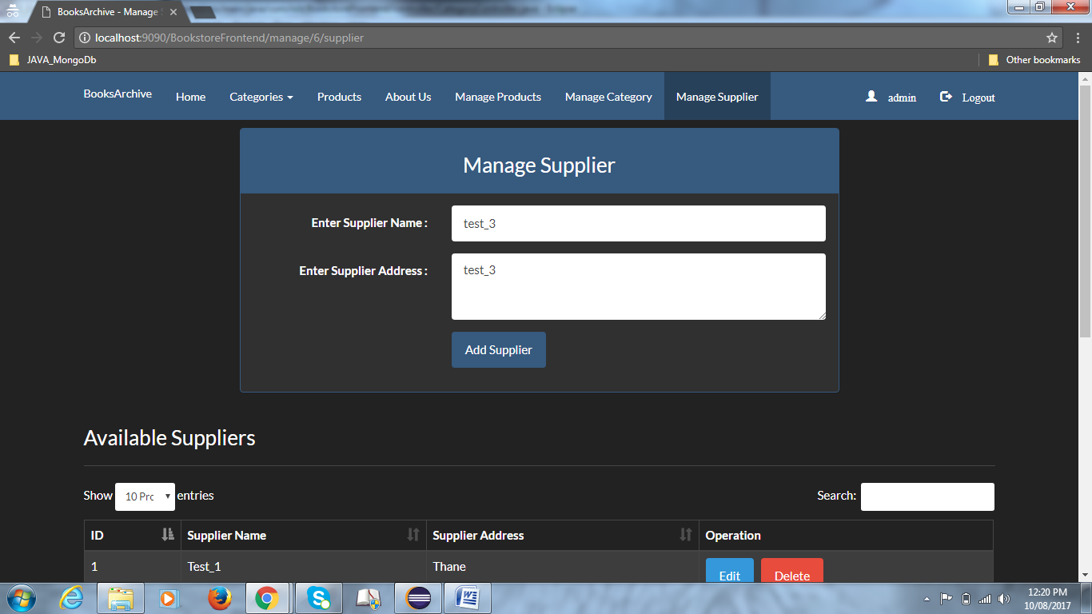

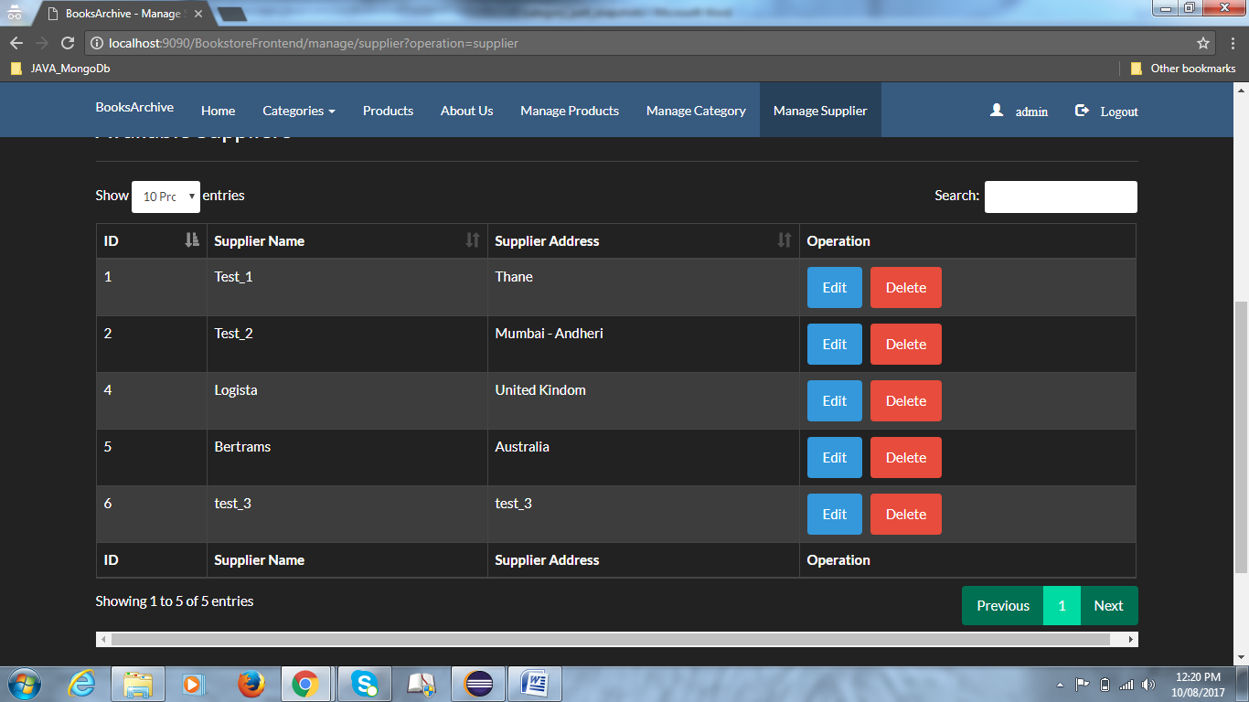

In database : (supplier updated)

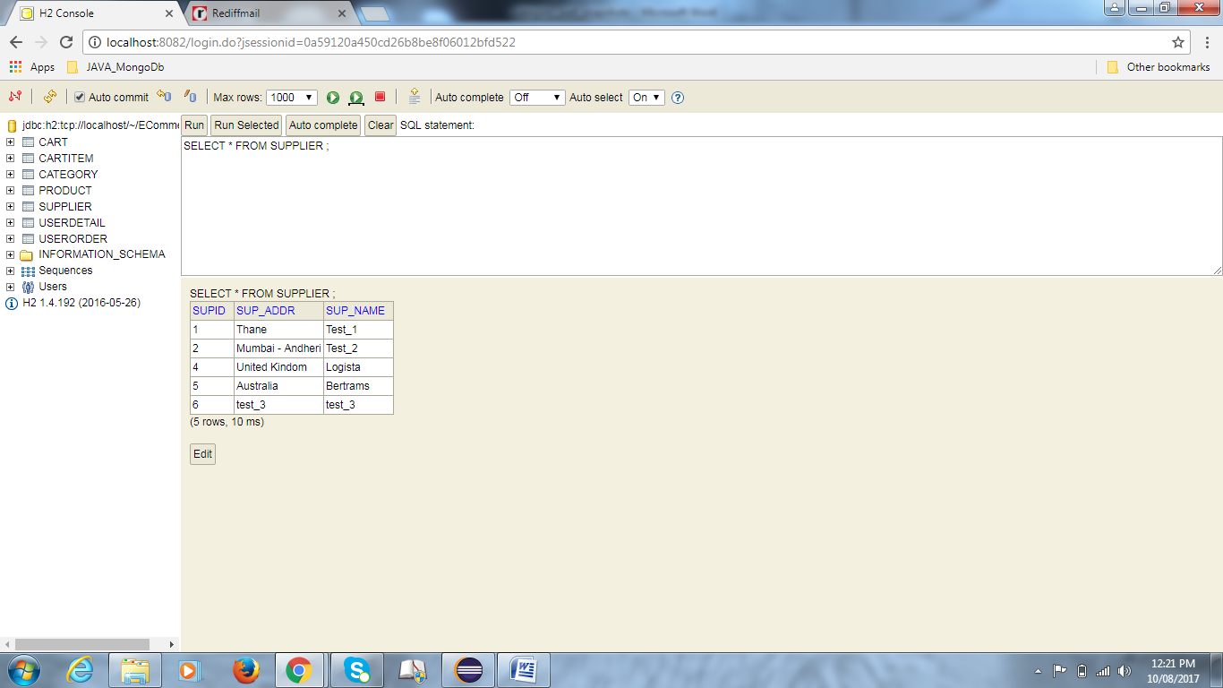

=====================================================================================

On changing workspace - Product Images are not getting stored in images folder : even after making the changes

FileUploadUtility.java

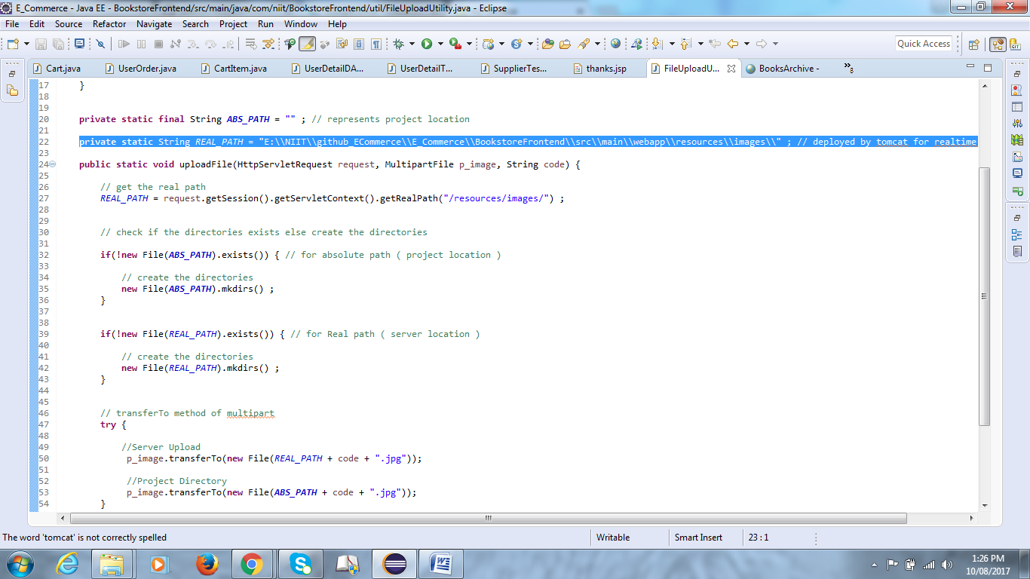

Product.java

