1. GitLab container is up…

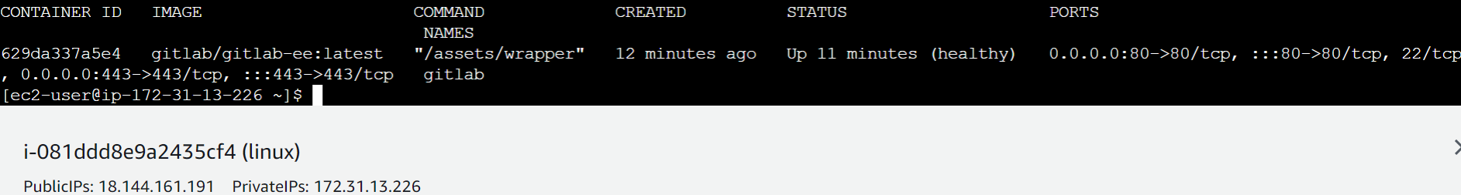

1. GitLab UI on EC2 IP address can be seen as below…

