

Solution Design Document
SIMPLE HTML CALCULATOR
Prepared: 12 June 2026 | Version 1.0 | Status: Draft

DISCLAIMER
This Solution Design Document (SDD) has been generated as part of an automated software development lifecycle (ADLC) pipeline. It is based on the Business Requirements Document (BRD) and Requirements Analysis (RA) provided as input. All technical decisions documented herein are derived from the stated requirements and standard web development best practices.
VERSION HISTORY

Version History
Version | Date | Description of Change | Reason for Change | Affected Sections
1.0 | 12 June 2026 | Initial SDD | New document | All
INTRODUCTION

1. Introduction

1.1 Business Context
The Simple HTML Calculator is a lightweight, single-file web application designed to perform basic arithmetic operations. The application serves as a demonstration of clean, self-contained front-end development practices with zero external dependencies.

1.2 Problem Statement
Users need a functional, visually appealing calculator accessible from any modern web browser without installation, plugins, or internet connectivity after the initial page load. The solution must be delivered as a single HTML file for maximum portability.

1.3 Core Areas
- Basic arithmetic operations (addition, subtraction, multiplication, division)
- Responsive user interface with modern styling
- Keyboard and mouse input support
- Graceful error handling for edge cases
PROJECT SCOPE

2. Project Scope

2.1 In Scope
- Single HTML file containing all HTML, CSS, and JavaScript
- Numeric keypad (0-9) and operator buttons (+, -, x, /)
- Display screen showing current input and results
- Clear (C) and Clear Entry (CE) functions
- Decimal point support
- Equals button for expression evaluation
- Keyboard input support
- Responsive design for desktop and mobile

2.2 Out of Scope
- Scientific calculator functions (trigonometry, logarithms, etc.)
- Calculation history or log
- Server-side processing or backend integration
- External testing frameworks

2.3 Workflow / Process Flow
The following diagram illustrates the end-to-end workflow of a user interacting with the calculator:
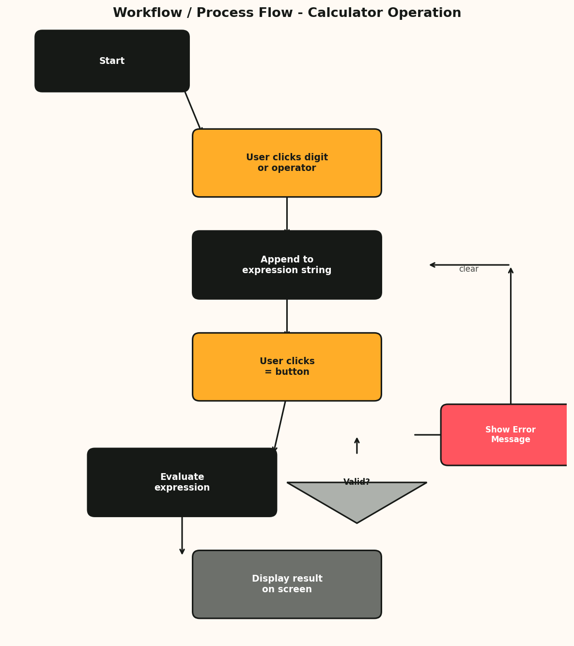
Figure 2.1: Calculator Workflow / Process Flow Diagram
SYSTEM OVERVIEW

3. System Overview

3.1 High-Level Description
The system consists of a single HTML file that combines presentation (HTML5), styling (CSS3), and application logic (vanilla JavaScript). The application runs entirely in the user's web browser with no server-side component. User interactions through button clicks or keyboard events trigger JavaScript functions that update the calculator's state and render results to the display area.

3.2 System Architecture
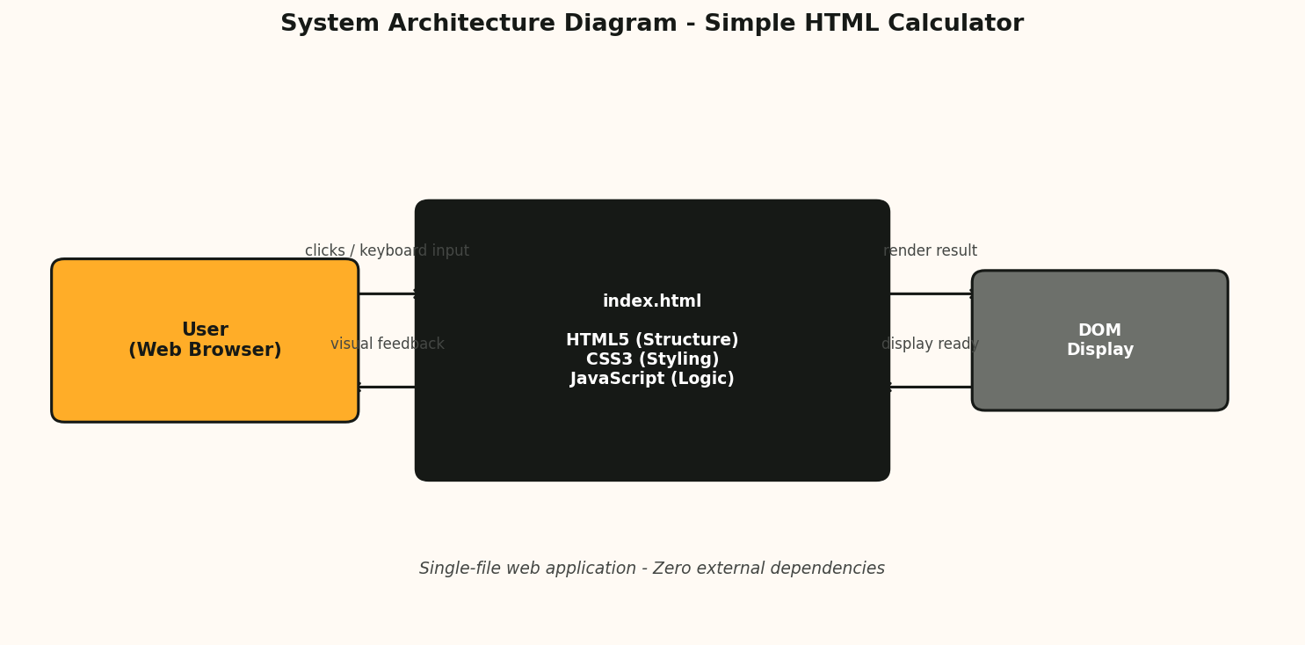
Figure 3.1: System Architecture Diagram

3.3 Data Flow
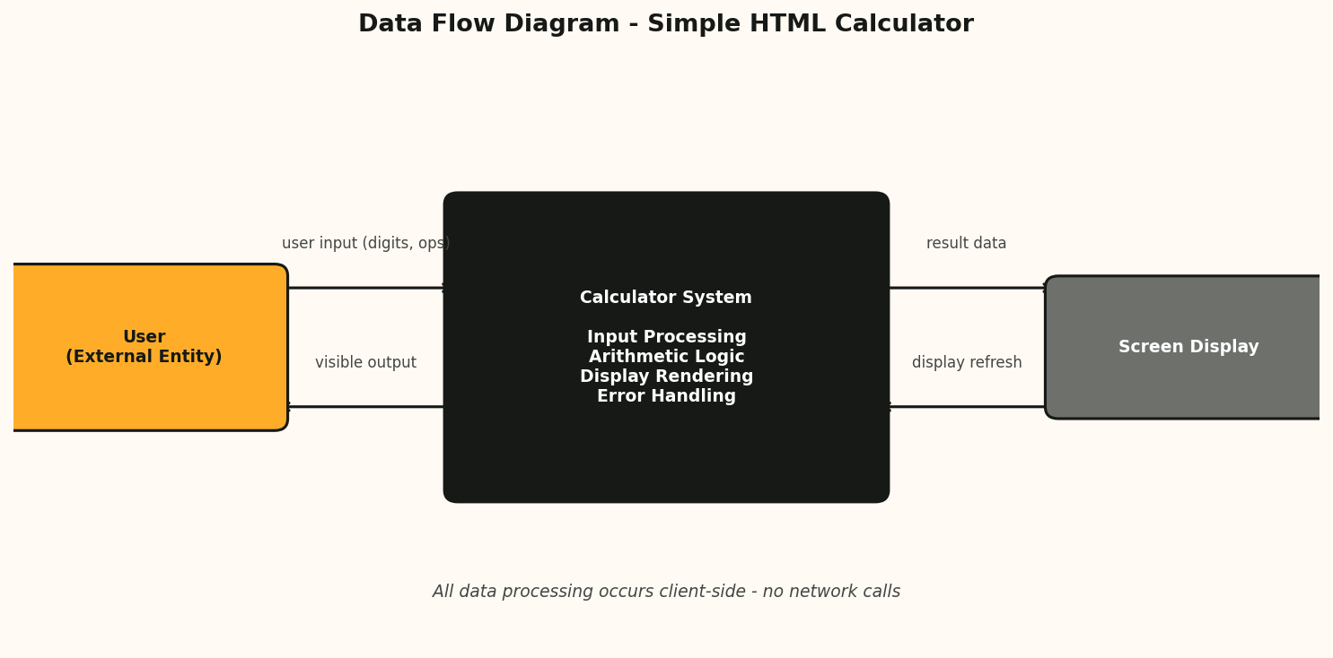
Figure 3.2: Data Flow Diagram
DESIGN CONSTRAINTS

4. Design Constraints

4.1 Assumptions and Dependencies
- The end user has a modern web browser with JavaScript enabled
- No external dependencies, CDN resources, or server components are required
- The calculator operates entirely client-side

4.2 Goals and Guidelines
- Clean, readable, well-commented code
- Modern visual design with consistent colour scheme and rounded corners
- Cross-browser compatibility (Chrome, Firefox, Edge, Safari)
- Responsive layout adapting to desktop and mobile viewports
DATABASE DESIGN

5. Database Design
The Simple HTML Calculator does not require any database or persistent storage. All application state (current expression, result value) is maintained in JavaScript runtime variables within the browser's memory. No data is stored, persisted, or transmitted.
HARDWARE & SOFTWARE DESIGN

6. Hardware and Software Detailed Design

6.1 Technology Stack
Component | Technology | Version | Purpose
Markup | HTML5 | Latest | Document structure and semantic elements
Styling | CSS3 | Latest | Visual presentation, layout, responsive design
Logic | JavaScript (ES6+) | Latest | Application logic, event handling, arithmetic evaluation
Runtime | Web Browser | Modern | Execution environment (Chrome, Firefox, Edge, Safari)

6.2 File Structure
The entire application is contained in a single file:
- index.html - HTML structure, embedded CSS in <style> tag, embedded JavaScript in <script> tag

6.3 Deployment
No deployment infrastructure is required. The single HTML file can be opened directly in any modern web browser from a local file system, web server, or any static hosting service.
DETAILED SYSTEM DESIGN

7. Detailed System Design

7.1 Component Architecture
The application is logically divided into three interconnected layers within the single file:

7.1.1 Presentation Layer (HTML)
- Container div for centering and layout
- Display area showing input expression and result
- Button grid for digits 0-9, operators, decimal point, clear, and equals

7.1.2 Styling Layer (CSS)
- Flexbox/Grid layout for responsive button grid
- Colour scheme: dark header, light buttons with hover effects, rounded corners
- Media queries for mobile responsiveness

7.1.3 Logic Layer (JavaScript)
- Expression builder - constructs the mathematical expression from user input
- Evaluation engine - safely evaluates the expression using Function() constructor
- Event handlers - manages both click events and keyboard events
- Error handler - catches division by zero and invalid expressions

7.2 User Interface Layout
The calculator UI follows a standard calculator layout:
+-----------------------------------+
| DISPLAY AREA |
| (current input / result) |
+----+----+----+----+ |
| C | CE | % | / | |
+----+----+----+----+ |
| 7 | 8 | 9 | * | |
+----+----+----+----+ |
| 4 | 5 | 6 | - | |
+----+----+----+----+ |
| 1 | 2 | 3 | + | |
+----+----+----+----+ |
| 0 | . | = | |
+----+----+----+----+-------------+
USE CASE DETAILS

8. Use Case Details
Use Case | Trigger | Input | Output | Error Handling
Addition | User clicks + or presses + key | Two numeric operands | Sum displayed on screen | N/A
Subtraction | User clicks - or presses - key | Two numeric operands | Difference displayed | N/A
Multiplication | User clicks x or presses * key | Two numeric operands | Product displayed | N/A
Division | User clicks / or presses / key | Two numeric operands | Quotient displayed | Division by zero shows error
Clear | User clicks C or presses Escape | Current expression | All cleared, display reset | N/A
Decimal | User clicks . or presses . key | Current number | Decimal point appended | Prevent multiple decimals
Evaluate | User clicks = or presses Enter | Complete expression | Calculated result | Invalid expression shows error
COMPONENT & MODULE DESIGN

9. Component and Module Design

9.1 Module Breakdown
Since this is a single-file application, the code is organised into logical sections within the <script> tag:
Module | Responsibility | Key Functions
Display Manager | Update the display area with current input and results | updateDisplay(), clearDisplay()
Expression Builder | Build mathematical expression from button/key events | appendValue(), appendOperator(), appendDecimal()
Expression Evaluator | Safely evaluate the expression string | evaluate()
Event Handler | Bind click and keyboard events to calculator functions | handleClick(), handleKeyboard()
Error Handler | Catch and display errors gracefully | handleError(), clearError()

9.2 State Management
The application state is managed through a few JavaScript variables:
Variable | Type | Purpose
currentExpression | String | Stores the current mathematical expression
displayValue | String | Stores the value shown on the display
lastResult | Number | Stores the last computed result
hasError | Boolean | Flag indicating if an error state is active
FUNCTIONAL REQUIREMENTS

10. Functional Requirements
ID | Requirement | Priority
FR-001 | Support addition of two numbers | High
FR-002 | Support subtraction of two numbers | High
FR-003 | Support multiplication of two numbers | High
FR-004 | Support division of two numbers | High
FR-005 | Numeric keypad with digits 0-9 | High
FR-006 | Display screen for input and result | High
FR-007 | Clear (C) and Clear Entry (CE) functions | Medium
FR-008 | Handle division by zero with error message | High
FR-009 | Decimal point input for floating-point numbers | Medium
FR-010 | Equals button to evaluate expression | High
FR-011 | Keyboard input support | Medium
FR-012 | Responsive and centred UI | Medium
IMPLEMENTATION STRATEGY

11. Implementation Steps Strategy

11.1 Phased Approach
Phase | Tasks | Deliverable
Phase 1: Skeleton | Create HTML structure with display and button grid | Basic layout
Phase 2: Styling | Apply CSS styling, colours, responsive design | Styled UI
Phase 3: Core Logic | Implement expression building and evaluation | Working calculator
Phase 4: Edge Cases | Add error handling, decimal validation, keyboard support | Polished application
Phase 5: Testing | Manual testing on multiple browsers and devices | Validated release
Phase 6: Documentation | Code comments and this SDD | Complete package
SECURITY

12. System Security and Integrity Controls

12.1 Security Considerations
- All code executes client-side; no data is sent to any external server
- Expression evaluation uses Function() constructor with input sanitisation to prevent injection
- No cookies, local storage, or tracking mechanisms are used
- No user data is collected, stored, or transmitted

12.2 Integrity Controls
- Input validation prevents multiple decimal points in a single number
- Division by zero is caught and displays a user-friendly error message
- Invalid expressions are caught during evaluation and handled gracefully
- The single-file nature ensures code integrity - no external dependencies to fail

