Practical-1
Aim: Installation and setup of java development kit (JDK),setup android SDK, setup eclipse IDE, setup android development tools (ADT) plugins, create android virtual device.
Environment Setup:
You will be glad to know that you can start your Android application development on either of the following operating systems:
- Microsoft Windows XP or later version.
- Mac OS X 10.5.8 or later version with Intel chip.
- Linux including GNU C Library 2.7 or later.
- Second point is that all the required tools to develop Android applications are freely available and can be downloaded from the Web.

- Following is the list of software's you will need before you start your Android application
programming:
- Java JDK5 or JDK6
- Android SDK
- Eclipse IDE for Java Developers (optional)
- Android Development Tools (ADT) Eclipse Plugin (optional)

- Here last two components are optional and if you are working on Windows machine then these components make your life easy while doing Java based application development. So let us have a look how to proceed to set required environment.

Step 1 - Setup Java Development Kit (JDK)
You can download the latest version of Java JDK from Oracle's Java site: Java SE Downloads. You will find instructions for installing JDK in downloaded files, follow the given instructions to install and configure the setup.

- Finally set PATH and JAVA_HOME environment variables to refer to the directory that contains java and javac, typically java_install_dir/bin and java_install_dir respectively.

- If you are running Windows and installed the JDK in C:\jdk1.6.0_15, you would have to put the following line in your C:\autoexec.bat file.

set PATH=C:\jdk1.6.0_15\bin;%PATH%
set JAVA_HOME=C:\jdk1.6.0_15

- lternatively, you could also right-click on My Computer, select Properties, then Advanced, thenEnvironment Variables. Then, you would update the PATH value and press the OK button.

- On Linux, if the SDK is installed in /usr/local/jdk1.6.0_15 and you use the C shell, you would put the following code into your .cshrc file.

setenv PATH /usr/local/jdk1.6.0_15/bin:$PATH
setenv JAVA_HOME /usr/local/jdk1.6.0_15
- Alternatively, if you use an Integrated Development Environment (IDE) Eclipse, then it will know automatically where you have installed your Java.

Step 2 - Setup Android SDK
You can download the latest version of Android SDK from Android official website: Android SDK Downloads.
- If you are installing SDK on Windows machine, then you will find a installer_rXX-windows.exe, so just download and run this exe which will launch Android SDK Tool Setup wizard to guide you through out of the installation, so just follow the instructions carefully. Finally you will have Android SDK Tools installed on your machine.

- If you are installing SDK either on Mac OS or Linux, check the instructions provided along with the downloaded android-sdk_rXX-macosx.zip file for Mac OS and android-sdk_rXX-linux.tgz file for Linux.

- This tutorial will consider that you are going to setup your environment on Windows machine having Windows 7 operating system.

- So let's launch Android SDK Manager using the option All Programs > Android SDK Tools > SDK Manager, this will give you following window:

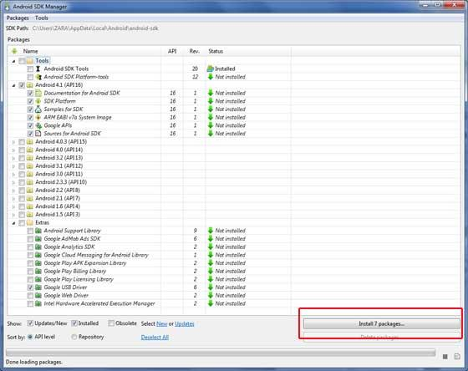

- Once you launched SDK manager, it’s time to install other required packages. By default it will list down total 7 packages to be installed, but I will suggest de-selecting Documentation for Android SDK and Samples for SDK packages to reduce installation time.

- Next click Install 7 Packages button to proceed, which will display following dialogue box:

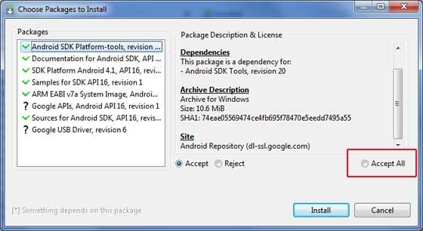

- If you agree to install all the packages, select Accept All radio button and proceed by clicking Install button.
- Now let SDK manager do its work and you go, pick up a cup of coffee and wait until all the packages are installed. It may take some time depending on your internet connection.
- Once all the packages are installed, you can close SDK manager using top-right cross button.

Step 3 - Setup Eclipse IDE
To install Eclipse IDE, download the latest Eclipse binaries from http://www.eclipse.org/downloads/.
- Once you downloaded the installation, unpack the binary distribution into a convenient location.

- For example in C:\eclipse on windows, or /usr/local/eclipse on Linux and finally set PATH variable appropriately.

- Eclipse can be started by executing the following commands on windows machine, or you can simply double click on eclipse.exe
%C:\eclipse\eclipse.exe

- Eclipse can be started by executing the following commands on Linux machine:

$/usr/local/eclipse/eclipse

- After a successful startup, if everything is fine then it should display following result:

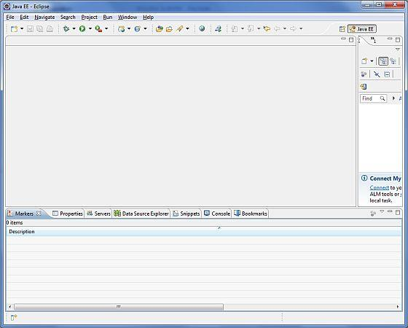

Step 4 - Setup Android Development Tools (ADT) Plugin
This step will help you in setting Android Development Tool plugin for Eclipse.
- Let's start with launching Eclipse and then, choose Help > Software Updates > Install New Software. This will display the following dialogue box.

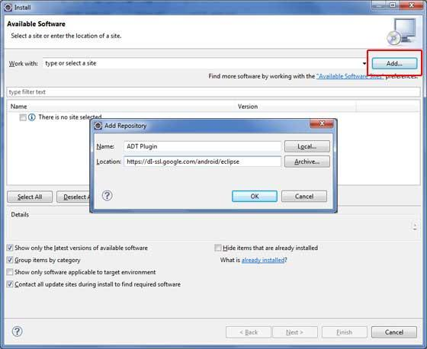

- Now use Add button to add ADT Plugin as name and https://dl-ssl.google.com/android/eclipse/ as the location.

- Then click OK to add this location, as soon as you will click OK button to add this location, Eclipse starts searching for the plug-in available the given location and finally lists down the found plugins.

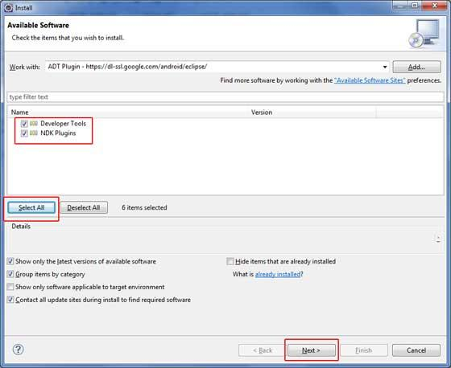

- Now select all the listed plug-ins using Select All button and click Next button which will guide you ahead to install Android Development Tools and other required plugins.

Step 5 - Create Android Virtual Device
To test your Android applications you will need a virtual Android device. So before we start writing our code, let us create an Android virtual device.
- Launch Android AVD Manager using Eclipse menu optionsWindow > AVD Manager> which will launch Android AVD Manager. Use New button to create a new Android Virtual Device and enter the following information, before clicking Create AVD button.
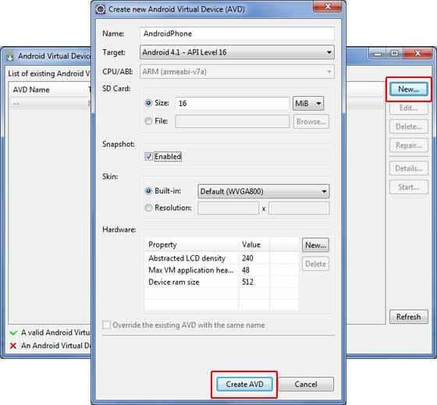

- If your AVD is created successfully it means your environment is ready for Android application development.

- If you like, you can close this window using top-right cross button. Better you re-start your machine and once you are done with this last step, you are ready to proceed for your first Android example but before that we will see few more important concepts related to Android Application Development.

Practical-2
Aim: Create “Hello World” application that will display “Hello World” in the middle of the screen using TextView Widget in the red color.

activity_main.xml:-
<RelativeLayout xmlns:android="http://schemas.android.com/apk/res/android"
xmlns:tools="http://schemas.android.com/tools"
android:layout_width="match_parent"
android:id="@+id/relative1"
android:layout_height="match_parent"
tools:context=".MainActivity" >

<TextView
android:id="@+id/textView1"
android:layout_width="wrap_content"
android:layout_height="wrap_content"
android:layout_centerHorizontal="true"
android:layout_centerVertical="true"
android:text="Hello World"
android:textSize="50sp" />

</RelativeLayout>
MainActivity.java
package com.example.pro1;

import android.app.Activity;
import android.graphics.Color;
import android.os.Bundle;
import android.widget.RelativeLayout;
import android.widget.TextView;

public class MainActivity extends Activity {

RelativeLayout rl;
TextView tvmsg;
@Override
public void onCreate(Bundle savedInstanceState) {
super.onCreate(savedInstanceState);
setContentView(R.layout.activity_main);

rl=(RelativeLayout) findViewById(R.id.relative1);
tvmsg = (TextView) findViewById(R.id.textView1);

rl.setBackgroundColor(Color.WHITE);
tvmsg.setTextColor(Color.RED);
}
}

Output:-
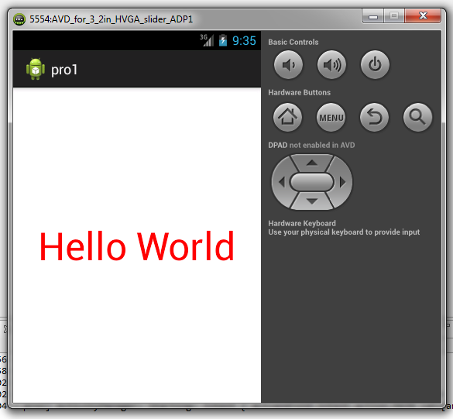

Practical-3
Aim: Create Application for Demonstration of android Activity life cycle.

strings.xml

<?xml version="1.0" encoding="utf-8"?>
<resources>

<string name="app_name">ActivityLifeCycle</string>
<string name="hello_world">Hello world!</string>
<string name="menu_settings">Settings</string>
<string name="txt1_text">Activity Lifecycle</string>

</resources>

activity_main.xml:-
<RelativeLayout xmlns:android="http://schemas.android.com/apk/res/android"
xmlns:tools="http://schemas.android.com/tools"
android:layout_width="match_parent"
android:layout_height="match_parent"
tools:context=".MainActivity" >

<TextView
android:id="@+id/textView1"
android:layout_width="wrap_content"
android:layout_height="wrap_content"
android:layout_centerHorizontal="true"
android:layout_centerVertical="true"
android:layout_marginLeft="62dp"
android:text="@string/txt1_text" />

</RelativeLayout>
MainActivity.java
package com.example.activitylifecycle;

import android.app.Activity;
import android.os.Bundle;
import android.widget.TextView;

public class MainActivity extends Activity {
TextView textView1;
String text;

@Override
protected void onCreate(Bundle savedInstanceState) {
super.onCreate(savedInstanceState);
setContentView(R.layout.activity_main);

textView1 = (TextView)findViewById(R.id.textView1 );
text =textView1.getText().toString();
text= text+"\nInside OnCreate Method";
textView1.setText(text);

}

@Override
protected void onStart() {
super.onStart();
text =textView1.getText().toString();
text= text+"\nInside OnStart Method";
textView1.setText(text);

}

@Override
protected void onStop() {
super.onStop();
text =textView1.getText().toString();
text= text+"\nInside OnStop Method";
textView1.setText(text);

}

@Override
protected void onResume() {
super.onResume();
text =textView1.getText().toString();
text= text+"\nInside OnResume Method";
textView1.setText(text);

}

@Override
protected void onPause() {
super.onPause();
text =textView1.getText().toString();
text= text+"\nInside OnPause Method";
textView1.setText(text);

}

@Override
protected void onDestroy() {
super.onDestroy();
text =textView1.getText().toString();
text= text+"\nInside OnDestroy Method";
textView1.setText(text);

}
}

Output:

Step 1. Run the application. MainActivity appeared.
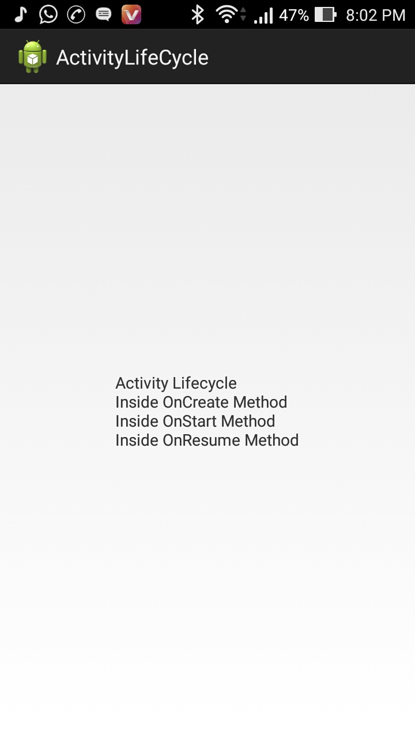
Step 2. Press the Back button on the emulator. We’ve returned to the MainActivity

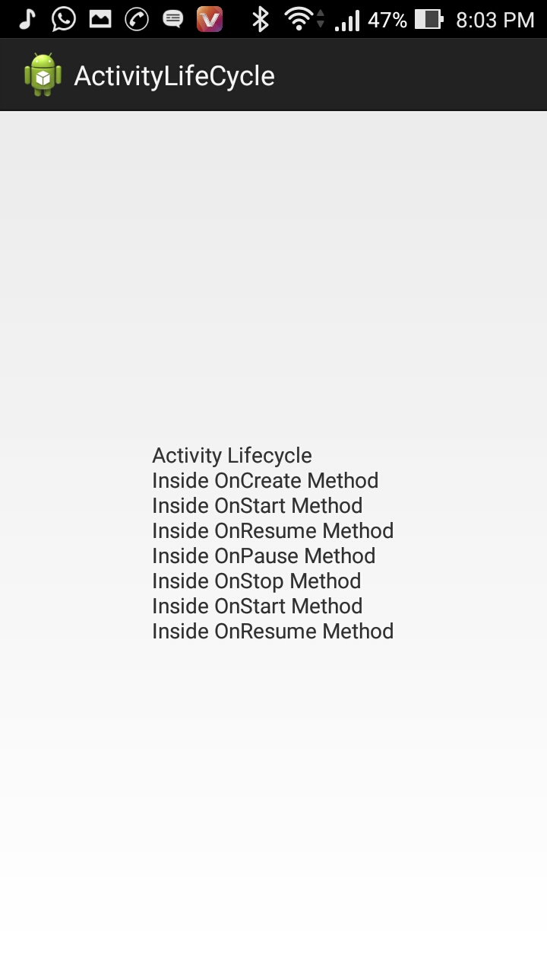

Practical-4
Aim: Create Application for Demonstration The use of onClickListner() using Button and TextView widget toolbox.
activity_main.xml:-
<LinearLayout xmlns:android="http://schemas.android.com/apk/res/android"
xmlns:tools="http://schemas.android.com/tools"
android:layout_width="match_parent"
android:layout_height="match_parent"
android:layout_alignParentBottom="true"
android:layout_centerHorizontal="true"
android:orientation="vertical" >

<TextView
android:id="@+id/textView1"
android:layout_width="wrap_content"
android:layout_height="wrap_content"
android:gravity="center_horizontal"
android:text="@string/hello_world"
android:textSize="45dp" />

<Button
android:id="@+id/button1"
android:layout_width="match_parent"
android:layout_height="wrap_content"
android:gravity="center_horizontal"
android:text="Add One" />

<Button
android:id="@+id/button2"
android:layout_width="match_parent"
android:layout_height="wrap_content"
android:gravity="center"
android:text="Sub One" />
</LinearLayout>

strings.xml
<?xml version="1.0" encoding="utf-8"?>
<resources>

<string name="app_name">Ashush</string>
<string name="hello_world">Your Total Is 0</string>
<string name="action_settings">Settings</string>

</resources>

activity_main.xml:-
package com.example.ashush;

import android.annotation.SuppressLint;
import android.os.Bundle;
import android.view.View;
import android.widget.Button;
import android.widget.TextView;

@SuppressLint("NewApi") public class MainActivity extends Activity{

int counter;
Button button1,button2;
TextView textView;
@Override
protected void onCreate(Bundle savedInstanceState) {
super.onCreate(savedInstanceState);
setContentView(R.layout.activity_main);
counter=0;
button1 = (Button)findViewById(R.id.button1);
button2=(Button)findViewById(R.id.button2);
textView=(TextView)findViewById(R.id.textView1);

button1.setOnClickListener(new View.OnClickListener() {

@Override
public void onClick(View v) {
// TODO Auto-generated method stub
counter++;
textView.setText("Your Total Is "+ counter);
}
});
button2.setOnClickListener(new View.OnClickListener() {

@Override
public void onClick(View v) {
// TODO Auto-generated method stub
counter--;
textView.setText("Your Total Is "+ counter);
}
});
}

}

Output:

Step 1. Run the application.

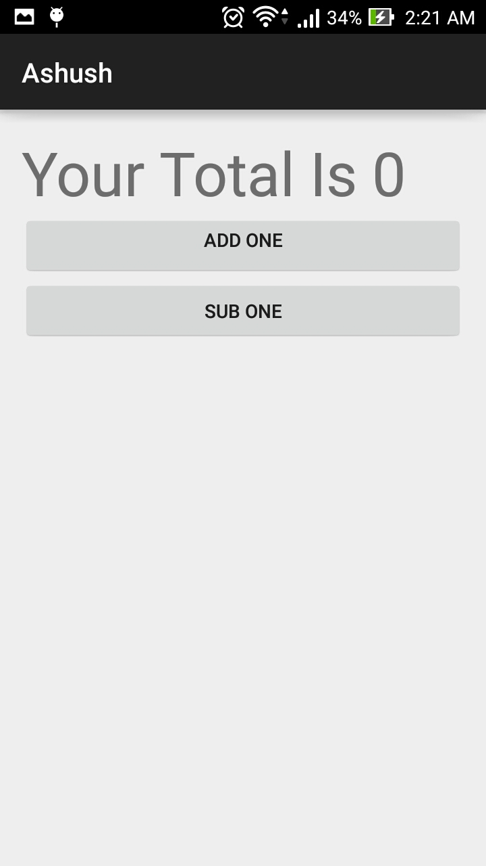

Step 2. When we press 5 times “Add One” Button.

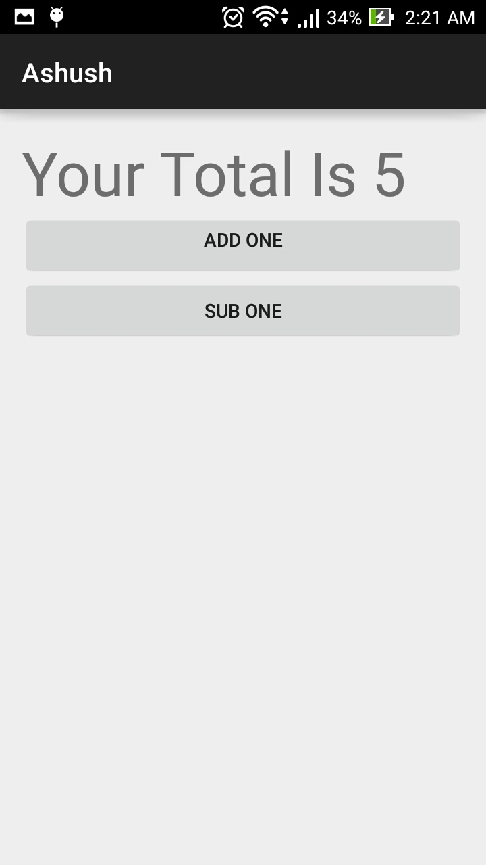

Step 3. When we press 8 times “Sub One” Button.

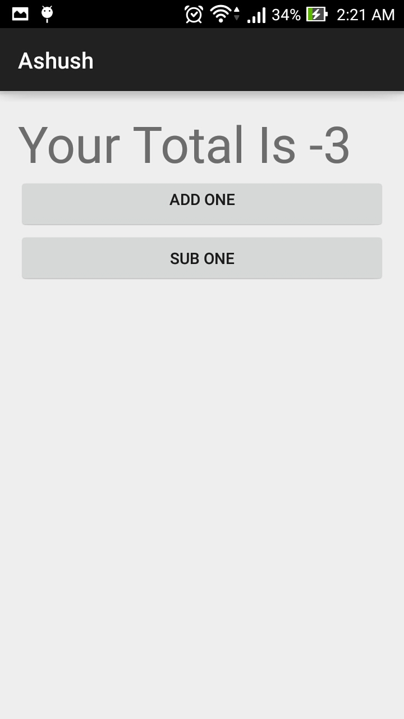

Practical:-5
Aim: Write a program for summation of two number using EditText and Toast

Activity_main.xml
<LinearLayout xmlns:android="http://schemas.android.com/apk/res/android"
xmlns:tools="http://schemas.android.com/tools"
android:layout_width="match_parent"
android:layout_height="match_parent"
android:orientation="vertical"
tools:context="com.example.sumofnumber.MainActivity" >

<EditText
android:id="@+id/editText1"
android:layout_width="match_parent"
android:layout_height="wrap_content"
android:hint="Enter 1st No."
android:ems="10" >

<requestFocus />
</EditText>

<EditText
android:id="@+id/editText2"
android:layout_width="match_parent"
android:layout_height="wrap_content"
android:hint="Enter 2nd No."
android:ems="10" />

<Button
android:id="@+id/button1"
android:layout_width="wrap_content"
android:layout_height="wrap_content"
android:onClick="calculateSum"
android:text="SUM" />

</LinearLayout>

MainActivity.java
package com.example.sumofnumber;

import android.support.v7.app.ActionBarActivity;
import android.os.Bundle;
import android.view.Menu;
import android.view.MenuItem;
import android.view.View;
import android.widget.EditText;
import android.widget.Toast;

public class MainActivity extends ActionBarActivity {

@Override
protected void onCreate(Bundle savedInstanceState) {
super.onCreate(savedInstanceState);
setContentView(R.layout.activity_main);
}

public void calculateSum(View v){
EditText et1 = (EditText)findViewById(R.id.editText1);
EditText et2 = (EditText)findViewById(R.id.editText2);
String v1= et1.getText().toString();
String v2= et2.getText().toString();
double result=Double.parseDouble(v1)+ Double.parseDouble(v2);
String ad= String.valueOf(result);
Toast toast=Toast.makeText(getApplicationContext(), "Sum= "+ad, Toast.LENGTH_LONG);
toast.show();
}

}

Output:
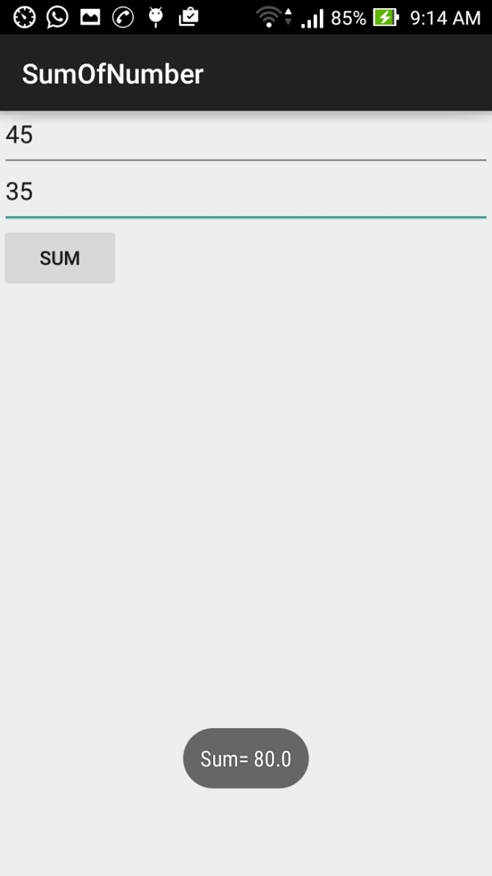
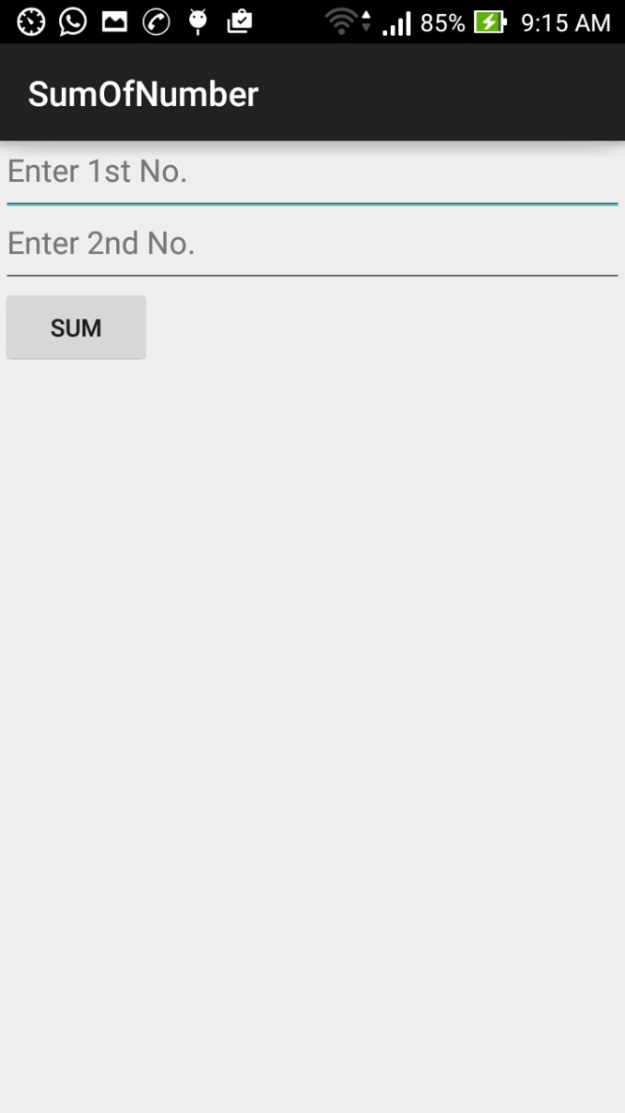

Practical:-6
Aim: Write a program for demonstrate the use of ImageButton ,Hidden TextView and Toast.
Activity_main.xml
<LinearLayout xmlns:android="http://schemas.android.com/apk/res/android"
xmlns:tools="http://schemas.android.com/tools"
android:layout_width="match_parent"
android:layout_height="match_parent"
android:orientation="vertical"
tools:context="com.example.imagebuttonwithtextview.MainActivity" >

<TextView
android:id="@+id/textview1"
android:layout_width="wrap_content"
android:layout_height="wrap_content"
android:layout_gravity="center_horizontal"
android:layout_marginTop="50dp"
android:visibility="invisible"
android:text="@string/hello_world" />

<ImageButton
android:id="@+id/imageButton1"
android:layout_width="wrap_content"
android:layout_height="wrap_content"
android:layout_gravity="center_horizontal"
android:onClick="showText"
android:contentDescription="Hi How r u"
android:src="@drawable/ic_launcher" />

</LinearLayout>
MainActivity.java
package com.example.imagebuttonwithtextview;

import android.support.v7.app.ActionBarActivity;
import android.os.Bundle;
import android.view.Menu;
import android.view.MenuItem;
import android.view.View;
import android.widget.TextView;
import android.widget.Toast;

public class MainActivity extends ActionBarActivity {

@Override
protected void onCreate(Bundle savedInstanceState) {
super.onCreate(savedInstanceState);
setContentView(R.layout.activity_main);
}

public void showText(View v) {
TextView tv=(TextView)findViewById(R.id.textview1);
String str=tv.getText().toString();
Toast.makeText(getApplicationContext(), str, Toast.LENGTH_LONG).show();

}
}

Output:
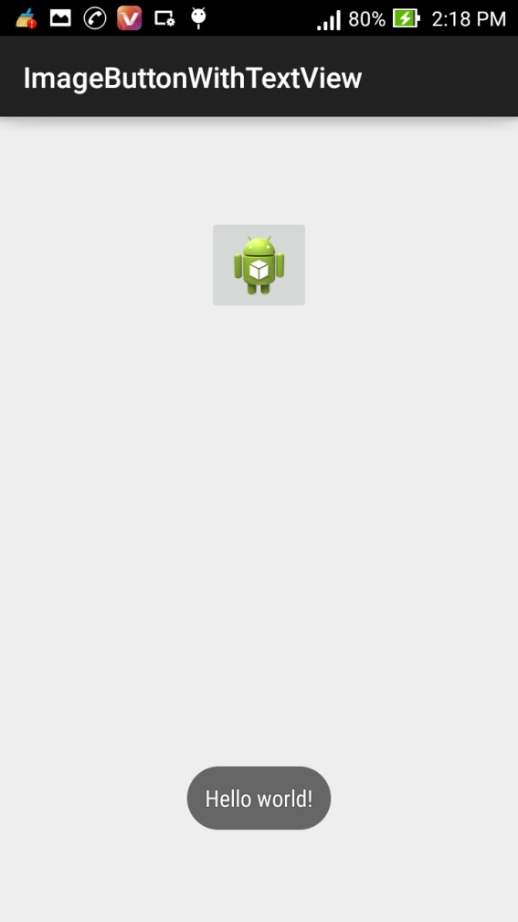
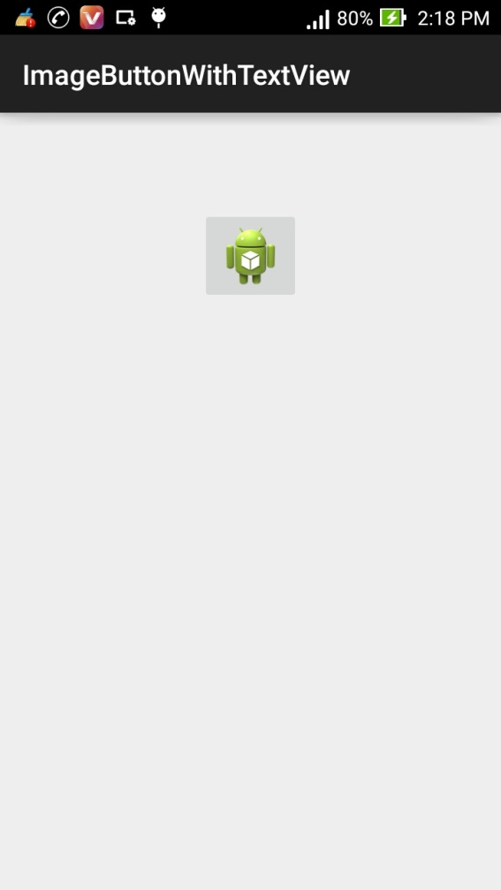
Practical:-7
Aim: Write a program for demonstrate the use of CheckBox
Activity_main.xml
<LinearLayout xmlns:android="http://schemas.android.com/apk/res/android"
xmlns:tools="http://schemas.android.com/tools"
android:layout_width="match_parent"
android:layout_height="match_parent"
android:orientation="vertical"
tools:context="com.example.checkboxbuttontoastp.MainActivity" >

<TextView
android:layout_width="wrap_content"
android:layout_height="wrap_content"
android:layout_gravity="center_horizontal"
android:layout_marginTop="70dp"
android:text="Which Languages Do You Know?" />

<CheckBox
android:id="@+id/checkBox1"
android:layout_width="wrap_content"
android:layout_height="wrap_content"
android:layout_gravity="center_horizontal"
android:layout_marginTop="50dp"
android:text="Android" />

<CheckBox
android:id="@+id/checkBox2"
android:layout_width="wrap_content"
android:layout_height="wrap_content"
android:layout_gravity="center_horizontal"
android:text="PHP" />

<CheckBox
android:id="@+id/checkBox3"
android:layout_width="wrap_content"
android:layout_height="wrap_content"
android:layout_gravity="center_horizontal"
android:text="JAVA" />

<Button
android:id="@+id/button1"
android:layout_width="wrap_content"
android:layout_height="wrap_content"
android:layout_gravity="center_horizontal"
android:layout_marginTop="20dp"
android:onClick="ShowMsg"
android:text="Button" />

</LinearLayout>

MainActivity.java
package com.example.checkboxbuttontoastp;

import android.support.v7.app.ActionBarActivity;
import android.os.Bundle;
import android.view.Menu;
import android.view.MenuItem;
import android.view.View;
import android.widget.CheckBox;
import android.widget.Toast;

public class MainActivity extends ActionBarActivity {

@Override
protected void onCreate(Bundle savedInstanceState) {
super.onCreate(savedInstanceState);
setContentView(R.layout.activity_main);
}
public void ShowMsg(View v) {
CheckBox cb1=(CheckBox)findViewById(R.id.checkBox1);
CheckBox cb2=(CheckBox)findViewById(R.id.checkBox2);
CheckBox cb3=(CheckBox)findViewById(R.id.checkBox3);
String result="You have Selected:\n";

if(cb1.isChecked())
{
result=result+cb1.getText().toString()+"\n";
}
if(cb2.isChecked())
{
result=result+cb2.getText().toString()+"\n";
}
if(cb3.isChecked())
{
result=result+cb3.getText().toString()+"\n";
}

Toast.makeText(this, result, Toast.LENGTH_LONG).show();

}
}

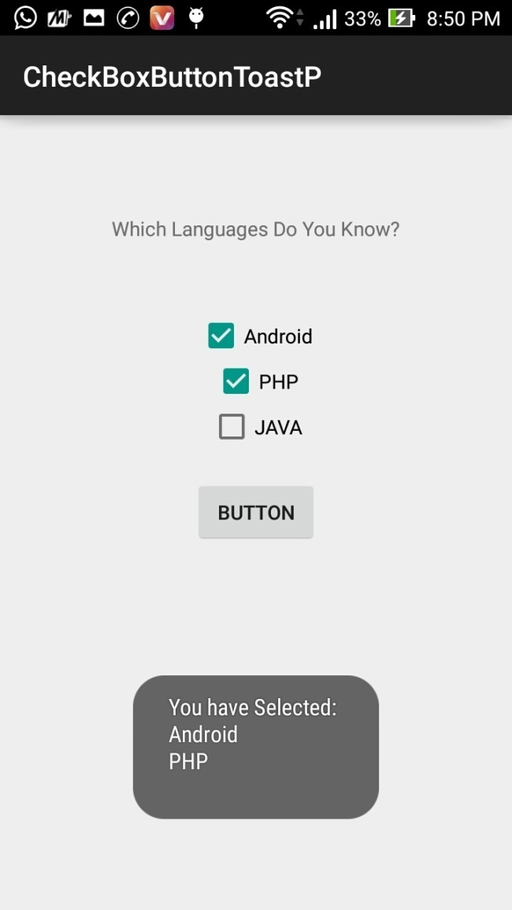
Output:
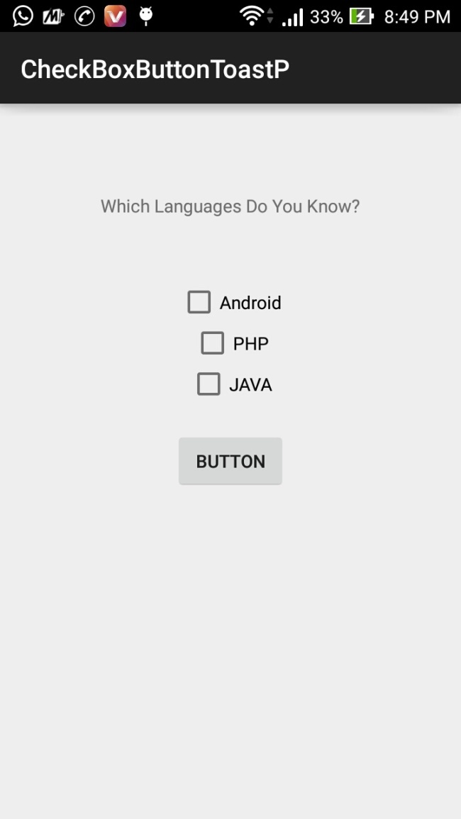
Practical:-8
Aim: Write a program for demonstrate the use of RadioButton.

Activity_main.xml
<LinearLayout xmlns:android="http://schemas.android.com/apk/res/android"
xmlns:tools="http://schemas.android.com/tools"
android:layout_width="match_parent"
android:layout_height="match_parent"
android:orientation="vertical"
tools:context="com.example.radiobuttonbuttontoastp.MainActivity" >

<TextView
android:layout_width="wrap_content"
android:layout_height="wrap_content"
android:layout_gravity="center_horizontal"
android:layout_marginTop="70dp"
android:text="Which Your Fav. Fruit?" />

<RadioGroup
android:id="@+id/RadioGroup1"
android:layout_width="wrap_content"
android:layout_height="wrap_content"
android:layout_gravity="center_horizontal" >

<RadioButton
android:id="@+id/RadioButton1"
android:layout_width="wrap_content"
android:layout_height="wrap_content"
android:layout_gravity="center_horizontal"
android:layout_marginTop="50dp"
android:checked="true"
android:text="Apple"/>

<RadioButton
android:id="@+id/RadioButton2"
android:layout_width="wrap_content"
android:layout_height="wrap_content"
android:layout_gravity="center_horizontal"
android:text="Mango" />

<RadioButton
android:id="@+id/RadioButton3"
android:layout_width="wrap_content"
android:layout_height="wrap_content"
android:layout_gravity="center_horizontal"
android:text="Both" />
</RadioGroup>

<Button
android:id="@+id/button1"
android:layout_width="wrap_content"
android:layout_height="wrap_content"
android:layout_gravity="center_horizontal"
android:layout_marginTop="20dp"
android:onClick="ShowResult"
android:text="Submit"/>

</LinearLayout>

MainActivity.java
package com.example.radiobuttonbuttontoastp;

import android.support.v7.app.ActionBarActivity;
import android.R.string;
import android.os.Bundle;
import android.view.Menu;
import android.view.MenuItem;
import android.view.View;
import android.widget.RadioButton;
import android.widget.RadioGroup;
import android.widget.Toast;

public class MainActivity extends ActionBarActivity {

@Override
protected void onCreate(Bundle savedInstanceState) {
super.onCreate(savedInstanceState);
setContentView(R.layout.activity_main);
}

public void ShowResult(View v) {
RadioGroup rg=(RadioGroup)findViewById(R.id.RadioGroup1);
int selectedRadioBtnID=rg.getCheckedRadioButtonId();
RadioButton SelectedRadioBtn=(RadioButton)findViewById(selectedRadioBtnID);

String selectedFruit=SelectedRadioBtn.getText().toString();
Toast.makeText(this, "Your Fav. Fruit is: "+selectedFruit, Toast.LENGTH_LONG).show();
}
}

Output:

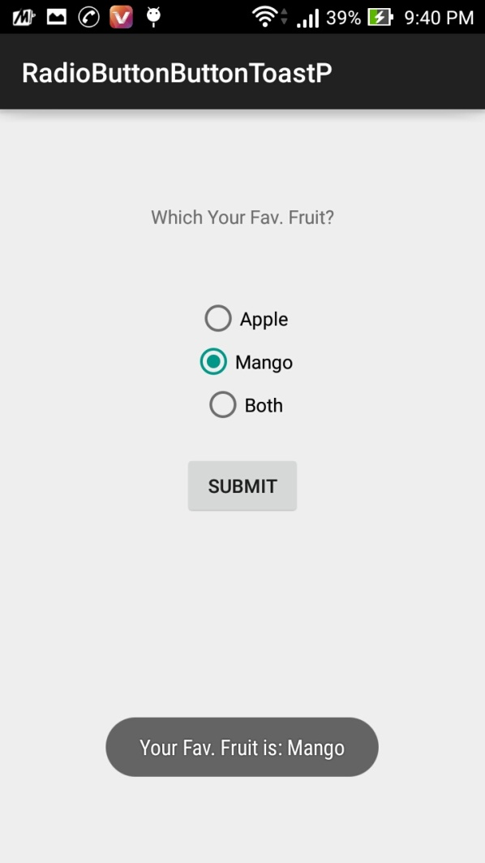
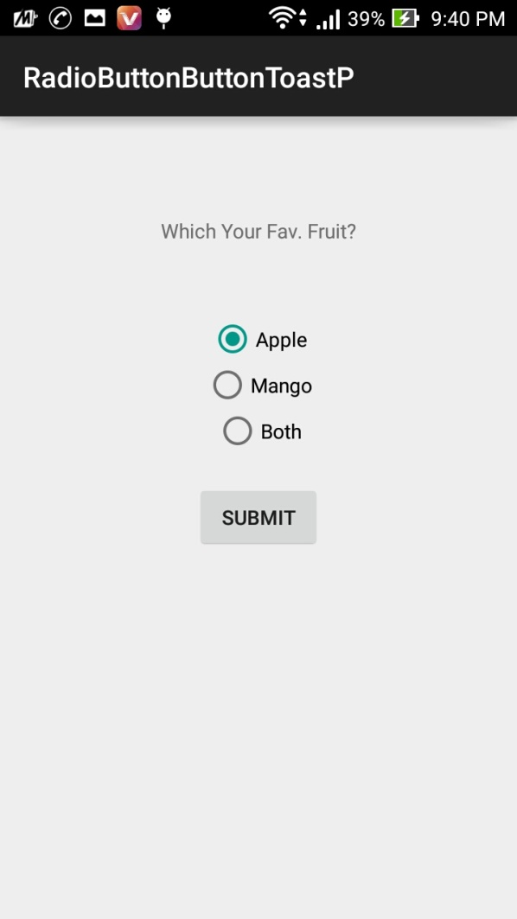

Practical:-9
Aim: Write a program for demonstrate the use of WebView.
.
Activity_main.xml

<RelativeLayout xmlns:android="http://schemas.android.com/apk/res/android"
xmlns:tools="http://schemas.android.com/tools"
android:layout_width="match_parent"
android:layout_height="match_parent"
android:paddingBottom="@dimen/activity_vertical_margin"
android:paddingLeft="@dimen/activity_horizontal_margin"
android:paddingRight="@dimen/activity_horizontal_margin"
android:paddingTop="@dimen/activity_vertical_margin"
tools:context="com.example.webviewp.MainActivity" >

<TextView android:text="WebView" android:layout_width="wrap_content"
android:layout_height="wrap_content"
android:id="@+id/textview"
android:textSize="35dp"
android:layout_alignParentTop="true"
android:layout_centerHorizontal="true" />

<TextView
android:layout_width="wrap_content"
android:layout_height="wrap_content"
android:text="Practical Point"
android:id="@+id/textView"
android:layout_below="@+id/textview"
android:layout_centerHorizontal="true"
android:textColor="#ff7aff24"
android:textSize="35dp" />

<EditText
android:layout_width="wrap_content"
android:layout_height="wrap_content"
android:id="@+id/editText"
android:hint="Enter Text"
android:focusable="true"
android:textColorHighlight="#ff7eff15"
android:textColorHint="#ffff25e6"
android:layout_marginTop="46dp"
android:layout_below="@+id/imageView"
android:layout_alignParentLeft="true"
android:layout_alignParentStart="true"
android:layout_alignRight="@+id/imageView"
android:layout_alignEnd="@+id/imageView" />

<ImageView
android:layout_width="wrap_content"
android:layout_height="wrap_content"
android:id="@+id/imageView"
android:src="@drawable/ic_launcher"
android:layout_below="@+id/textView"
android:layout_centerHorizontal="true" />

<Button
android:layout_width="wrap_content"
android:layout_height="wrap_content"
android:text="Enter"
android:id="@+id/button"
android:layout_alignTop="@+id/editText"
android:layout_toRightOf="@+id/imageView"
android:layout_toEndOf="@+id/imageView" />

<WebView
android:layout_width="wrap_content"
android:layout_height="wrap_content"
android:id="@+id/webView"
android:layout_below="@+id/button"
android:layout_alignParentLeft="true"
android:layout_alignParentStart="true"
android:layout_alignParentRight="true"
android:layout_alignParentEnd="true"
android:layout_alignParentBottom="true" />

</RelativeLayout>

MainActivity.java
package com.example.webviewp;

import android.support.v7.app.ActionBarActivity;
import android.os.Bundle;
import android.view.Menu;
import android.view.MenuItem;
import android.view.View;
import android.webkit.WebView;
import android.webkit.WebViewClient;
import android.widget.Button;
import android.widget.EditText;
import java.io.FileInputStream;
import java.io.FileOutputStream;

public class MainActivity extends ActionBarActivity {
Button b1;
EditText ed1;
WebView wv1;
@Override
protected void onCreate(Bundle savedInstanceState) {
super.onCreate(savedInstanceState);
setContentView(R.layout.activity_main);
b1=(Button)findViewById(R.id.button);
ed1=(EditText)findViewById(R.id.editText);

wv1=(WebView)findViewById(R.id.webView);
wv1.setWebViewClient(new MyBrowser());

b1.setOnClickListener(new View.OnClickListener() {
@Override
public void onClick(View v) {
String url = ed1.getText().toString();

wv1.getSettings().setLoadsImagesAutomatically(true);
wv1.getSettings().setJavaScriptEnabled(true);
wv1.setScrollBarStyle(View.SCROLLBARS_INSIDE_OVERLAY);
wv1.loadUrl(url);
}
});
}
private class MyBrowser extends WebViewClient {
@Override
public boolean shouldOverrideUrlLoading(WebView view, String url) {
view.loadUrl(url);
return true;
}
}

Manifest.xml

<?xml version="1.0" encoding="utf-8"?>
<manifest xmlns:android="http://schemas.android.com/apk/res/android"
package="com.example.webviewp"
android:versionCode="1"
android:versionName="1.0" >

<uses-sdk
android:minSdkVersion="11"
android:targetSdkVersion="21" />
<uses-permission android:name="android.permission.INTERNET" />
<application
android:allowBackup="true"
android:icon="@drawable/ic_launcher"
android:label="@string/app_name"
android:theme="@style/AppTheme" >
<activity
android:name=".MainActivity"
android:label="@string/app_name" >
<intent-filter>
<action android:name="android.intent.action.MAIN" />

<category android:name="android.intent.category.LAUNCHER" />
</intent-filter>
</activity>
</application>

Output:
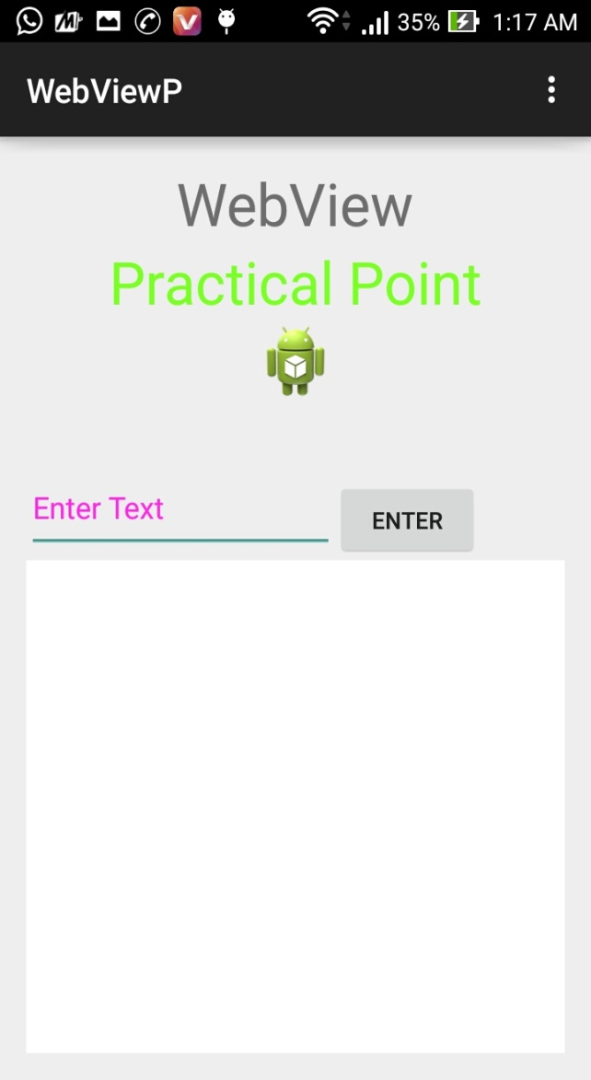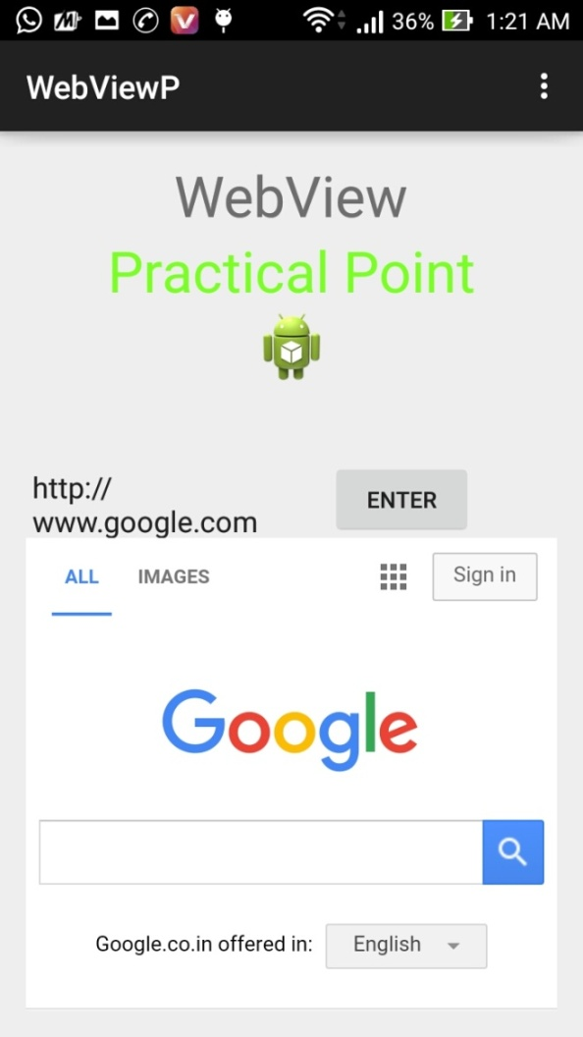

Practical:-10
Aim: Write a program for demonstrate the use of GridView.
Activity_main.xml

<RelativeLayout xmlns:android="http://schemas.android.com/apk/res/android"
xmlns:tools="http://schemas.android.com/tools"
android:layout_width="match_parent"
android:layout_height="match_parent"
android:paddingBottom="@dimen/activity_vertical_margin"
android:paddingLeft="@dimen/activity_horizontal_margin"
android:paddingRight="@dimen/activity_horizontal_margin"
android:paddingTop="@dimen/activity_vertical_margin"
tools:context="com.example.gridviewp.MainActivity" >

<GridView
android:id="@+id/gridview"
android:layout_width="match_parent"
android:layout_height="wrap_content"
android:layout_centerHorizontal="true"
android:columnWidth="90dp"
android:verticalSpacing="10dp"
android:horizontalSpacing="10dp"
android:stretchMode="columnWidth"
android:gravity="center"
android:numColumns="3" >
</GridView>

</RelativeLayout>

MainActivity.java
package com.example.gridviewp;

//import android.R;
import com.example.gridviewp.R;
import android.support.v7.app.ActionBarActivity;
import android.os.Bundle;
import android.view.Menu;
import android.view.MenuItem;
import android.widget.GridView;

public class MainActivity extends ActionBarActivity {

@Override
protected void onCreate(Bundle savedInstanceState) {
super.onCreate(savedInstanceState);
setContentView(R.layout.activity_main);

GridView gridview = (GridView) findViewById(R.id.gridview);
gridview.setAdapter(new ImageAdapter(this));
}

}

ImageAdepter.java

package com.example.gridviewp;

import android.content.Context;
import android.view.View;
import android.view.ViewGroup;
import android.widget.BaseAdapter;
import android.widget.GridView;
import android.widget.ImageView;

public class ImageAdapter extends BaseAdapter {
private Context mContext;

// Constructor
public ImageAdapter(Context c) {
mContext = c;
}

public int getCount() {
return mThumbIds.length;
}

public Object getItem(int position) {
return null;
}

public long getItemId(int position) {
return 0;
}

// create a new ImageView for each item referenced by the Adapter
public View getView(int position, View convertView, ViewGroup parent) {
ImageView imageView;

if (convertView == null) {
imageView = new ImageView(mContext);
imageView.setLayoutParams(new GridView.LayoutParams(85, 85));
imageView.setScaleType(ImageView.ScaleType.CENTER_CROP);
imageView.setPadding(100, 100, 100, 100);
}
else
{
imageView = (ImageView) convertView;
}
imageView.setImageResource(mThumbIds[position]);
return imageView;
}

// Keep all Images in array
public Integer[] mThumbIds = {
R.drawable.sample_1, R.drawable.sample_3,
R.drawable.sample_4, R.drawable.sample_5,
R.drawable.sample_6, R.drawable.sample_7,
R.drawable.sample_2, R.drawable.sample_8,
R.drawable.sample_9, R.drawable.sample_10,
R.drawable.sample_11, R.drawable.sample_12,
R.drawable.sample_13, R.drawable.sample_14,
R.drawable.sample_15, R.drawable.sample_16,
R.drawable.sample_17, R.drawable.sample_18,
R.drawable.sample_1, R.drawable.sample_5,
R.drawable.sample_6, R.drawable.sample_7
};
}

Output:
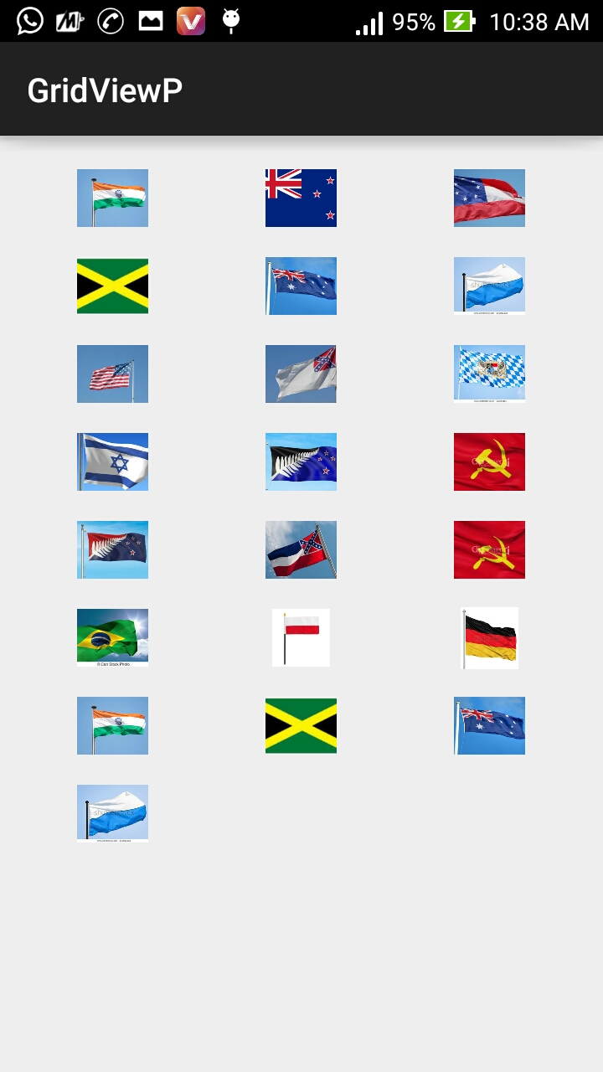

Practical:-11

Aim: Create sample application with login module.(Check username and password) On successful login,Change Textview “Login Successful”.And on failing login,alert user using Toast “Login fail”.
MainActivity.java:-
package com.example.loginscreen;
import android.annotation.SuppressLint;
import android.app.Activity;
import android.graphics.Color;
import android.os.Bundle;
import android.view.Menu;
import android.view.View;
import android.widget.Button;
import android.widget.EditText;
import android.widget.TextView;
import android.widget.Toast;
public class MainActivity extends Activity {
private EditText username=null;
private EditText password=null;
TextView t1;
private Button login;
@Override
protected void onCreate(Bundle savedInstanceState) {
super.onCreate(savedInstanceState);
setContentView(R.layout.activity_main);
username = (EditText)findViewById(R.id.editText1);
password = (EditText)findViewById(R.id.editText2);
t1=(TextView) findViewById(R.id.textView4);
t1.setVisibility(View.GONE);
login = (Button)findViewById(R.id.button1);
}
public void login(View view){
if(username.getText().toString().equals("admin") &&
password.getText().toString().equals("admin")){
t1.setVisibility(view.VISIBLE);
}
else{
Toast.makeText(getApplicationContext(), "Login Fail",
Toast.LENGTH_SHORT).show();
t1.setVisibility(view.GONE);
}
}
@Override
public boolean onCreateOptionsMenu(Menu menu) {
// Inflate the menu; this adds items to the action bar if it is present.
getMenuInflater().inflate(R.menu.activity_main, menu);
return true;
}}
activity_main.xml:-

<RelativeLayout xmlns:android="http://schemas.android.com/apk/res/android"
xmlns:tools="http://schemas.android.com/tools"
android:layout_width="match_parent"
android:layout_height="match_parent"
android:paddingBottom="20sp"
android:paddingLeft="20sp"
android:paddingRight="20sp"
android:paddingTop="20sp"
tools:context=".MainActivity" >

<TextView
android:id="@+id/textView1"
android:layout_width="wrap_content"
android:layout_height="wrap_content"
android:layout_alignParentTop="true"
android:layout_centerHorizontal="true"
android:layout_marginTop="18dp"
android:text="@string/hello_world"
android:textAppearance="?android:attr/textAppearanceLarge" />

<TextView
android:id="@+id/textView2"
android:layout_width="wrap_content"
android:layout_height="wrap_content"
android:layout_alignParentLeft="true"
android:layout_below="@+id/textView1"
android:layout_marginTop="50dp"
android:text="@string/username"
android:textAppearance="?android:attr/textAppearanceMedium" />

<EditText
android:id="@+id/editText1"
android:layout_width="wrap_content"
android:layout_height="wrap_content"
android:layout_alignBottom="@+id/textView2"
android:layout_marginLeft="32dp"
android:layout_toRightOf="@+id/textView2"
android:ems="10" >

<requestFocus />
</EditText>

<TextView
android:id="@+id/textView3"
android:layout_width="wrap_content"
android:layout_height="wrap_content"
android:layout_alignLeft="@+id/textView2"
android:layout_below="@+id/textView2"
android:layout_marginTop="38dp"
android:text="@string/password"
android:textAppearance="?android:attr/textAppearanceMedium" />

<EditText
android:id="@+id/editText2"
android:layout_width="wrap_content"
android:layout_height="wrap_content"
android:layout_alignBottom="@+id/textView3"
android:layout_alignLeft="@+id/editText1"
android:ems="10"
android:inputType="textPassword" />

<Button
android:id="@+id/button1"
android:layout_width="wrap_content"
android:layout_height="wrap_content"
android:layout_below="@+id/editText2"
android:layout_centerHorizontal="true"
android:layout_marginTop="60dp"
android:onClick="login"
android:text="@string/Login" />

<TextView
android:id="@+id/textView4"
android:layout_width="wrap_content"
android:layout_height="wrap_content"
android:layout_centerHorizontal="true"
android:layout_centerVertical="true"
android:layout_marginTop="20sp"
android:layout_below="@+id/editText2"
android:text="Login Successfull" />

</RelativeLayout>

strings.xml:-
<?xml version="1.0" encoding="utf-8"?>
<resources>

<string name="app_name">LoginScreen</string>
<string name="action_settings">Settings</string>
<string name="hello_world">Login Screen</string>
<string name="username">Username:</string>
<string name="password">Password:</string>
<string name="Login">Login:</string>
<string name="attempts">Attempts Left:</string>
<string name="menu_settings">Settings</string>
</resources>

Output:-
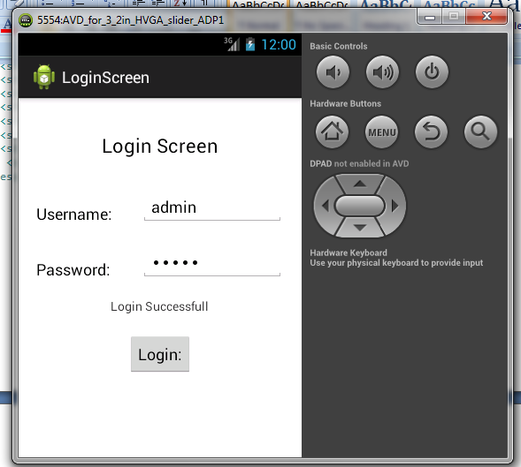

Practical:-12
Aim: Create an application for demonstration of Starting New Activity using Intent.
Using Implicit Intent

activity_main.xml:-

<RelativeLayout xmlns:androclass="http://schemas.android.com/apk/res/android"
xmlns:tools="http://schemas.android.com/tools"
android:layout_width="match_parent"
android:layout_height="match_parent"
tools:context=".MainActivity" >
<EditText
android:id="@+id/editText1"
android:layout_width="wrap_content"
android:layout_height="wrap_content"
android:layout_alignParentTop="true"
android:layout_centerHorizontal="true"
android:layout_marginTop="44dp"
android:ems="10" />
<Button
android:id="@+id/button1"
android:layout_width="wrap_content"
android:layout_height="wrap_content"
android:layout_below="@+id/editText1"
android:layout_centerHorizontal="true"
android:layout_marginTop="54dp"
android:onClick="ImpInt"
android:text="Visit" />
</RelativeLayout>
MainActivity.java:-

package com.example.implicitintent;

import android.support.v7.app.ActionBarActivity;
import android.content.Intent;
import android.net.Uri;
import android.os.Bundle;
import android.view.Menu;
import android.view.MenuItem;
import android.view.View;
import android.widget.Button;
import android.widget.EditText;

public class MainActivity extends ActionBarActivity {

protected void onCreate(Bundle savedInstanceState) {
super.onCreate(savedInstanceState);
setContentView(R.layout.activity_main);

}
public void ImpInt(View v) {
EditText editText1=(EditText)findViewById(R.id.editText1);
Button button1=(Button)findViewById(R.id.button1);
String url=editText1.getText().toString();
Intent intent=new Intent(Intent.ACTION_VIEW,Uri.parse(url));
startActivity(intent);
}

@Override
public boolean onCreateOptionsMenu(Menu menu) {
// Inflate the menu; this adds items to the action bar if it is present.
getMenuInflater().inflate(R.menu.main, menu);
return true;
}

@Override
public boolean onOptionsItemSelected(MenuItem item) {
// Handle action bar item clicks here. The action bar will
// automatically handle clicks on the Home/Up button, so long
// as you specify a parent activity in AndroidManifest.xml.
int id = item.getItemId();
if (id == R.id.action_settings) {
return true;
}
return super.onOptionsItemSelected(item);
}
}

Output:-

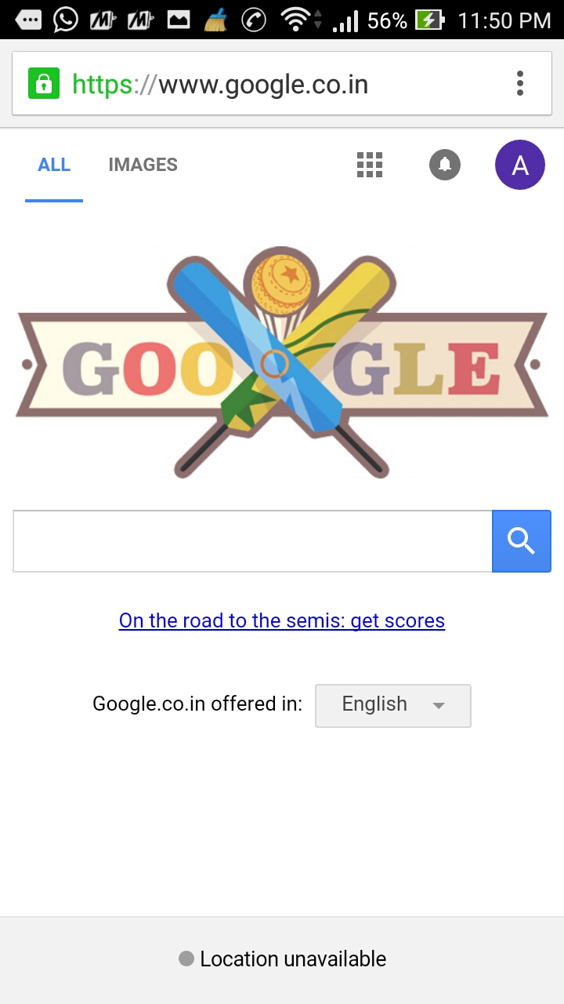
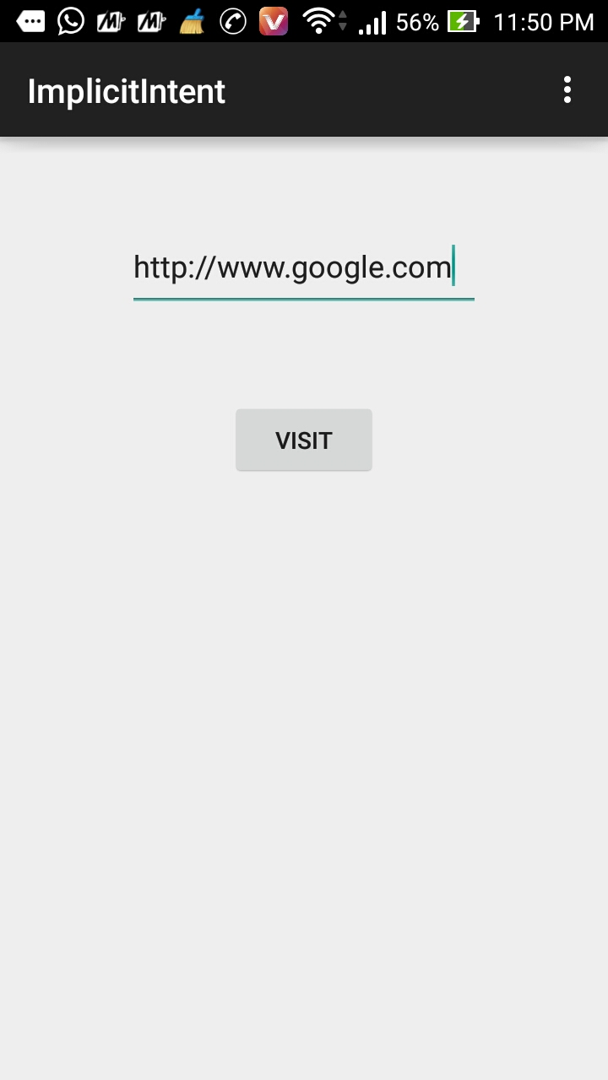
Using Explicit Intent
activity_main.xml
<LinearLayout xmlns:androclass="http://schemas.android.com/apk/res/android"
xmlns:tools="http://schemas.android.com/tools"
android:layout_width="match_parent"
android:layout_height="match_parent"
tools:context=".MainActivity" >

<Button
android:id="@+id/Button01"
android:layout_width="wrap_content"
android:layout_height="wrap_content"
android:onClick="onClick"
android:text="Call second activity" />

<TextView
android:id="@+id/TextView01"
android:layout_width="wrap_content"
android:layout_height="wrap_content"
android:text="First Activity"

</LinearLayout>

activitytwo_main.xml
<RelativeLayout xmlns:androclass="http://schemas.android.com/apk/res/android"
xmlns:tools="http://schemas.android.com/tools"
android:layout_width="match_parent"
android:layout_height="match_parent"
tools:context=".MainActivity" >

<Button
android:id="@+id/Button01"
android:layout_width="wrap_content"
android:layout_height="wrap_content"
android:onClick="onClick"
android:text="Call First activity" />

<TextView
android:id="@+id/TextView01"
android:layout_width="wrap_content"
android:layout_height="wrap_content"
android:text="Second Activity" />

</RelativeLayout>

MainActivity.java

public class MainActivity extends ActionBarActivity {
@Override
protected void onCreate(Bundle savedInstanceState) {
super.onCreate(savedInstanceState);
setContentView(R.layout.activity_main);
Button button1=(Button)findViewById(R.id.Button01);

button1.setOnClickListener(new OnClickListener(){
public void onClick(View view) {
Intent i = new Intent(getApplicationContext(), MainActivityTwo.class);
i.putExtra("Value1", "Android By Javatpoint");
i.putExtra("Value2", "Simple Tutorial");
// Set the request code to any code you like, you can identify the
// callback via this code
startActivity(i);
}
});
}

MainActivityTwo.java
public class MainActivityTwo extends Activity {
/** Called when the activity is first created. */
@Override
public void onCreate(Bundle bundle) {
super.onCreate(bundle);
TextView tv=new TextView(this);
tv.setText("second activity");
setContentView(R.layout.activitytwo_main);
Bundle extras = getIntent().getExtras();
String value1 = extras.getString("Value1");
String value2 = extras.getString("Value2");
Toast.makeText(getApplicationContext(),"Values are:\n First value: "+value1+
"\n Second Value: "+value2,Toast.LENGTH_LONG).show();
Button button1=(Button)findViewById(R.id.Button01);
button1.setOnClickListener(new OnClickListener(){
public void onClick(View view) {
Intent i = new Intent(getApplicationContext(), MainActivity.class);
startActivity(i);
}
});
}
}

AndroidMenifest.xml
<?xml version="1.0" encoding="utf-8"?>
<manifest xmlns:android="http://schemas.android.com/apk/res/android"
package="com.example.explicitintent"
android:versionCode="1"
android:versionName="1.0" >
<uses-sdk
android:minSdkVersion="8"
android:targetSdkVersion="21" />
<application
android:allowBackup="true"
android:icon="@drawable/ic_launcher"
android:label="@string/app_name"
android:theme="@style/AppTheme" >
<activity
android:name=".MainActivity"
android:label="@string/app_name" >
<intent-filter>
<action android:name="android.intent.action.MAIN" />
<category android:name="android.intent.category.LAUNCHER" />
</intent-filter>
</activity>
<activity
android:name="MainActivityTwo"
android:label="ActivityTwo" >
</activity>
</application>
</manifest>

Output:
