Practical 1: ERP Before-After Analysis

What Enterprise Resource Planning (ERP)?

Enterprise resource planning (ERP) is business process management software that allows an organization to use a system of integrated applications to manage the business and automate many back office functions related to technology, services and human resources. ERP software integrates all facets of an operation, including product planning, development, manufacturing, sales and marketing.

ERP software is considered an enterprise application as it is designed to be used by larger businesses and often requires dedicated teams to customize and analyze the data and to handle upgrades and deployment. In contrast, Small business ERP applications are lightweight business management software solutions, customized for the business industry you work in.

Advantages

The fundamental advantage of ERP is that integrating myriad businesses processes saves time and expense. Management can make decisions faster and with fewer errors. Data becomes visible across the organization. Tasks that benefit from this integration include.
- Sales forecasting, which allows inventory optimization.
- Chronological history of every transaction through relevant data compilation in every area of operation.

Example Of ERP Implementation in Company

TATA Motors:-

SAP ERP application was developed by SAP AG to guide the urgency of the big software company, and mid-sized organizations in all sectors and industries. This application provides among all the other benefits of open communication within the company and its functions.
- Objectives for SAP in TATA Motors:
- To improve revenue collection from sales
- To reduce application of efforts and increasing efficiency.
- To reduce cost by improvement in operations area.
- To increase productivity.

- SAP ERP Solution implementation.
- Tata Motors has experienced increase in productivity and cost control.
- Another benefit is in reduction of number of different application run on them as well as the no. of servers.
- Introduction of disaster recovery management done for one entity.
- Significant reduction in the number of non-value-added activities.

IDBI Bank:-

After the drastic change in top management in January 2001, the bank felt a need to improve the technology platform so that bank can transform itself in order to fulfill the challenges in the future. Inadequate network forced IDBI to adopt a technology platform which enabled IDBI to communicate with its customers with the help of many delivery channels. Scalability & Complete integrated solution was the need of the hour. IDBI initially used centrally system from Kindle but it was proving to be inefficient to meet new objectives, so it was changed.
- Objectives Of ERP in IDBI Bank:
  - Cash Management
  - Teller Operations
  - Position Management
  - Technical Architecture

After Implementation of Financial
- Capability of handling 3 lakhs transactions in a day from 8 lakhs customer accounts
- IDBI became 3rd largest pvt.bank in terms of distribution of branch networks.
- Financial offers customers a unified view of their relationship with bank which helps in achieving customer satisfaction.
Maruti Suzuki Ltd:-

- Before implementation of the ERP.
The company used to depend upon its home grown, disparate systems to manage its business. But these systems were inefficient and were not able to communicate with each other and thus required a lot of manual work like entering data multiple times. And it was very difficult for the staff to generate the results and reports. There was a lack of control over processes. The company also added four new business sectors in 2002 which also required constant attention and human intervention and thus making it difficult to manage the system.

- Post Implementation.
There was a smooth transition from the old legacy systems to the newly adopted Oracle E – Business Suite. The company selected Oracle Consulting to determine the company’s requirements, to design the system, to develop the project plan, to deploy the software, to manage the parties involved and finally to provide the three months post – implementation support to the company. The training programs were also designed for the employees. Under the training programs the user manuals were provided. There was also Train the Trainer program and Train the super users program under the Training programs.

Wockhardt:-

Wockhardt is one of the major players in the Indian sector for Healthcare services. Besides providing the healthcare services via its chain of hospitals, Wockhardt also manufactures and markets various formulations, nutrition products, biopharmaceuticals, active pharmaceutical ingredients (APIs) and vaccines.

Objectives Of SAP Implementation.
- Establish a single, integrated ERP solution.
- Improve visibility and standardize the current business processes across the organization.
- Provide a platform for free flow of information and a central data repository.
- Introduce best practices of Life Science Industry for all locations.
- SAP Implementation.
  - Project Planning
  - Business Process Study
  - Installation
  - Training
  - Business Requirement mapping
  - Configuration

Hero Honda Motors Limited:-

- Reasons For ERP implementation.
  - IT should be the Part and Parcel of the Hero Honda.
  - Migration from a slower and questionable network to a faster and more reliable network.
  - Aligning IT with the business.
  - IT to be used as a strategic business tool.
  - To go for a common systems across the organization.

- ERP Implementation.
  - Current Scenario is that nobody asks any other department for the information, one can log into the system and see reports online.
  - Significant amount of cost reduction and efficiency is witnessed by the employees, a better cost control measures are implemented with the new system.
  - It has helped calculating the consumables,fuel and power cost, tool inventory cost, plant overheads etc. and they become ready for the future CRM and SCM implementation.

TISCO (Tata Iron and Steel Company Limited):-

- Need of an ERP System.

TISCO was facing two main problems. Firstly, the systems which were they using were outdated and it was also having some errors. Secondly, the system was mostly designed for the process and which made them to pay less attention to the customer needs. [3] Finally, company decided to implement a new ERP system which is error-free as well as less complex and which will also help them to become more Customer friendly.

- Results.

Finally TISCO got success in SAP ERP implementation project. This project helped the company in terms of financial, technical and managerial aspects. This project made company to update its customers daily and providing a good quality of service across the country which led to the improvement of customer management. This project had led company to an improved productivity, enhanced customer service, speed delivery and reduced cost. The system was less complex and a user friendly which was the biggest advantage. This project helped the company to reduce the product cost and gain more profit in the industry.
Practical 2: Case study on ERP

TISCO (Tata Iron and Steel Company Limited)

1. Introduction

TISCO (Tata Iron and Steel Company Limited) is the world's sixth largest steel company which was established by Indian businessman Jamshetji Nusserwanji Tata in 1907. It is also the largest private sector steel company in India in terms of domestic production. The company is the fifth largest steel producer in the world as it produces 18 million tons of steel in India and 52.32 million tons overseas.
The aim of the company was to maintain its reputation in the steel industry. For this they had to do some advancement in their technology because, the legacy system was outdated. Basically they wanted to transit from a production-driven company to customer-driven company which will make them more Customer friendly. For the improvement in the system they had implemented ERP SAP 3 which later on resulted in a success of company. Generally it's not so easy to be successful in the ERP implementation process, but as the company had taken right decision on right time, they were able to get the desired results from the implementation

2. ERP Implementation

2.1 Need of an ERP System
TISCO was facing two main problems. Firstly, the systems which were they using were outdated and it was also having some errors. Secondly, the system was mostly designed for the process and which made them to pay less attention to the customer needs. Finally, company decided to implement a new ERP system which is error-free as well as less complex and which will also help them to become more Customer friendly.

2.2 ERP System Selection
The company wanted such an ERP system which would satisfy the factors such as time, profit, cost, compatibility, support, transparency and future requirements. While working on these factors company was also forecasting the condition which will become in the future after implementing any ERP system. So finally after a thorough study, the company ended up with the SAP 3 ERP which was fulfilling all the requirements of the company.

2.3 ERP Implementation Process
The ERP implementation process is a very time consuming because it has to go through some major factors like planning, designing and testing. Most important thing is that the system should meet the company's demands. Thus, to implement the SAP ERP system, a period of 8 months was allotted which was a big challenge for the company. But the company was able to meet the deadline successfully.

3. Factors Contributing to Success

3.1 Planning
The initial step for the company was to list out the goals that are is to be achieved. According to the goals they designed the process plan. TISCO wanted to create such an environment which will always make them to learn something new by which they can make changes to make the system more efficient. They had also planned about the changes that can affect the system in future. By this they can immediately implement the solutions for the changes without wasting the time. The company wanted the software to work in such a way that it would improve the products and services which will make the company to maintain its reputation in the steel industry.

3.2 Process Organization
It's always good when the process is divided into some parts so that each process can be handled separately with less complexity. So the company had divided the whole process into two parts. The process which was more complex and had more transactions was defined as the ‘Hubs' and the process with less complexity and transaction was defined as the ‘Spokes'. Hubs are the major part whereas the Spokes are the minor parts. Spokes were attached to the Hubs because finally the whole process was going to run together. These processes were designed into the SAP modules. Enough training had been given to the developers to work on these modules so that they can handle the problems which might occur while testing these modules. The company had given deadlines for each module because the final task was to run all these modules at the same time. And at this point if any kind of errors would occur then, there should be enough time to work on it. So, In order to run all these modules together the developers had to do the proper implementation of their knowledge.

3.3 Final Stage
At this stage the company was ready with all the modules and was preparing to go live with the entire project. This stage was very crucial for them because this is the moment when they will get to know the results. As the company did not face any problems while working on the project, the desired results were expected. They had done the thorough analysis of the whole process and implemented the solutions for the changes where they were required. So the company was quite confident about the outcomes.

3.4 Result
Finally TISCO got success in SAP ERP implementation project. This project helped the company in terms of financial, technical and managerial aspects. This project made company to update its customers daily and providing a good quality of service across the country which led to the improvement of customer management. This project had led company to an improved productivity, enhanced customer service, speed delivery and reduced cost. The system was less complex and a user friendly which was the biggest advantage. This project helped the company to reduce the product cost and gain more profit in the industry.

3.5 Future Steps
The success of this project was motivating for both the TISCO and the ERP vendors. Now TISCO is not only using this software but they are also going to work on it further to gain more benefits for the company as well as for the stakeholders. This will help company to make more profits and satisfy the customer needs efficiently.

4. Conclusion

Many big companies have failed to implement ERP systems. Due to this fact many companies doesn't prefer to implement ERP. But this fact did not affect TISCO's morale. They worked very hard on the project which made them more confident about the results. The speed at which they worked and the way they synchronized all the work was remarkable. This was one of the major contributing factors for the success. Finally the project gave the desired results and fulfilled all their expectations.

Practical 3: Introduction on Open ERP Tool

Open ERP is an impressive software system, being simple to use and yet providing great benefits in helping you manage your company. It’s easy to install under both Windows and Linux compared with other enterprise-scale systems, and offers unmatched functionality.
The objective of this first part of the book is to help you to start discovering it in practice. Installation and Initial Setup, gives detailed guidance for installing it. Next, in Guided Open ERP is an impressive software system, being simple to use and yet providing great benefits in
helping you manage your company. It’s easy to install under both Windows and Linux compared with other enterprise-scale systems, and offers unmatched functionality.
An Open ERP system is formed from three main components:
• The PostgreSQL database server, which contains all of the databases, each of which contains all data and most elements of the Open ERP system configuration,
• The Open ERP application server, which contains all of the enterprise logic and ensures that Open ERP runs optimally,
• The web server, a separate application called the Open Object client-web, which enables you to connect to Open ERP from standard web browsers and is not needed when you connect using a GTK client.
To download the version of Open ERP for Windows, follow these steps:
1. Navigate to the site http://openerp.com.
2. Click Downloads on the menu at the left then, underWindows Installers, All in One.
3. This brings up the demonstration version Windows installer, currently openerp-allinone-setup-5.0.0-3.
4. Save the file on your PC - it’s quite a substantial size because it downloads everything including the PostgreSQL database system, so will take some time.

To install Open ERP and its database you must be signed in as an Administrator on your PC. Double- click the installer file to install it and accept the default parameters on each dialog box as you go.
If you had previously tried to install the all-in-one version of Open ERP, you have to uninstall that first because various elements of a previous installation could interfere with your new installation. Make sure that all Tiny ERP, Open ERP and PostgreSQL applications are removed: you’re likely to have to restart your PC to finish removing all traces of them.
The Open ERP client can be opened, ready to use the Open ERP system, once you have completed the all–in-one installation. The next step consists of setting up the database, and is covered in the final section of this chapter Creating the database.

1. Independent installation on Windows
System administrators can have very good reasons for wanting to install the various components of a Windows installation separately. For example, your company may not support the version of PostgreSQL or Python that’s installed automatically, or you may already have PostgreSQL installed on the server you’re using, or you may want to install the database server, application server and web server on separate hardware units.
For this situation you can get separate installers for the Open ERP server and client from the same location as the all-in-one auto-installer. You’ll also have to download and install a suitable version of PostgreSQL independently.
You must install PostgreSQL before the Open ERP server, and you must also set it up with a user and password so that the Open ERP server can connect to it. Tiny’s web-based documentation gives full and current details.
Connecting users on other PCs to the Open ERP server.

To connect other computers to the Open ERP server you must set the server up so that it’s visible to the other PCs, and install a GTK client on each of the those PCs:

1. Make your Open ERP server visible to other PCs by opening the Windows Firewall in the Control Panel, then asking the firewall to make an exception of the Open ERP server. In the Exceptions tab of Windows Firewal click on Add a program... and choose Open ERP Server in the list provided. This step enables other computers to see the Open ERP application on this server.

2. Install the Open ERP client (openerp-client-5.X.exe), which you can download in the same way as you downloaded the other Open ERP software, onto the other PCs.

To run the client installer on every other PC you’ll need to have administrator rights there. The installation is automated, so you just need to guide it through its different installation steps.
To test your installation, start by connecting through the Open ERP client on the server machine while you’re still logged in as administrator.
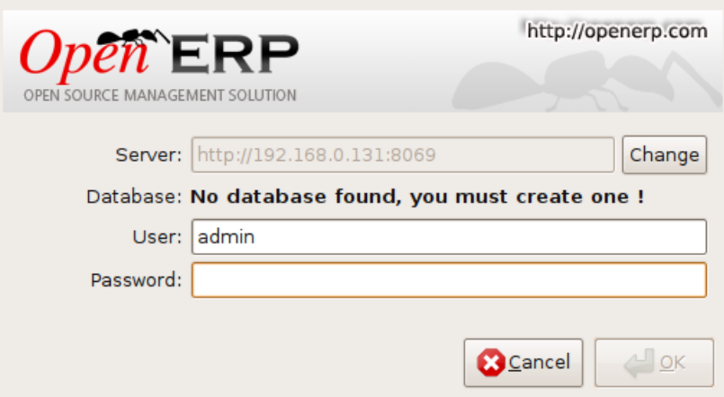

- To connect to Open ERP

You can monitor events effectively from the messages they’ve sent.

Open ERP uses this mechanism to inform users about certain system events. For example if there’s a problem concerning the procurement of a product a request is sent by Open ERP to the production manager.
Send a request to get an understanding of its functionality:
1. Click on the Requests link that should currently be showing No Requests. This opens a window that lists all of your waiting requests.
2. Click New to create and send a new request.
3. Complete the subject of the request, such as How are things? then give a description of the enquiry in the field.
4. Click the Search button to the right of the To field and select Administrator in the window that opens (that’s the user that you’re already connected as).
5. You can then link this request to other system documents using the References field, which could, for example, be a partner or a quotation or a disputed invoice.
6. Click Send to send the request to the intended recipient – that’s yourself in this case. Then click MAIN MENU to return to the original screen.
To check your requests:

1. Click on the link to the right of the Requests label to open a list of your requests. (It’s possible that you’ll still see the statement No Requests because this information is updated periodically rather than instantly.) The list of requests then opens and you can see the requests you’ve been sent there.
Open ERP, a modern approach to integrated business management,
2. Click the Edit icon, represented by a pencil, at the right hand end of the request line. That opens the request in edit mode.
3. You can then click the Reply button and make your response in the Request field that appears in place of the original message.
4. Click Send to save your response and send it to the original sender.

Practical 4: Create a module settings in open ERP

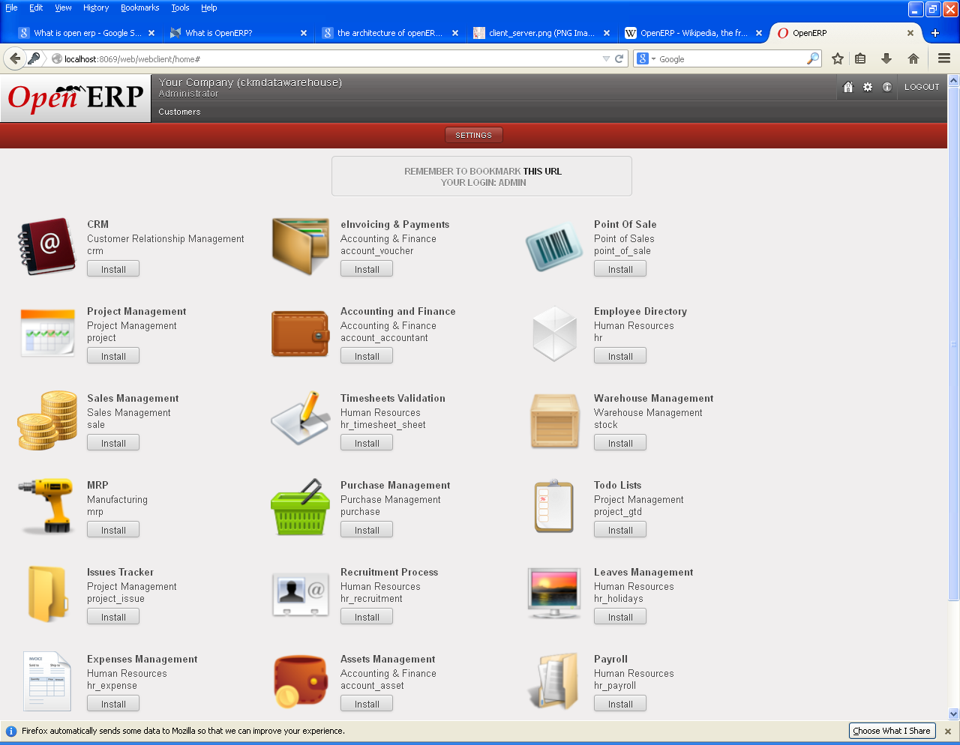
Data warehouse:
Data warehouse is database designed to support decision making in a organization. Data from the production databases are copied to the data warehouse so that queries can be performed without disturbing the performance or the stability of the production systems. Data warehousing contain a wide variety of data that present a coherent picture of business conditions at a single point in time. The term data warehousing generally refers to the combination of many different databases across an enterprise. The primary concept of data warehousing is the data stored for business analysis can most effectively be accessed, by separating it from the data in the operational systems.
Sales:
Applications in sales order management represent a company’s most important point of contact with customers. This application allows a company to manage sales operation quickly and efficiently provide comprehensive solutions for the management of quotes, orders, contracts, price and customers discounts. The system can also customize and streamline orders entry procedures to the specific requirement of the both an individual business and customers as well as generate intelligent pricing and discount strategies.

Purchase:
It is increasingly essential in today’s evermore competitive business environment because it enables a company to make the correct purchase decisions about quality and price, where quality refers to supply lead-time as well as product itself.

Financial accounting:
The objective is company’s wide control and integration of financial information that is essential to strategic decision making.
This modules gives you the ability to centrally track financial accounting within an international framework of multiple companies languages, currencies, and charts. Most of the modules comply with international accounting standards such as GAAP, and IAS.

Practical 5: Use a warehouse module in open ERP
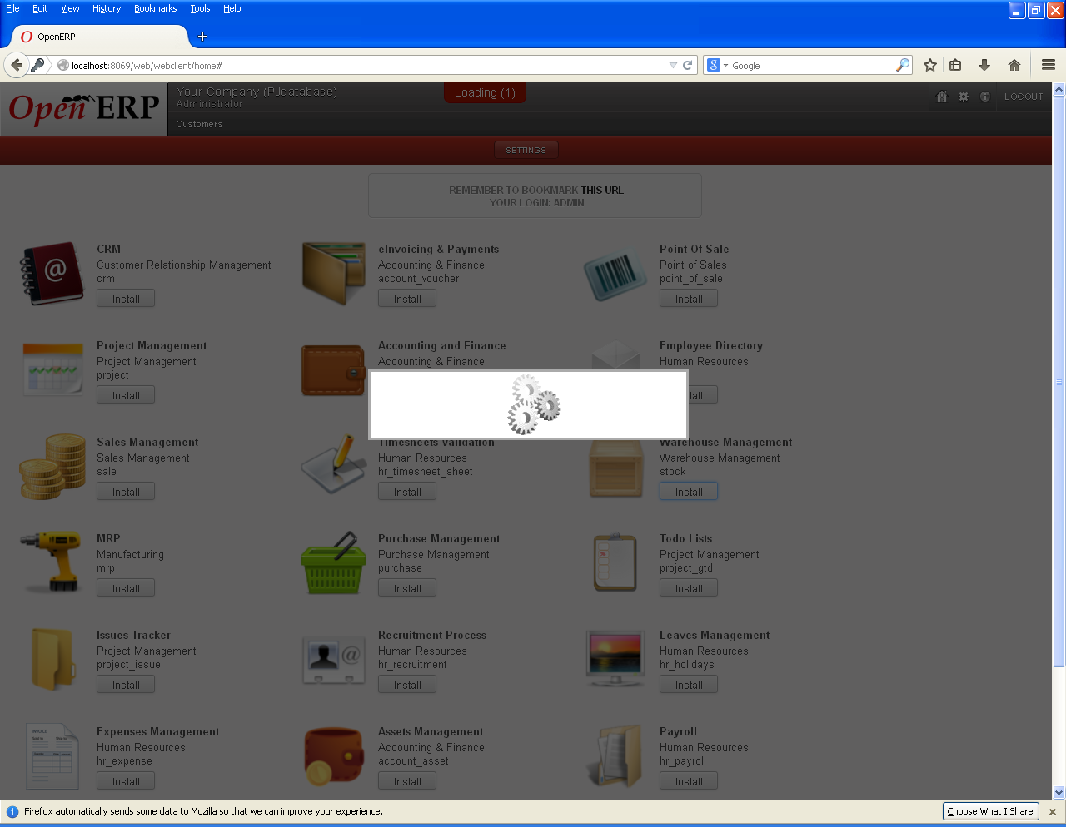
As shown in the above figure, Warehouse Management module is to be installed.
Development of a data warehouse includes development of systems to extract data from operating systems plus installation of a warehouse database system that provides managers flexible access to the data.

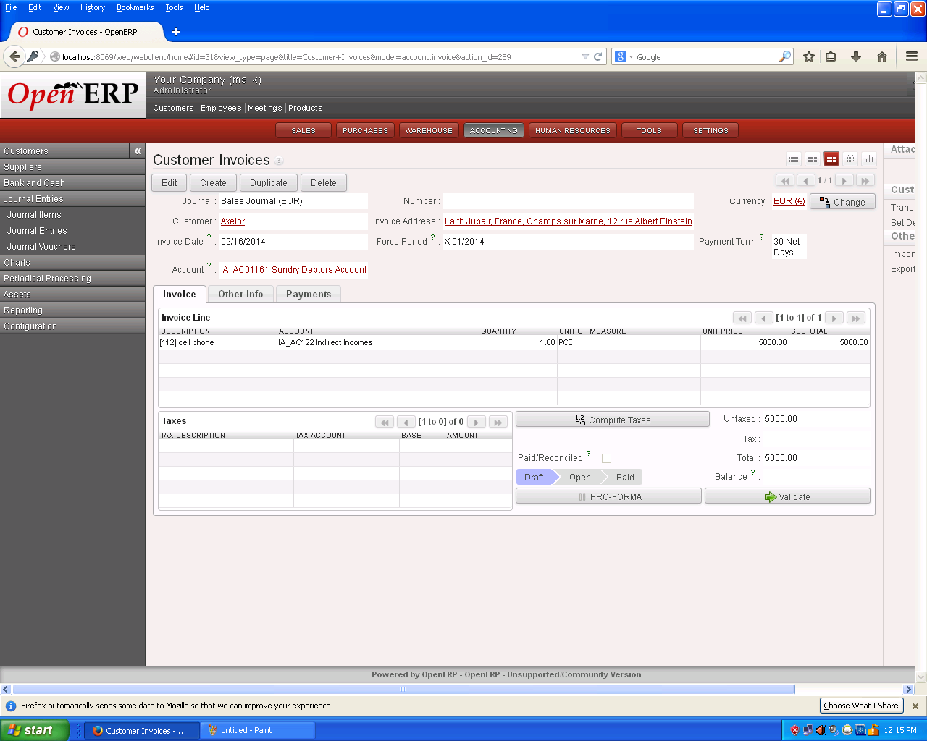
The primary goals of data warehouse are:
- Provide access to the data of an organization
- Data consistency
- Capacity to separate and combine data
- Inclusion of tools setup to query, analyze and present information
- Publish used data
- Drive business reengineering

Incoming Shipments:
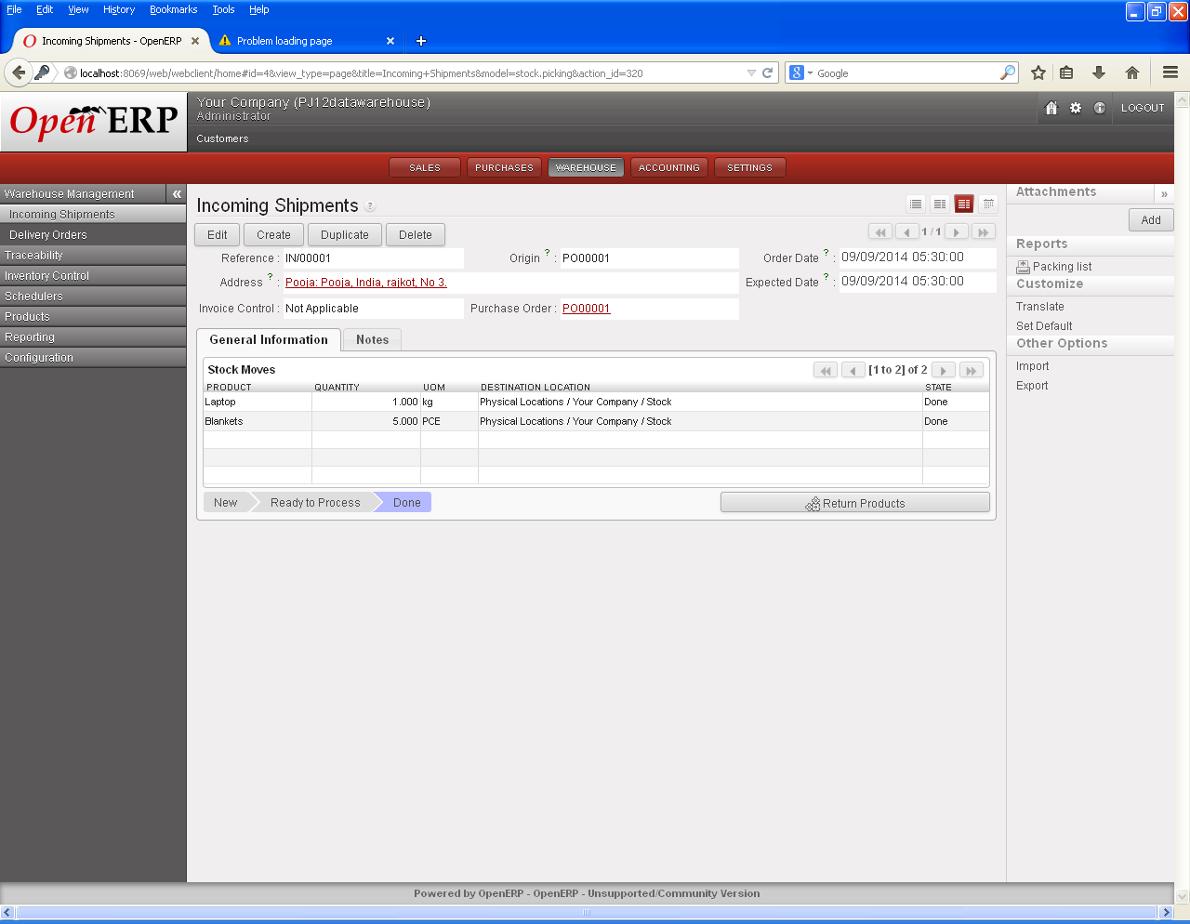

Delivery Orders:
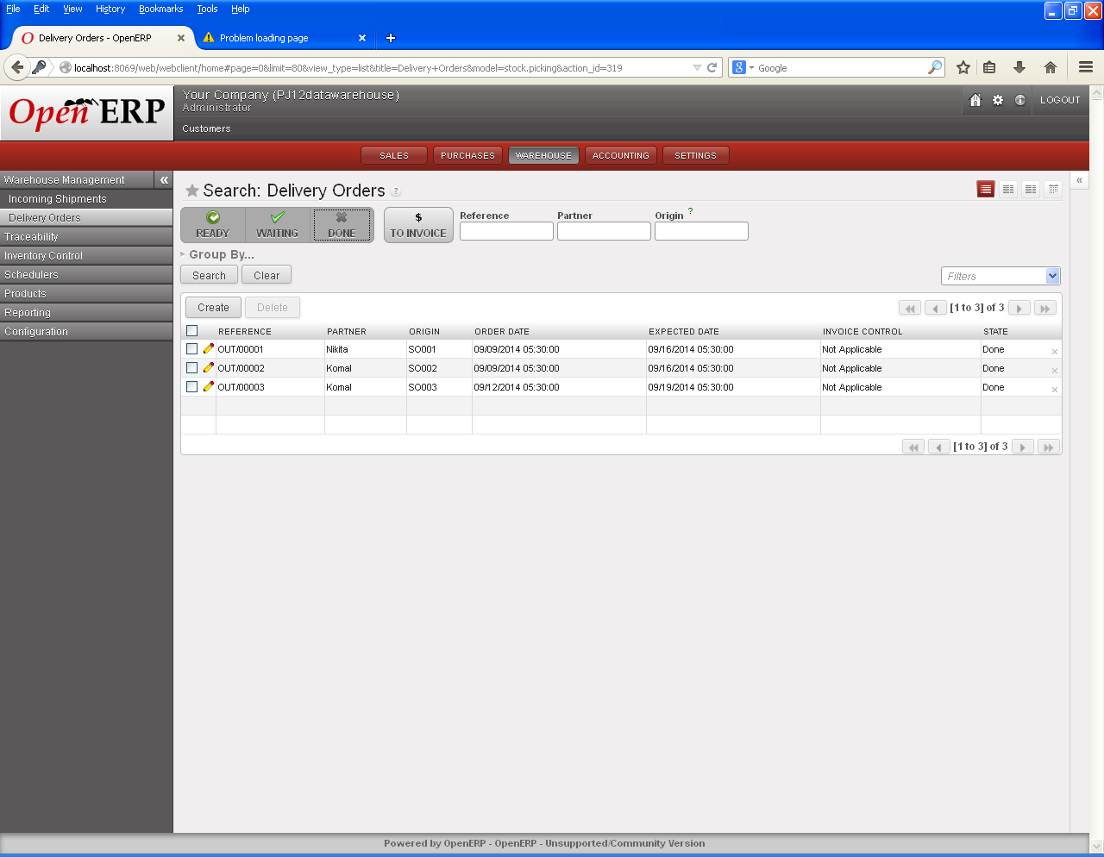

Practical 6: Implement and configure Sales, purchase in Open ERP
SALES:
The sales related business transactions:
- Sales queries, such as inquiries and quotations
- Sales orders
- Outline agreements, such as contracts and scheduling agreements
- Delivery/shipment
- Invoicing/billing
- After sales support
Basic functions of sales order-processing:
- Inquiry handling
- Quotation preparation and processing
- Contracts and contract management
- Monitoring the sales transaction
- Scheduling the delivery
- Checking for the availability
- Calculating the pricing and taxes
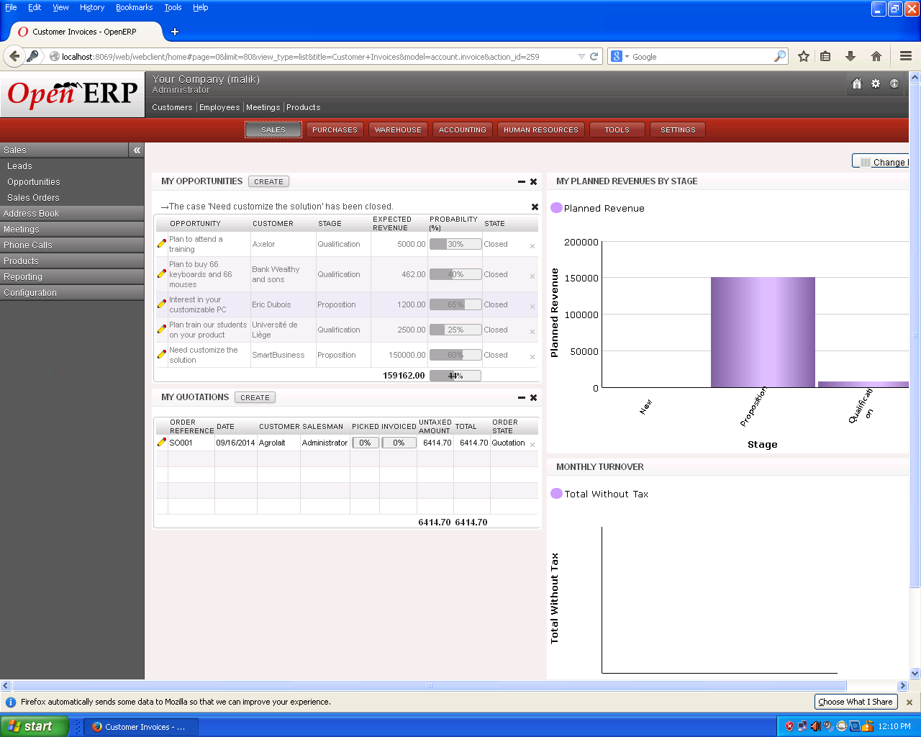
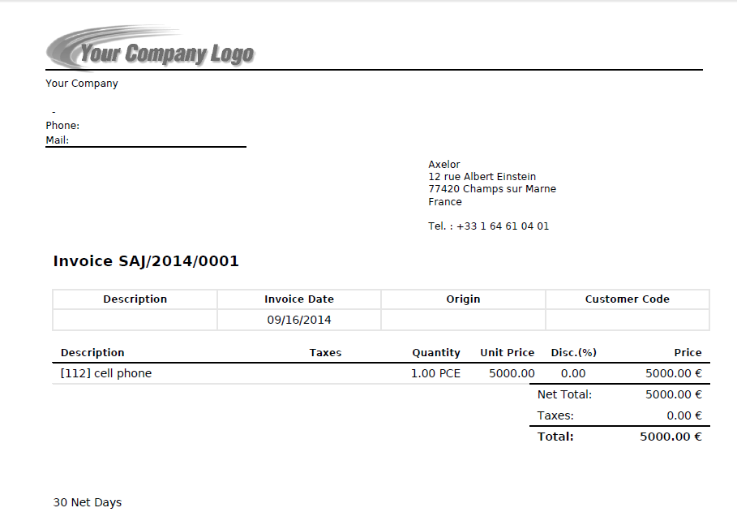

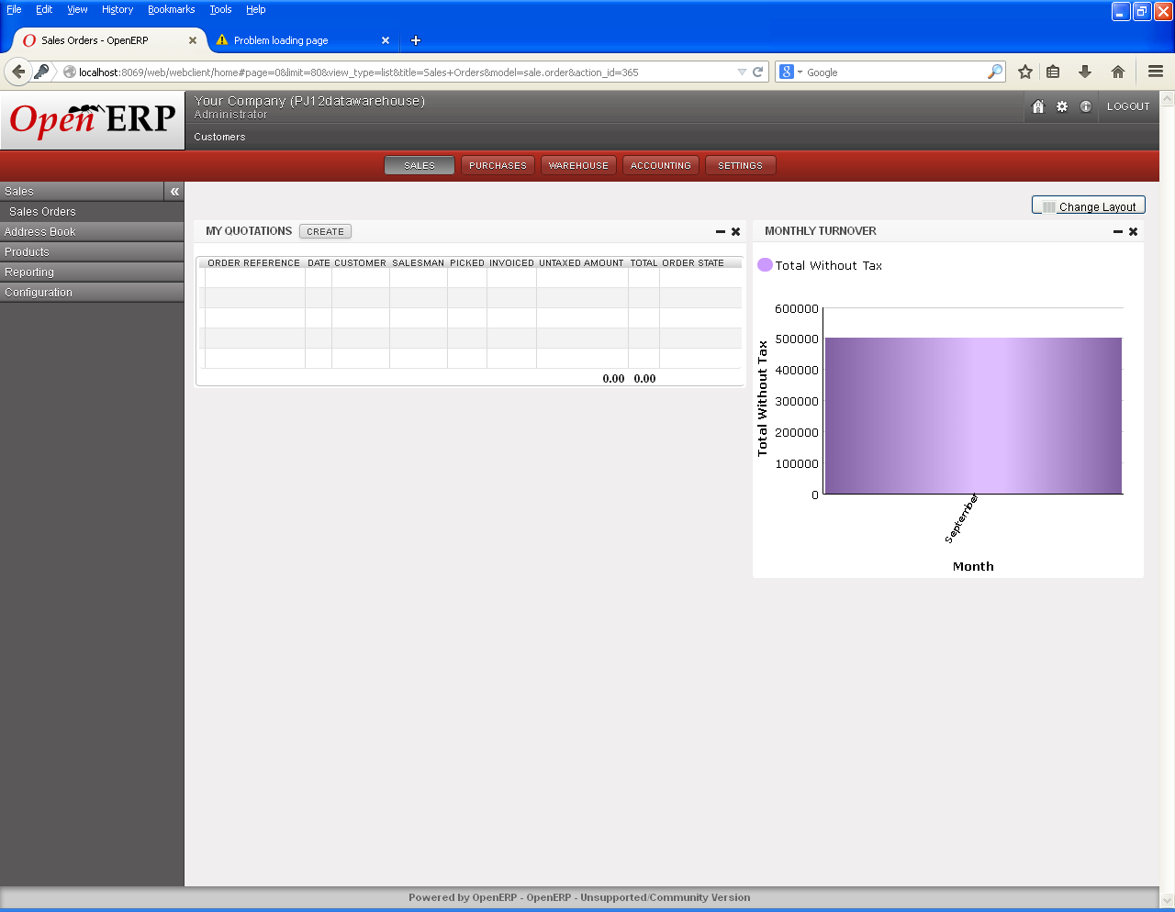

PURCHASE:
Purchase order management includes online requisitioning, centralized contract management, just-in-time schedules and vendor management offering access to an approved suppliers list, purchase order management enables a purchase quotation to be sent to multiple suppliers.
