DNA Sequence Predictions using NLP and ML
ABSTRACT: -
Deoxyribonucleic acid (DNA) is a biological macromolecule. Its main function is information storage. At present, the advancement of sequencing technology had caused DNA sequence data to grow at an explosive rate, which has also pushed the study of DNA sequences in the wave of big data. Moreover, machine learning is a powerful technique for analyzing largescale data and learns spontaneously to gain knowledge. It has been widely used in DNA sequence data analysis and obtained a lot of research achievements. Firstly, the review introduces the development process of sequencing technology, expounds on the concept of DNA sequence data structure and sequence similarity. Then we analyze the basic process of data mining, summary several major machine learning algorithms like Multinomial NB Classifier & Random Forest, and put forward the challenges faced by machine learning algorithms in the mining of biological sequence data and possible solutions in the future. Then we review four typical applications of machine learning in DNA sequence data: DNA sequence alignment, DNA sequence classification, DNA sequence clustering, and DNA pattern mining. We analyze their corresponding biological application background and significance, and systematically summarized the development and potential problems in the field of DNA sequence data mining using Multinomial NB Classifier & Random Forest. Finally, we summarize the content of the review and look into the future of some research directions for the next step.

EXSISTING SYSTEM | PROPOSED SYSTEM
- A vast amount of sequence data has been generated due to advancements in DNA sequencing technology. This exponential increase requires new and efficient methods for the analysis of DNA sequence data. Predicting genes in this newly sequenced data is an important and essential step towards genome annotation. Genome annotation helps in determining function of these genes.  - Accurate splice site prediction in DNA sequences leads to correct gene structure prediction in eukaryotes and it requires effective modelling of regions surrounding these sites. A large number of methods for splice site prediction are available in literature but very few of them are suitable to be incorporated as gene prediction module because of their complexity. In this paper, a splice site prediction method based on second order markov model and support vector machine is developed. | - DNA sequence expresses many information about species which are behaviors, appearance, their parent’s information etc. Those information helps to identify a species separately form other species. Therefore, identifying the DNA Sequence order and their classification is significant need in today. Nowadays the Genetic expression is used frequently in medical sector. It applies to recognize the cancers, down syndrome, mutations, tumors etc.  - The goal of DNA sequencing is identifying the order of nucleotides of a given DNA section. We analyze their corresponding biological application background and significance, and systematically summarized the development and potential problems in the field of DNA sequence data mining using Multinomial NB Classifier & Random Forest and got an highest accuracy of 98.4%.
EXISTING ALGORITHM  - Support Vector Machine (SVM) | PROPOSED ALGORITHM: -  - Multinomial NB Classifier and Count Vector
- Markov chain models and SVM are well established methods and have been successfully used in the field of bioinformatics to solve various problems. Their use in the field of splice site prediction is not new. The individual application of these methods for splice site prediction doesn’t give satisfactory results. However, the results can be improved by combining these methods. In most of the previous attempts where SVM is employed for classification, the DNA sequence data is directly provided as input through binary encoding scheme. These classifiers are not able to distinguish between true and false sites which suggest that SVM need more powerful information modeling approach than simply the sequence data. | ALGORITHM DEFINITION: -  - The multinomial Naive Bayes classifier is suitable for classification with discrete features (e.g., word counts for text classification). The multinomial distribution normally requires integer feature counts. However, in practice, fractional counts such as tf-idf may also work.  - It is a Bayesian learning approach popular in Natural Language Processing (NLP). The program guesses the tag of a text, such as an email or a newspaper story, using the Bayes theorem. It calculates each tag's likelihood for a given sample and outputs the tag with the greatest chance.
DRAWBACKS: -  - It does not execute very well when the data set has more sound i.e. target classes are overlapping.  - It doesn't perform well when we have large data set because the required training time is higher.  - In cases where the number of features for each data point exceeds the number of training data samples, the SVM will underperform. | ADVANTAGES: -  - It is easy to implement as you only have to calculate probability.  - Used for both continuous and discrete data.  - It is highly scalable and can easily handle large datasets.

SYSTEM ARCHITECTURE
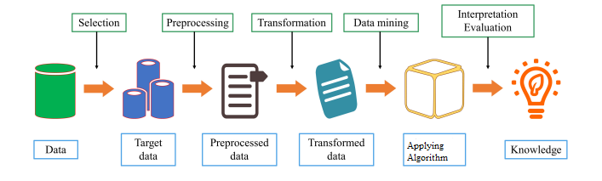

Fig. Proposed Methodology

MINIMUMSYSTEM REQUIREMENTS
HARDWARE REQUIREMENTS
- PROCESSOR : Pentium i3 Processor
- RAM : 2GB DD RAM
- HARD DISK : 250 GB

SOFTWARE REQUIREMENTS
- BACK END : PYTHON
- OPERATING SYSTEM : WINDOWS 7
- IDE : Spider3

