Abstract
Conventionally, wireless controlled robots user circuits, which have a drawback of limited working range, limited frequency range and limited control. Use of mobile phones for robotic control can overcome these limitations. It provides the advantages of robust control, working range as large as the coverage area of the service provider, no interference with other controllers and up to twelve controls.

Although, the apperanceand capabilities of robot vary vastly, all robots share the feature of a mechanical, movables structure under some form of control. The control of robot involves three distent phases: perception, processing, action. Generally, the preceptors are sensors mounted on the robot, processing is done by the on board microcontroller and the task is performed using motors or with some other actuators.

In the project the robot is controlled by a mobile phone that makes a call to the mobile phone attached to the robot. In the course of a call, if any button is pressed a tone corresponding to the button pressed is heard at the other end called ‘Dual Tone Multiple frequency’ (DTMF) tone. The robot receives these tones with help of phone stacked in the robot. The received tone is processed by the microcontroller with the help of DTMF decoder ic cm8870 .these ic sends a signals to the the motor driver ic l293d which derives the motor forward,revarse…etc

INTRODUCTION :

Radio control (often abbreviated to R/C or simply RC) is the use of radio signals to remotely control a device. The term is used frequently to refer to the control of model vehicles from a hand-held radio transmitter. Industrial, military, and scientific research organizations make [traffic] use of radio-controlled vehicles as well.

A remote control vehicle is defined as any mobile device that is controlled by a means that does not restrict its motion with an origin external to the device. This is often a radio control device, cable between control and vehicle, or an infrared controller. A remote control vehicle (Also called as RCV) differs from a robot in that the RCV is always controlled by a human and takes no positive action autonomously.

One of the key technologies which underpin this field is that of remote vehicle control. It is vital that a vehicle should be capable of proceeding accurately to a target area; maneuvering within that area to fulfill its mission and
returning equally accurately and safely to base.

Recently, Sony Ericsson released a remote control car that could be controlled by any Bluetooth cell phone. Radio is the most popular because it does not require the vehicle to be limited by the length of the cable or in a direct line of sight with the controller (as with the infrared set-up). Bluetooth is
still too expensive and short range to be commercially viable.

TECHNOLOGY USED :

Dual-Tone Multi-Frequency (DTMF)

Dual-tone multi-frequency (DTMF) signaling is used for telecommunication signaling over analog telephone lines in the voice-frequency band between telephone handsets and other communications devices and the switching center. The version of DTMF used for telephone tone dialing is known by the trademarked term Touch-Tone (canceled March 13,
1984), and is standardized by ITU-T Recommendation Q.23. It is also known in the UK as MF4. Other multi-frequency systems are used for signaling internal to the telephone network.

As a method of in-band signaling, DTMF tones were also used by cable television broadcasters to indicate the start and stop times of local commercial insertion points during station breaks for the benefit of cable companies. Until better out-of-band signaling equipment was developed in the
1990s, fast, unacknowledged, and loud DTMF tone sequences could be heard during the commercial breaks of cable
channels in the United States and elsewhere.

BLOCK DIAGRAM :

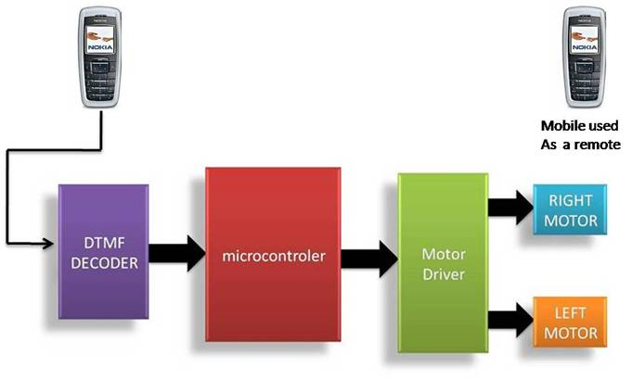

DESCRIPTION:

As shown in the above block diagram, first block

is the
Cell Phone. So,
it acts
as a DTMF generator
with tone

depending upon key
pressed. DTMF
Decoder ,i.e., IC CM8870

decodes the received tone & gives binary equivalent of it to the

microcontroller. The
controller is
programmed
such that

appropriate output is
given to Motor Driver IC L293D which

will drive the two DC Motors connected to it. The concept used for driving is ‘Differential Drive’. So, ultimately the two motors

rotate phone.
according to the key pressed
on the
keypad
of the
cell

COMPONENTS USED:

1) RESISTORS: 2) CAPACITORS:

VALUE QUANTITY
100k | 2
10k | 5
330k | 1

VALUE QUANTITY
0.1 uF 2
22 pF 4

3) OSCILLATORS: 4)ICs:

VALUE QUANTITY
CM 8870 | 1
Atmega16 | 1
74ls04 | 1
L293D NE | 1
L7805 CV | 1

3.57 MHz 1
12 MHz 1
VALUE QUANTITY

5) MISCELLANEOUS:

COMPONENT | QUANTITY
12V ,50 RPM DC MOTOR | 2
DIODE, 4007 | 1
RESET SWITCH | 1
1.5V DC BATTERYs | 9
CONNECTING WIRES | 7

Page 22

CIRCUIT DIAGRAM :

