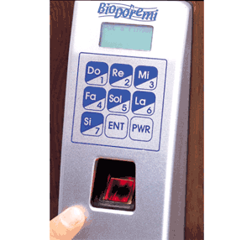

Department of Embedded System

CETPA INFOTECH PVT. LTD

INTRODUCTION

The microcontroller based Door locker is an access control system that allows only authorized persons to access a restricted area. The system is fully controlled by the 8 bit microcontroller AT89C2051 which has a 2Kbytes of ROM for the program memory. The password is stored in the EPROM so that we can change it at any time.

The system has a Keypad by which the password can be entered through it. When the entered password equals with the password stored in the memory then the gate gets open. If we entered a wrong password then the Alarm is switched on.
This system is best suitable for corporate offices, ATMs and home security.

Features :
- Easy to use for day to day operation.
- LCD display
- Needs to be programmed only once.
- Easy to program.
- Previous and current password is stored in EEPROM

Benefits :
- Accuracy
- No manual intervention
- Saves man power and money
- Easy programming with the help of manual.

CIRCUIT DESCRIPTION

In this project we have used 8051 microcontroller.20th pin of microcontroller is ground whereas 40th pin is supply.

The system comprises a small electronic unit with a numeric keypad, which is
fixed out side the entry door to control a stepper motor. When an authorized person enters predetermined user ID and password via the keypad, the stepper motor is operated for a limited time so the door can be open. At the end of preset delay, the stepper motor is operated in reverse direction and the door gets locked again.

When the code has been incorrectly entered, the code lock will switch to block mode.
A buzzer is provided for audio acknowledgment of the wrong password.
This project uses regulated 5V, 500mA power supply. 7805 three terminal voltage regulator is used for voltage regulation. Bridge type full wave rectifier is used to rectify the ac out put of secondary of 230/12V step down transformer.

89c51 MICROCONTROLLER ARCHITECTURE

8051 Microcontroller

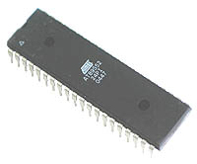

The AT89C51 is a low-power, high-performance CMOS 8-bit microcomputer with 4K
bytes of Flash programmable and erasable read only memory (PEROM). The device
is manufactured using Atmel’s high-density nonvolatile memory technology and is
compatible with the industry-standard MCS-51 instruction set and pin out. The on-chip Flash allows the program memory to be reprogrammed in-system or by a conventional non-volatile memory programmer. By combining a versatile 8-bit CPU with Flash on a monolithic chip, the Atmel AT89C51 is a powerful microcomputer which provides a highly-flexible and cost-effective solution to many embedded control applications.

The AT89C51 provides the following standard features: 4K bytes of Flash, 128 bytes of RAM, 32 I/O lines, two 16-bit timer/counters, a five vector two-level interrupt architecture, a full duplex serial port, on-chip oscillator and clock circuitry. In addition, the AT89C51 is designed with static logic for operation down to zero frequency and supports two software selectable power saving modes. The Idle Mode stops the CPU while allowing the RAM, timer/counters, serial port and interrupt system to continue functioning. The Power-down Mode saves the RAM contents but freezes the oscillator disabling all other chip functions until the next hardware reset

CIRCUIT DIAGRAM

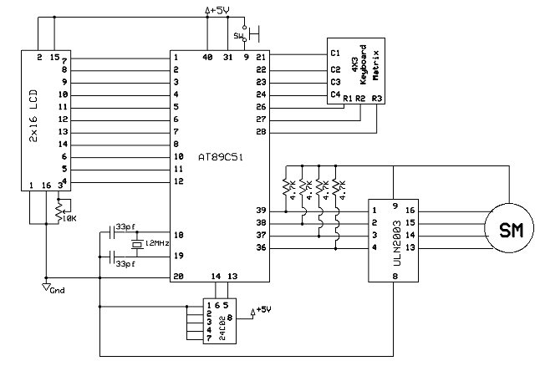

COMPONENTS USED

Sr. no. | Component used | Quantity (no.s)
1. | 89c51 microcontroller (base + IC) | 1
2. | Diode (4007, .7v) | 4
3. | Uln 2003 (base + IC) | 1
4. | Unipolar Stepper motor | 1
5. | 10k resistance | 6
6. | 4.7k resistance | 7
7. | 470 ohms resistance | 4
8. | Crystal oscillator (12Mhz frequency) | 1
9. | buzzer | 1
10. | Transformer (220v-909) | 1
11. | L.E.D.s | 3
12. | Ceramic Capacitor (30pf-33pf) | 2
13. | Electrolytic capacitor (100 microfarad,470 microfarad) | 1,1
14. | Seven segment(LT 542) | 2
15. | Voltage regulator (7805)(+5v) | 1
16. | EEPROM(24C02) | 1
17. | 2-Pin connector | 1
18. | 5-pin connector | 1
19. | 2- pin switches | 17
20. | Cello tape (for electrical use) | 1
21. | Supply wire | 2 mts

