SYNOPSIS
ON
AUTOMATIC TEMPRATURE CONTROLLER

BY
CETPA INFOTECH PRIVATE LIMITED

Block Diagram of temperature indicator using IC89C52:

POWER SUPPLY

7805 REGULATOR

DS1621
TEMPRATURE SENSOR

MCU
AT89C52

LCD DISPLAY
(16*1)

CONSTRUCTION AND WORKING OF THE CIRCUIT
The figure above shows the basic block diagram of the temperature indicator system using microcontroller AT89C52. The power supply for the circuit is regulated by the IC7805 and supplied to different parts of the unit. DS1621 is the temperature sensor chip. The microcontroller unit (MCU) reads the temperature from the sensor. The temperature data is compared with certain user-define temperature values and processed inside the MCU as per the program and then sent to the LCD display.The functions of each section of the circuit are explained in the following sections.

Power Supply
The power supply unit consists of a step-down transformer (230V AC primary to 0-9V, 250mA secondary), bridge rectifier and voltage regulator. The output of the transformer is fed to bridge rectifier diodes D1 through D4 (each IN4007). The ripple from the output bridge rectifier is filtered by capacitor C1 and fed to regulator IC7805. The regulated output is given to the temperature sensor, microcontroller unit and LCD module, respectively.
When the switch S1 is closed, LED1 glows to indicate the presence of power in the system.
Temperature Sensor
Temperature sensor chip DS1621 (IC3) is an 8-pin DIP IC. The pin details of DS1621 are shown in its diagram and the internal block diagram in figure-3. The chip can measure temperatures from -55 to 125 degree Celsius in 0.5 degree Celsius increments, which are read as 9-bit values. It can operate off 2.7V to 5.5V. Data is read /written via a 2-wire serial interface. Pins 1 and 2 of the temperature IC are connected to pins 11 and 10 of the microcontroller, respectively. The thermal alarm output (Tout) of IC DS1621 activates when the temperature exceeds user defined high temperature TH. The output remains active until the temperature drops below user-defined low temperature Tl. User-defined temperature settings are stored in the non-volatile memory. Temperature settings and temperature readings are all communicated to/from IC DS1621 over a 2-wire serial cable. The most significant bit (MSB) of the data is transmitted first and the last significant bit (LSB) is transmitted last.
Addressing
The chip address of DS1621 comprises internal preset code nibble '1001' (binary) followed by internally configurable address pins/bits A2, A1 and A0. The eighth bit of the address byte is determined by the type of operation (either read or write) that is to be performed. For writing to the device the eight bit is '0' and for reading from the device the eighth bit is '1'. In our case, A2, A1 and A0 pins are grounded and hence the device address for writing is '1001000b' or 90 (hex) and for reading the device address is '10010001b' or 91 (hex).

Configuration/Status register
This register can be accessed for reading or writing by issuing command byte AC(hex) from the master (82C52). This register is particularly required if DS1621 is used for thermostat control, since it contains flag bits THF (high-temperature flag) which are set to '1' when temperature crosses the respective limits earlier written into TH and TL registers. It also contains the flag bit (done), which is set to '1' when results of conversion are available after issuing of start conversion command EE(hex). The other bits of configuration register are defined. 'NVB' is the non-volatile memory busy flag, '1' is to write to an E2 memory cell in progress, '0' indicates that non-volatile memory is not busy, 'POL' is non-volatile output polarity bit ('1'=active high and '0' = active low) and '1shot' is one-shot mode. A copy to E2 may take up to 10ms. If 1shot is '1', DS1621 will perform one temperature conversion upon reception of the start convert T protocol. If 1shot is '0', DS1621 will continuously perform temperature conversions. This bit is non-volatile.

Command Set
Complete command instruction set for accessing various internal registers as well as for starting and stopping of conversion process are given in Table. For understanding the exact sequence in which start bit, address byte, acknowledgement bit, command byte and data bytes are to be sent along the I2C bus, please refer to the datasheet of DS1621, wherein these aspects have been explained in proper detail. This will help in understanding the contents of the main program.

Microcontroller Unit
Microcontroller AT89C52 (IC2) is a 40 pin IC from Atmel. Its pin details are shown in the pin description diagram. Like AT89C51, it also belongs to the 8031/8051 family. Microcontroller AT89C52 has a 256*8 bit internal random- access memory (RAM), eight interrupt sources and 8KB of flash memory compared to 128*8 -bit internal RAM, six interrupt sources and 4KB flash memory in AT89C51. By combining a versatile 8-bit CPU with flash memory on a monolithic chip, Atmel AT89C52 is a powerful, highly cost-effective solution to many embedded control applications. Ports 0 and 2 are 8-bit bidirectional input/ output (I/O) ports. These ports haven't been used in this temperature indicator. Port 1 is an 8-bit bidirectional I/O port with internal pull-ups. Ports 1.0 through 1.7 are connected to pins 7 through 14 of the LCD. Port 1 output buffers can sink/ source four TTl inputs. Port 3 is a 8-bit bidirectional I/O port with internal pull-ups. Ports 3.0 and 3.1 of IC2 are connected to serial clock line (SCL) and serial data line (SDA) of IC3, respectively. Port 3 output buffers can sink/source four TTL inputs. A 12MHz crystal oscillator is connected to XTAL1 and XTAL2 pins for operation of the microcontroller. A high pulse on RST pin (pin 9) while the oscillator is running resets the microcontroller. In this circuit, this pin is connected to +Vcc through capacitors C5 (10uF, 16V). The external-access enable pin (EA) is connected to +Vcc for internal program executions. This pin also receives the 12V programming enable voltage (Vpp) during flash programming when 12V program is selected

TESTING

Visualization Test:
When the fabrication process is completed & all the components have been mounted perfectly the visualization testing is performed. In this testing the circuit is scanned simply by the eyes & not by the help of any instrument. It to ensure that the soldering is perfect and there is no loose connection between the components.

Pre-heating Test:
This test is performed to check the heat tolerance of the components. In this the circuit is provided power supply and left for some time. After a interval of time it is checked that if there is any component get faulty component specially for IC’s.

Applications:

- This system can be placed near computer processors for heat sensing.
- Placed near heat sensitive devices to indicate the temperature.
- This system can interfaced with computers and temperature can be controlled.
Circuit Diagram:
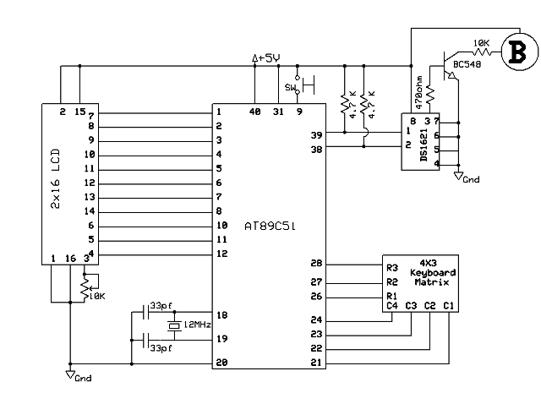

Component’s List for Project
AT89C51 1
DS-1621 1
2 Line LCD 1
Buzzer 1
Transistor BC 548 1
LED 1
Resistances 10K 5
Resistance 470 ohm 5
33picofarad Ceramic Disk Capacitor 2
Crystal Osci. (12 MHz) 1
Mini Switch 13
10K Pot (Preset) 1
Diode 1n4007 4
IC Base (8Pin, 40Pin) 1 each
Relimate (5 pin and 2 pin) 1 each
Relimate (16pin) 2
Power chord 1
Capacitor 100Microfarad/ 25v 1
Capacitor 10 Microfarad / 25v 1
Voltage Regulator IC 7805 1
Transformer (9-0-9) 1

