SYNOPSIS
ON
FISH FEEDER

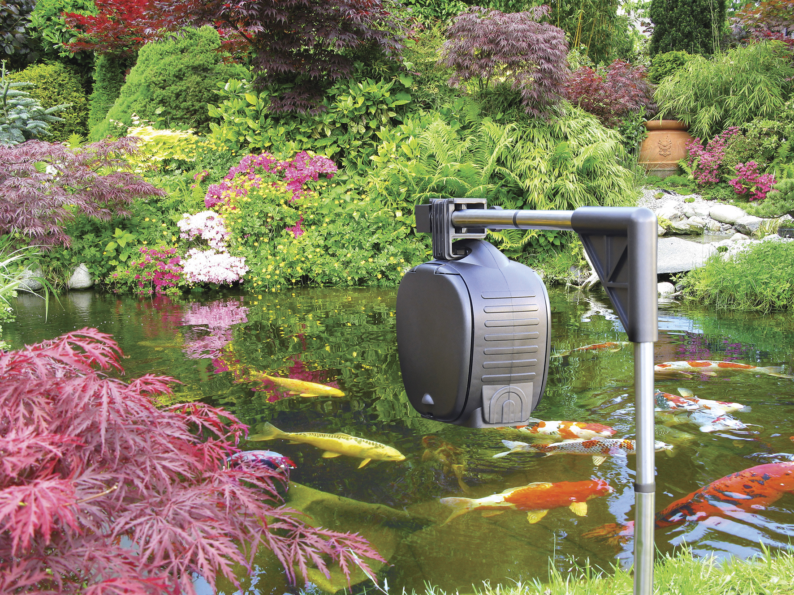

Department of Embedded System
CETPA INFOTECH PVT. LTD

INTRODUCTION

This project is design that is use to dispense fish food automatically into an aquarium, after every 2min. It will be capable of dispensing frozen blocks of food at a several times a day at any desired time (all times are programmable).

Features :
- Dispense food at preset times.
- time can easily be changed if required.
- Easy to use for day to day operation.
- Stand alone device – no computer or any other hardware required.
- Needs to be programmed only once.
- Easy to program.

Benefits :
- No need to assign a person for giving the food every time
- Accuracy to timings
- No manual intervention
- Saves man power and money
- Easy programming with the help of manual.

CIRCUIT DESCRIPTION

In this project we have used 8051 microcontroller.20th pin of microcontroller is ground whereas 40th pin is supply.Two seven segment is connected to different port.stepper motor is also used.

When reset is pressed after 1 min stepper motor rotates representing gate is opening. After that counting starts from 1 to 10 on seven segment. As counting stop after 10, stepper motor again rotates representing gate is closed.
So after every 1 min gate will be open for 10 sec.and after 10 sec it will be closed automatically.

And if reset is pressed it will starts from starting.

89c51 MICROCONTROLLER ARCHITECTURE

8051 Microcontroller

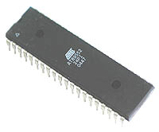

The AT89C51 is a low-power, high-performance CMOS 8-bit microcomputer with 4K
bytes of Flash programmable and erasable read only memory (PEROM). The device
is manufactured using Atmel’s high-density nonvolatile memory technology and is
compatible with the industry-standard MCS-51 instruction set and pin out. The on-chip Flash allows the program memory to be reprogrammed in-system or by a conventional non-volatile memory programmer. By combining a versatile 8-bit CPU with Flash on a monolithic chip, the Atmel AT89C51 is a powerful microcomputer which provides a highly-flexible and cost-effective solution to many embedded control applications.

The AT89C51 provides the following standard features: 4K bytes of Flash, 128 bytes of RAM, 32 I/O lines, two 16-bit timer/counters, a five vector two-level interrupt architecture, a full duplex serial port, on-chip oscillator and clock circuitry. In addition, the AT89C51 is designed with static logic for operation down to zero frequency and supports two software selectable power saving modes. The Idle Mode stops the CPU while allowing the RAM, timer/counters, serial port and interrupt system to continue functioning. The Power-down Mode saves the RAM contents but freezes the oscillator disabling all other chip functions until the next hardware reset

COMPONENTS USED

Sr. no. | Component used | Quantity (no.s)
1. | 89c51 microcontroller (base + IC) | 1
2. | Diode (4007, .7v) | 4
3. | Uln 2003 (base + IC) | 1
4. | Unipolar Stepper motor | 1
5. | 10k resistance | 6
6. | 4.7k resistance | 7
7. | 470 ohms resistance | 4
8. | Crystal oscillator (12Mhz frequency) | 1
9. | Buzzer | 1
10. | Transformer (220v-909) | 1
11. | L.E.D.s | 3
12. | Ceramic Capacitor (30pf-33pf) | 2
13. | Electrolytic capacitor (100 microfarad,470 microfarad) | 1,1
14. | Seven segment(LT 542) | 2
15. | Voltage regulator (7805)(+5v) | 1
16. | 2-Pin connector | 1
17. | 5-pin connector | 1
18. | 2- pin switches | 1
19. | Cello tape (for electrical use) | 1
20. | Supply wire | 2 mts

CIRCUIT DIAGRAM

