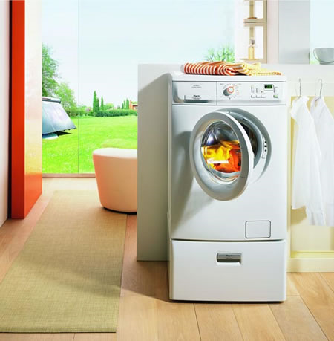

Department of Embedded System
CETPA INFOTECH PVT. LTD

INTRODUCTION

This project is automatic washing machine. The device shows each step to be carried out,on LCD and a beep announces each operation.

This project is designed with most reliable microcontroller based technology to get best reliability and maintenance free life.

Features :
- Time for each operation can easily be changed if required.
- Easy to use for day to day operation.
- Stand alone device – no computer or any other hardware required.
- LCD display
- Needs to be programmed only once.
- Easy to program.

Benefits :
- Accuracy to timings
- No manual intervention
- Saves man power and money
- Easy programming with the help of manual.

CIRCUIT DESCRIPTION

In this project we have used 8051 microcontroller.20th pin of microcontroller is ground whereas 40th pin is supply. LCD is connected with the port 1 of the MC. Control lines are connected with port 3 of the MC. The contrast of the LCD is controlled by 10k variable resistor and buzzer is connected to port P0.2.

When reset is pressed “WELCOME TO ALL” will be displayed on LCD. Now after 2 sec buzzer will ring displaying “PUT WATER AND DETERGENT” on the LCD and now after dat motor rotate for 6sec.
Then ‘SOAK CLOTH” will be displayed and again motor rotates for 6sec.and after that “RINSE” is displayed on lcd and at last ‘FINISH” is displayed.

CIRCUIT DIAGRAM

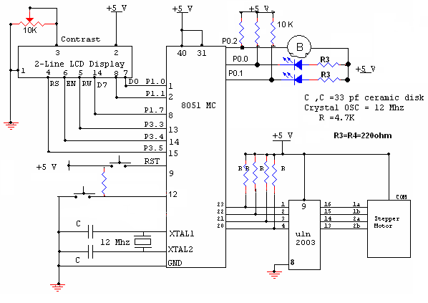

COMPONENTS USED

Sr. no. | Component used | Quantity (no.s)
 | 89c51 microcontroller (base + IC) | 1
 | Diode (4007, .7v) | 4
 | 10k resistance | 6
 | 4.7k resistance | 7
 | 470 ohms resistance | 4
 | Crystal oscillator (12Mhz frequency) | 1
 | buzzer | 1
 | Transformer (220v-909) | 1
 | L.E.D.s | 1
 | Ceramic Capacitor (30pf-33pf) | 2
 | Electrolytic capacitor (100 microfarad,470 microfarad) | 1,1
 | ULN 2003 | 1
 | Voltage regulator (7805)(+5v) | 1
 | 2-Pin connector | 1
 | 5-pin connector | 1
 | 2- pin switches | 1
 | LCD(2*16 Line) | 1
 | Stepper Motor | 1
 | Supply wire | 2 mts

