2010

Department of Embedded System
CETPA INFOTECH PVT. LTD

REPORT ON ELECTRONIC VOTING MACHINE



CONTENT

- Introduction

2. Component Used

3. Circuit Diagram

4. Circuit Description

- 8051 Microcontroller Architecture

6. Serial communication through RS232

7. Diode

8. Resistor

9.Crystal Oscillator

10. Voltage Regulator

11. Capacitor

12. Momentary switch

13. Source Code in Assembly

14. Pcb Layout

15. Bibliography

INTRODUCTION

This project is design for the student to make them understand the technology used in a now a day’s voting machine system, which is used in whole world.. The voting machine is programmed for the specific operation. Every operation on the voting machine is defined is display on the monitor.

Features :
- Easy to use for day to day operation.
- Stand alone device – no computer or any other hardware required.
- Needs to be programmed only once.
- Easy to program.

Benefits :
- No need to assign a person
- No manual intervention
- Saves man power and money
- Easy programming with the help of manual.

COMPONENTS USED

Sr. no. | Component used | Quantity (no.s)
1. | AT 89c51 Micro controller (base + IC) | 1
2. | Diode (4007, .7v) | 4
3. | 10k resistance | 2
4. | Crystal oscillator (11.0592Mhz frequency) | 1
5. | L7805CN (voltage regulator) | 1
6. | Transformer (220v-909) | 1
7. | LEDs | 2
8. | 9 Pin DB connector | 1
9. | Electrolytic capacitor (10 microfarad) | 4
10. | Electrolytic capacitor (1000 microfarad) | 1
11. | RS 232 cable (male female) | 1
12. | 2-Pin connector | 1
13. | MAX 232 IC | 1
14. | 2- pin switches | 5
15 | 24C02 | 1
16. | Cello tape (for electrical use) | 1

CIRCUIT DIAGRAM

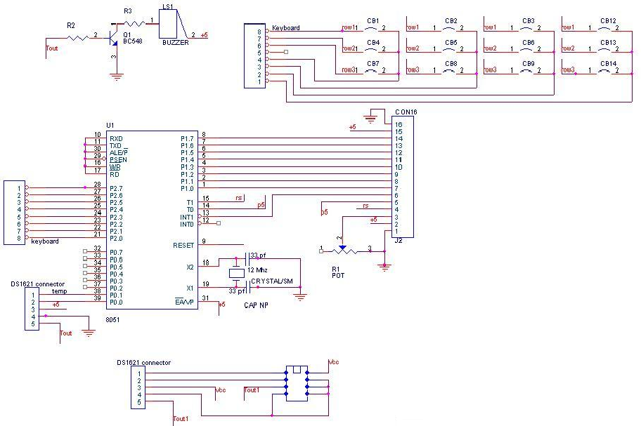

CIRCUIT DESCRIPTION

In this project we try to give the Idea of prototype voting machines. We are using micro controller AT89C51 for controlling the voting operation. The voting machine is designed for three Political parties. There is a Monitor display for showing the status of voting by interfacing the voting machine with the PC. For connecting the voting machine with PC we use the Hyper Terminal communication system, which are already come with the Window2000\XP operating system.

89c51 MICROCONTROLLER ARCHITECTURE

8051 Microcontroller

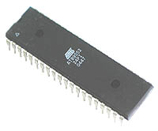

The AT89C51 is a low-power, high-performance CMOS 8-bit microcomputer with 4K
bytes of Flash programmable and erasable read only memory (PEROM). The device
is manufactured using Atmel’s high-density nonvolatile memory technology and is
compatible with the industry-standard MCS-51 instruction set and pin out. The on-chip Flash allows the program memory to be reprogrammed in-system or by a conventional non-volatile memory programmer. By combining a versatile 8-bit CPU with Flash on a monolithic chip, the Atmel AT89C51 is a powerful microcomputer which provides a highly-flexible and cost-effective solution to many embedded control applications.

The AT89C51 provides the following standard features: 4K bytes of Flash, 128 bytes of RAM, 32 I/O lines, two 16-bit timer/counters, a five vector two-level interrupt architecture, a full duplex serial port, on-chip oscillator and clock circuitry. In addition, the AT89C51 is designed with static logic for operation down to zero frequency and supports two software selectable power saving modes. The Idle Mode stops the CPU while allowing the RAM, timer/counters, serial port and interrupt system to continue functioning. The Power-down Mode saves the RAM contents but freezes the oscillator disabling all other chip functions until the next hardware reset.

Pin Configuration:

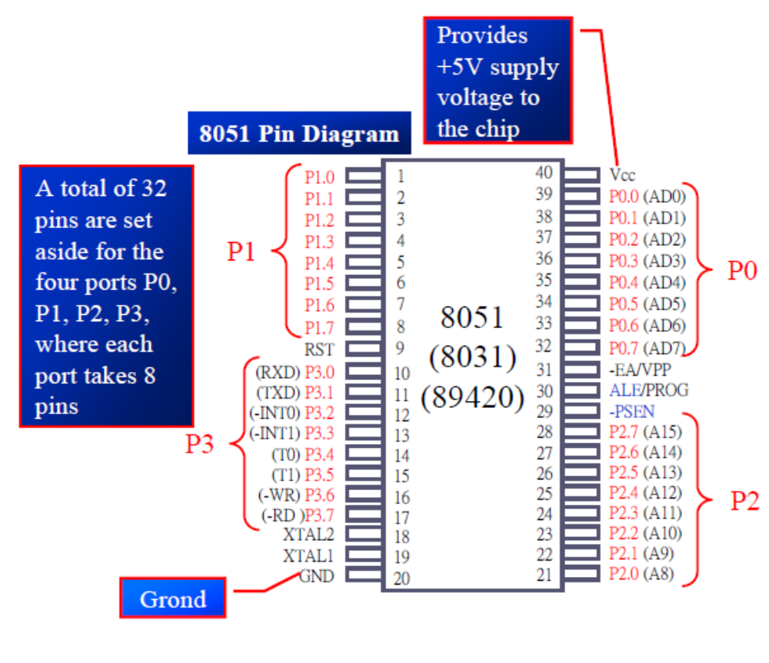

Pin Description:

VCC:
Supply voltage.

GND:
Ground.

Port 0:
Port 0 is an 8-bit open-drain bi-directional I/O port. As an output port, each pin can sink eight TTL inputs. When 1s are written to port 0 pins, the pins can be used as high impedance inputs. Port 0 may also be configured to be the multiplexed low order

Address /data bus during accesses to external program and data memory. In this mode P0 has internal pull ups. Port 0 also receives the code bytes during Flash programming,
and outputs the code bytes during program verification. External pull ups are required during program verification.

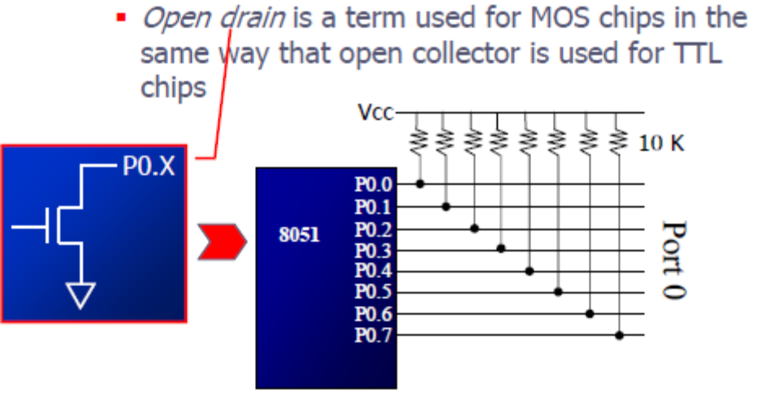

Port 1:
Port 1 is an 8-bit bi-directional I/O port with internal pull-ups. The Port 1 output buffers can sink/source four TTL inputs. When 1s are written to Port 1 pins they are pulled high by the internal pull-ups and can be used as inputs. As inputs, Port 1 pins that are externally being pulled low will source current (IIL) because of the internal pull-ups. Port 1 also receives the low-order address bytes during Flash programming and verification.

Port 2:
Port 2 is an 8-bit bi-directional I/O port with internal pull-ups. The Port 2 output buffers can sink/source four TTL inputs. When 1s are written to Port 2 pins they are pulled high by the internal pull-ups and can be used as inputs. As inputs, Port 2 pins that are externally being pulled low will source current (IIL) because of the internal pull-ups.
Port 2 emits the high-order address byte during fetches from external program memory and during accesses to external data memory that use 16-bit addresses (MOVX @ DPTR). In this application, it uses strong internal pull-ups when emitting 1s. During accesses to external data memory that use 8-bit addresses (MOVX @ RI), Port 2 emits the contents of the P2 Special Function Register. Port 2 also receives the high-order address bits and some control signals during Flash programming and verification.

Port 3:
Port 3 is an 8-bit bi-directional I/O port with internal pull-ups. The Port 3 output buffers can sink/source four TTL inputs. When 1s are written to Port 3 pins they are pulled high by the internal pull-ups and can be used as inputs. As inputs, Port 3 pins that are externally being pulled low will source current (IIL) because of the pull-ups. Port 3 also serves the functions of various special features of the AT89C51 as listed below: Port 3 also receives some control signals for Flash programming and verification.

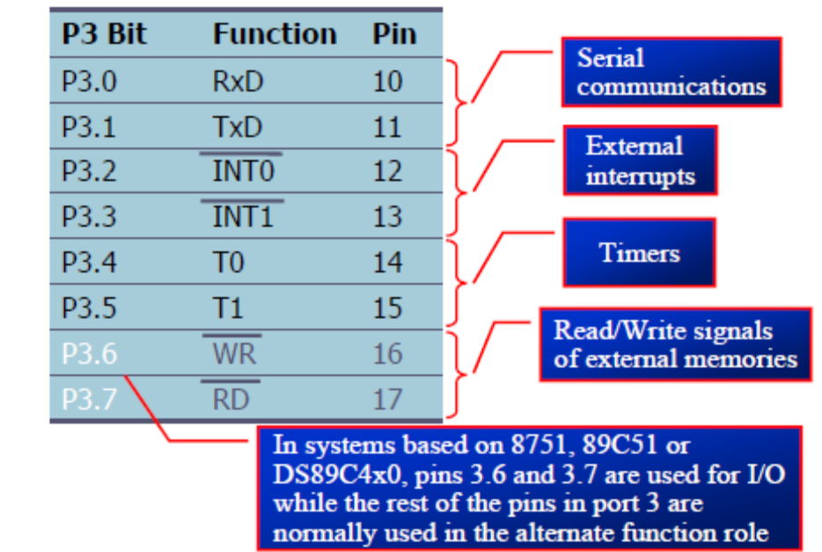

ALE/PROG:
Address Latch Enable output pulse for latching the low byte of the address during accesses to external memory. This pin is also the program pulse input (PROG) during Flash programming. In normal operation ALE is emitted at a constant rate of 1/6 the oscillator frequency, and may be used for external timing or clocking purposes. Note, however, that one ALE
Pulse is skipped during each access to external Data Memory. If desired, ALE operation can be disabled by setting bit 0 of SFR location 8EH. With the bit set, ALE is active only during a MOVX or MOVC instruction. Otherwise, the pin is weakly pulled high. Setting the ALE-disable bit has no effect if the microcontroller is in external execution mode.

RESET:
Reset input. A high on this pin for two machine cycles while the oscillator is running resets the device.

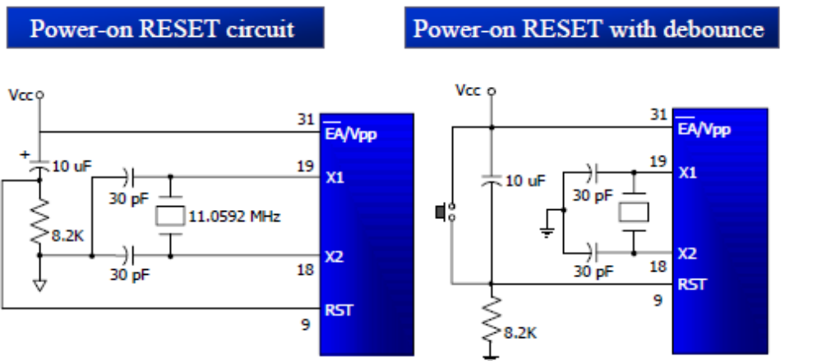

PSEN:
Program Store Enable is the read strobe to external program memory. When the AT89C51 is executing code from external program memory, PSEN is activated twice each machine cycle, except that two PSEN activations are skipped during each access to external data memory.

EA/VPP:
External Access Enable. EA must be strapped to GND in order to enable the device to fetch code from external program memory locations starting at 0000H up to FFFFH. Note, however, that if lock bit 1 is programmed, EA will be internally latched on reset. EA should be strapped to VCC for internal program executions. This pin also receives the 12-volt programming enable voltage (VPP) during Flash programming, for parts that require 12-volt VPP.

XTAL1:
Input to the inverting oscillator amplifier and input to the internal clock operating circuit.

XTAL2:
Output from the inverting oscillator amplifier.

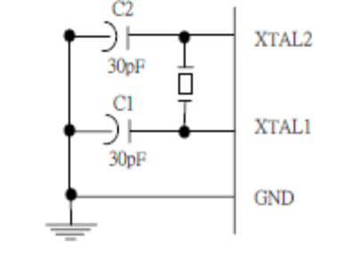

Oscillator Characters:
XTAL1 and XTAL2 are the input and output, respectively, of an inverting amplifier which can be configured for use as an on-chip oscillator, as shown in Figure 1. Either a quartz crystal or ceramic resonator may be used. To drive the device from an external clock source, XTAL2 should be left unconnected while XTAL1 is driven as shown in Figure 2. There are no requirements on the duty cycle of the external clock signal, since the input to the internal clocking circuitry is through a divide-by-two flip-flop, but minimum and maximum voltage high and low time specifications must be observed.

Idle Mode:
In idle mode, the CPU puts itself to sleep while all the on chip peripherals remain active. The mode is invoked by software. The content of the on-chip RAM and all the special functions registers remain unchanged during this mode. The idle mode can be terminated by any enabled interrupt or by a hardware reset. It should be noted that when idle is terminated by a hard ware reset, the device normally resumes program execution, from where it left off, up to two machine cycles before the internal reset algorithm takes control. On-chip hardware inhibits access to internal RAM in this event, but access to the port pins is not inhibited. To eliminate the possibility of an unexpected write to a port pin when Idle is terminated by reset, the instruction following the one that invokes Idle should not be one that writes to a port pin or to external memory.

Programming the Flash:
The AT89C51 is normally shipped with the on-chip Flash memory array in the erased state (that is, contents = FFH) and ready to be programmed. The programming interface accepts either a high-voltage (12-volt) or a low-voltage (VCC) program enable signal. The low-voltage programming mode provides a convenient way to program the AT89C51 inside the user’s system, while the high-voltage programming mode is compatible with conventional third party Flash or EPROM programmers. The AT89C51 is shipped with either the high-voltage or low-voltage programming mode enabled.
The AT89C51 code memory array is programmed byte by byte in either programming mode. To program any nonblank byte in the on-chip Flash Memory, the entire memory must be erased using the Chip Erase Mode.

Programming Algorithm:
Before programming the AT89C51, the address, data and control signals should be set up according to the Flash programming mode table. To program the AT89C51, take the following steps.
1. Input the desired memory location on the address lines.
2. Input the appropriate data byte on the data lines.
3. Activate the correct combination of control signals.
4. Raise EA/VPP to 12V for the high-voltage programming mode.
5. Pulse ALE/PROG once to program a byte in the Flash array or the lock bits. The byte-write cycle is self-timed and typically takes no more than 1.5 ms.

Repeat steps 1 through 5, changing the address and data for the entire array or until the end of the object file is reached.

Data Polling: The AT89C51 features Data Polling to indicate the end of a write cycle. During a write cycle, an attempted read of the last byte written will result in the complement of the written datum on PO.7. Once the write cycle has been completed, true data are valid on all outputs, and the next cycle may begin. Data Polling may begin any time after a write cycle has been initiated.

Ready/Busy: The progress of byte programming can also be monitored by the RDY/BSY output signal. P3.4 is pulled low after ALE goes high during programming to indicate BUSY. P3.4 is pulled high again when programming is done to indicate READY.

Program Verify: If lock bits LB1 and LB2 have not been programmed, the programmed code data can be read back via the address and data lines for verification. The lock bits cannot be verified directly. Verification of the lock bits is achieved by observing that their features are enabled.

Chip Erase: The entire Flash array is erased electrically by using the proper combination of control signals and by holding ALE/PROG low for 10 ms. The code array is written with all “1”s. The chip erase operation must be executed before the code memory can be re-programmed.

Reading the Signature Bytes: The signature bytes are read by the same procedure as a normal verification of locations 030H, 031H, and 032H, except that P3.6 and P3.7 must be pulled to a logic low. The values returned are as follows.
(030H) = 1EH indicates manufactured by Atmel
(031H) = 51H indicates 89C51
(032H) = FFH indicates 12V programming
(032H) = 05H indicates 5V programming

Special Function Registers:

A map of the on-chip memory area called the Special Function Register (SFR) space. Note that not all of the addresses are occupied, and unoccupied addresses may not be implemented on the chip. Read accesses to these addresses will in general return random data, and write accesses will have an indeterminate effect. User software should not write 1s to these unlisted locations, since they may be used in future products to invoke.

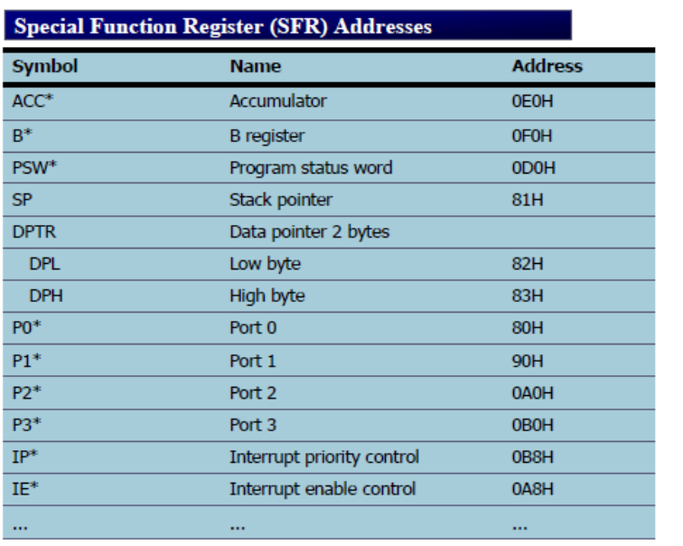

Data Memory:
The AT89C52 implements 256 bytes of on-chip RAM. The upper 128 bytes occupy a parallel address space to the Special Function Registers. That means the upper 128 bytes have the same addresses as the SFR space but are physically separate from SFR space. When an instruction accesses an internal location above address 7FH, the address mode used in the instruction specifies whether the CPU accesses the upper 128 bytes of RAM or the SFR space. Instructions that use direct addressing access SFR space. new features. In that case, the reset or inactive values of the new bits will always be 0.

Interrupt Registers:
The individual interrupt enable bits are in the IE register. Two priorities can be set for each of the six interrupt sources in the IP register. specifies whether the CPU accesses the upper 128 bytes of RAM or the SFR space. Instructions that use direct addressing access SFR space. For example, the following direct addressing instruction accesses the SFR at location 0A0H (which is P2).
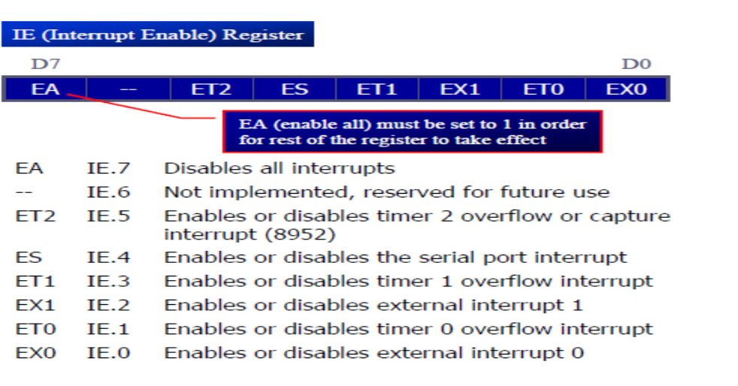
Instructions that use indirect addressing access the upper 128 bytes of RAM. For example, the following indirect addressing instruction, where R0 contains 0A0H, accesses the data byte at address 0A0H, rather than P2 (whose address is 0A0H).

Timer 0 and 1:
Timer 0 and Timer 1 in the AT89C52 operate the same way as Timer 0 and Timer 1 in the AT89C51.

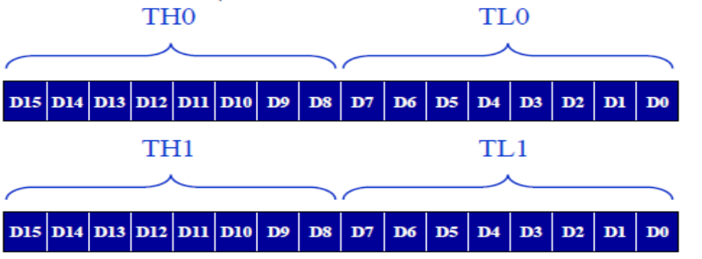

Timer 2:
Timer 2 is a 16-bit Timer/Counter that can operate as either a timer or an event counter. The type of operation is selected by bit C/T2 in the SFR T2CON. Timer 2 has three operating modes: capture, auto-reload (up or down counting), and baud rate generator. The modes are selected by bits in T2CON. Timer 2 consists of two 8-bit registers, TH2 and TL2. In the Timer function, the TL2 register is incremented every machine cycle. Since a machine cycle consists of 12 oscillator periods, the count rate is 1/12 of the oscillator frequency. In the Counter function, the register is incremented in response to a 1-to-0 transition at its corresponding external input pin, T2. In this function, the external input is sampled during S5P2 of every machine cycle. When the samples show a high in one cycle and a low in the next cycle, the count is incremented. The new count value appears in the register during S3P1 of the cycle following the one in which the transition was detected. Since two machine cycles (24 oscillator periods) are required to recognize a 1-to-0 transition, the maximum count rate is 1/24 of the oscillator frequency. To ensure that a given level is sampled at least once before it changes, the level should be held for at least one full machine cycle.

Capture Mode:
In the capture mode, two options are selected by bit EXEN2 in T2CON. If EXEN2 = 0, Timer 2 is a 16-bit timer or counter which upon overflow sets bit TF2 in T2CON. This bit can then be used to generate an interrupt. If EXEN2 = 1, Timer 2 performs the same operation, but a 1- to-0 transition at external input T2EX also causes the current value in TH2 and TL2 to be captured into CAP2H and RCAP2L, respectively. In addition, the transition at T2EX causes bit EXF2 in T2CON to be set. The EXF2 bit, like TF2, can generate an interrupt.

Auto-reload (Up or Down Counter):
Timer 2 can be programmed to count up or down when configured in its 16-bit auto-reload mode. This feature is invoked by the DCEN (Down Counter Enable) bit located in the SFR T2MOD. Upon reset, the DCEN bit is set to 0 so that timer 2 will default to count up. When DCEN is set, Timer 2 can count up or down, depending on the value of the T2EX pin.

Interrupts:
The AT89C52 has a total of six interrupt vectors: two external interrupts (INT0 and INT1), three timer interrupts (Timers 0, 1, and 2), and the serial port interrupt. Each of these interrupt sources can be individually enabled or disabled by setting or clearing a bit in Special Function Register IE. IE also contains a global disable bit, EA, which disables all interrupts at once. Note that bit position IE.6 is unimplemented. In the AT89C51, bit position IE.5 is also unimplemented. User software should not write 1s to these bit positions, since they may be used in future AT89 products. Timer 2 interrupt is generated by the logical OR of bits TF2 and EXF2 in register T2CON. Neither of these flags cleared by hardware when the service routine is vectored . In fact, the service routine may have to determine whether it was TF2 or EXF2 that generated the interrupt, and that bit will have to be cleared in software. . The Timer 0 and Timer 1 flags, TF0 and TF1, are set at S5P2 of the cycle in which the timers overflow.

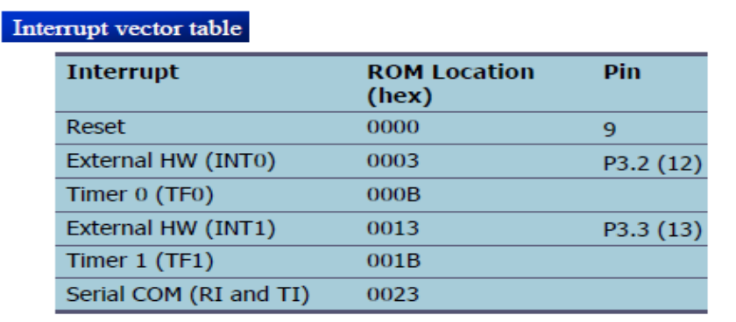

The values are then polled by the circuitry in the next cycle.However, the Timer 2 flag, TF2, is set at S2P2 and is polled in the same cycle in which the timer overflows.

SERIAL COMMUNICATION:

Computers transfer data in two ways:
Parallel: Often 8 or more lines (wire conductors) are used to transfer data to a device that is only a few feet away.

Serial: To transfer to a device located many meters away, the serial method is used. The data is sent one bit at a time.

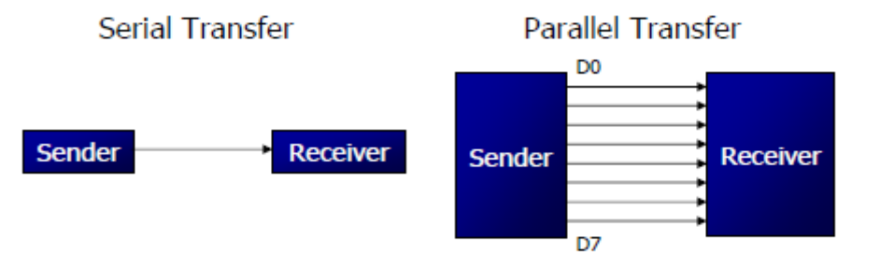

At the transmitting end, the byte of data must be converted to serial bits using parallel-in-serial-out shift register. At the receiving end, there is a serial in-parallel-out shift register to receive the serial data and pack them into byte. When the distance is short, the digital signal can be transferred as it is on a simple wire and requires no modulation. If data is to be transferred on the telephone line, it must be converted from 0s and 1s to audio tones.
This conversion is performed by a device called a modem, “Modulator/demodulator”.
Serial data communication uses two methods; Synchronous method transfers a block of data at a time Asynchronous method transfers a single byte at a time It is possible to write software to use either of these methods, but the programs can be tedious and long. There are special IC chips made by many manufacturers for serial communications UART (universal asynchronous Receiver transmitter) USART (universal synchronous asynchronous Receiver-transmitter). If data can be transmitted and received, it is a duplex transmission. If data transmitted one way a time, it is referred to as half duplex. If data can go both ways at a time, it is full duplex.

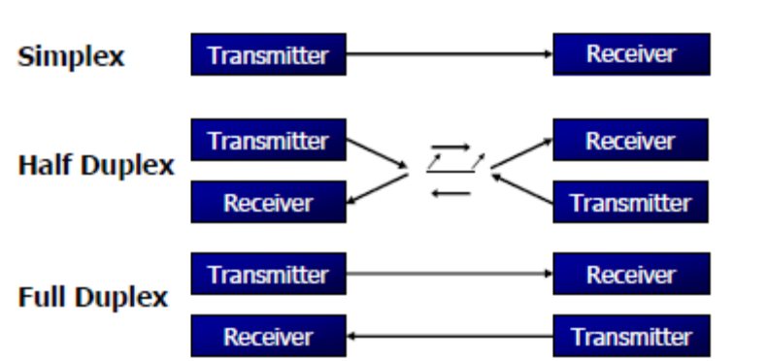

A protocol is a set of rules agreed by both the sender and receiver on.
When the data begins and ends. Asynchronous serial data communication is widely used for character-oriented transmissions;
Each character is placed in between start and stop bits, this is called framing.
Block-oriented data transfers use the synchronous method.
The start bit is always one bit, but the stop bit can be one or two bits The start bit is always a 0 (low) and the stop bit(s) is 1 (high)

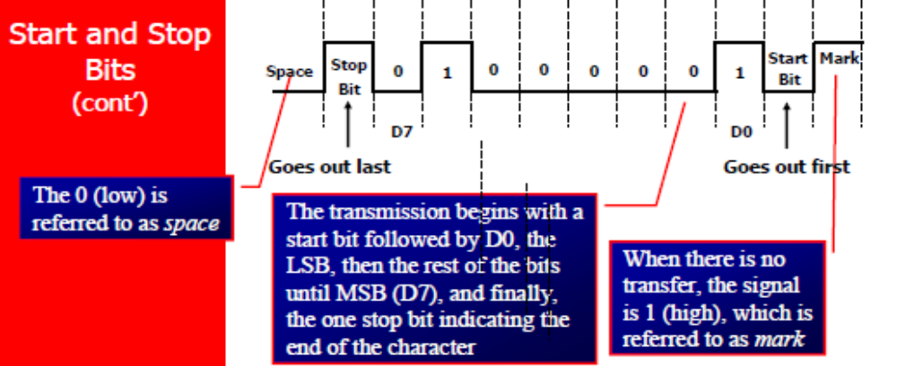

SBUF is an 8-bit register used solely for serial communication. For a byte data to be transferred via the TxD line, it must be placed in the SBUF Register. The moment a byte is written into SBUF, it is framed with the start and stop bits and transferred serially via the TxD line SBUF holds the byte of data when it is received by 8051 RxD line. When the bits are received serially via RxD, the 8051 de-frames it by eliminating the stop and start bits, making a byte out of the data received, and then placing it in SBUF
MOV SBUF,#’D’ ;load SBUF=44h, ASCII for ‘D’
MOV SBUF,A ;copy accumulator into SBUF
MOV A,SBUF ;copy SBUF into accumulator

SCON is an 8-bit register used to program the start bit, stop bit, and data bits of data framing, among other things.

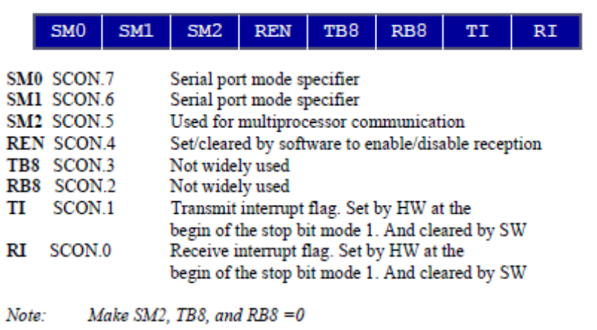

SM0, SM1: They determine the framing of data by specifying the number of bits per character, and the start and stop bits.

SM2: This enables the multiprocessing capability of the 8051.

REN (receive enable): It is a bit-addressable register. When it is high, it allows 8051 to receive data.

RxD pin: If low, the receiver is disable.

TI (transmit interrupt): When 8051 finishes the transfer of 8-bit character. It raises TI flag to indicate that it is ready to transfer another byte.TI bit is raised at the beginning of the stop bit

RI (receive interrupt): When 8051 receives data serially via RxD, it gets rid of the start and stop bits and places the byte in SBUF register. It raises the RI flag bit to indicate that a byte has been received and should be picked up before it is lost. RI is raised halfway through the stop bit.

Serial Communication
through RS 232

General Description:
The MAX220–MAX249 family of line drivers/receivers is intended for all EIA/TIA-232E and V.28/V.24 communications interfaces, particularly applications where ±12V is
not available. These parts are especially useful in battery-powered systems, since their low-power shutdown mode reduces power dissipation to less than 5μW. The MAX225, MAX233, MAX235, and MAX245/MAX246/MAX247 use no external components and are recommended for applications where printed circuit board space is critical.

Applications:
- Portable Computers
- Low-Power Modems
- Interface Translation
- Battery-Powered RS-232 Systems
- Multi-drop RS-232 Networks

Detailed Description:
The MAX220–MAX249 contain four sections: dual charge-pump DC-DC voltage converters, RS-232 drivers, RS-232 receivers, and receiver and transmitter enable control inputs.

Dual Charge-Pump Voltage Converter:
The MAX220–MAX249 have two internal charge-pumps that convert +5V to ±10V (unloaded) for RS-232 driver operation. The first converter uses capacitor C1 to double the +5V input to +10V on C3 at the V+ output. The second converter uses capacitor C2 to invert +10V to -10V on C4 at the V- output. A small amount of power may be drawn from the +10V (V+) and -10V (V-) outputs to power external circuitry. except on the MAX225 and MAX245–MAX247, where these pins are not available. V+ and V- are not regulated, so the output voltage drops with increasing load current. Do not load V+ and V- to a point that violates the minimum ±5V EIA/TIA-232E driver output voltage when sourcing current from V+ and V- to external circuitry.
When using the shutdown feature in the MAX222, MAX225, MAX230, MAX235, MAX236, MAX240, MAX241, and MAX245–MAX249, avoid using V+ and V to power external circuitry. When these parts are shut down, V- falls to 0V, and V+ falls to +5V. For applications where a +10V external supply is applied to the V+ pin (instead of using the internal charge pump to generate +10V), the C1 capacitor must not be installed and the SHDN pin must be tied to VCC. This is because V+ is internally connected to VCC in shutdown mode.

RS-232 Drivers:
The typical driver output voltage swing is ±8V when loaded with a nominal 5kΩ RS-232 receiver and VCC = +5V. Output swing is guaranteed to meet the EIA/TIA- 232E and V.28 specification, which calls for ±5V minimum driver output levels under worst-case

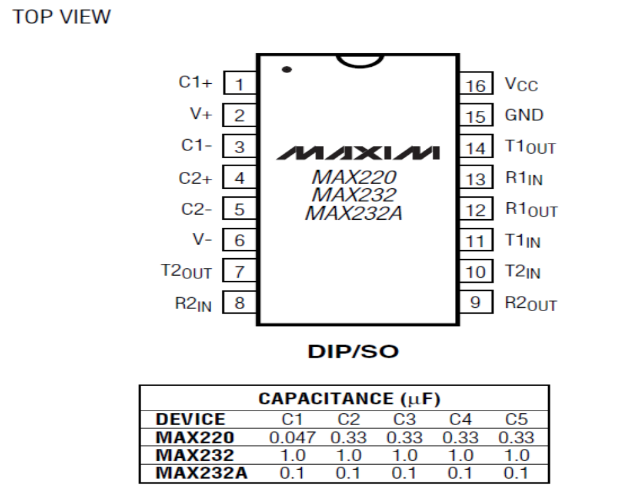
conditions. These include a minimum 3kΩ load, VCC = +4.5V, and maximum operating temperature. Unloaded driver output voltage ranges from (V+ -1.3V) to (V- +0.5V).
Input thresholds are both TTL and CMOS compatible. The inputs of unused drivers can be left unconnected since 400kΩ input pull-up resistors to VCC are built in (except for the MAX220). The pull-up resistors force the outputs of unused drivers low because all drivers invert. The internal input pull-up resistors typically source 12μA, except in shutdown mode where the pull-ups are disabled. Driver outputs turn off and enter a high-impedance state—where leakage current is typically microamperes (maximum 25μA)—when in shutdown mode, in three-state mode, or when device power is removed. Outputs can be driven to ±15V. The power supply current typically drops to 8μA in shutdown mode. The MAX220 does not have pull-up resistors to force the outputs of the unused drivers low. Connect unused inputs to GND or VCC.
The MAX239 has a receiver three-state control line, and the MAX223, MAX225, MAX235, MAX236, MAX240, and MAX241 have both a receiver three-state control line and a low-power shutdown control. Table 2 shows the effects of the shutdown control and receiver three state control on the receiver outputs. The receiver TTL/CMOS outputs are in a high-impedance, three-state mode whenever the three-state enable line is high (for the MAX225/MAX235/MAX236/MAX239– MAX241), and are also high-impedance whenever the shutdown control line is high. When in low-power shutdown mode, the driver outputs are turned off and their leakage current is less than 1μA with the driver output pulled to ground. The driver output leakage remains less than 1μA, even if the transmitter output is back driven between 0V and (VCC + 6V). Below -0.5V, the transmitter is diode clamped to ground with 1kΩ series impedance. The transmitter is also zener clamped to approximately VCC + 6V, with a series impedance of 1kΩ.
The driver output slew rate is limited to less than 30V/μs as required by the EIA/TIA-232E and V.28 specifications. Typical slew rates are 24V/μs unloaded and 10V/μs loaded with 3Ω and 2500pF.

RS-232 Receivers:
EIA/TIA-232E and V.28 specifications define a voltage level greater than 3V as a logic 0, so all receivers invert. Input thresholds are set at 0.8V and 2.4V, so receivers respond to TTL level inputs as well as EIA/TIA-232E and V.28 levels.
The receiver inputs withstand an input over voltage up to ±25V and provide input terminating resistors with nominal 5kΩ values. The receivers implement Type 1 interpretation of the fault conditions of V.28 and EIA/TIA-232E.
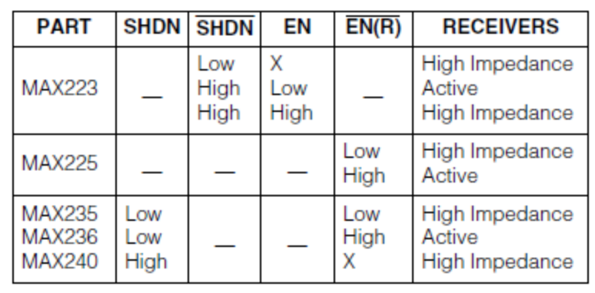
The receiver input hysteresis is typically 0.5V with a guaranteed minimum of 0.2V. This produces clear output transitions with slow-moving input signals, even with moderate amounts of noise and ringing. The receiver propagation delay is typically 600ns and is
independent of input swing direction.

Low-Power Receive Mode:
The low-power receive-mode feature of the MAX223, MAX242, and MAX245–MAX249 puts the IC into shutdown mode but still allows it to receive information. This
is important for applications where systems are periodically awakened to look for activity. Using low-power receive mode, the system can still receive a signal that will activate it on command and prepare it for communication at faster data rates. This operation conserves system power.

Negative Threshold—MAX243:
The MAX243 is pin compatible with the MAX232A, differing only in that RS-232 cable fault protection is removed on one of the two receiver inputs. This means that control lines such as CTS and RTS can either be driven or left floating without interrupting communication. Different cables are not needed to interface with different pieces of equipment.
The input threshold of the receiver without cable fault protection is -0.8V rather than +1.4V. Its output goes positive only if the input is connected to a control line that is actively driven negative. If not driven, it defaults to the 0 or “OK to send” state. Normally‚ the MAX243’s other receiver (+1.4V threshold) is used for the data line (TD or RD)‚ while the negative threshold receiver is connected to the control line (DTR‚ DTS‚ CTS‚ RTS, etc.).
Other members of the RS-232 family implement the optional cable fault protection as specified by EIA/TIA- 232E specifications. This means a receiver output goes high whenever its input is driven negative‚ left floating‚ or shorted to ground. The high output tells the serial communications IC to stop sending data. To avoid this‚ the control lines must either be driven or connected with jumpers to an appropriate positive voltage level.

Shutdown—MAX222–MAX242:
On the MAX222‚ MAX235‚ MAX236‚ MAX240‚ and MAX241‚ all receivers are disabled during shutdown. On the MAX223 and MAX242‚ two receivers continue to operate in a reduced power mode when the chip is in shutdown. Under these conditions‚ the propagation delay increases to about 2.5μs for a high-to-low input transition. When in shutdown, the receiver acts as a CMOS inverter with no hysteresis. The MAX223 and MAX242 also have a receiver output enable input (EN for the MAX242 and EN for the MAX223) that allows receiver output control independent of SHDN (SHDN for MAX241). With all other devices‚ SHDN (SHDN for MAX241) also disables the receiver outputs.
The MAX225 provides five transmitters and five receivers‚ while the MAX245 provides ten receivers and eight transmitters. Both devices have separate receiver and transmitter-enable controls. The charge pumps turn off and the devices shut down when a logic high is applied to the ENT input. In this state, the supply current drops to less than 25μA and the receivers continue to operate in a low-power receive mode. Driver outputs enter a high-impedance state (three-state mode). On the MAX225‚ all five receivers are controlled by the ENR input. On the MAX245‚ eight of the receiver outputs are controlled by the ENR input‚ while the remaining two receivers (RA5 and RB5) are always active. RA1–RA4 and RB1–RB4 are put in a three-state mode when ENR is a logic high.

Receiver and Transmitter Enable:
Control Inputs:
The MAX225 and MAX245–MAX249 feature transmitter and receiver enable controls. The receivers have three modes of operation: full-speed receive (normal active)‚ three state (disabled)‚ and low power receive (enabled receivers continue to function at lower data rates). The receiver enable inputs control the full-speed receive and three-state modes. The transmitters have two modes of operation: full-speed transmit (normal active) and three-state (disabled). The transmitter enable inputs also control the shutdown mode. The device enters shutdown mode when all transmitters are disabled. Enabled receivers function in the low-power receive mode when in shutdown.
The MAX246 has ten receivers and eight drivers with two control pins, each controlling one side of the device. A logic high at the A-side control input (ENA) causes the four A-side receivers and drivers to go into a three-state mode. Similarly, the B-side control input (ENB) causes the four B-side drivers and receivers to go into a three-state mode. As in the MAX245, one Aside and one B-side receiver (RA5 and RB5) remain active at all times. The entire device is put into shutdown mode when both the A and B sides are disabled (ENA = ENB = +5V).
.

pplications Information:
Figures below show pin configurations and typical operating circuits. In applications that are sensitive to power-supply noise, VCC should be decoupled to ground with a capacitor of the same value as C1 and C2 connected as close as possible to the device.

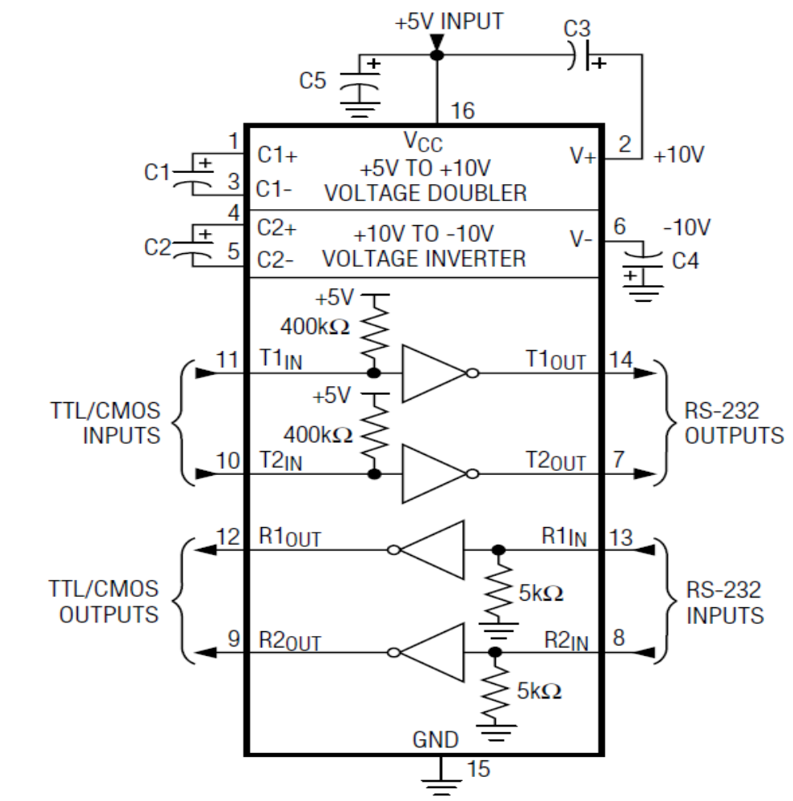
MAX220/MAX232/MAX232A Typical Operating Circuit

FEATURES OF RS-232 CABLE:

The rate of data transfer in serial data communication is stated in bps (bits per second). Another widely used terminology for bps is baud rate. It is modem terminology and is defined as the number of signal changes per second. In modems, there are occasions when a single change of signal transfers several bits of data. As far as the conductor wire is concerned, the baud rate and bps are the same, and we use the terms interchangeably. The data transfer rate of given computer system depends on communication ports incorporated into that system.
E.g. IBM PC/XT could transfer data at the rate of 100 to 9600 bps.
Pentium-based PCs transfer data at rates as high as 56K bps.
In asynchronous serial data communication, the baud rate is limited to 100K bps. An interfacing standard RS232 was set by the Electronics Industries Association (EIA) in 1960. The standard was set long before the advent of the TTL logic family, its input and output voltage levels are not TTL compatible. In RS232, a 1 is represented by -3 ~ -25 V,
while a 0 bit is +3 ~ +25 V, making -3 to +3 undefined.

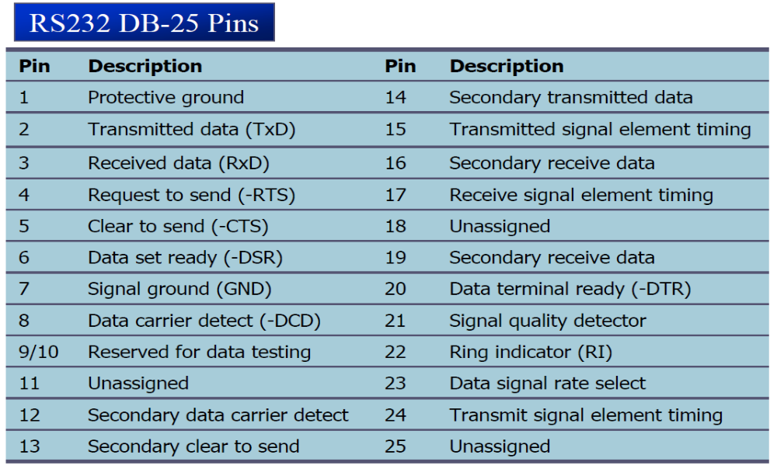
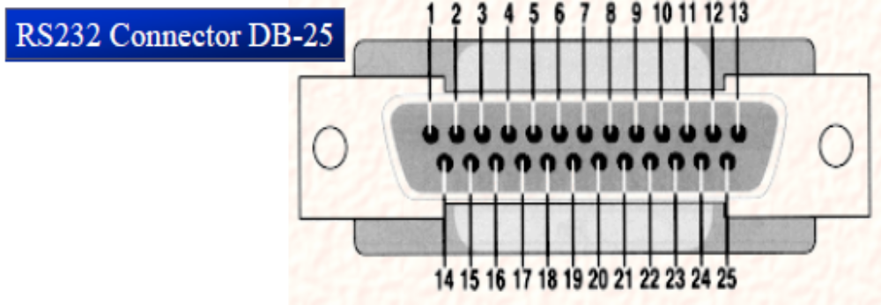

Current terminology classifies data communication equipment as:
DTE (data terminal equipment) refers to terminal and computers that send and receive data.
DCE (data communication equipment) refers to communication equipment, such as modems.

The simplest connection between a PC and microcontroller requires a minimum of three pins, TxD, RxD, and ground.

DTR (data terminal ready):
When terminal is turned on, it sends out signal DTR to indicate that it is ready for communication.

DSR (data set ready):
When DCE is turned on and has gone through the self-test, it assert DSR to indicate that it is ready to communicate.

RTS (request to send):
When the DTE device has byte to transmit, it assert RTS to signal the modem that it has a byte of data to transmit.

CTS (clear to send):
When the modem has room for storing the data it is to receive, it sends out signal CTS to DTE to indicate that it can receive the data now.

DCD (data carrier detect):
The modem asserts signal DCD to inform the DTE that a valid carrier has been detected and that contact between it and the other modem is established.

RI (ring indicator):
An output from the modem and an input to a PC indicates that the telephone is ringing. It goes on and off in synchronous with the ringing sound

Since not all pins are used in PC cables, IBM introduced the DB-9 version of the
serial I/O standard.
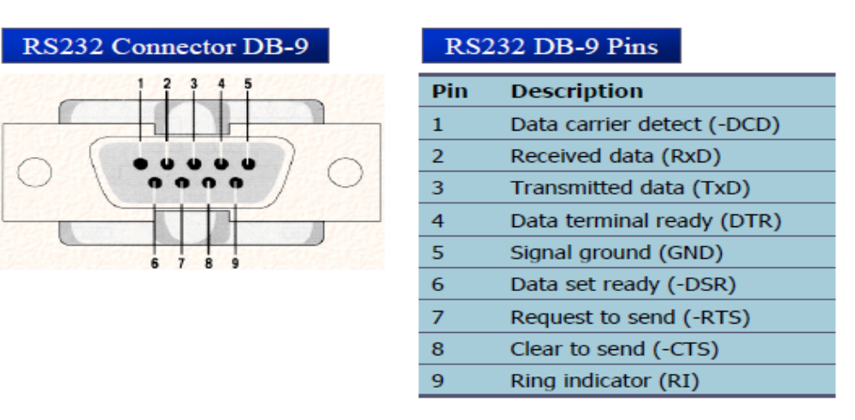

DIODE

A diode is a two-terminal electronic component that conducts electric current in only one direction. The term usually refers to a semiconductor diode, the most common type today, which is a crystal of semiconductor connected to two electrical terminals, a P-N junction.
The most common function of a diode is to allow an electric current in one direction (called the diode's forward direction) while blocking current in the opposite direction (the reverse direction). Thus, the diode can be thought of as an electronic version of a check valve. This unidirectional behavior is called rectification, and is used to convert alternating current to direct current, and remove modulation from radio signals in radio receivers.

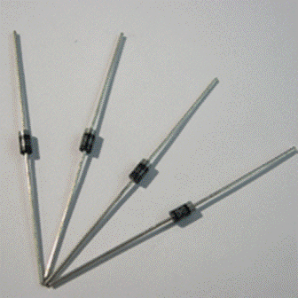

RESISTANCE

The electrical resistance of an object is a measure of its opposition to the passage of a steady electric current. An object of uniform cross section will have a resistance proportional to its length and inversely proportional to its cross-sectional area, and proportional to the resistivity of the material.

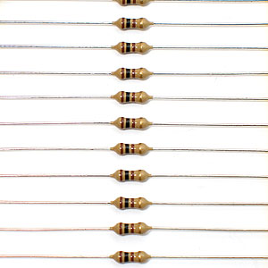

The resistance of a resistive object determines the amount of current through the object for a given potential difference across the object, in accordance with Ohm's law: I =V/R
R is the resistance of the object, measured in ohms, equivalent to J·s/C² V is the potential difference across the object, measured in volts I is the current through the object, measured in amperes
For a wide variety of materials and conditions, the electrical resistance does not depend on the amount of current through or the amount of voltage across the object, meaning that the resistance R is constant for the given temperature and material. Therefore, the resistance of an object can be defined as the ratio of voltage to current.In the case of nonlinear objects (not purely resistive, or not obeying Ohm's law), this ratio can change as current or voltage changes; the ratio taken at any particular point, the inverse slope of a chord to an I–V curve, is sometimes referred to as a "chordal resistance" or "static resistance".[

CRYSTAL OSCILLATOR

A crystal oscillator is an electronic circuit that uses the mechanical resonance of a vibrating crystal of piezoelectric material to create an electrical signal with a very precise frequency. This frequency is commonly used to keep track of time (as in quartz wristwatches), to provide a stable clock signal for digital integrated circuits, and to stabilize frequencies for radio transmitters and receivers. The most common type of piezoelectric resonator used is the quartz crystal, so oscillator circuits designed around them were called "crystal oscillators".
Quartz crystals are manufactured for frequencies from a few tens of kilohertz to tens of megahertz.

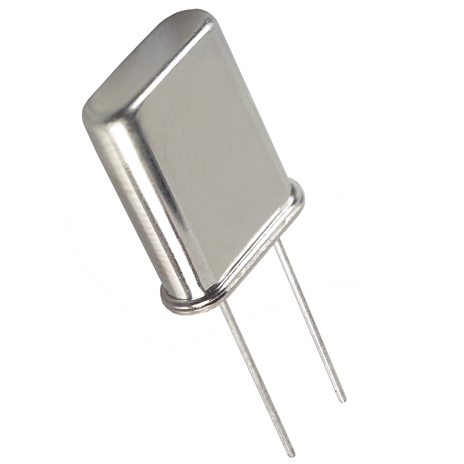

A quartz crystal can be modelled as an electrical network with a low impedance (series) and a high impedance (parallel) resonance point spaced closely together.

VOLTAGE REGULATOR

The MC78XX/LM78XX/MC78XXA series of three terminal positive regulators are available in the TO-220/D-PAK package and with several fixed output voltages, making them useful in a wide range of applications. Each type employs internal current limiting, thermal shut down and safe operating area protection, making it essentially indestructible. If adequate heat sinking is provided, they can deliver over 1A output current. Although designed primarily as fixed voltage regulators, these devices can be used with external components to obtain adjustable voltages and currents.

Features
• Output Current up to 1A
• Output Voltages of 5, 6, 8, 9, 10, 12, 15, 18, 24V
• Thermal Overload Protection
• Short Circuit Protection
• Output Transistor Safe Operating Area Protection

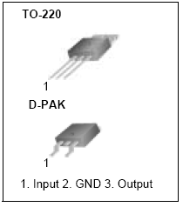
Pin Diagram of the Power IC

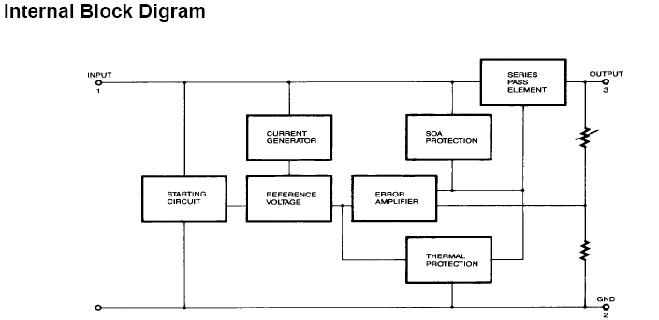
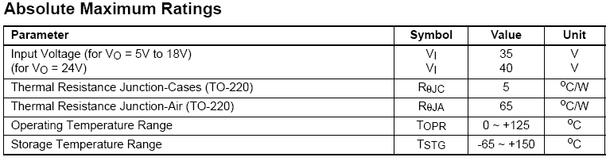

Typical Applications:
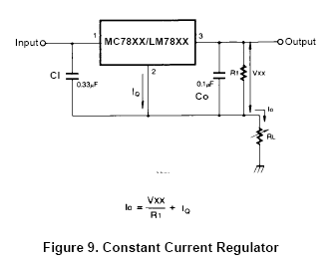
Notes:
(1) To specify an output voltage. substitute voltage value for "XX." A common ground is required between the input and the Output voltage. The input voltage must remain typically 2.0V above the output voltage even during the low point on the input ripple voltage.
(2) CI is required if regulator is located an appreciable distance from power Supply filter.
(3) CO improves stability and transient response

CAPACITOR

A capacitor or condenser is a passive electronic component consisting of a pair of conductors separated by a dielectric (insulator). When a potential difference (voltage) exists across the conductors, an electric field is present in the dielectric. This field stores energy and produces a mechanical force between the conductors. The effect is greatest when there is a narrow separation between large areas of conductor, hence capacitor conductors are often called plates.
Capacitors are widely used in electronic circuits to block the flow of direct current while allowing alternating current to pass, to filter out interference, to smooth the output of power supplies, and for many other purposes. They are used in resonant circuits in radio frequency equipment to select particular frequencies from a signal with many frequencies.

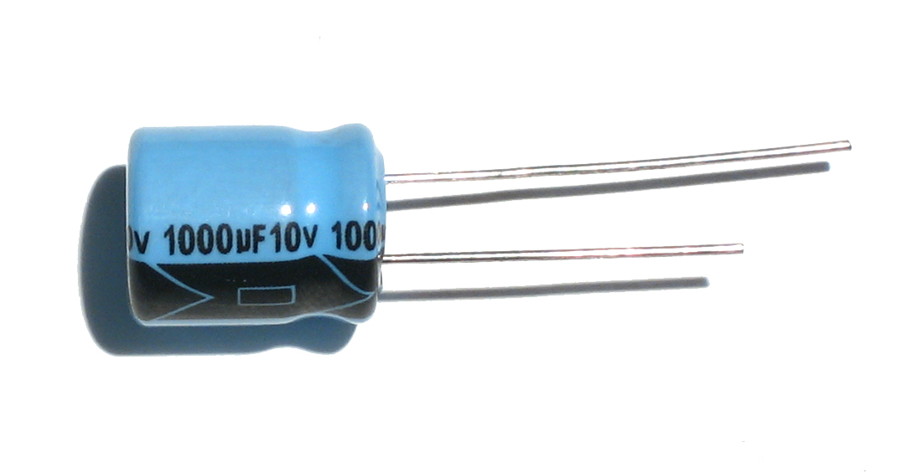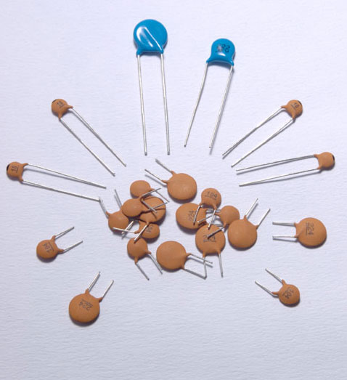

TYPES OF CAPACITOR:

Aluminum Electrolytic Capacitors
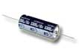 | 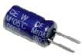 | 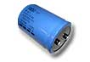 | 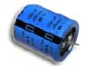 | 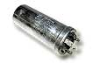 | 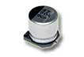
Axial Leads | Radial Leads | Computer Grade | Snap Mount | Twist Lok | Surface Mount

Tantalum Capacitors
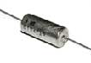 | 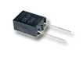 | 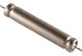 | 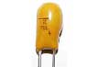 | 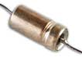 | 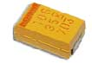
Solid Tantalum  ( Axial Leads ) | Solid Tantalum  ( Radial Leads ) | Foil Tantalum  ( Axial Leads ) | Dipped Tantalum | Wet Tantalum | Surface Mount

Ceramic Capacitors
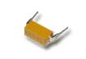 | 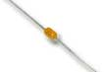 | 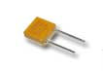 | 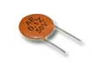 | 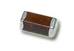
Dip Guard | Monolithic  ( Axial Leads ) | Monolithic  ( Radial Leads ) | Disc | Surface Mount

Film Capacitors
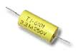 | 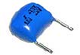 | 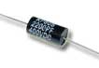 | 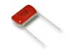 | 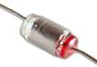
Polyester  ( Axial Leads ) | Polyester  ( Radial Leads ) | Polypropylene  ( Axial Leads ) | Polypropylene  ( Radial Leads ) | Polystyrene  ( Axial Leads )

Mica Capacitors
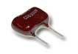 | 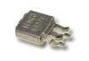 | 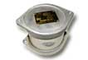
Dipped Mica | Metal Clad | Transmitting

Oil Capacitors
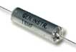 | 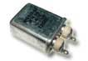
Hermetically Sealed  ( Axial Leads ) | Hermetically Sealed  ( Radial Leads )

Other Capacitor Types
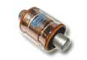 | 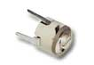 | 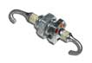
Vacuum Capacitors | Trimmers | Feed Thru

MOMENTARY SWITCH

In electronics, a switch is an electrical component that can break an electrical circuit, interrupting the current or diverting it from one conductor to another.
The most familiar form of switch is a manually operated electromechanical device with one or more sets of electrical contacts.

Each set of contacts can be in one of two states: either 'closed' meaning the contacts are touching and electricity can flow between them, or 'open', meaning the contacts are separated and nonconducting.

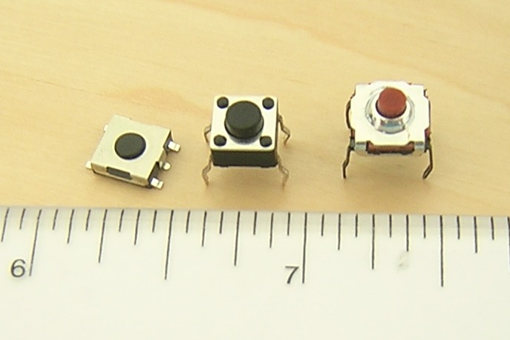

A switch may be directly manipulated by a human as a control signal to a system, such as a computer keyboard button, or to control power flow in a circuit, such as a light switch. Automatically-operated switches can be used to control the motions of machines, for example, to indicate that a garage door has reached its full open position or that a machine tool is in a position to accept another workpiece. Switches may be operated by process variables such as pressure, temperature, flow, current, voltage, and force, acting as sensors in a process and used to automatically control a system.

SOURCE CODE IN ASSEMBLY

$mod51
in equ p0
scl bit p2.4
sda bit p2.5
org 0h
ljmp main1
org 0003h
ljmp intrupt
org 0020h
main1: setb p3.2
mov ie,#81h
setb tcon.0
mov tmod,#20h
mov scon,#50h
mov th1,#-3
setb tr1
setb scl
setb sda
setb p2.6
mov r5,#00h
mov r6,#00h
mov r7,#00h
main: mov in,#11111110b
mov a,in
anl a,#11111110b
cjne a,#11111110b,j
sjmp main
j: mov a,in
jb acc.1,j2
inc r5
clr p2.6
acall delay1
acall delay1
setb p2.6
busy1: jnb p0.1,busy1
ljmp eewrite
sjmp main
j2: jb acc.2,j3
inc r6
clr p2.6
acall delay1
acall delay1
setb p2.6
busy2: jnb p0.2,busy2
ljmp Iewrite
sjmp main
j3: jb acc.3,j4
inc r7
clr p2.6
acall delay1
acall delay1
setb p2.6
busy3: jnb p0.3,busy3
ljmp IIwrite
j4: sjmp main
intrupt:
mov dptr,#mydata0
acall routs
acall delay_15ms
mov r1,#05h
acall step
mov dptr,#mydata1
acall routs
acall delay_15ms
mov r1,#06h
acall step
mov dptr,#mydata2
acall routs
acall delay_15ms
mov r1,#07h
acall step
reti
eewrite: mov a,#10100000b
acall i2cstart
acall i2cwrite
mov a,#05h
mov 30h,a
acall i2cwrite
mov a,r5
acall i2cwrite
acall i2cstop
acall jkl
ljmp main
Iewrite: mov a,#10100000b
acall i2cstart
acall i2cwrite
mov a,#06h
mov 30h,a
acall i2cwrite
mov a,r6
acall i2cwrite
acall i2cstop
acall jkl
ljmp main
IIwrite: mov a,#10100000b
acall i2cstart
acall i2cwrite
mov a,#07h
mov 30h,a
acall i2cwrite
mov a,r7
acall i2cwrite
acall i2cstop
acall jkl
ljmp main
i2cstart: setb sda
acall delay
setb scl
acall delay
clr sda
clr scl
ret
i2cstop: clr scl
clr sda
setb scl
acall delay
setb sda
mov c,sda
ret
i2cwrite: mov r0,#08h
i2cwrite_loop: rlc a
mov sda,c
setb scl
acall delay
clr scl
djnz r0,i2cwrite_loop
mov c,sda
setb scl
acall delay
clr scl
ret
i2cread: mov c,sda
mov r0,#8
rlc a
i2cread_loop: setb scl
mov c,sda
rlc a
acall delay
clr scl
djnz r0,i2cread_loop
ret
delay: mov r4,#100
loop: djnz r4,loop
ret
delay1: mov r4,#0ffh
jll: mov r1,#0ffh
jl: djnz r1,jl
djnz r4,jll
ret
jkl: mov a,#10100000b
acall i2cstart
acall i2cwrite
mov a,#00h
acall i2cwrite
acall i2cread
acall i2cstop
ret
mydata0: db 'VOTER NO.1=',0
mydata1: db ' VOTER NO.2=',0
mydata2: db ' VOTER NO.3=',0

routs: clr a
movc a,@a+dptr
jz here
acall display
inc dptr
sjmp routs
here: acall delay_15ms
ret
delay_15ms: mov r3,#4h
loop14: mov r2,#0ffh
loop1: djnz r2,loop1
djnz r3,loop14
ret
display: mov sbuf,a
loopi: jnb ti,loopi
clr ti
ret
step: mov a,#10100000b
acall i2cstart
acall i2cwrite
mov a,r1
acall i2cwrite
acall i2cstop
acall i2cstart
mov a,#10100001b
acall i2cwrite
acall i2cread
acall i2cstop
mov 33h,a
mov a,r1
cjne a,#05h,kl
mov 34h,33h
mov a,33h
acall sett
ret

kl: cjne a,#06h,kl1
mov 35h,33h
mov a,33h
acall sett
ret

kl1: mov 36h,33h
mov a,33h
acall sett
ret

sett: da a
mov 37h,a
anl a,#0f0h
swap a
add a,#30h
mov 50h,a
acall display
mov a,37h
anl a,#0fh
add a,#30h
mov 51h,a
acall display
ret
end

PCB Layout

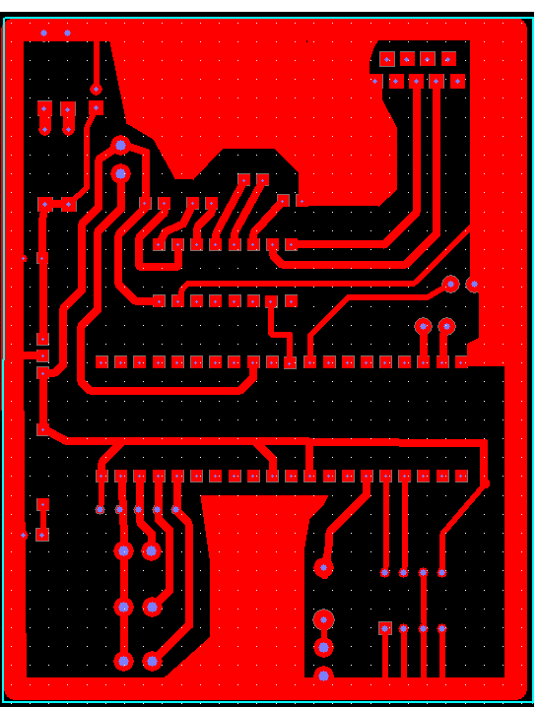

BIBLOGRAPHY

- SEDRA SMITH

- INTRODUCTION TO 8051 MICROCONTROLLER … MAZIDI

- INTRODUCTION TO 8051 MICROCONTROLLER … AYALA

- www.wikipedia.com

