git config --global user.email "aditi.bhatnagar28@gmail.com"
git config --global user.name "aditi04"

- Initialize a Git Repository
git init

- Add files to the repository
git add ~/exercises/file1.txt ~/exercises/file2.txt ~/exercises/file3.txt

- Unstage 1 file
git rm --cached ~/exercises/file3.txt

- Commit the files
git commit -m "Added file1.txt and file2.txt" ~/exercises/file1.txt ~/exercises/file2.txt

- Add a remote
git remote add repo1 https://github.com/aditi04/repo1.git

- Undo changes to a particular file
git revert master

- Push changes to Github
git push repo1 master

- Clone the repository
git clone https://github.com/aditi04/repo1

- Add changes to one of the copies and pull the changes in the other.
git pull repo1 master

- Add changes to both repos, try to push from both without taking a pull.
Change clone,push
change repo,push=> error
forcefull push

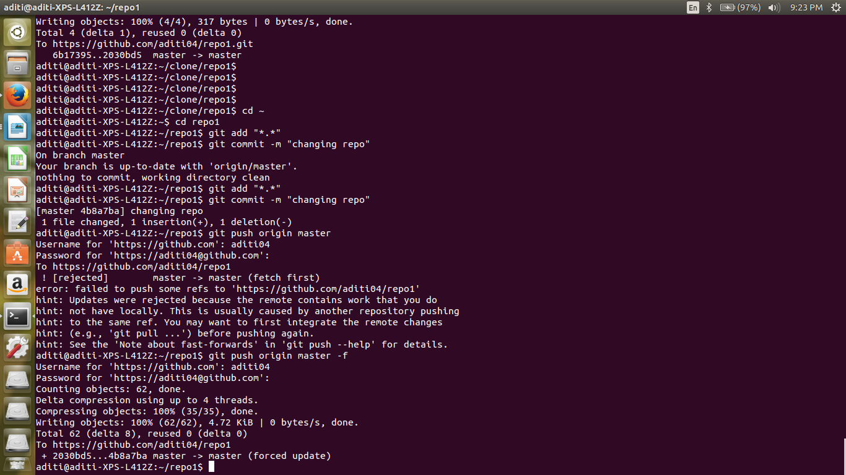

- Check differences between a file and its staged version
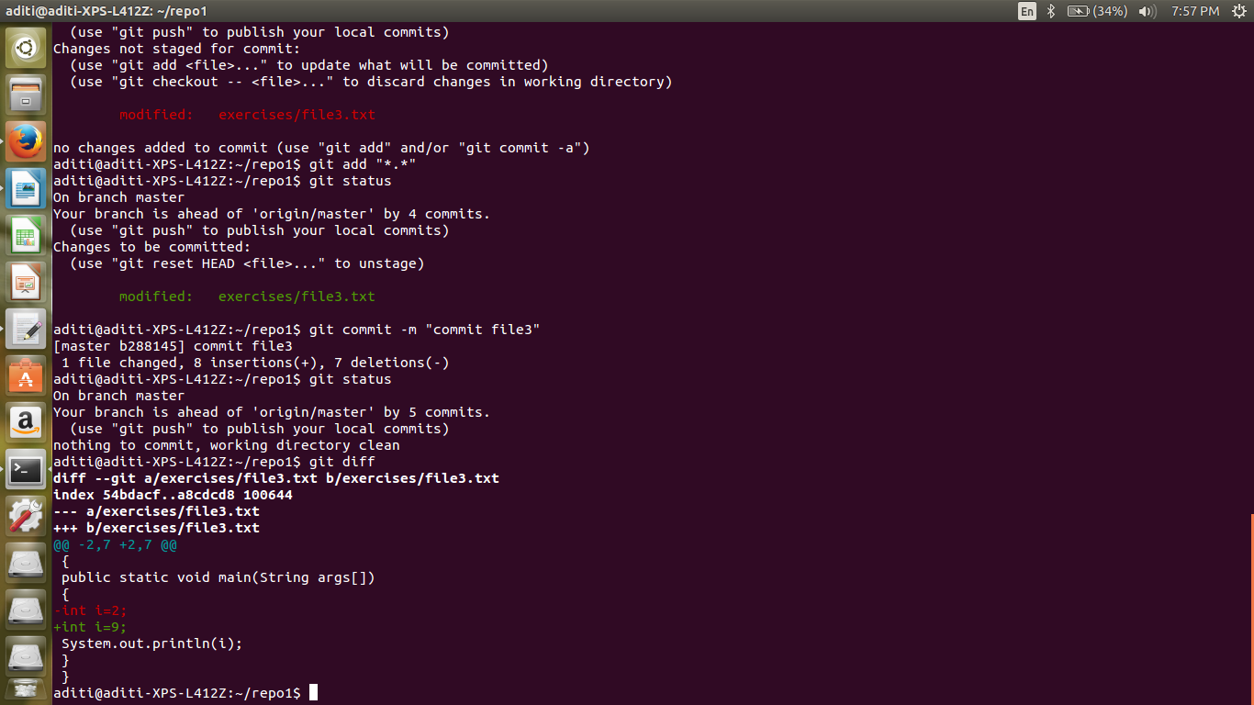

- Ignore a few files to be checked in

- Create a new branch. Diverge them with commits
git add file.txt
git commit -m "hi" file.txt
git branch branch1
git checkout branch1
nano file.txt
git commit -m "learn to branch" file.txt

- Edit the same file at the same line on both branches and commit

- Try merging and resolve merge conflicts
git checkout master
git merge branch1

- Stash the changes and pop them
git stash
git statsh list
git stash apply

