1.What are the two values of the Boolean data type? How do you write them?

**Two values-True or False**

2. What are the three different types of Boolean operators?

**Boolean AND**

**Boolean OR**

**Boolean NOT**

3. Make a list of each Boolean operator's truth tables (i.e. every possible combination of Boolean values for the operator and what it evaluate ).

**AND- OR- NOT**

**1 0 0 0 0 0 1 0**

**0 0 0 1 1 1 0 1**

**0 1 0 1 0 1**

**1 1 1 0 1 1**

4. What are the values of the following expressions?

(5 > 4) and (3 == 5) = **False**

not (5 > 4) = **False**

(5 > 4) or (3 == 5) = **True**

not ((5 > 4) or (3 == 5)) = **False**

(True and True) and (True == False) = **False**

(not False) or (not True) = **True**

5. What are the six comparison operators?

**>, <,==,>=,<=,!=**

6. How do you tell the difference between the equal to and assignment operators?Describe a condition and when you would use one.

**== is for comparing the two operands while = is for assignment operator**

7. Identify the three blocks in this code:

**spam = 0**

**if spam == 10:**

**print('eggs')**

**if spam > 5:**

**print('bacon')**

**else:**

**print('ham')**

**print('spam')**

**print('spam')**

**‘harm’**

**‘spam’**

**’spam’**

8. Write code that prints Hello if 1 is stored in spam, prints Howdy if 2 is stored in spam, and prints Greetings! if anything else is stored in spam.

**spam = 1**

**if spam == 1:**

**print('Hello')**

**elif spam==2:**

**print('Howdy')**

**else:**

**print('Greetings')**

9.If your programme is stuck in an endless loop, what keys you’ll press?

**If working with the vscode, we can close the terminal or debug window**

10. How can you tell the difference between break and continue?

**Break- break condition will terminate the loop, irrespective of the loop completely executed or not.**

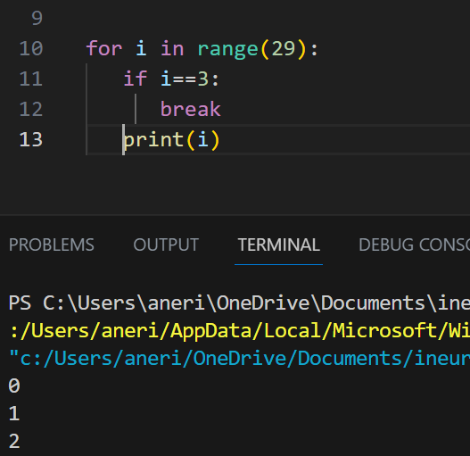

**Continue- The continue is used to skip the current iteration of the loop and proceed to the next iteration. When continue statement is encountered within the loop, the current iteration is skipped and loop moved to next iteration.**

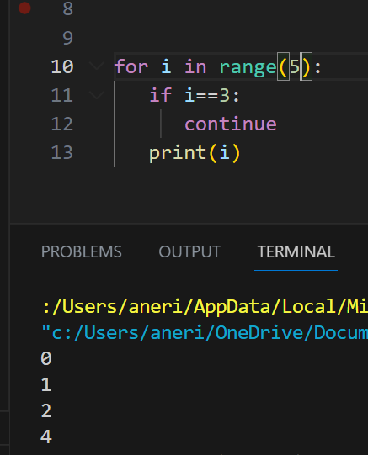

11. In a for loop, what is the difference between range(10), range(0, 10), and range(0, 10, 1)?

**The above syntax option is to create the way to print numbers but there is only the slightly difference in the syntax and behaviour**

12. Write a short program that prints the numbers 1 to 10 using a for loop. Then write an equivalent program that prints the numbers 1 to 10 using a while loop.

**For loop- for i in range(1,11):**

**Print(i)**

**While loop- i=1**

**while i<=10:**

**print(i)**

**i=i+1**

13. If you had a function named bacon() inside a module named spam, how would you call it after importing spam?

import spam

spam.bacon()