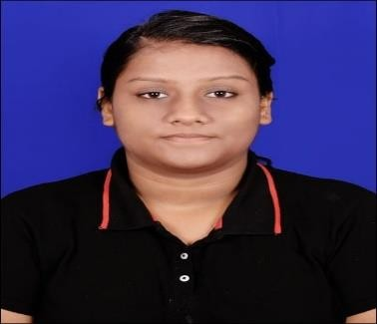ADITI BUBNA

Masters of Computer Application

[aditibubna11@gmail.com](mailto:aditibubna11@gmail.com%20) | +91-8249088463

|  |  |  |  |
| --- | --- | --- | --- |
| **EDUCATION** | | | |
| **Year** | **Degree/Exam** | **Institute** | **CGPA / %** |
| 2020 | BCA | Trident Academy of Technology | 7.56/ 10 |
| 2017 | Intermediate | F.M. college, Balasore | 80.83 % |
| 2015 | ICSE, 10th | SVCS, Balasore | 80.33 % |
| **SKILLS AND EXPERTISE** | | | |
| **|** C programming **|** C++ **|** JAVA **|** PYTHON |MS-OFFICE| Django | HTML | JAVA script | Tally | | | |
| **INTERNSHIPS** | | | |
| **Internee APPSTONE PVT.LTD (Unpaid)** (Jan 2020 - Mar 2020) Underwent **python with Django training** and used the same to build a website for travel management. The website could handle operations like login details, travel details, accept payment and booking  confirmation. The website was designed using HTML and CSS. | | | |
| **PROJECTS** | | | |
| **FASHI**: - Designed an E-commerce website, wherein the users can search, select and purchase products. Front-end design was made using HTML, CSS and backend was performed using Django. **MySQL** was also used where user’s login details were saved in a database. | | | |
| **CERTIFICATIONS** | | | |

**Python programming Lakshya Instituition, BBSR** (Oct 2019 - Dec 2019) Underwent python learning from basics to advanced including different datatype handling like lists, tuples, dictionaries. Also, different libraries like numpy, pandas, matplotlib were taught.

**Programming in CORE JAVA Lakshya Instituition, BBSR** (Mar 2019 - Apr 2019) Proficient in Java programming using scanner class, with a knowledge in arraylist as well. Also a brief knowledge in File handling using Java was given.

**Diploma in Financial Accounting NeXT Computer Education Pvt. Ltd., BLS** (NOV 2015 - JUN 2016) Trained in MS-OFFICE tools like MS-WORD, MS-EXCEL, MS-POWERPOINT. Also experience in

Tally ERP 9.0 for accounting purpose.

**I hereby declare that all the particulars of information and facts stated above are true, correct and complete to the best of my knowledge.**