Software Design Document

For

Booking a Ride

Prepared by: SAS team

- Scope:
This document presents the high level design for booking a Ride. This will facilitate the user to get cab without hassles.

- Consideration for producing a High Level Design:
- Software Life Cycle :
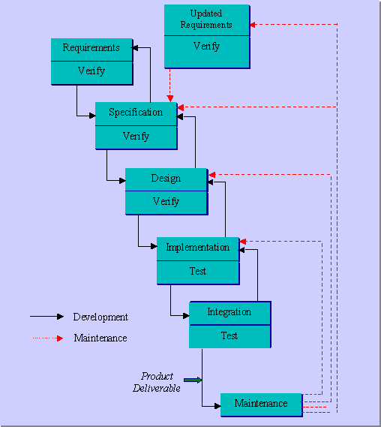

- Architectural View:
Technical Platform – This application based on service oriented architecture. We will develop this application using REST service architecture. In back-end we will use MonGo DB to store the cab details and driver details.

Reliability/Availability – It is not highly accurate but will give you precise usefulness on time.

Performance –

Use Cases – Below are the user cases:

Available Cabs at your location- When you open this application, it will show you the available cars near to your location
Book a Cab - you will search for a cab based on your source, destinations input
Find Driver - Based on the input it will fire a REST service, which will fetch you the list of drivers at your nearest location. This Service is a repetitive one and will give you chance twice.
First it will search within 2km . If it cannot find a driver in that radius then it will search within 5km radius. If still no cabs are present in the location, User will get a message saying “No cabs found”.
Assign a driver – Once you confirm, driver will be assigned to you.

- Logical view:

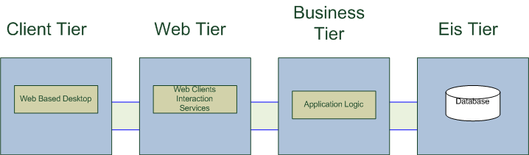
(Note : Adopted from SOA course details.)

Web Based Desktop – Login Screen

Services – RSET Services

Application Logic –

Enterprise Information Syatem – user profile, driver profile, ride advertisement

- Design View:
Below services are parts of the design:

Driver Manager Service:

Search Driver:

Mapping Driver:

Show cab based on your Current Location

User input for source position and destination Position
Start

LOGIN

Mapping driver service will map the particular driver against the client request.

Assign the Driver

