Insights with influential words
&
Reduces human intervention in live chat.

Open questions
- Can we automate the LIVE chat feature to avoid continuous human intervention?

Can we automate the LIVE chat feature to avoid continuous human intervention or help the user by providing frequently used keywords?
Use Case :
- User will post the query.
- Filter the frequently used keywords from the query.
- Show the other keywords entered by other users with the similar mindset (sentiment ).
- User might pick up some more keywords from the provided set of keywords.
- The business impact can be tested by the clickstream data from the provided set of keywords.

Some more viewpoints :
We tried to gather some tweet data related to Grabhouse and proceeded with some analysis related to it.
- This is a creenshot of a word cloud displaying the sentiments retrieved from the tweet data of the user using R-tool.
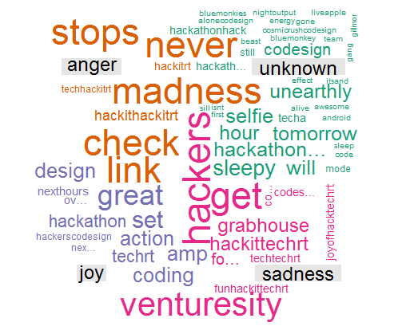
Same color represents similar sentiments. Once user will click on anyword, he will be redirected to the search result page.
- This screenshot represents the different mood of the users while twitting.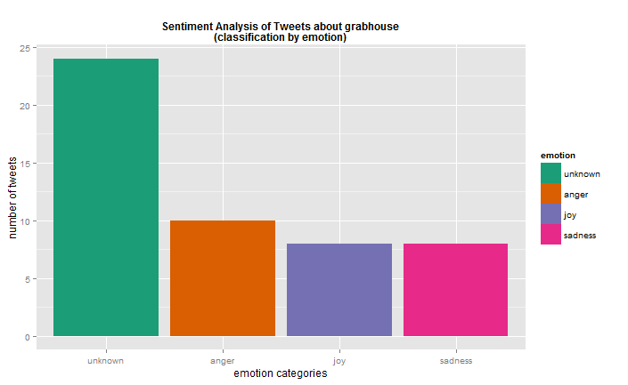
- This screenshot categorizes the reviews under 3 broad categories – negative, positive, neutral.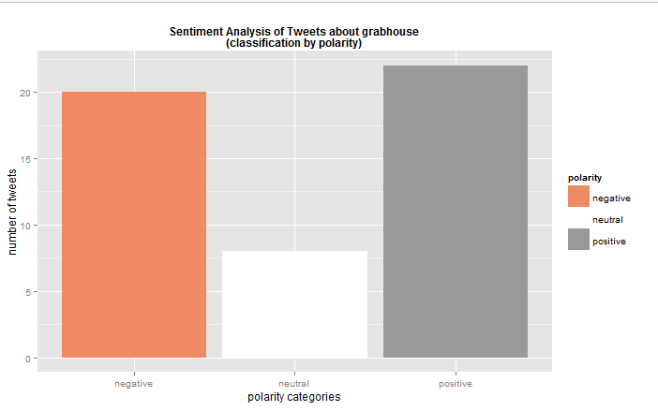
- This is the screenshot from the R-tool which performs the elastic search on the data core and provided the matching results accordingly.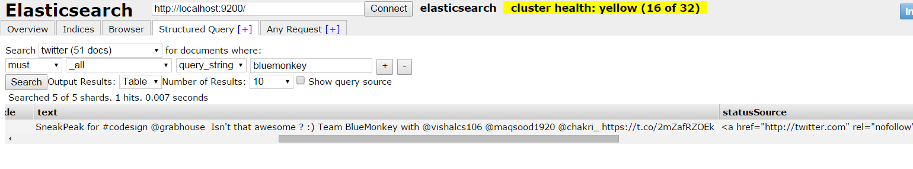
- This is the demo from the app developed and code against this is also checked in where user will choose the location. And the user will be provided with other frequently used keywords which other users used alongwith this keyword.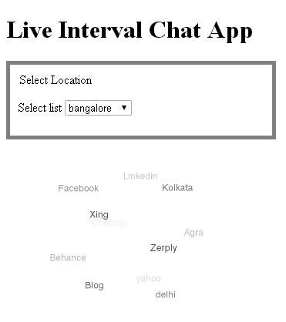

System Architecture:
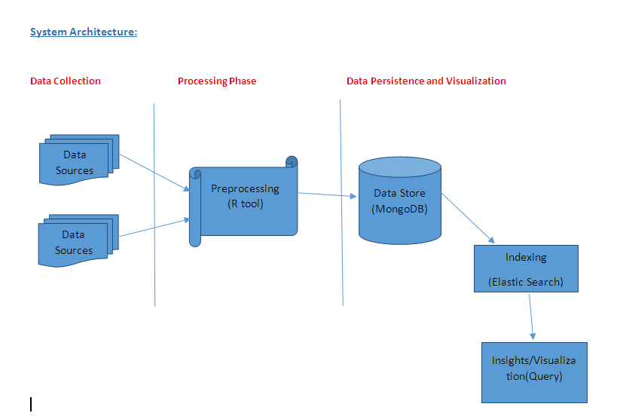
Technical flow planning :
- Stream chat data using streaming API’s.
- Doing preprocessing using R tool i.e., removing stop words, stemming etc.,
- Storing the structured data in persistent store (i.e., mongoDB(NOSQL) in our case) which could be available to any consumer to do further processing.
- In our case, we are using text Indexing framework to create indexes over our data and do some queries.
- The entire output will be shown as beautiful UI which is similar to a search engine.

Basic Flow-diagram
Search for Keywords
Get the keyword and Rest service call
Hit to the DB and Look-up for Search Result
User
Database

Result will be displayed here

- User knows what the price range they are looking for is. Do they know what all refinements they will apply on the search page if they are looking for some house where their elder parents will stay alone the whole day?

Purpose:
If the user is searching for home where their elder parents will stay, he will google first to check what will his top priorities to search home for them. Then apply those filters on websites like Grabhouse to get results as per their need.
To skip the google search, we can provide guidance to the user to meet their requirements.

Design flow:
Objective facet: good for elder people, good for kids, good for working people etc.
Subjective facet: price-range, is car-parking available, area, nearby hospital, nearby school, nearby grocery store, nearby bus-stop, airport etc.
- Decide on some objective facets which the end user can search for.
- Define some rules which will map the objective facets to the refinements on the search page.

Use case:
- User clicks on “good for elder people”
- The rule engine maps the activity ( i.e. “good for elder people”) with the specific refinements say refine by nearby hospital, a nearby park in an apartment with security.
- As per the final refinements it will generate a url to redirect the user to the search result page.

