Mobile Phone Price Prediction Using SVM

# Objective

To develop a model that predicts the price range of a mobile phone based on its technical specifications using Support Vector Machine (SVM).

# Dataset Description

The dataset includes features such as battery power, RAM, screen dimensions, camera quality, and connectivity options (e.g., 4G, 3G, WiFi). The target variable is 'price_range' which categorizes phones into four pricing tiers: 0 (low), 1 (medium), 2 (high), 3 (very high).

# Steps Performed

1. Loaded the dataset using pandas.  
2. Split the dataset into features (X) and target (y).  
3. Applied StandardScaler to normalize the data.  
4. Trained an SVM classifier with an RBF kernel.  
5. Evaluated the model using confusion matrix and classification report.

# Visualizations

Class Distribution in Dataset:

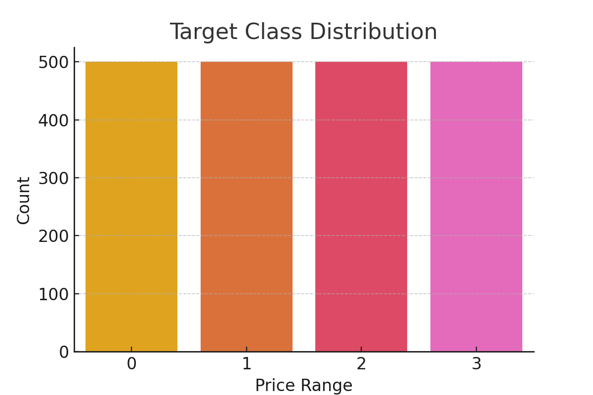

Feature Correlation Heatmap:

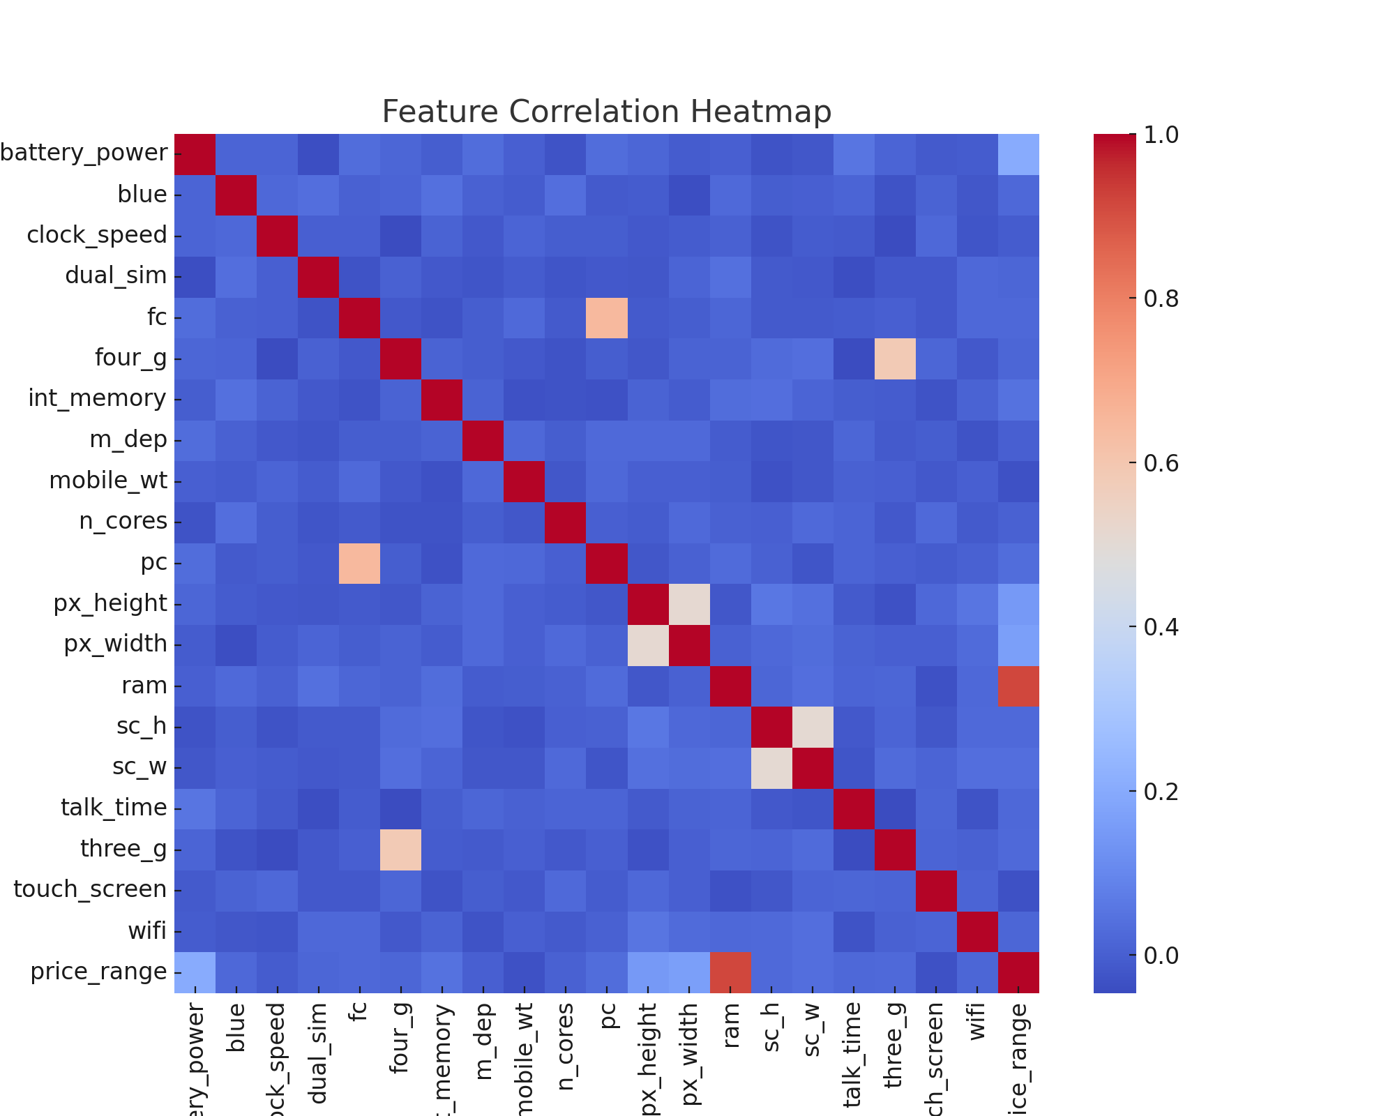

Confusion Matrix for Model Evaluation:

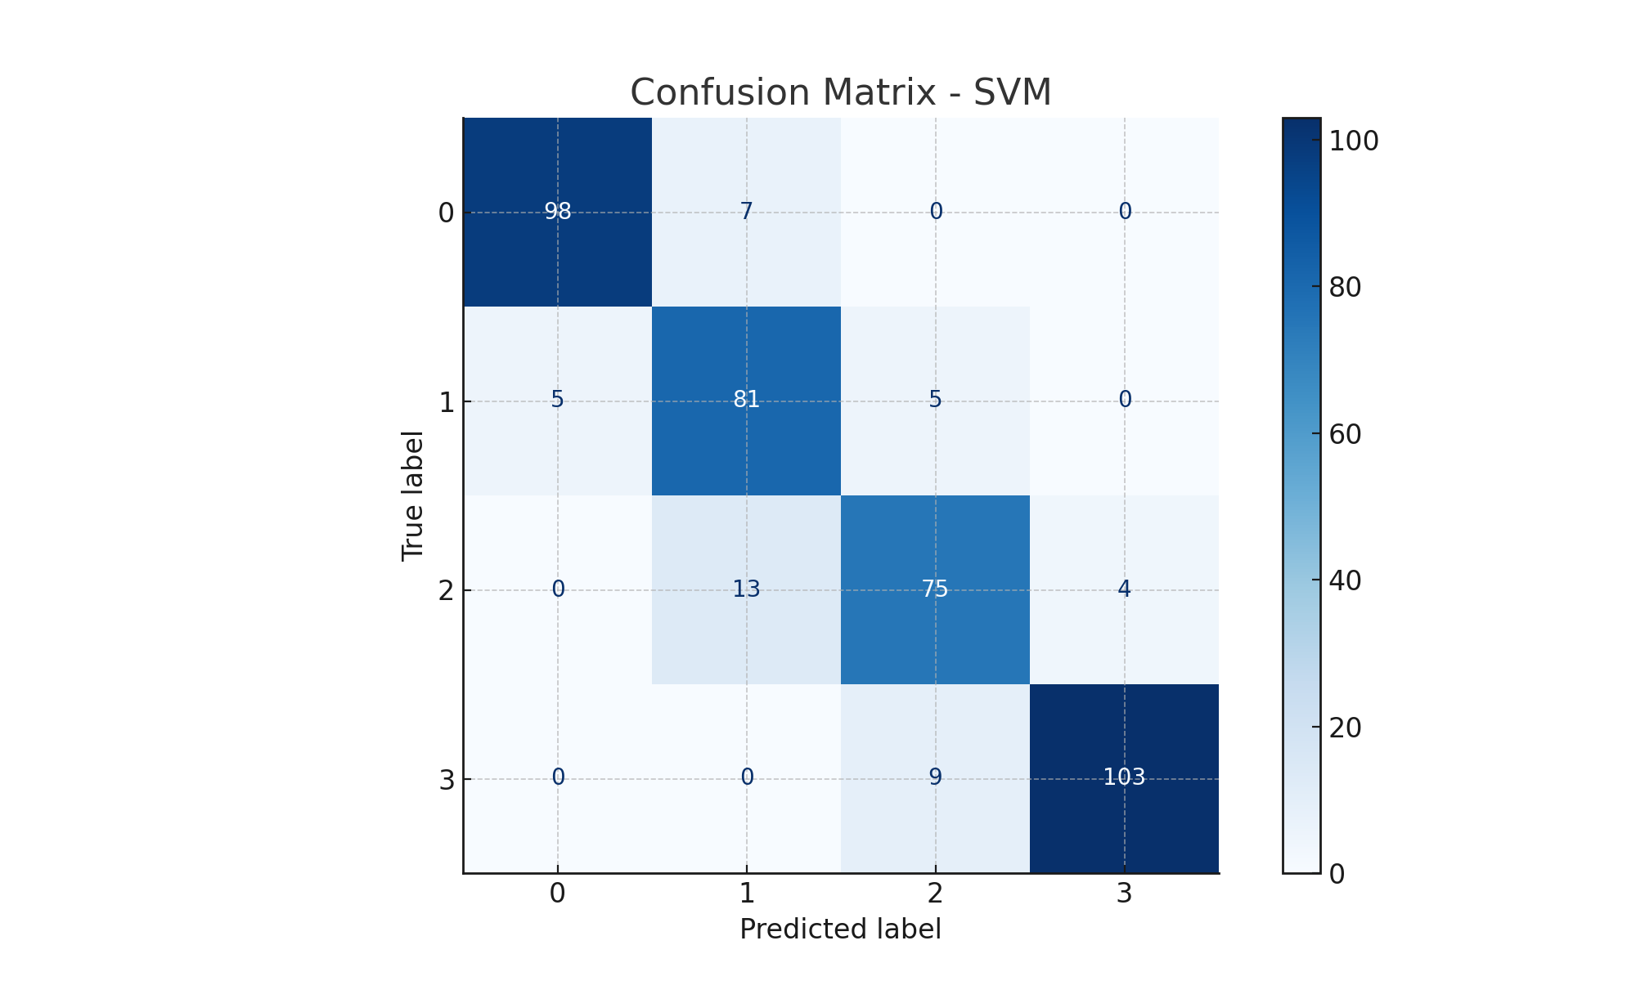

# Classification Report

precision recall f1-score support  
  
 0 0.95 0.93 0.94 105  
 1 0.80 0.89 0.84 91  
 2 0.84 0.82 0.83 92  
 3 0.96 0.92 0.94 112  
  
 accuracy 0.89 400  
 macro avg 0.89 0.89 0.89 400  
weighted avg 0.90 0.89 0.89 400