Energy Resilience through Renewables
How electrification could reduce India’s exposure to oil shocks
Prepared by: Aditi Sahu
Class XII · Oct 2026

Work in progress · Under review
This white paper is a work in progress. More analysis, data and detail are being added, and the current draft is under review. Figures and conclusions may change in later versions.

Summary
India buys most of its energy from other countries. In 2024-25 it imported about 89% of its crude oil, half of its natural gas and a quarter of its coal. This makes the Indian economy vulnerable to events it cannot control, such as wars in the Gulf or sudden jumps in global oil prices. The 2026 Hormuz crisis showed this clearly.
This project argues that electrifying the economy and generating that electricity from domestic sources (sunlight, wind and, over time, nuclear power) is not only a climate policy. It is also a way to protect India’s economy. The key reason is simple: oil must be bought again every day, but a solar panel is bought once and then produces electricity for 25 years.
Key findings
- Energy imports are a large, recurring cost. India’s gross fossil-fuel import bill is roughly 5% of GDP. The 2026 Hormuz crisis added about $22 billion of extra import costs in six months.
- Clean electricity is now cheaper than new coal. Solar power with battery storage that can supply electricity at peak times has been contracted at ₹5.25/kWh for 25 years, below the ₹5.38–6.30/kWh of new coal plants.
- Coal gets more expensive as it runs less. Using a simple cost function, the paper shows why coal plants become costlier per unit as cheap solar takes over daytime demand.
- The future depends on how fast India builds. In my scenario model, a high-ambition path cuts coal’s share of electricity from 71% today to about 15% by 2047 and lowers average generation costs by about 17% compared with a stalled path. A stalled path would need hundreds of gigawatts of new coal plants.
- The main obstacles are the power grid and manufacturing, not the cost of generating clean electricity. India still imports nearly all the polysilicon and wafers used to make solar panels.
- Oil - Inflation Relationship: I am designing a statistical study to measure how strongly oil price shocks raise Indian consumer prices, and whether electric vehicles are weakening that link.

1. Why energy is an economic question
Almost everything an economy does uses energy: trucks carry goods, factories run machines, farmers pump water, and families cook and light their homes. When energy becomes expensive, the cost of nearly everything rises at once.
In this paper the term economic sovereignty looks at three measurable questions:
- How much of India’s energy is imported?
- How strongly do foreign price shocks affect prices inside India?
- How much of the equipment needed for clean energy is made in India?

2. The problem: an economy that imports its energy
Official statistics from the Ministry of Statistics (MoSPI) show how dependent India is on imported fossil fuels [4].
Fuel | Share imported (FY2024-25) | Main use
Crude oil | 89.4% | Transport fuels, LPG, industry
Natural gas | 49.7% | Fertiliser, industry, cooking gas, power
Coal | 23.5% | Electricity, steel, cement
Table 1. India’s import dependence for fossil fuels. Source: MoSPI, Energy Statistics India 2026 [4].
Economists call a sudden rise in the price of an essential input an aggregate supply shock. Because oil is used almost everywhere, a jump in its price raises costs across the whole economy at the same time. Prices go up while production slows down, which is the worst combination for a government and a central bank to manage.
Case study: the 2026 Hormuz crisis
In late February 2026, military strikes on Iran led to the effective closure of the Strait of Hormuz, the narrow sea route through which a large share of the world’s oil and gas travels. For India the effects were immediate [5][15]:
- The price of India’s crude oil basket peaked near $157 per barrel in March 2026.
- The rupee fell to about 93–94 per US dollar, and the Reserve Bank of India spent about $46 billion defending it.
- Extra fossil-fuel import costs were about $22 billion (gross) between March and August 2026, or $14.4 billion net, 0.38% of GDP [5].
- Consumer price inflation rose from 3.21% in February to 3.93% in May.
India coped, thanks to large foreign-exchange reserves and by buying oil from more countries. But the crisis showed how exposed the economy remains.

3. The central idea: buying fuel versus buying machines
There is an important difference between importing fuel and importing equipment:
- Fuel is a repeating cost. It is burned once, so it must be bought again every day, at whatever price the world market sets.
- Equipment is a stock. A solar panel is bought once and then keeps producing electricity for decades, whatever happens to fuel prices.
A worked example makes the difference concrete. Consider 1 gigawatt (GW) of solar panels in India.
Step 1: yearly output. Solar panels in India produce on average about 18.5% of their maximum possible output (their capacity factor):
1 GW × 0.185 × 8,760 hours ≈ 1.62 TWh per year
Step 2: lifetime output. Panels lose about 0.5% of their output each year, so output in year t is 1.62 × 0.995ᵗ. The total over 25 years is a geometric series:
S = a(1 − rⁿ) / (1 − r) = 1.62 × (1 − 0.995²⁵) / (1 − 0.995) ≈ 38 TWh
Step 3: compare costs. If that electricity had come from imported liquefied natural gas (LNG), India would have needed about 259 million units (MMBtu) of gas. At $12 per unit that costs about $3.1 billion; at the 2022 crisis price of $34 it costs about $8.8 billion. The solar hardware itself costs only about $0.10–0.12 billion, which is 1–4% of the fuel it replaces.
This is the core of the argument. Electrification turns energy from a recurring foreign bill into a one-time investment. And if a supplier stops selling solar panels, the panels already installed keep working. If a supplier stops selling oil, the economy is affected within weeks.

4. Why clean electricity is winning on cost

4.1 Fixed costs and variable costs
Every power plant has two kinds of cost:
- Fixed costs are paid whether the plant runs or not: loan repayments, staff and maintenance.
- Variable costs are paid only for each unit produced, mostly fuel.
Coal is mainly a variable-cost technology: fuel makes up about 60% of its cost. Solar and wind are the opposite. Almost all their cost is the upfront investment, and their sunlight and wind are free. Because the grid uses the plants that are cheapest to run first, solar and wind are used whenever they are available, and coal is pushed to the hours that remain.

4.2 Why coal becomes more expensive as it runs less
A coal plant’s plant load factor (PLF) is the share of the year it effectively runs at full power. If a plant’s yearly fixed cost per kilowatt is F and its fuel cost per kWh is v, its average cost per unit is:
Average cost = v + F / (8,760 × PLF)
This is a hyperbola: as PLF falls, the same fixed cost is shared over fewer units, so each unit becomes more expensive. Using values calibrated to Indian data (fuel ≈ ₹2.9/kWh and fixed cost ≈ ₹1.9/kWh at 69% PLF), the formula becomes 2.9 + 1.9 × 0.69 / PLF.
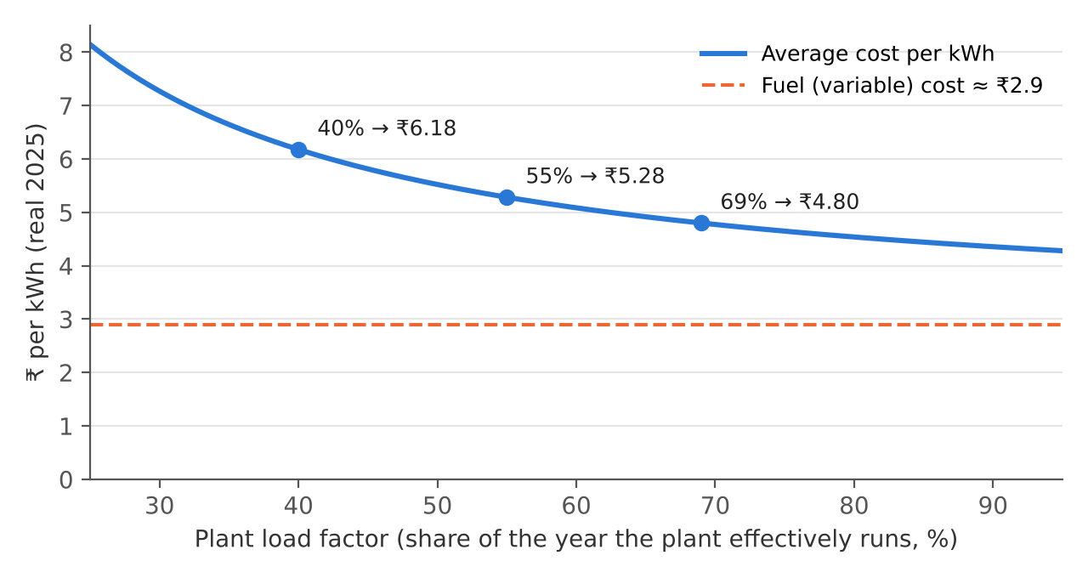
Figure 1. Average cost of coal electricity as a function of plant load factor. The cost of one more unit (the fuel cost) stays flat, but the average rises steeply as the plant runs less. Author’s calculation based on Ember data [2].
India’s coal fleet ran at about 69% in 2024-25 (₹4.80/kWh in this model). If solar pushes it down to 55%, the cost rises to about ₹5.28/kWh; at 40% it is about ₹6.18/kWh. Coal plants will still be needed in the evenings, so they cannot simply be closed. The result is a coal fleet that is needed but underused, and increasingly expensive per unit.

4.3 What the market shows
The Solar Energy Corporation of India (SECI) has contracted solar-plus-battery power that must be available 90% of the time during peak hours. It cleared at ₹5.25 per kWh, fixed for 25 years [9]. New coal contracts cost ₹5.38–6.30 per kWh, and that price rises with fuel costs. Firm clean power is now cheaper than new coal.

4.4 The catch: interest rates
Because solar and storage are paid for upfront, their cost depends heavily on the interest rate at which the money is borrowed. The yearly repayment on a loan is set by the capital recovery factor:
CRF = r / (1 − (1 + r)⁻ⁿ)
where r is the interest rate and n the number of years. Raising the interest rate from 8% to 10% increases solar’s cost by about 15%, but coal’s by only about 7%. Cheap, stable finance is therefore as important for the transition as cheap panels.

5. Projecting the future: a scenario model
To see where different choices could lead, I built a scenario model in Python that runs year by year from 2025 to 2047. It works as follows:
- Electricity demand grows by 5.5% a year until 2035 and 4.5% a year after that, plus extra demand from electric vehicles.
- Clean electricity = installed capacity × capacity factor, for solar, wind, hydro and nuclear power.
- Coal fills whatever demand is left (demand − clean supply).
- The model then calculates costs, carbon emissions and the oil saved by electric vehicles.
It compares three policy paths:
Scenario | Solar added per year | Nuclear by 2047 | Idea
Stalled transition | 30 GW | 30 GW | Clean-energy growth slows
Current-policy trajectory | 45–50 GW | 60 GW | Today’s pace continues
Electrotech sovereignty | 60 → 115 GW | 100 GW | Build-out speeds up with demand
Table 2. The three scenarios in the model.
Result in 2047 | Stalled | Current policy | Electrotech
Coal share of electricity (71% in 2025) | 64% | 46% | 15%
Average generation cost (₹/kWh) | 4.55 | 4.23 | 3.76
New coal plants needed beyond today’s pipeline | ≈380 GW | ≈240 GW | 0
Oil saved by electric vehicles, 2025–2047 | 4.1 bn barrels | 7.9 bn barrels | 12.1 bn barrels
Table 3. Main projections for 2047. These are projections that depend on the model’s assumptions, not forecasts.
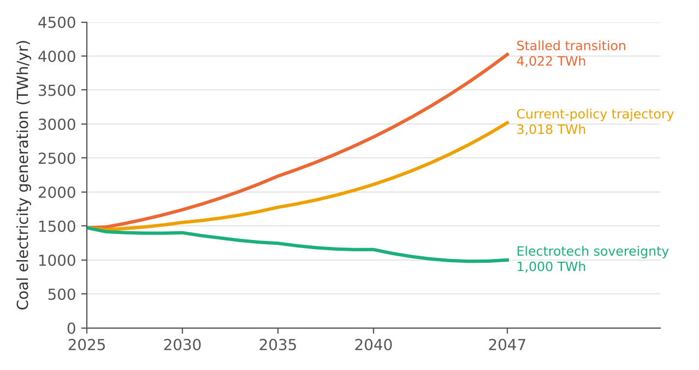
Figure 2. Coal electricity generation under the three scenarios (author’s model).
Three results stand out:
- Today’s pace does not stop coal from growing. Even the current-policy path needs about 240 GW of new coal plants by 2047, because demand grows so fast.
- The high-ambition path is cheaper in the long run, but not at first. Around 2030 its costs are slightly higher, because batteries are still expensive and coal’s fixed costs are spread over fewer units. By 2047 it is about 17% cheaper. Economists would call this a transition hump.
- Only the high-ambition path makes coal decline, and it needs 85–115 GW of new solar a year in the 2030s and 2040s.
When the model broke, and what I learned
In an early version, the model kept the coal fleet at a fixed size. In the stalled scenario, the demand left for coal became so large that the model showed coal plants running at more than 100% of their capacity, which is physically impossible.
The error was an assumption: that the coal fleet stays the same size whatever happens. I changed the model so that it builds new coal plants whenever the existing fleet would have to run above 70%. This revealed that a stalled transition would need roughly 380 GW of new coal, on top of today’s fleet of about 240 GW.
I then tested how sensitive this number is. With demand growth one percentage point lower, it falls to about 194 GW; one point higher, it rises to about 609 GW. Allowing plants to run up to 80% before new ones are built lowers it to about 299 GW. The honest conclusion is “roughly 150–600 GW”: the exact number is uncertain, but the direction is clear.

6. What could slow the transition

6.1 The power grid
Generating clean electricity is not enough; it must reach homes and factories at the right moment. India’s transmission lines have been built at only about 80% of the planned rate over the past five years, and in January–March 2026 about 470 GWh of renewable electricity was wasted (curtailed) because the grid could not take it [3].
Grid stability also matters. The frequency of India’s grid must stay close to 50 Hz. When a large power plant suddenly fails, the frequency starts to fall, and how fast it falls is described by the swing equation:
df/dt = f₀ ΔP / (2HS)
Here ΔP is the lost power, and H × S measures the energy stored in the spinning turbines of coal, hydro and nuclear plants (inertia). Solar panels have no spinning parts, so replacing coal with solar reduces inertia. India’s grid inertia is still healthy today, and its recent problem has actually been the opposite: too much power at midday, which pushed the frequency up to 50.39 Hz in August 2024 [11]. The solutions are already being bought: batteries with grid-forming inverters that imitate spinning machines, synchronous condensers (spinning machines that burn no fuel), and a ₹1.86 lakh crore programme to expand state transmission networks that includes 50 GWh of batteries [15].

6.2 Dependence on China for equipment
India now has about 172 GW of factory capacity to assemble solar modules [8], but it still imports about 100% of its polysilicon and 98% of its wafers, mostly from China [10]. Battery manufacturing has barely started: by October 2025 only 1.4 GWh of a 50 GWh battery-cell target had been built [15]. This dependence is real. However, it is a dependence on equipment (a stock), which is less dangerous than dependence on fuel (a flow).

6.3 Nuclear power
Nuclear power is one of the safest and lowest-carbon sources of electricity, and in April 2026 India’s Prototype Fast Breeder Reactor reached criticality, a major step in its long-term plan to use thorium. But the government’s target of 100 GW by 2047 would require building about 4 GW every year, far faster than India has ever managed, at costs above solar with storage. Nuclear power’s value is mainly strategic (reliable, land-efficient, domestic fuel), not cheapness.

7. Work in progress: does electrification weaken oil’s grip on prices?
Status
This section describes a study that is designed but not yet carried out. No results are reported here; they will be presented in the next version of this paper.

7.1 The question
When global oil prices rise by 10%, how much do Indian consumer prices rise, and how quickly? Economists call this share the pass-through. If electrification really protects the economy, the pass-through should become smaller as more vehicles and households switch from oil to electricity.

7.2 What is already known
Research published by the Reserve Bank of India estimates that a 10% rise in crude oil prices raises consumer inflation by about 0.20 percentage points [6]. A quick check with the 2026 crisis is encouraging: crude prices were about 38% above normal between March and August, which suggests an increase in inflation of about 0.76 percentage points, and actual inflation rose by about 0.72 points between February and May. But one event cannot prove a relationship.

7.3 The planned method: a linear regression
I plan to use monthly data and a linear regression, which finds the line that best explains how one quantity changes with another:
πₜ = a + b₀·Δoilₜ + b₁·Δoilₜ₋₁ + … + b₆·Δoilₜ₋₆ + c·controlsₜ + εₜ
- πₜ is consumer inflation in month t.
- Δoil is the percentage change in the price of oil in rupees, measured this month and in each of the previous six months, because the effect takes time to spread.
- The controls account for other causes of inflation, such as food prices and interest rates.
- The sum b₀ + b₁ + … + b₆ is the pass-through.
The key test is to add one more term, Δoil × EV share. If its coefficient is negative, the effect of oil prices on inflation is shrinking as electric vehicles spread. That would be direct evidence for this paper’s argument.

7.4 Data and challenges
All the data is free and published monthly: consumer prices (MoSPI), oil prices (PPAC and the US Energy Information Administration), exchange and interest rates (Reserve Bank of India) and electric-vehicle registrations (VAHAN). The study faces some known challenges:
- Government-controlled fuel prices. India often keeps petrol and diesel prices unchanged for months, so oil shocks may show up later or through government finances instead of prices.
- Correlation is not causation. Oil prices often rise when the whole world economy is booming, so other factors must be separated out.
- Early days for EVs. Electric vehicles are still a small share of road transport, so the effect may be too small to measure yet. That would itself be a useful finding.

8. Conclusion and next steps
The evidence so far supports the paper’s central argument for energy security and economic stability. Electricity from domestic sources replaces a recurring foreign bill with a one-time investment, and clean electricity is already cheaper than new coal. The argument is weaker for industrial independence, because India still depends on imports for the most valuable parts of the clean-energy supply chain. Whether India builds its grid, storage and manufacturing fast enough in the next decade will decide which way it goes.
Next steps for this research:
- Carry out the oil-to-inflation regression described in Section 7.
- Estimate learning curves: how quickly solar and battery costs fall as more are built.
- Model electricity demand from income growth and temperature.
- Add uncertainty ranges to the scenario model instead of single numbers.
- Test hour by hour whether evening demand can be met without new coal.

Glossary
Term | Meaning
Capacity factor | The share of its maximum possible output that a power plant actually produces over a year.
Plant load factor (PLF) | The capacity factor of a coal plant; how much it actually runs.
Merit order | The rule that the grid uses the plants that are cheapest to run first.
Aggregate supply shock | A sudden change, such as an oil price spike, that raises costs across the whole economy at once.
Pass-through | The share of a price change in one good (like oil) that shows up in overall consumer prices.
Curtailment | Electricity that could have been generated but was wasted because the grid could not use or carry it.
Inertia | Energy stored in the spinning turbines of power plants, which slows down changes in grid frequency.
TWh / GW | A gigawatt (GW) measures power at a moment; a terawatt-hour (TWh) measures energy over time (1 TWh = 1 GW running for 1,000 hours).

References
[1] Ember (Jan 2026). India’s electrotech fast-track: where China built on coal, India is building on sun. https://ember-energy.org/latest-insights/indias-electrotech-fast-track-where-china-built-on-coal-india-is-building-on-sun/
[2] Ember (Apr 2026). Coal’s diminishing role in India’s electricity transition: coal power to get costlier. https://ember-energy.org/latest-insights/coals-diminishing-role-in-indias-electricity-transition/coal-power-to-get-costlier/
[3] Ember (May 2026). Transmission gaps are beginning to constrain India’s rapid renewables integration. https://ember-energy.org/latest-insights/transmission-gaps-are-beginning-to-constrain-indias-rapid-renewables-integration/
[4] Ministry of Statistics and Programme Implementation (Mar 2026). Energy Statistics India 2026. https://www.mospi.gov.in
[5] CREA (Aug 2026). What the Hormuz crisis has cost fossil fuel importers, March to August 2026. https://energyandcleanair.org/what-the-hormuz-crisis-has-cost-fossil-fuel-importers-march-to-august-2026/
[6] Kundu, S., Tewari, S. & Bhattacharyya, I. (Jul 2025). Revisiting the oil price and inflation nexus in India. RBI Bulletin (as reported by Business Today). https://www.businesstoday.in/latest/economy/story/crude-oil-shock-10-price-spike-can-push-inflation-up-20-bps-says-rbi-research-485970-2025-07-23
[7] Balakrishnan, V. & Bangroo, Z. (May 2026). Crude Oil Shock and CPI Inflation in India. Isaac Centre for Public Policy, Ashoka University. https://icpp.ashoka.edu.in/policy/discussion-paper/crude-oil-shock-and-cpi-inflation-in-india
[8] Press Information Bureau (Aug 2026). India’s Solar Growth Enters a New Era. https://www.pib.gov.in/PressReleasePage.aspx?PRID=2293256
[9] Saur Energy (Aug 2026), reporting an IECC (UC Berkeley) working paper. SECI’s ₹5.25/kWh FDRE tender shows solar-storage can mimic coal. https://www.saurenergy.com
[10] Business Today (Jun 2026). Behind India’s import dependence is solar installations. https://www.businesstoday.in/magazine/deep-dive/story/behind-indias-import-dependence-is-solar-installations-539458-2026-06-27
[11] Central Electricity Regulatory Commission (Mar 2025). Suo Motu Petition No. 2/SM/2025 on high-frequency operation. https://cercind.gov.in/2025/orders/2-SM-2025.pdf
[12] Our World in Data. Energy dataset. https://github.com/owid/energy-data
[13] Kilian, L. (2009). Not all oil price shocks are alike. American Economic Review 99(3): 1053–1069.
[14] Blanchard, O. & Galí, J. (2007). The macroeconomic effects of oil shocks: why are the 2000s so different from the 1970s? NBER Working Paper 13368.
[15] Author’s companion report and scenario model: Electrons as Sovereignty: India’s Energy Transition (v5, October 2026), which documents all figures and calculations in full.

Note on method: AI research tools were used to help gather and cross-check sources and to review calculations. All figures were checked against the sources listed.

