# Project Summary: Burglar Alarm with User Interface

## Summary

The idea is to design a burglar alarm that can detect movements and provide auditory output. The user shall be able to turn the alarm on/off and configure the settings.

The goal is to get a basic understanding of designing applications on a multi-core microcontroller. Hence, I have tried to keep the application simple. I intend to do the project in 2-3 iterations, building a level of complexity after each iteration.

## Components

1. Microcontroller (Aurix TC297)
2. PIR sensor
3. Buzzer
4. TFT display
5. Push buttons

## Iteration1: Bare metal implementation

* Decide on suitable components for the controller.
* Set up the hardware connection
* Implement drivers for the hardware
* Test components individually

Limitation: Each core can run only one thread

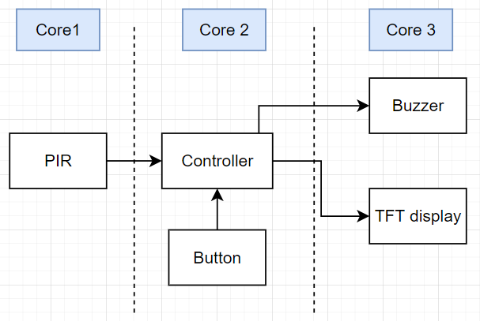

Behavior:

Interrupt from the button turns the alarm ON/OFF based on the previous state.

When the alarm is ON, core 1 continuously reads the input from the PIR sensor. Core 2 monitors this value, sends a notification to Core 3 when a movement is detected.

Core 3 controls the buzzer and TFT display. Buzzer sound is played, and a simple message is displayed on the TFT.

## Iteration2: Add Operating System

* Emulate the same behavior on an operating system
* The goal is to understand trivialities associated with an Operating system when used on a multicore controller

## Iteration 3: Integrate more functionalities

* Behavior: User shall be able to configure initial time gap on the TFT, after which the sensor should start monitoring movements.
* Additional button to control settings on the TFT display

## Project Timeline

|  |  |
| --- | --- |
| Month | Tasks |
| May, 2022 | Research, System design and architecture, evaluate components, circuit design |
| June, 2022 | Component tests, Circuit test, gain hardware know-how of multicore, install necessary tools, setup skinny sheep |
| July, 2022 | Iteration 1, set up OS, unit testing |
| August, 2022 | Iteration 2, Iteration 3 (50%), unit testing |
| September, 2022 | Iteration 3, testing (unit + system) |