Detecting AI-Generated Text
A Comparative Evaluation of Classical and Transformer-Based Classifiers

SEA 820 — Final Project Report | Aditi & Victoria | July 2026
Repository: github.com/aditi2-bsa/SEA800-AI-Text-Detection

1. Introduction
The rapid adoption of large language models has made it substantially harder to tell AI-generated writing apart from human writing, with real consequences for academic integrity, misinformation, and content moderation. This project asks how well two very different families of text classifier can separate AI-generated essays from human-written ones: a classical bag-of-words pipeline (TF-IDF features feeding Logistic Regression, Multinomial Naive Bayes, and a Linear SVM) and a fine-tuned transformer (DistilBERT). Both are evaluated on the same dataset, the same stratified train/test split, and the same random seed, reused across four notebooks — exploratory analysis, the classical baseline, the transformer, and a joint error analysis — so that the comparison in the sections that follow is between the models themselves and not an artifact of different data handling.
We expected the transformer to win. Transformers are built to capture context and style in a way a bag-of-words representation structurally cannot, and DistilBERT is a well-established, competent baseline for exactly this kind of classification task. What we found instead was close to the opposite: a Linear SVM over TF-IDF features slightly but consistently outperformed a fine-tuned DistilBERT, and — more importantly — every model tested scored above 97% accuracy, with the best two above 99.9%. We read that not as a success story but as a prompt to look harder. The rest of this report works through where that performance actually comes from, including a specific, checkable dataset artifact that may explain a meaningful share of it, and argues that the artifact matters more to the conclusions of this project than the leaderboard order does.

2. Dataset & Exploratory Data Analysis
Source and size. The dataset is Kaggle's AI Vs Human Text collection (Gerami, 2024), comprising 487,235 essays labelled human-written (0) or AI-generated (1), with no missing values and no exact duplicate rows. After removing 36 AI-labelled texts under 20 words — noise rather than usable signal for a task about writing style — 487,199 essays remained, split 80/20 with a fixed, stratified random seed (random_state = 42) that is reused, unchanged, in every later notebook. Reusing one split guarantees the classical and transformer models are scored on exactly the same 97,440 held-out essays, which is what makes the head-to-head comparison in Section 4 meaningful.
Property | Value
Total rows | 487,235
Human (label 0) | 305,797 (62.8%)
AI (label 1) | 181,438 (37.2%)
Missing values | 0
Exact duplicates | 0
Texts under 20 words (removed) | 36 (all AI)
Final dataset after filters | 487,199
Train / test split | 389,759 / 97,440 — stratified, random_state = 42
Table 1. Dataset overview after quality filtering.
Class imbalance. Human essays make up 62.8% of the data and AI essays 37.2% — not severe, but large enough that a classifier that always predicts “human” would already score 62.8% accuracy. Accuracy alone is therefore a poor headline metric here; we report macro-F1 alongside it throughout, and used class_weight='balanced' in both discriminative classical models — Logistic Regression and the Linear SVM (Section 3); Multinomial Naive Bayes does not accept this parameter — specifically so the minority AI class isn't underweighted during training.
Length. AI-generated essays are both shorter and dramatically more uniform than human essays: a median of 337 words versus 390, and a standard deviation of 117.0 versus 186.9 (Figure 1). Human essay length ranges from 14 to 1,668 words; AI-generated length ranges from 1 to 1,239. Essay length turns out to be a real, if weak, predictive signal on its own, and it resurfaces in Section 5, where DistilBERT's 256-token input limit interacts directly with this same asymmetry.
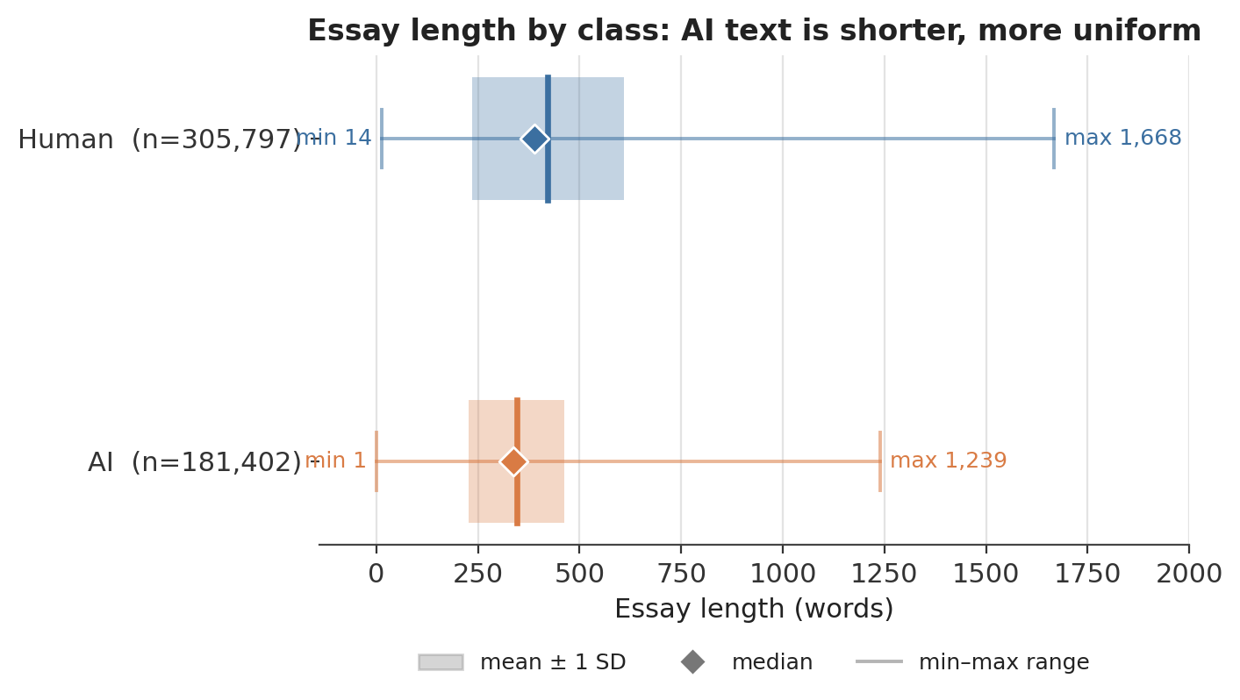
Figure 1. Essay length by class. AI-generated text clusters tightly around a shorter median; human text is longer on average and far more spread out.
Quality filters. Beyond the 36 short-text removals, no further cleaning was required at this stage — there were no missing values and no exact duplicates to resolve. A related but distinct question, near-identical (not exactly identical) essays that may straddle the train/test boundary, was still an open check as of this report; see Sections 5 and 7.
Vocabulary — and the most important finding in this report. On a balanced 40,000-essay sample, the words most associated with AI-generated text skew abstract and hedging: equitable, fostering, nuances, policymakers, sustainability, contexts, disproportionate, testament. The words most associated with human text include concrete numbers (83, 147, micrograms), informal misspellings (driveless, wont) — and, most tellingly, anonymisation placeholders: teacher_name, school_name, and proper_name (Table 2).
AI-associated vocabulary | Human-associated vocabulary
equitable, fostering, nuances, policymakers, sustainability, contexts, disproportionate, testament | teacher_name, school_name, proper_name (redaction tokens); driveless, wont (misspellings); 83, 147, micrograms (specific figures)
Table 2. Vocabulary most strongly associated with each class (balanced 40k sample).
Those placeholder tokens exist because the human-written portion of this corpus was drawn from student essays that had personally identifying details redacted before release; the AI-generated portion was never anonymised, because there was no name in it to redact. That difference has nothing to do with how the two kinds of text are written and everything to do with how the dataset was assembled. A model does not need to learn anything about linguistic style to exploit it — detecting the literal substring “teacher_name” is enough, on its own, to flag an essay as human with very high confidence. We come back to how much this single artifact could be inflating the headline numbers in Sections 4, 6, and 7.

3. Methodology
Preprocessing. The only preprocessing decision carried over from the EDA was removing the 36 AI-labelled essays under 20 words (Section 2). Everything else — capitalisation, punctuation, and the anonymisation placeholders discussed above — was left as the original text, so that the classical pipeline's exposure to those placeholders is not accidentally different from the transformer's.
Split and seed. All four notebooks call the same stratified 80/20 split with random_state = 42, generated once and reused rather than re-split per notebook. This is what makes the classical-vs-transformer comparison in Section 4 and the shared-error analysis in Section 5 valid: both model families are evaluated on the identical 97,440 held-out essays. The tradeoff, returned to in Section 7, is that this same test set was also used to choose between DistilBERT's two hyperparameter configurations below — a mild form of leakage into model selection that a dedicated validation split would avoid.
TF-IDF baseline. Features were unigrams and bigrams via scikit-learn's TF-IDF vectorizer (Pedregosa et al., 2011). Bigrams matter specifically for this task because several of the strongest AI-associated signals are two-word phrases — “in conclusion,” “this essay” — that a unigram-only representation could only approximate. Three classifiers were trained on identical features: Logistic Regression, Multinomial Naive Bayes, and a Linear SVM, all with class_weight='balanced', which re-weights the training loss inversely to class frequency so the minority AI class (37.2% of the data) contributes as much to the objective as the majority Human class rather than being down-weighted simply for being smaller.
DistilBERT. The transformer model was distilbert-base-uncased, fine-tuned with the Hugging Face Trainer API (Wolf et al., 2020) on a Colab T4 GPU using mixed precision (fp16). DistilBERT compresses BERT through knowledge distillation during pre-training, reported to retain roughly 97% of BERT's language-understanding performance at about 60% of the inference cost (Sanh et al., 2019) — a relevant tradeoff on a single, session-limited T4. For the same practical reason, fine-tuning used a stratified ~40,000-row subsample of the 389,759-row training set rather than the full set, with inputs truncated to max_length=256 tokens rather than the 512 DistilBERT supports. Both choices trade information for a training run that fits inside a Colab session; Sections 4 and 7 return to what they may have cost the transformer specifically.
Exp | LR | Epochs | Batch | Accuracy | F1 (AI) | Macro-F1
A | 2e-5 | 2 | 16 | 0.9933 | 0.9911 | 0.9929
B | 5e-5 | 1 | 16 | 0.9947 | 0.9929 | 0.9943
Table 3. DistilBERT hyperparameter experiments, evaluated on the full 97,440-row test set.
Experiment B outperformed Experiment A on every metric, and Experiment A's own epoch-1 checkpoint scored better than its epoch-2 checkpoint — a sign of mild overfitting once training runs past a single pass over a 40k-example subsample. Experiment B is carried forward as “the” DistilBERT model in the comparison in Section 4.

4. Results
Table 4 summarises performance on the shared 97,440-essay test set, sorted by macro-F1. Every model scores above 97% accuracy and the top three are within half a point of each other on most metrics — but the ranking is consistent and, on closer look, more surprising than a single “simple model wins” headline suggests:
Model | Accuracy | Precision (AI) | Recall (AI) | F1 (AI) | Macro-F1
Linear SVM + TF-IDF | 0.9997 | 0.9995 | 0.9996 | 0.9996 | 0.9997
Logistic Regression + TF-IDF | 0.9963 | 0.9965 | 0.9935 | 0.9950 | 0.9960
DistilBERT (Exp B) | 0.9947 | 0.9900 | 0.9958 | 0.9929 | 0.9943
Multinomial Naive Bayes | 0.9727 | 0.9798 | 0.9461 | 0.9626 | 0.9705
Table 4. Model comparison on the shared 97,440-essay test set.
Both TF-IDF linear models beat the fine-tuned transformer, not just the strongest one. The Linear SVM is the best model overall, but plain Logistic Regression is second — DistilBERT places third, ahead of only Multinomial Naive Bayes. That a completely unremarkable linear model, with no fine-tuning and no contextual representation at all, outperforms a fine-tuned transformer is a stronger and more specific result than “the best classical model won”: it points at something about the signal in this dataset, not something special about the SVM.
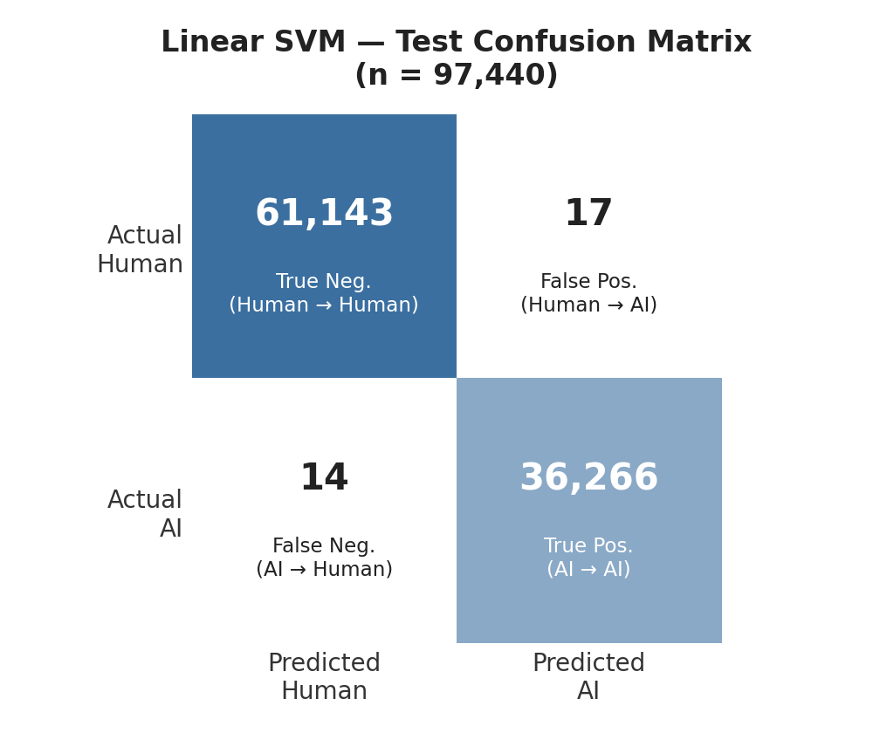 | 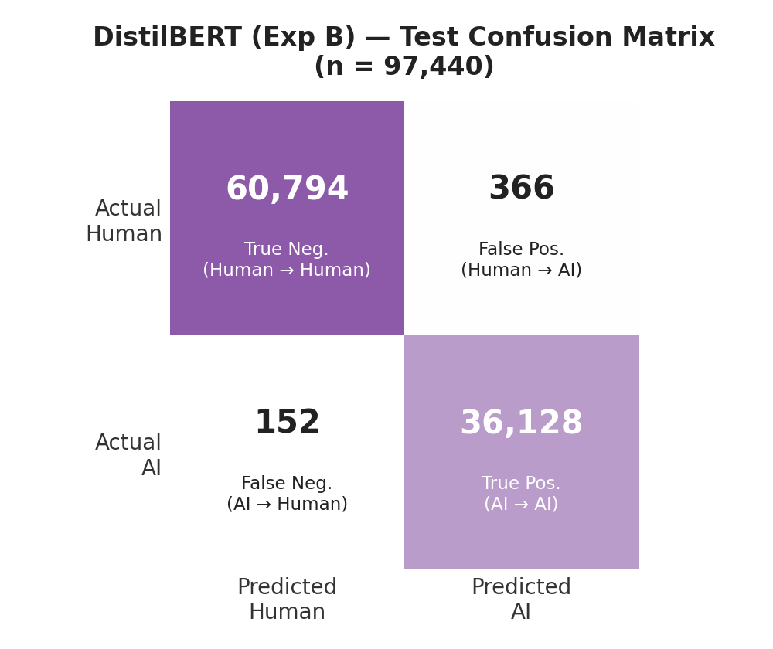
Figures 2–3. Test-set confusion matrices for the Linear SVM (left) and DistilBERT Exp B (right).
The two confusion matrices tell a consistent story. The SVM's errors are rare and roughly balanced between false positives and false negatives (17 vs. 14). DistilBERT's errors skew toward false positives — it flags human essays as AI-generated (366) more than twice as often as it misses genuine AI essays (152).
Why did the simpler models win?
We see four plausible, non-exclusive explanations, and we think more than one is true at once rather than there being a single cause:
- Linear separability on surface cues. Several of the strongest signals in this dataset — the phrase “in conclusion,” the anonymisation placeholders, distinctive word choices like “equitable” or “fostering” — are close to linearly separable lexical cues. Logistic Regression's own coefficients push toward “AI” for exactly these formulaic markers (“in conclusion,” “additionally,” “however,” “essay”) and toward “human” for concrete, situational words (“because,” “you,” “car,” “driving,” “nasa”). A linear model over sparse bag-of-words features is, in effect, built for exactly this kind of signal; a transformer's capacity for contextual nuance goes unused, or is even a mild handicap, when the dominant signal is close to “does this string appear.”
- Training-data volume. The SVM trained on the full 389,759-example training set; DistilBERT fine-tuned on a ~40,000-example stratified subsample (Section 3) for compute reasons. A roughly tenfold data disadvantage is, on its own, a plausible and unglamorous explanation for a few tenths of a percentage point of accuracy.
- Truncation. DistilBERT saw at most the first 256 tokens of every essay; TF-IDF saw the whole document regardless of length. Given that human text has a long right tail (up to 1,668 words, Section 2), truncation should cost the transformer disproportionately on longer essays — and Section 5's length analysis supports exactly that pattern.
- Possible near-duplicate leakage. Section 5 flags near-identical essays that appear to straddle the train/test boundary. If confirmed, some fraction of every number in this section is inflated by a model having effectively already seen a close paraphrase of a “held-out” essay during training — a risk that applies to both model families, though not necessarily equally.
We want to be explicit about something the headline numbers obscure: accuracy above 99.9% on a real, messy, human-vs-AI writing task should raise suspicion before it raises confidence. A task this easy for two structurally very different model families most likely means both are latching onto artifacts of how this specific dataset was built — the anonymisation tokens chief among them — rather than learning a robust, general notion of “AI-generated writing.” We treat that as the central finding of this report, not a footnote to it, and it is the reason we do not recommend deploying either model as-is (Sections 6, 7).

5. Error Analysis
How the two models fail. The SVM made 31 errors on the 97,440-essay test set; DistilBERT made 518 — a nearly 17× difference in error count between two models within half a percentage point of each other on accuracy (Table 5).
Model | Total errors | False positives | False negatives
Linear SVM + TF-IDF | 31 | 17 | 14
DistilBERT (Exp B) | 518 | 366 | 152
Table 5. Error counts by model (false positive = human essay predicted AI; false negative = AI essay predicted human).
Merging both models' predictions on the shared test set shows the errors barely overlap (Figure 4): of DistilBERT's 518 errors, only 9 are essays the SVM also got wrong. The other 509 are mistakes unique to the transformer, and the SVM's own 22 unique errors are, in turn, mistakes DistilBERT gets right. That is a stronger and more specific claim than “the SVM has a lower error rate” — nearly all of DistilBERT's mistakes are cases the simpler, feature-based model already handles correctly.
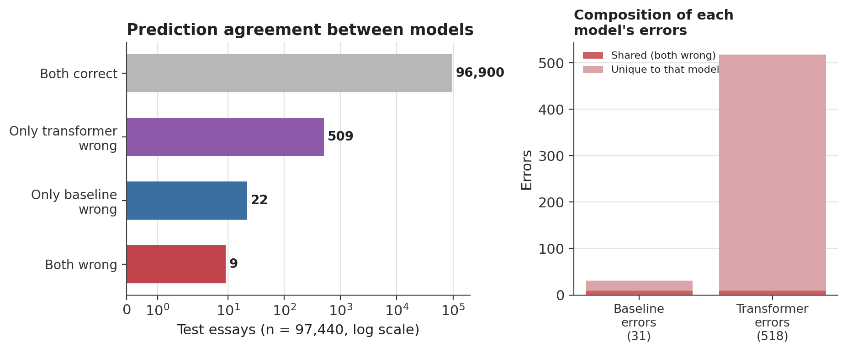
Figure 4. Agreement between the two models on the test set. Errors barely overlap: only 9 of 540 combined mistakes are shared.
Length effect. The two models fail in different directions with respect to length (Figure 5). The SVM's correctly classified essays run slightly longer than its errors (median 363 vs. 337 words) — if anything, the SVM struggles marginally more on shorter essays, where there is simply less lexical evidence available. DistilBERT shows the opposite, and a much larger, effect: its errors run longer than its correct predictions (median 414.5 vs. 362 words), and 83.8% of its errors fall on essays over 256 words, versus 67.7% for the SVM's much smaller error set, which has no truncation mechanism to explain the figure at all. The 256-token limit corresponds to roughly 190 words after sub-word tokenisation, so this threshold sits above the point at which truncation actually begins — meaning the true share of DistilBERT's errors on truncated essays is higher still. This is circumstantial rather than conclusive, but it is specific to, and consistent with, the truncation explanation raised in Section 4.
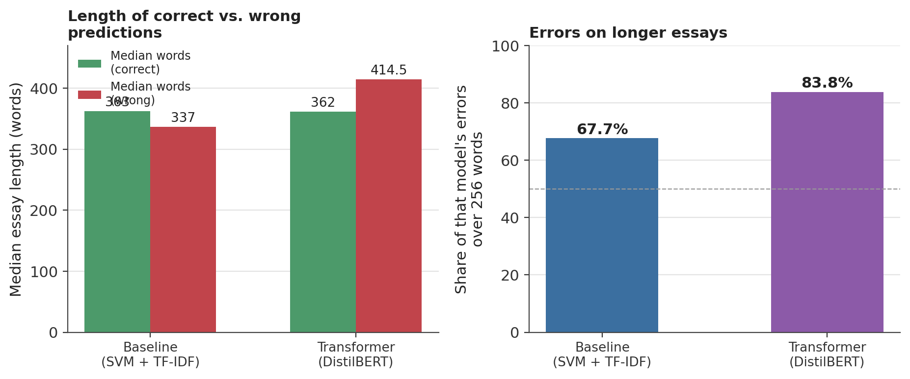
Figure 5. Left: median essay length for correct vs. wrong predictions, by model. Right: share of each model's errors on essays over 256 words.
Formulaic-phrase effect. AI-generated essays that both models classify correctly contain a formulaic transition phrase (“in conclusion,” “additionally,” and similar) about 88.7% of the time; AI-generated essays that DistilBERT misses contain one only 64.5% of the time. The transformer's failures cluster on the AI-generated essays that read least like the templated AI writing both models otherwise lean on — arguably the harder and more interesting AI text to catch, and exactly the case where a genuinely robust detector would earn its keep. The equivalent figure for the SVM's false negatives is not reported, because 14 examples is too small a sample to support a percentage without being misleading.
Reading the actual errors
Pulling two or three misclassified essays directly from the notebook output and discussing what specifically makes each one hard is what turns this section from a table of numbers into an actual analysis, and three such cases are examined below:
Example 1 — DistilBERT false negative (true label: AI; predicted: human; 232 words).
“Online classes can be an useful way for students to receive an education, but they also come with risks that cannot be ignored. Some schools in the United States should not offer online classes for their students because…”
This essay contains none of the formulaic markers Section 4 identifies as the model's dominant AI signal — no "in conclusion," no "additionally," no "however." It opens instead with a direct argumentative claim ("schools… should not offer online classes… because") that reads as ordinary human essay structure. It also contains a genuine slip, "an useful" for "a useful," precisely the class of imperfection the EDA (Section 2) associated with human writing. Here an AI-generated error does the same misleading work as a human misspelling, pushing the model toward exactly the wrong label.Example 2 — DistilBERT false positive (true label: human; predicted: AI; 472 words).
“Imagine a world completely pollution free. A world with no worry about greenhouse gases or global warming. While it’s highly unlikely that we will get to that point, we can still try to reach this perfectly healthy world…”
At 472 words, this essay is truncated well past the point where DistilBERT's errors concentrate (median error length 414.5 words; 83.8% of errors on essays over 256 words). The model reached its verdict having seen under half the text, never encountering whatever more distinctly human material the second half contained. The polished, rhetorical opening likely reinforces the AI-leaning read as well, but given how closely this case matches the length pattern quantified above, truncation is the more likely driver, with register a compounding rather than independent cause.Example 3 — a near-duplicate pair, one per split (both true label: AI; both missed, one by each model).
“Do you ever wonder how school would be like if you could pick your own close/elective?” — missed by the Linear SVM.
“Do you ever wonder how school would be like IZ you could pick your own classes/electives?” — missed by DistilBERT.
The two copies differ only through scattered character corruption ("if" rendered as "IZ," "classes/electives" as "close/elective"), which is exactly why an exact-string check finds no match and Section 2 reports zero exact duplicates despite this pair existing. Exact-duplicate checking is therefore blind to a form of redundancy this corpus demonstrably contains: two members of the same near-duplicate cluster both appear in our test set. We cannot conclude from this alone that a third copy sat in training — but it makes cross-split straddling likely, and if it occurred, the 0.9997 macro-F1 measures partial memorisation rather than generalisation. Because the differences sit inside words rather than in casing or punctuation, even the normalisation fix proposed in Section 7 may not catch pairs of this kind.

Data quality: character corruption. Independently of the length and phrase patterns, the error analysis surfaced essays with corrupted text — literal artifacts such as “TLE work” and “iy Roiert Duffer” appearing where clean text should be. This looks like an encoding or scraping error somewhere upstream in how the dataset was assembled, not a property of AI or human writing. It matters for two reasons: it is a plausible, unglamorous explanation for some fraction of both models' errors (a classifier cannot extract a real signal from garbled tokens), and it is a caution against reading every number in this report as a clean measurement of model skill rather than, in part, a measurement of label and text quality in this specific Kaggle release.
Near-duplicate essays. The error analysis also surfaced essays that are near-identical — differing by only a handful of characters — with one copy in the training set and its near-twin in the test set. This is distinct from the exact-duplicate check in Section 2, which found zero exact duplicates. If a model trained on one near-duplicate and was then evaluated on its near-twin, that test example was never an independent measurement of generalisation, and depending on how many such pairs exist, some portion of the near-perfect scores in Section 4 could reflect memorisation rather than genuine detection skill. This check was still in progress as of this report (Section 7) and is, in our view, the single highest-priority open item: if it changes the effective train/test split, every number in Section 4 and this section is subject to revision.

6. Ethical Considerations
This project's numbers are strong enough that the more important ethical question is not “does this work” but “what would happen if someone believed it worked as well as it appears to.”
Bias against non-native English writers. Independent research on commercial GPT detectors found they misclassify writing by non-native English speakers as AI-generated at far higher rates than writing by native speakers — in one widely cited evaluation, more than half of non-native-authored TOEFL essays were flagged as AI-generated versus near-perfect accuracy on native-speaker essays — plausibly because non-native writing tends toward lower lexical variability, a statistical property that overlaps with what many detectors treat as an “AI-generated” signal (Liang et al., 2023). Our models were not evaluated against a labelled non-native-English corpus, so we cannot rule this out here. Given that our own top AI-associated vocabulary (equitable, fostering, nuances, disproportionate) leans toward the same formal, lower-variability register a fluent non-native writer might also produce, we treat this as a live risk rather than a theoretical one.
The anonymisation artifact is a fairness problem, not just an accuracy problem. Sections 2 and 4 describe how anonymisation placeholders (teacher_name, school_name, proper_name) appear in the human-written portion of this dataset and nowhere in the AI-generated portion, for reasons entirely unrelated to writing style. A model that leans on this shortcut is not just reporting an inflated accuracy number — it would misclassify perfectly ordinary human writing that happens not to mention a name, and it offers little basis for confidence about human text from outside this specific dataset (published writing, professional email, non-student text), where no such placeholder pattern would exist at all.
The two models may share this blind spot even though their errors don't overlap. Section 5 found that the SVM's and DistilBERT's individual errors barely overlap (9 shared out of 540 combined errors) — on the surface, evidence that the two models fail differently. But failing on different examples is not the same as relying on genuinely different, robust signal: both models had access to the same anonymisation artifact, and both could be exploiting it through different specific mechanisms — an exact string match for the linear model, a learned embedding-space association for the transformer — while sharing the same underlying vulnerability. We would want the token-stripping experiment proposed in Section 7 before treating either model's near-perfect score as evidence of genuine, transferable skill, and we'd flag any claim that the two models' blind spots are simply “the same” as too strong given how little their individual errors overlap.
Consequences of getting this wrong in practice. A tool like this is realistic to imagine deployed in an academic-integrity context, where a false positive — flagging a real student's real writing as AI-generated — can mean a plagiarism accusation against someone who did nothing wrong, while a false negative lets actual misuse through undetected. Those two error types are not symmetric in their consequences, and neither model in this report was optimised or evaluated with that asymmetry in mind: both were trained to minimise an overall error rate that treats a false accusation and a missed detection as equally costly, which they are not.
Recommendation. We do not think the results in this report support deploying either model as an accusatory or decision-making tool, in an educational setting or otherwise, without first retraining on a version of the dataset with the anonymisation tokens stripped (Section 7), validating specifically against non-native English writing, and evaluating false-positive and false-negative costs separately rather than through a single aggregate metric.

7. Limitations & Future Work
Scope limitations
- DistilBERT was fine-tuned on a ~40,000-row subsample, not the full 389,759-row training set available to the classical models (Sections 3–4).
- Inputs were truncated at 256 tokens; whether the 512-token limit DistilBERT supports would close some of the gap to the SVM is untested.
- The same test set was used both for final evaluation and, earlier, to choose between DistilBERT's two hyperparameter configurations (Section 3) — a mild form of leakage into model selection that a held-out validation split would avoid.
- Every result in this report comes from one dataset, one mixed and unspecified set of AI generators, and one genre — student-style essays. None of it should be assumed to transfer to, for example, AI-generated news articles, code, or creative writing, or to models released after this dataset was built.
- Most importantly (Sections 4–6): some unknown share of every model's performance may rest on dataset artifacts — the anonymisation tokens and possible near-duplicate leakage — rather than a generalisable notion of AI-generated writing.
Future work
- Resolve the near-duplicate check (Section 5) by normalising text — lowercasing, stripping punctuation and whitespace — and re-checking for cross-split matches; re-run every downstream number if it changes the split.
- Add a proper three-way train / validation / test split so model selection no longer touches the test set.
- Re-run DistilBERT at max_length=512 to test directly whether truncation was costing it accuracy.
- Try a stronger or more efficient transformer variant — RoBERTa, or LoRA fine-tuning of a larger base model — now that the DistilBERT baseline and its main weaknesses are understood.
- Most informative of all: strip the anonymisation placeholder tokens from the human-written essays and retrain both model families from scratch. The resulting drop in accuracy would be a direct, quantified estimate of how much of every number in this report is the anonymisation artifact rather than genuine detection skill.

8. Conclusion & References
Conclusion
Across four notebooks and one shared test set, a Linear SVM over TF-IDF features outperformed a fine-tuned DistilBERT at distinguishing AI-generated from human-written essays — and a plain, un-tuned Logistic Regression beat it too. That ran opposite to what we expected going in. Every model scored above 97% accuracy and the top two above 99.9%, which we read not as a triumph but as a reason to look harder: the dataset contains at least one clear artifact — anonymisation placeholders present only in human-written text — capable of driving accuracy on its own, and a still-unresolved near-duplicate check that could mean some test essays were never truly held out.
The error analysis reinforced that reading. The two models' mistakes barely overlap; the length and truncation effects line up specifically with the transformer's 256-token configuration; and the small number of genuinely hard cases skew toward AI text that least resembles the formulaic phrasing both models otherwise rely on. We conclude that this project measured something real but narrower than “AI-text detection” in general — performance on one specific Kaggle release, substantially shaped by how that release happens to have been assembled. Neither model, as currently trained, is ready for a real deployment decision, particularly not one, like an academic-integrity flag, where a false positive carries a real cost to a real person. The clearest next step is also the cheapest: strip the anonymisation tokens, retrain, and see how much of this report's headline numbers survive.
References
Gerami, S. (2024). AI Vs Human Text [Data set]. Kaggle. https://www.kaggle.com/datasets/shanegerami/ai-vs-human-text
Liang, W., Yuksekgonul, M., Mao, Y., Wu, E., & Zou, J. (2023). GPT detectors are biased against non-native English writers. Patterns, 4(7), 100779. https://doi.org/10.1016/j.patter.2023.100779
Pedregosa, F., Varoquaux, G., Gramfort, A., Michel, V., Thirion, B., Grisel, O., Blondel, M., Prettenhofer, P., Weiss, R., Dubourg, V., Vanderplas, J., Passos, A., Cournapeau, D., Brucher, M., Perrot, M., & Duchesnay, É. (2011). Scikit-learn: Machine learning in Python. Journal of Machine Learning Research, 12, 2825–2830.
Sanh, V., Debut, L., Chaumond, J., & Wolf, T. (2019). DistilBERT, a distilled version of BERT: Smaller, faster, cheaper and lighter. arXiv preprint arXiv:1910.01108.
Wolf, T., Debut, L., Sanh, V., Chaumond, J., Delangue, C., Moi, A., Cistac, P., Rault, T., Louf, R., Funtowicz, M., Davison, J., Shleifer, S., von Platen, P., Ma, C., Jernite, Y., Plu, J., Xu, C., Le Scao, T., Gugger, S., Drame, M., Lhoest, Q., & Rush, A. (2020). Transformers: State-of-the-art natural language processing. In Proceedings of the 2020 Conference on Empirical Methods in Natural Language Processing: System Demonstrations (pp. 38–45). Association for Computational Linguistics.

