CIE
COPYRIGHT INFORMATION EXTRACTION FORM
TITLE: Trackify -Smart Expense Monitoring System
SCHOOL: Chitkara University, Rajpura, Punjab
Name: Aditi
Roll No.: 2211981019

All MEMBERS DETAILS
NAME | EMP CODE / ROLL NO | ADDRESS WITH EMAIL ID AND CONTACT NO.
Aditi | 2211981019 | Nangal, Punjab  aditi1019.be22@chitkarauniversity.edu.in  7626009972
Dr. Monika Aggarwal | CET1004057 | monika.aggarwal@chitkara.edu.in  94638 65180

ABSTRACT

1.1 Problem Background
In today’s fast-paced lifestyle, individuals often struggle to manage their daily expenses effectively. Many people rely on manual tracking such as notebooks or digital notes, which frequently result in inaccurate records, lack of financial awareness, and difficulty in monitoring spending patterns. The absence of a structured and user-friendly system makes it challenging to analyze financial behaviour and maintain budget discipline. Hence, there is a need for a modern, visually intuitive, and interactive expense tracking solution.

1.2 Objective of the Project
The objective of the project is to design and develop a web-based personalized expense tracking solution that helps users efficiently manage their daily expenses. The system focuses on enhancing user experience through intuitive UI/UX design along with structured expense tracking and analysis.

1.3 Proposed Solution
Trackify is a web application that allows users to track, control, and analyze their expenses using an exciting and intuitive interface.
Core functionalities integrated in Trackify include user authentication, expense management, analytical dashboard, and calendar records tracker. The application follows a story-based UI/UX approach, ensuring a modern, simple, and user-friendly experience.
In particular, the UI/UX design of the system has been independently conceived and implemented. The development process has been oriented toward implementing this design approach in practice.

1.4 Key Features or Functionality
The system provides:
- Secure login and user interaction interface
- Category-based expense entry (food, travel, shopping, etc)
- Calendar-based expense records for date-wise tracking
- Weekly and monthly analytics visualization
- Smart insights for better financial understanding
- Savings goal tracking system
The application emphasizes interactive UI elements, smooth navigation, and visually rich dashboards, making financial tracking intuitive and engaging.

1.5 Technology / Method Used
The system is developed using modern technologies:
- Frontend: HTML, CSS, JavaScript
- Backend: Node.js (Express.js)
- Styling: Tailwind CSS
- Build Tool: Vite
- Database: MongoDB
The focus has been on creating a responsive, visually appealing, and user-centric interface, ensuring usability across devices.

1.6 Expected Outcome & Benefits
Trackify aims to improve financial awareness and promote expense management habits among users.
Key benefits include:
- Improved tracking of daily expenses
- Clear visualization of spending patterns
- Better visualization and spending decisions
- Reduced manual errors
- Enhanced user engagement through intuitive UI/UX

1.7 Original Contribution Statement
The UI/UX design of Trackify is an original contribution, independently designed and developed with a focus on modern design principles, user interaction, and visual storytelling.
The layout, design flow, color schemes, and user experience elements are uniquely conceptualized to provide an engaging and intuitive financial tracking platform.
While standard web technologies and learning resources were used for implementation, the overall interface design, structure and user experience are original and developed by the author.

1.8 User Interface Screenshots:
The following screenshots represent the user interface of the Trackify application:
Figure 1: User Dashboard Interface (in Dark mode)
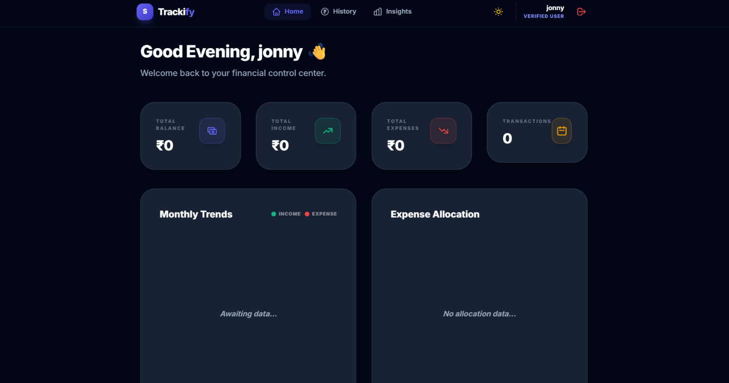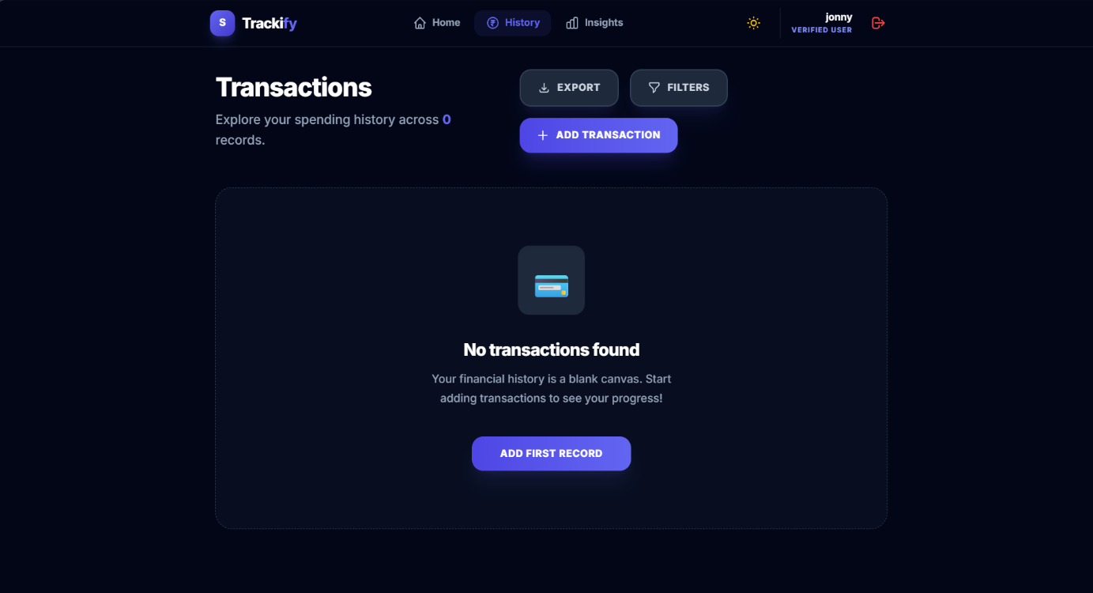

Figure 2: Admin Dashboard Interface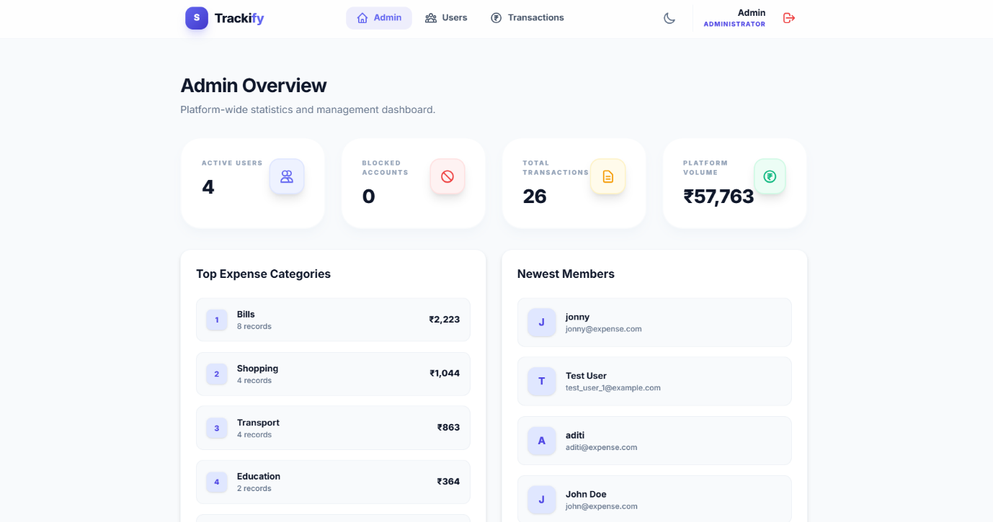
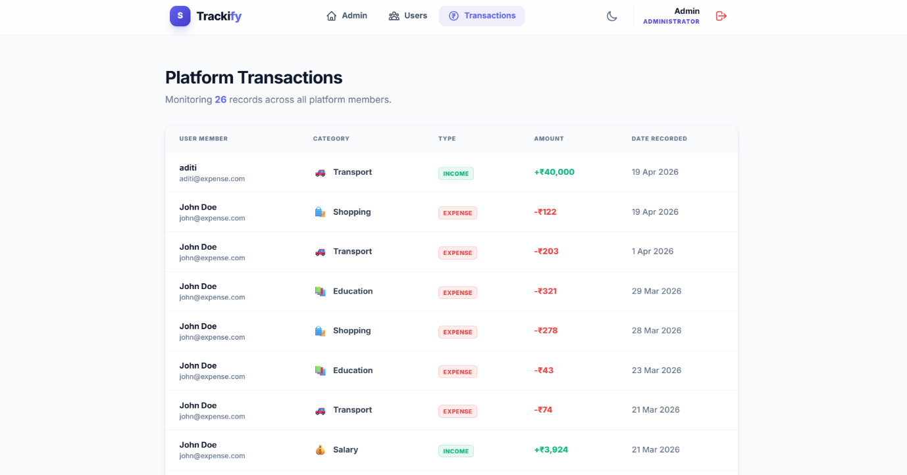

Figure 3: Login & Signup Interface:
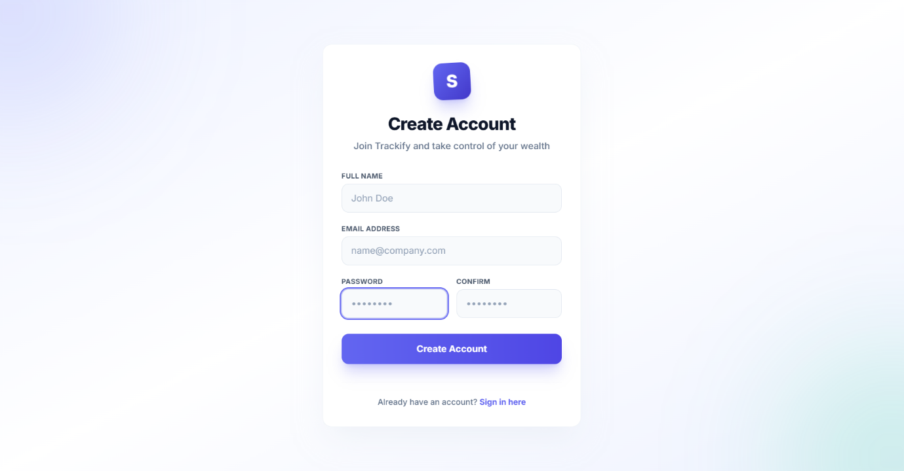
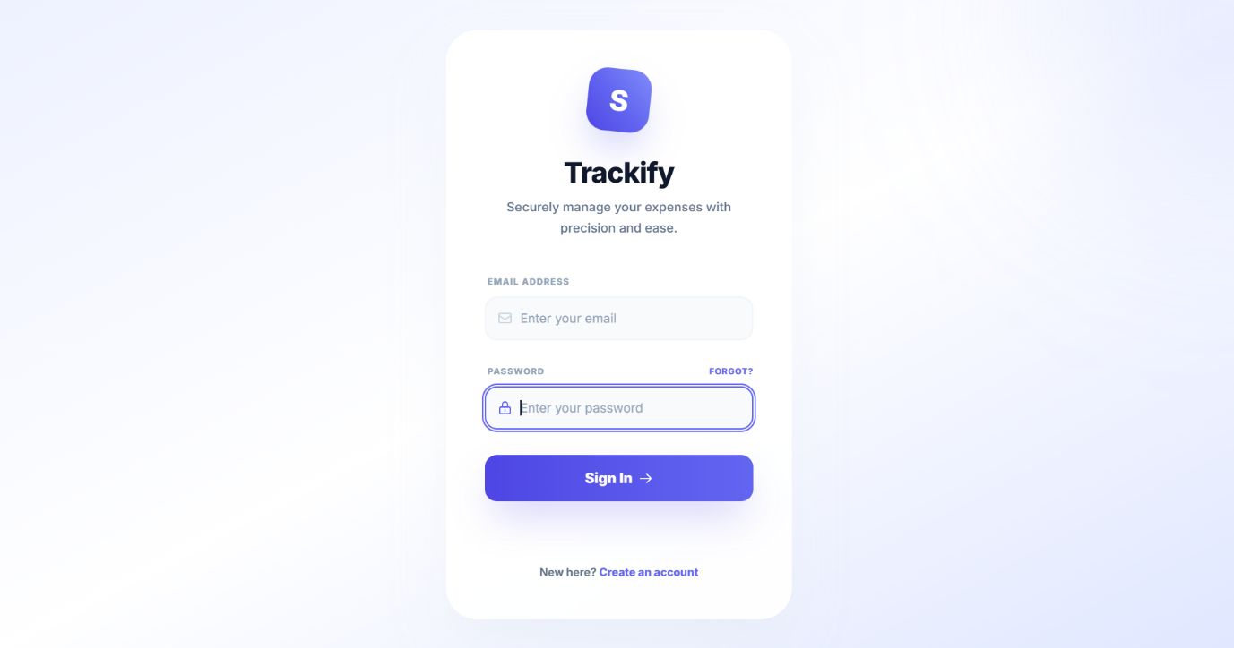

1.9 Conclusion:
Trackify is designed to provide a simple, interactive, and efficient solution for managing daily expenses. The system combines structured expense tracking with a user-friendly interface to enhance financial awareness and decision-making. The project successfully demonstrates the importance of intuitive UI/UX design in improving user experience.

1.10 Future Scope:
In future, the system can be enhanced by integrating advanced features such as AI-based spending analysis, mobile application support, and secure-based data-storage. Additional improvements can include personalized financial recommendations and real-time notifications.

1.11 Deployment Details:
The Trackify application has been successfully deployed on a cloud platform to ensure real-time accessibility and usability.
The complete system is hosted using Render, enabling API handling, user authentication, and database connectivity.
This deployment allow users to access and interact with the application online without relying on local environments.

Live Application URL:
https://trackify-ulmg.onrender.com

