Debug Problem
Problem:
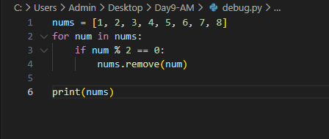
CORRECT SOLUTION:
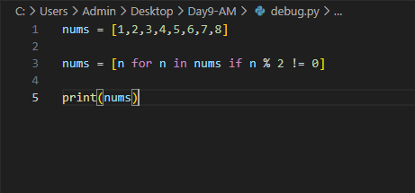

Why bug occurs:
List is modified during iteration, so elements are skipped.

