Probability

case 1: Manufacturing quality control
Industry problem statement: A manufacturing company uses an AI-based computer vision system to inspect electronic components or manufactured products. Each product is classified as either defective or non-defective.

Binomial Distribution
Number of trails (n) =20
Probability of defect (p) =0.05
Mean : 1.0000
Variance: 0.9500
Probability of exactly 2 defects: P(X = 2) = 0.18867680
PMF graph:
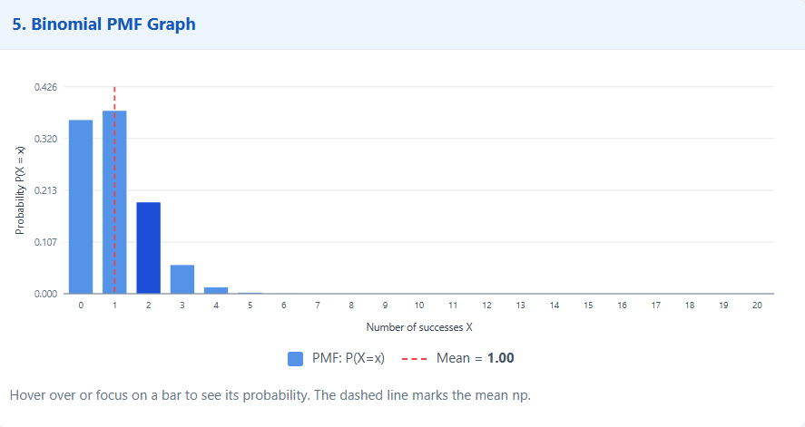
Probability of defect (p) =0.1

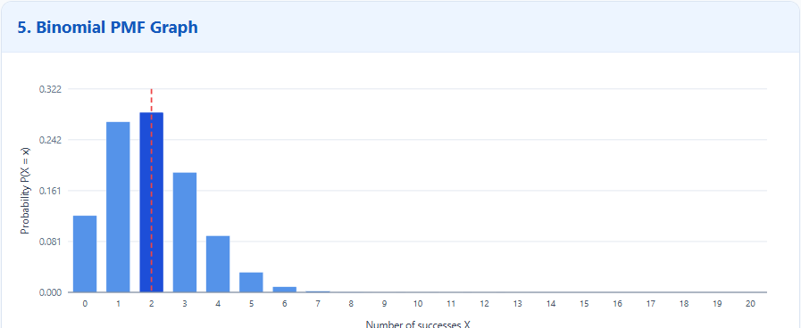

Observation:
When probability of defects changes from 0.05 to 0.1 ,number of defects increases. Mean(peak) is changed from 1.00 to 2.00. Graph shifts towards right.

Poisson Distribution
Mean=λ = 5
n=100, hence p=0.05
BINOMIAL PMF graph:
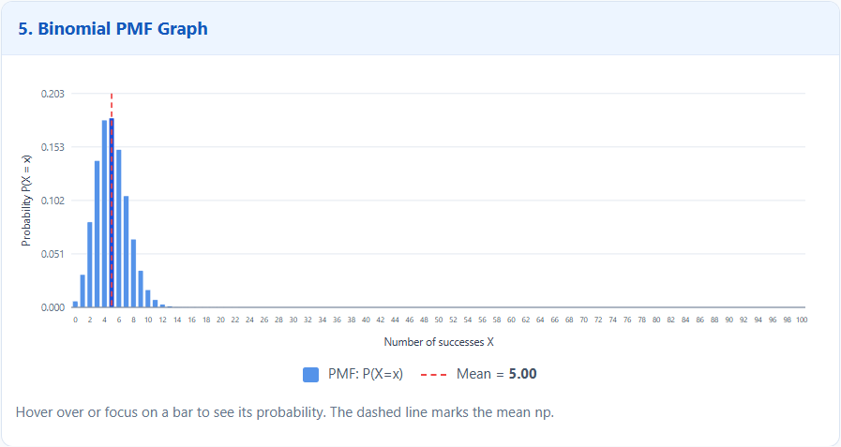

PMF graph:

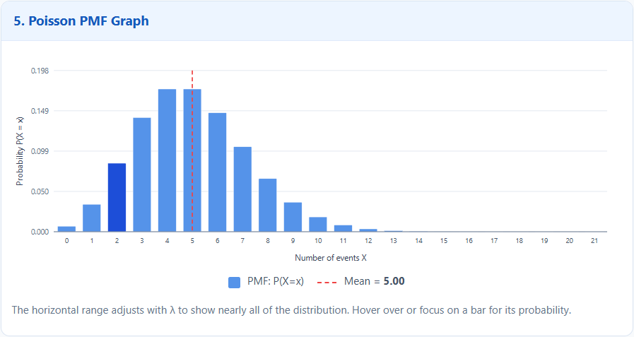

Observation:
Binomial PMF graph is more sharply concentrated around the mean,while Poisson PMF graph is more spread out.Binomial tracks successes and has finite trails where poisson tracks independent events and extends to infinity.

Geometric Distribution
Probability of defect (p) =0.05
Mean=20
Variance=380
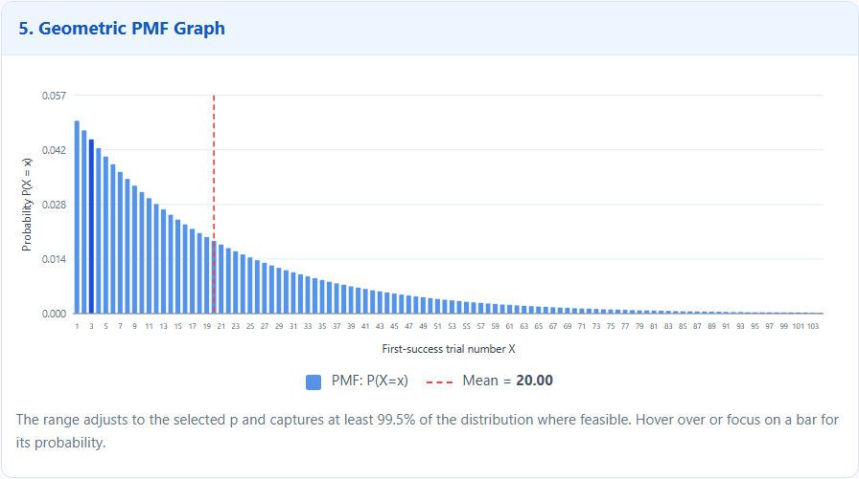
Observation:
The geometric graph continously decreases, it has peak at X=1and has a long tail towards right.

Conclusions:
In smaller batches (n=20)finding defects is rare (P(X = 2) = 0.18867680).For high volumes Poisson distribution simplifies calculation. In geometric as p (chances of defect)is small(0.05)inspector must examine an average of 20 consecutive items to find 1 defect. As variance is so high(380) the inspector could get lucky on first try or find nothing even after 50 checks.

case 2: Cloud operations and cybersecurity monitoring
Industry problem statement A cloud service provider operates servers and APIs used by thousands of customers. Its operations team monitors failed requests, security alerts, and retry attempts.

Binomial Distribution
Number of trails (n) =100
Probability of defect (p) =0.0225
Mean : 2.2500
Variance: 2.1994
Probability of exactly 3 defects: P(X = 3) = 0.20257408
PMF graph:
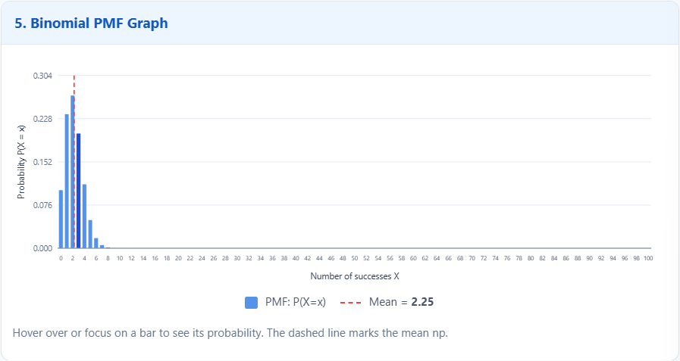

Observation:
The calculated probability indicates that, the probability of observing exactly three failures in 100 trials is approximately 20.26%.

Poisson Distribution
Mean=λ = 3
Probability of k alerts are given by P(X = k) = (e^{−λ} *λ^{k} )/ k!
Number of alerts (k) | Probability = P(X = k)
0 | 0.04978707
1 | 0.14936121
2 | 0.22404181
3 | 0.22404181
4 | 0.16803136
5 | 0.10081881
10 | 0.00081015
15 | 0.00000055
16 | 0.00000010
17 | 0.00000002
18 | 0.00000000
PMF graph:
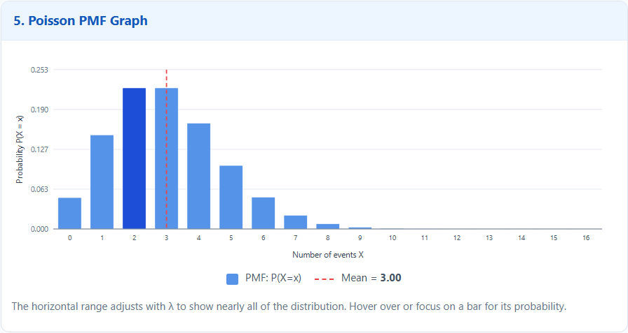

Observation:
For an average alert rate of three, the probabilities of two and three alerts are each approximately 22.40%. The probability of four or more alerts is approximately 35.28%.
Mean=λ = 2
Number of alerts (k) | Probability = P(X = k)
0 | 0.13533528
1 | 0.27067057
2 | 0.27067057
3 | 0.18044704
4 | 0.09022352
5 | 0.03608941
10 | 0.00003819
11 | 0.00000694
12 | 0.00000116
14 | 0.00000003
15 | 0.00000000

PMF graph:

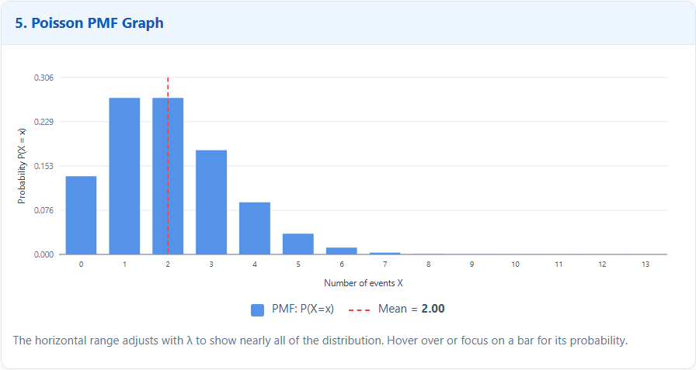

Mean=λ = 5
Number of alerts (k) | Probability = P(X = k)
0 | 0.00673795
1 | 0.03368973
2 | 0.08422434
3 | 0.14037390
4 | 0.17546737
5 | 0.17546737
10 | 0.01813279
15 | 0.00015725
20 | 0.00000026
22 | 0.00000001
23 | 0.00000000

PMF graph:
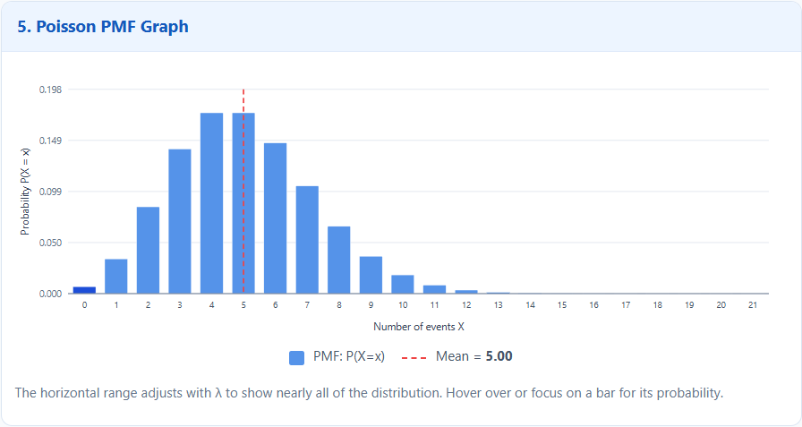

Observation:
- When λ = 2, the probabilities are concentrated around one and two alerts.
- When λ = 3, the probabilities of two and three alerts are relatively high.
- When λ = 5, the probability of four or more alerts increases to approximately 73.50%.
- As λ increases, the distribution shifts towards higher alert counts.

Geometric Distribution
Probability of defect (p) =0.8
Mean=1.2500
Variance=0.3125

Probability of success is given by P(X = k) = (1 − p)ᵏ⁻¹ × p
Attempt number(k) | Probability =P(X = k)
1 | 0.80000000
2 | 0.16000000
3 | 0.03200000

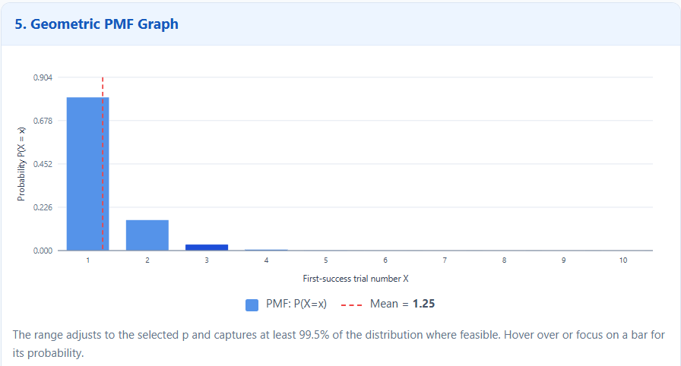
Observation:
Since the probability of success on each attempt is 0.8, the probability that the first success occurs decreases with each successive attempt. The probability of the first success occurring on the third attempt is 3.2%.These results help operations teams understand failures, monitor alert levels, and plan retry policies.

Conclusions:
The Binomial distribution helps estimate the chances of a specific number of failures, while the Poisson distribution simplifies alert-count calculations at different average rates. In the Geometric distribution, with a success probability of 0.8, the average number of attempts until success is 1.25.

