**INDEX**

| **S.NO.** | **DATE** | **Exercises** | **Page No.** | **Marks** | **Sign** |
| --- | --- | --- | --- | --- | --- |
|  |  |  |  |  |  |
|  |  | DDL Commands – CREATE, ALTER, DROP |  |  |  |
| 1 | 1 |  |  |  |  |
|  |  | DDL Commands with Constraints – PRIMARY, FOREIGN |  |  |  |
| 2 |  | KEY, UNIQUE, CHECK |  |  |  |
|  |  |  |  |  |  |
|  |  | DML Commands – INSERT, SELECT, UPDATE, DELETE |  |  |  |
| 3 |  |  |  |  |  |
|  |  | SELECT with various clause – WHERE, pattern matching |  |  |  |
| 4 |  |  |  |  |  |
|  |  | SELECT with various clause – BETWEEN, IN, Aggregate |  |  |  |
| 5 |  | Function |  |  |  |
|  |  |  |  |  |  |
|  |  | SELECT with various clause – GROUP BY, HAVING, ORDER |  |  |  |
| 6 |  | BY |  |  |  |
|  |  |  |  |  |  |
|  |  | SubQuery& Correlated Query |  |  |  |
| 7 | 3 |  |  |  |  |
|  |  | Joins – EquiJoin, InnerJoin, OuterJoin |  |  |  |
| 8 |  |  |  |  |  |
|  |  | VIEW, INDEX, SEQUENCE |  |  |  |
| 9 |  |  |  |  |  |
|  |  | Simple programming exercises using CASE, IF, ITERATE, |  |  |  |
| 10 |  | LEAVE, LOOP |  |  |  |
|  |  |  |  |  |  |
|  |  | Simple programming exercises using REPEAT, WHILE |  |  |  |
| 11 |  |  |  |  |  |
|  |  | TCL Commands – COMMIT, ROLLBACK, SAVEPOINT |  |  |  |
| 12 |  |  |  |  |  |
|  |  | DCL Commands – GRANT, REVOKE |  |  |  |
| 13 |  |  |  |  |  |
|  |  | Procedures |  |  |  |
| 14 |  |  |  |  |  |
|  |  | Function |  |  |  |
| 15 |  |  |  |  |  |
|  |  | Cursors |  |  |  |
| 16 |  |  |  |  |  |
|  |  | Triggers |  |  |  |
| 17 |  |  |  |  |  |
|  |  | Database Connectivity – Using PhP& MySQL |  |  |  |
| 18 |  |  |  |  |  |
|  |  |  |  |  |  |



Ex.No. 1

Date:

**DDL Commands – CREATE, ALTER, DROP**

**Aim:**

To Create, Alter and Drop the table using Data Definition Language.

**Description**:

Data Definition Language (DDL) statements are used to define the database structure or schema.

DDL Commands: Create, Alter, Drop, Rename, Truncate

∙ CREATE - to create objects in the database

* + ALTER - alters the structure of the database
* ∙ DROP - delete objects from the database
  + TRUNCATE - remove all records from a table, including all spaces allocated for the records are removed
  + RENAME - rename an object

**SYNTAX:**

**CREATE TABLE**

CREATE TABLE table_name

(

column_name1 data_type,

column_name2 data_type,

column_name3 data_type,

*....*

);

**ALTER A TABLE**

To add a column in a table

ALTER TABLE table_name

ADD column_namedatatype;

To delete a column in a table

ALTER TABLE table_name

DROP COLUMN column_name;

**DROP TABLE**

DROP TABLE table_name;

**TRUNCATE TABLE**

TRUNCATE TABLE table_name;

**Questions:**

1) Create a table name STUDENT with following structure.

|  | Column |  |  |  |
| --- | --- | --- | --- | --- |
| # | Name | Description | Data Type |  |
|  |  |  |
|  |  | Registration |  |  |
| 1 | RegNo | Number | NUMBER(3) |  |
| 2 | Name | Student Name | VARCHAR(15) |  |
|  |  | Gender of the |  |  |
| 3 | Gender | student | CHAR(1) |  |
| 4 | DOB | Date of Birth | DATE |  |
| 5 | MobileNo | Mobile Number | NUMBER(10) |  |
| 6 | City | Location of stay | VARCHAR(15) |  |

2) Create a table name FACULTY with following structure.

|  | Column |  |  |  |
| --- | --- | --- | --- | --- |
| # | Name | Description | Data Type |  |
|  |  |  |
| 1 | FacNo | Faculty Identifier | VARCHAR(4) |  |
| 2 | FacName | Faculty Name | VARCHAR(15) |  |
| 3 | Gender | Gender of faculty | CHAR(1) |  |
| 4 | DOB | Date of Birth | DATE |  |
| 5 | DOJ | Date of Join | DATE |  |
| 6 | MobileNo | Mobile Number | NUMBER(10) |  |

3) Create a table name DEPARTMENT with following structure.

|  | Column |  |  |  |
| --- | --- | --- | --- | --- |
| # | Name | Description | Data Type |  |
|  |  |  |
| 1 | DeptNo | Department Identifier | VARCHAR(4) |  |
| 2 | DeptName | Department Name | VARCHAR(15) |  |
| 3 | DeptHead | Department Head | VARCHAR(4) |  |



4) Create a table name COURSE with following structure.

|  | Column |  |  |  |
| --- | --- | --- | --- | --- |
| # | Name | Description | Data Type |  |
|  |  |  |
| 1 | CourseNo | Course Identifier | VARCHAR(3) |  |
|  |  | Course |  |  |
| 2 | CourseDesc | Description | VARCHAR(14) |  |
| 3 | CourseType | Course Type | CHAR(1) |  |
| 4 | SemNo | Semester Number | CHAR(1) |  |
| 5 | HallNo | Hall Number | VARCHAR(4) |  |
| 6 | FacNo | Faculty Identifier | VARCHAR(4) |  |

1. Modify the table FACULTY by adding a column name DeptNo of datatype VARCHAR(4)

**OUTPUTS:**

1)

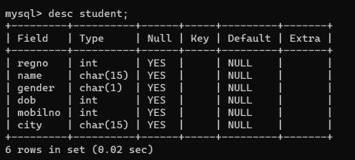

2)

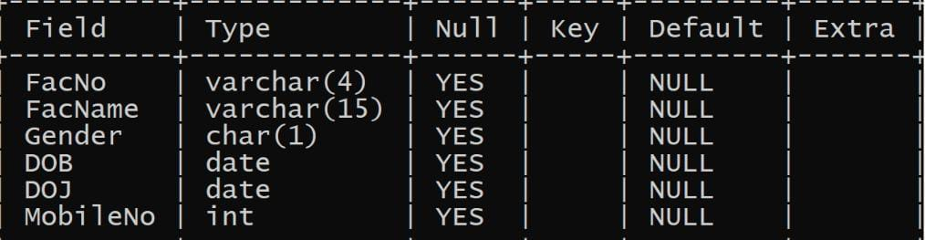

3)

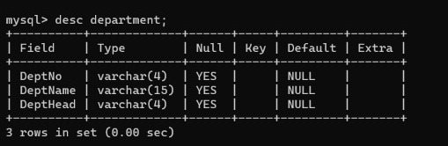

4)

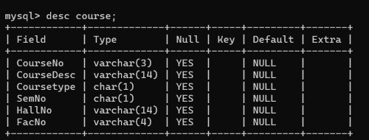

5)

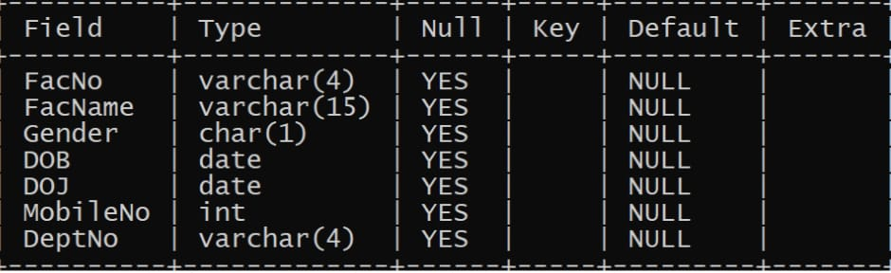

**RESULT:**

Tables are created, altered and modified using DDL commands.



