**DDL Commands with Constraints – PRIMARY, FOREIGN KEY, UNIQUE, CHECK**

1) Alter the table STUDENT with following structure. 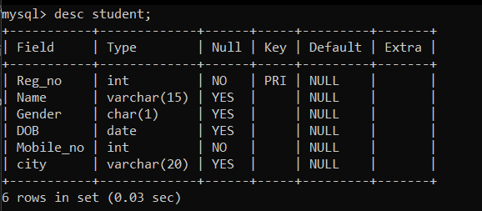

1. Alter the table name FACULTY with following structure. The DeptNo in this table refers the DeptNo in the DEPARTMENT table.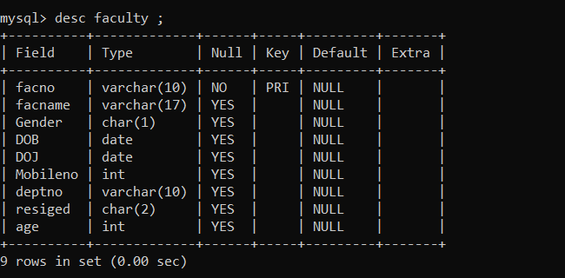

| 3) | After the FACULTY table is successfully created, test if you can add a constraint |
| --- | --- |
| FOREIGN KEY to the DeptNo of this table. | |
|  | Alter the table name DEPARTMENT with following structure. |
| 5) | Alter the table name COURSE with following structure. |

