

Ex. No.: 4

Date:

**SELECT with various clause – WHERE, pattern matching**

**AIM:**

To view the records from the tables using SELECT commands with WHERE Clause and Pattern matching.

**DESCRIPTION**:

The SELECT statement allows you to get the data from tables. A table consists of rows and columns like a spreadsheet. Often, you want to see a subset rows, a subset of columns, or a combination of two. The result of the SELECT statement is called a result set that is a list of rows, each consisting of the same number of columns.

**SELECT:**

SELECT

column_1, column_2, ...

FROM

table_1

[INNER | LEFT |RIGHT] JOIN table_2 ON conditions

WHERE

conditions

GROUP BY column_1

HAVING group_conditions

ORDER BY column_1

LIMIT offset, length;

The SELECT statement consists of several clauses as explained in the following list:

* + SELECT followed by a list of comma-separated columns or an asterisk (*)
* to indicate that you want to return all columns.
  + FROM specifies the table or view where you want to query the data.
* ∙ JOIN gets related data from other tables based on specific join conditions.
* ∙ WHERE clause filters row in the result set.
  + GROUP BY clause groups a set of rows into groups and applies aggregate
* functions on each group.
* ∙ HAVING clause filters group based on groups defined by GROUP BY clause.
  + ORDER BY clause specifies a list of columns for sorting.
  + LIMIT constrains the number of returned rows.



**Questions:**

**WHERE:**

1. The student counsellor wanted to display the registration number, student name and date of birth for all the students.
2. The controller of examinations wanted to list all the female students
3. Who are the boy students registered for course with the course number “C001“
4. Display all faculty details joined before “November 2014”
5. Display all the courses not allotted to halls



**LIKE:**

1. List the students whose name ends with the substring “ma”
2. Display all students whose name contains the substring “ma”
3. Find all the students who are located in cities having “Sal” as substring
4. Display the students whose names do not contain six letters.
5. Find all the students whose names contains “th”

**OUTPUTS:**

1)

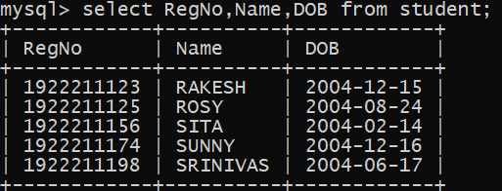

2)

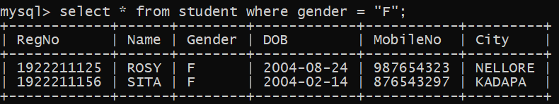

3)

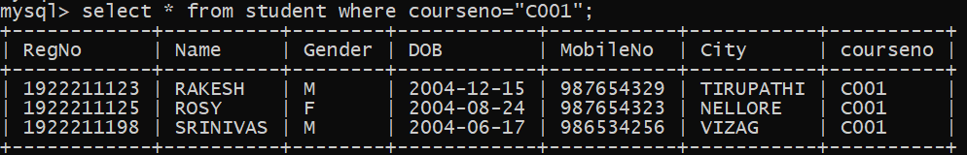

4)

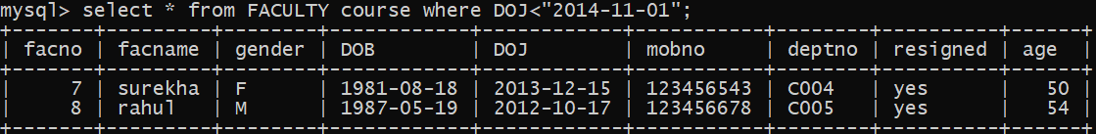

5)

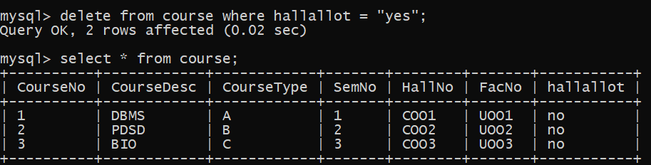

**LIKE:**

The LIKE operator is commonly used to select data based on patterns. Using the LIKE operator in the right way is essential to increase the query performance.

The LIKE operator allows you to select data from a table based on a specified pattern. Therefore, the LIKE operator is often used in the WHERE clause of the SELECT statement.

MySQL provides two wildcard characters for using with the LIKE operator, the percentage % and underscore _ .

* + The percentage ( % ) wildcard allows you to match any string of zero or
* more characters.
  + The underscore ( _ ) wildcard allows you to match any single character.

6)

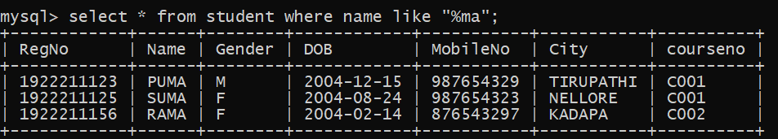

7)

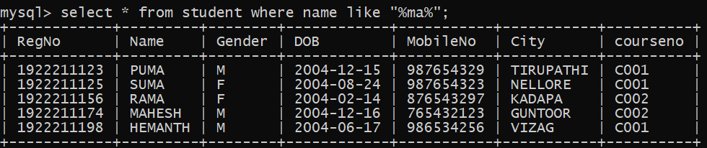

8)

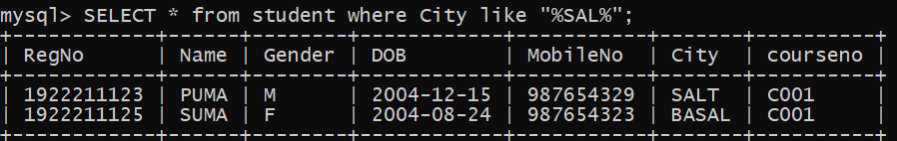

9)

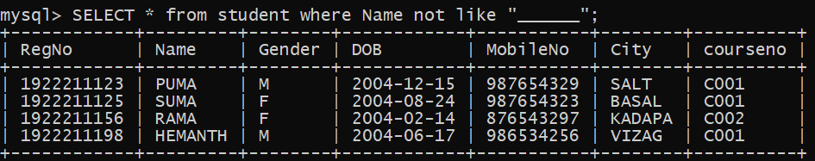

10)

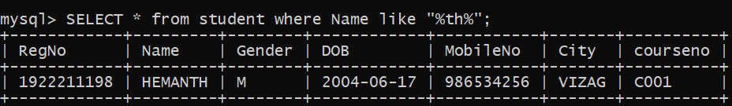

**RESULT**:

The records from the tables are displayed using SELECT commands with WHERE Clause and Pattern matching.

