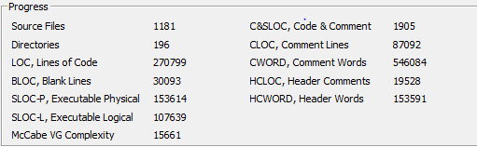

commons-math-master 3.6.1

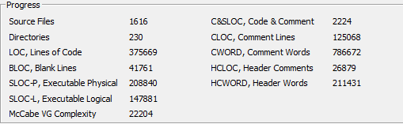

commons-math-MATH_3_6

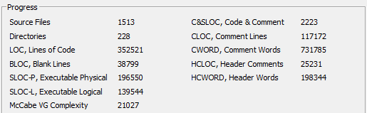

commons-math-MATH_3_5

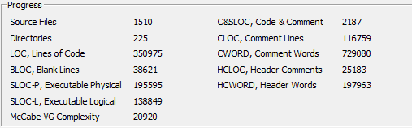

commons-math-MATH_3_4

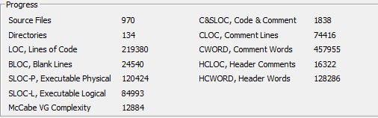

commons-math-MATH_3_0