Experiment.6

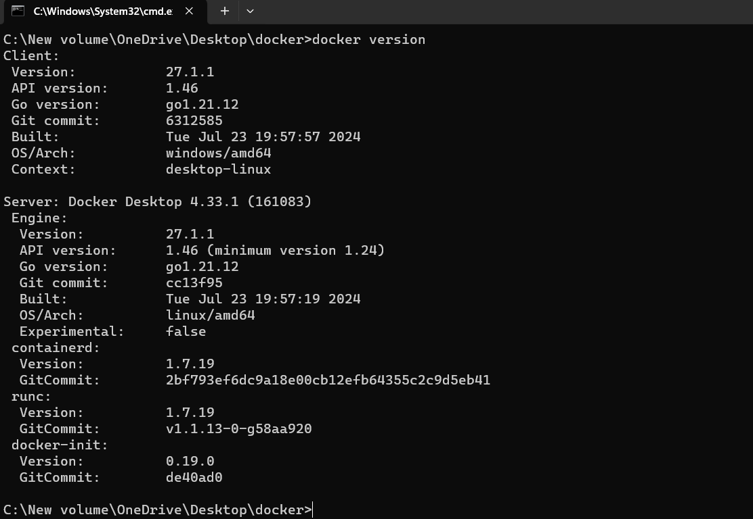**Aim**- To create docker image using terraform Step 1: Check the docker functionality

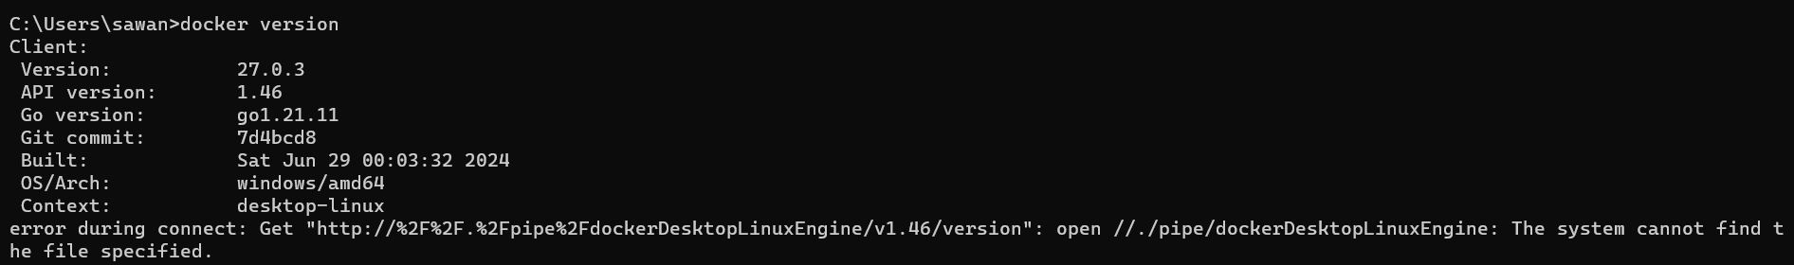

**Step 2: Firstly create a new folder named ‘Docker’ in the ‘TerraformScripts’ folder. Then create a new docker.tf file using Atom editor and write the followingcontents into it to create a Ubuntu Linux container.**

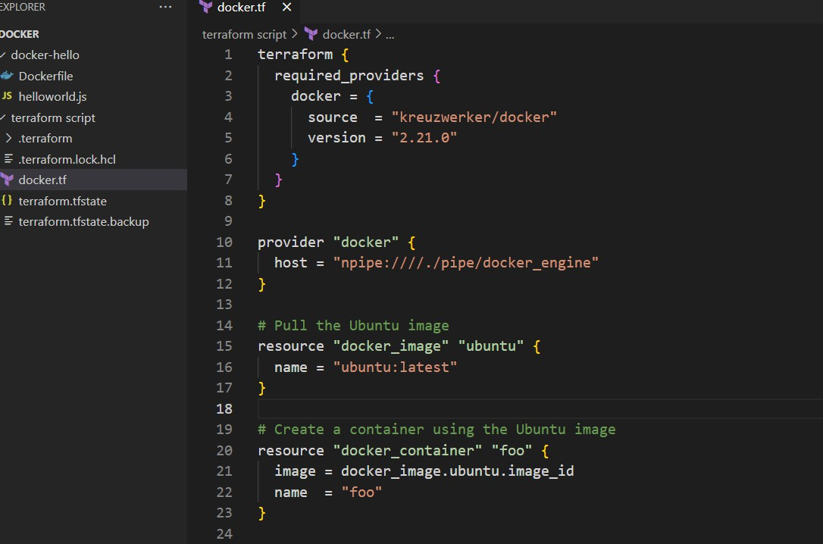

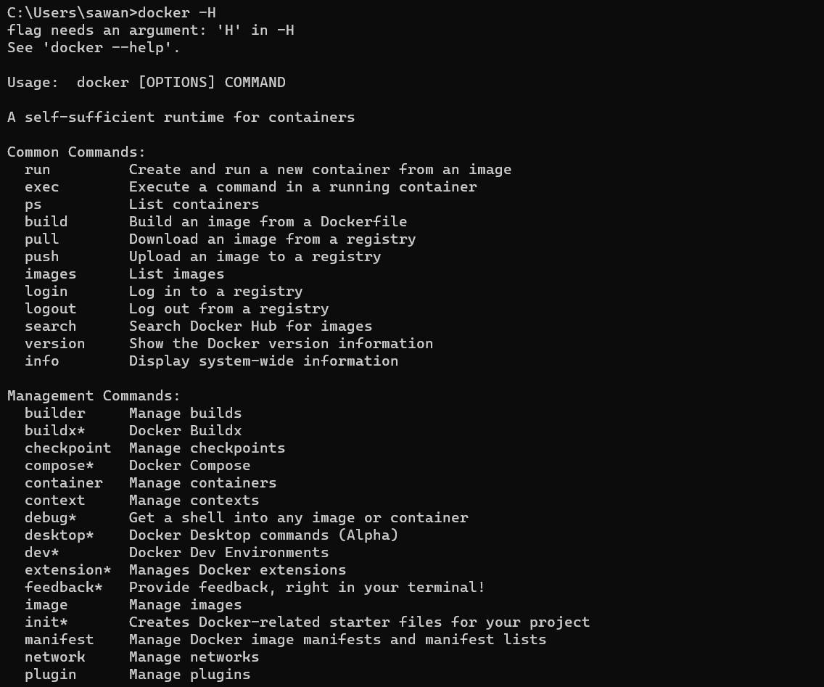

**Step 3: Execute Terraform Init command to initialize the resources**

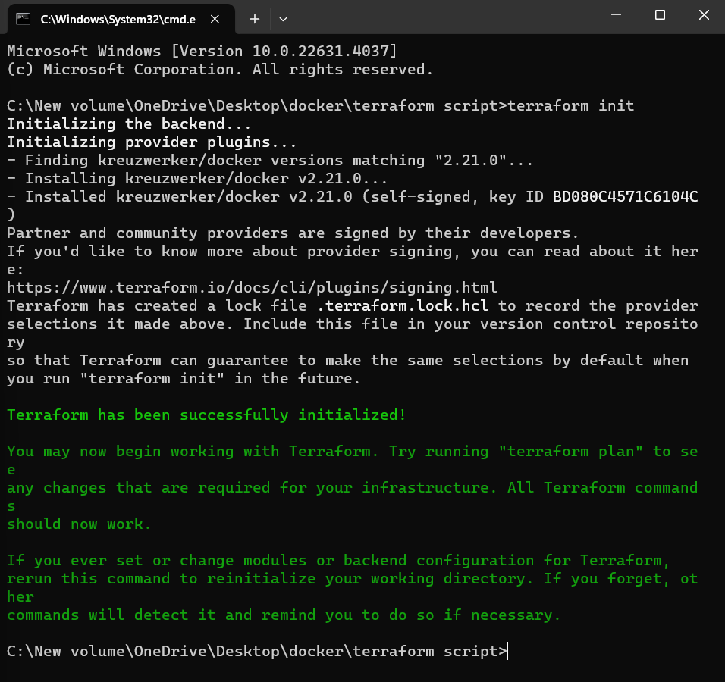

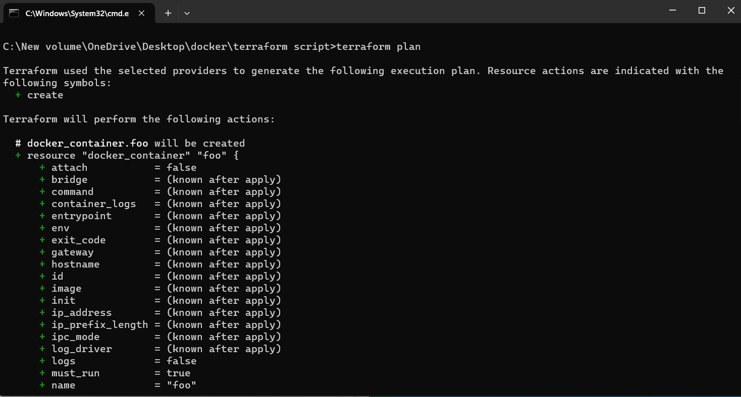**Step 4: Execute Terraform plan to see the available resources**

**Step 5: Execute Terraform apply to apply the configuration, which will automatically create and run the Ubuntu Linux container based on our configuration. Using command : “terraform apply”**

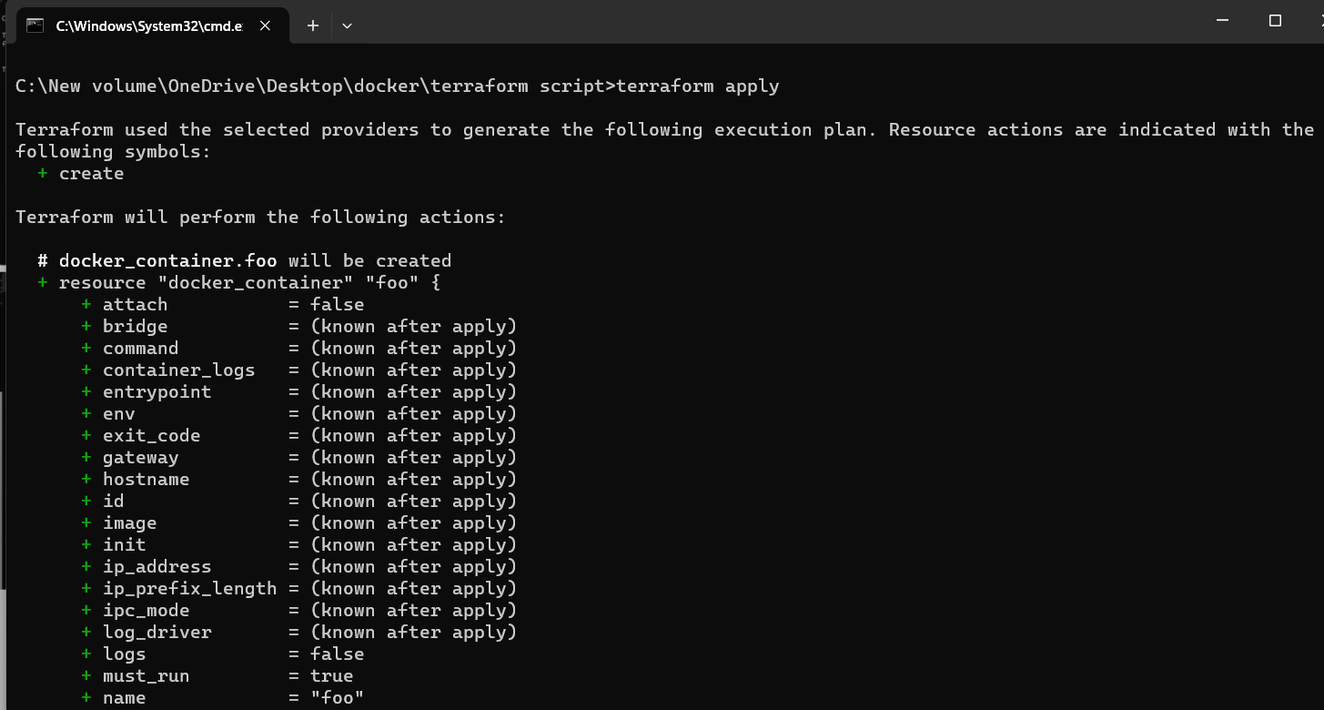

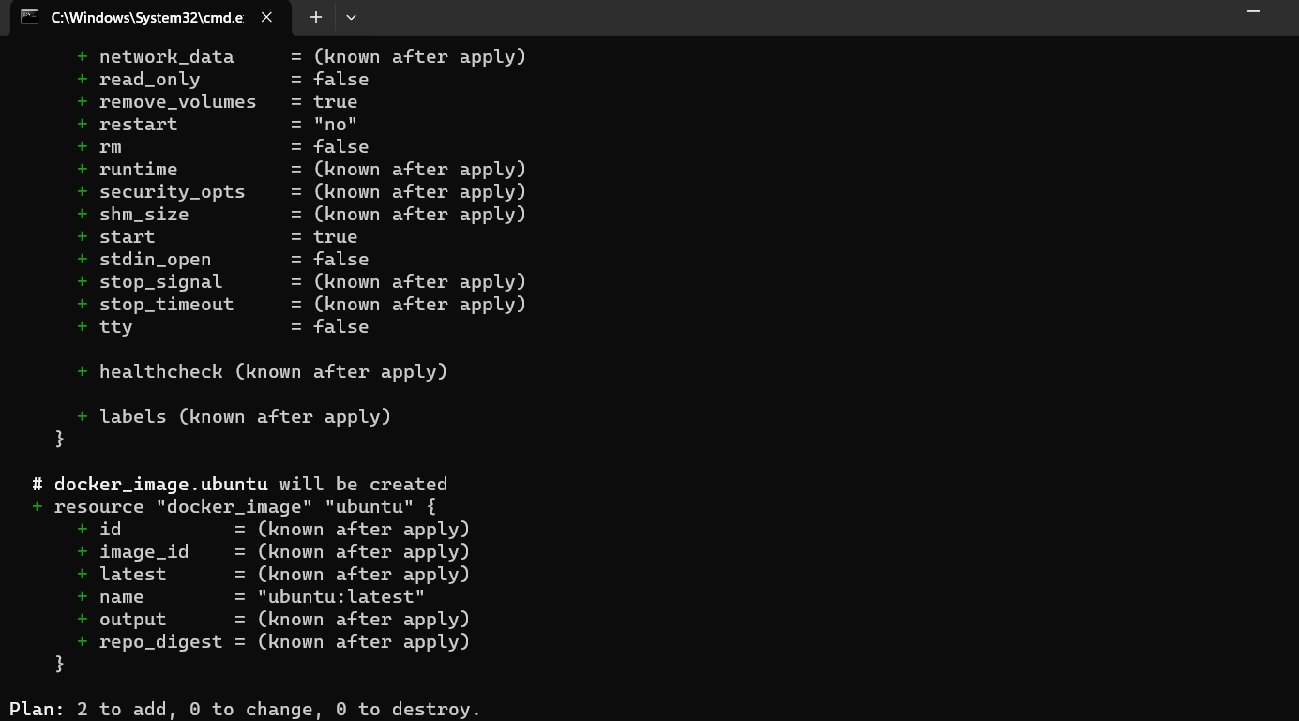

Docker images, Before Executing Apply step and Execute Terraform destroy to delete the configuration, which will automatically

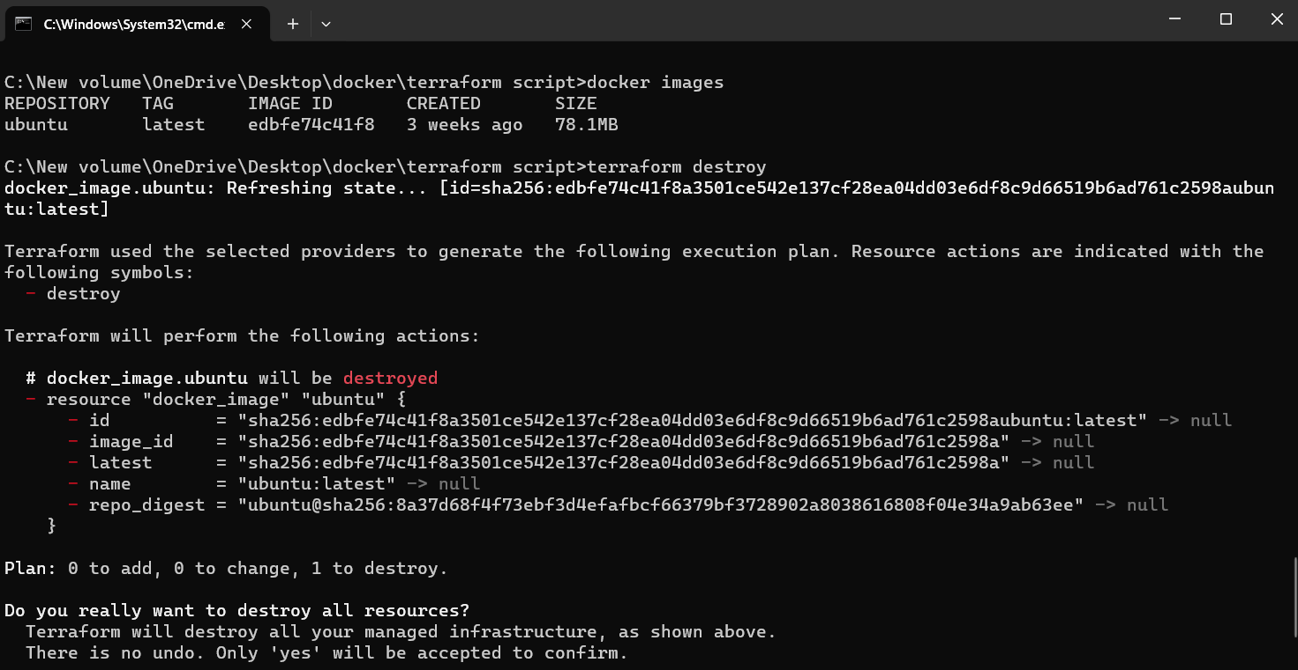delete the Ubuntu Container.

