
LEARNING MANAGEMENT SYSTEM WITH SMART STUDY PLANNER


Submitted By: Aditi Patidar Submitted To: MP Online

TABLE OF CONTENTS
- Abstract
- Introduction
- Problem Statement
- Objectives of the Project
- Existing System Analysis
- Proposed System
- System Architecture
- Use Case Diagram
- Data Flow Diagram (DFD)
- Entity Relationship Diagram (ER Diagram)
- Database Design
- Functional Requirements
- Non-Functional Requirements
- Project Snapshots
- Module Description
- API Design
- Frontend Design
- Backend Design
- Security Implementation
- Testing and Validation
- Results and Outputs
- Future Enhancements
- Conclusion
- References

ABSTRACT
The Learning Management System with Smart Study Planner is a web-based academic management platform designed to help students efficiently organize their courses, study tasks, deadlines, and daily learning schedules.
The application integrates course management, task tracking, study planning, and dashboard analytics into a centralized system. The frontend is developed using ReactJS while FastAPI is used for backend development. MySQL serves as the database layer and JWT authentication ensures secure user access.
The platform improves productivity, enhances time management, and enables users to monitor their academic progress through real-time analytics.

INTRODUCTION
With increasing academic workloads, students often struggle to manage multiple courses, assignments, deadlines, and study schedules effectively. Traditional methods such as notebooks, spreadsheets, and manual planners lack automation and progress tracking capabilities.
The Learning Management System with Smart Study Planner provides a centralized platform where users can manage courses, create study tasks, schedule learning sessions, and track performance through analytical dashboards.
The system follows a modern client-server architecture using ReactJS, FastAPI, SQLAlchemy, and MySQL.

PROBLEM STATEMENT
Students face several challenges during academic planning:
• Difficulty managing multiple courses.
• Missed assignment deadlines.
• Lack of organized study schedules.
• No centralized academic tracking system.
• Limited visibility into learning progress.
The absence of an integrated planning platform results in reduced productivity and inefficient learning management.

OBJECTIVES
• Develop a centralized academic management platform.
• Manage courses and associated study tasks.
• Enable efficient study scheduling.
• Track task completion status.
• Provide progress analytics and dashboards.
• Improve academic productivity through structured planning.

EXISTING SYSTEM
Current systems used by students include:
• Manual notebooks
• Personal diaries
• Spreadsheet planners
• Generic task management tools
Limitations:
• No academic-specific functionality.
• No course-task relationship.
• Lack of deadline monitoring.
• No analytics or progress tracking.
• No integrated study planner.

PROPOSED SYSTEM
The proposed LMS platform provides:
• User Registration and Login
• JWT-Based Authentication
• Course Management
• Task Management
• Daily Study Planner
• Dashboard Analytics
• Progress Monitoring
Benefits:
• Better organization
• Increased productivity
• Efficient deadline management
• Improved study planning
• Real-time progress tracking

SYSTEM ARCHITECTURE DIAGRAM
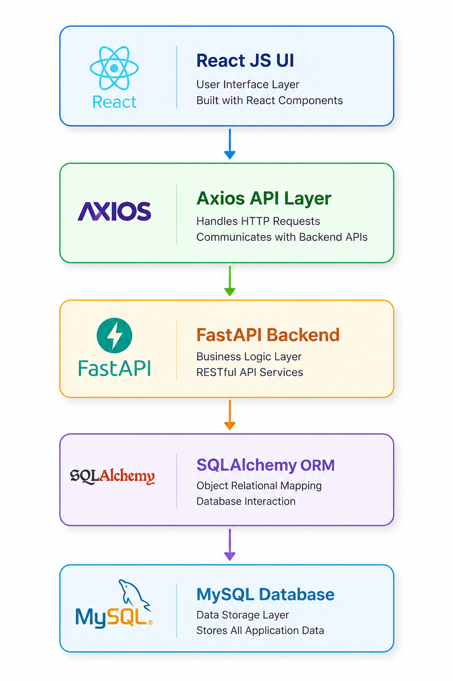

USE CASE DIAGRAM
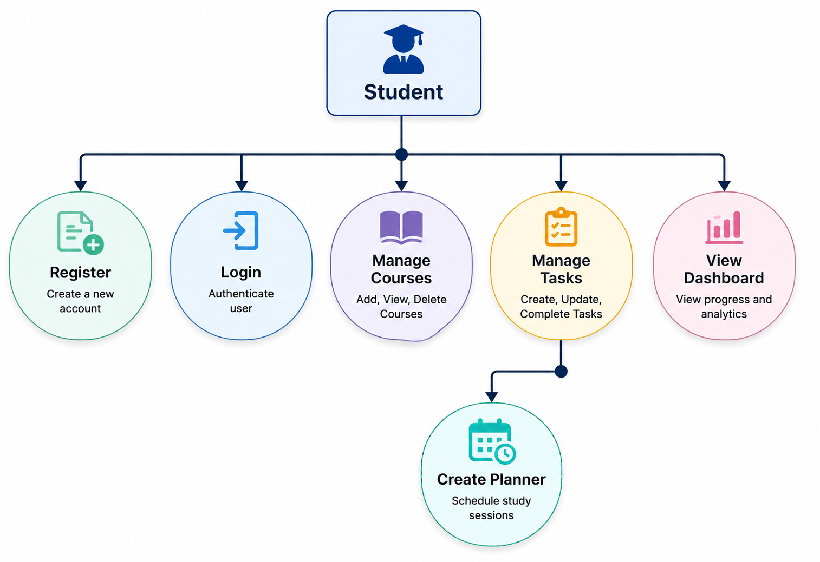

DATA FLOW DIAGRAM
DFD LEVEL 0
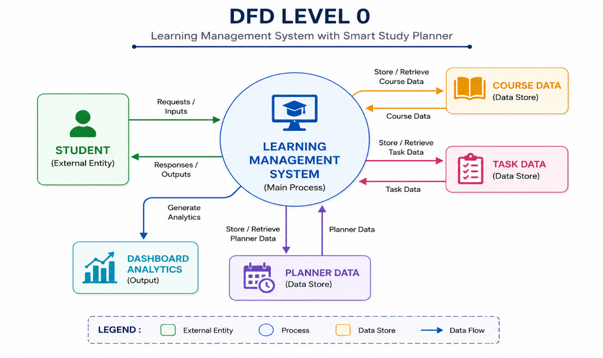
DFD LEVEL 1
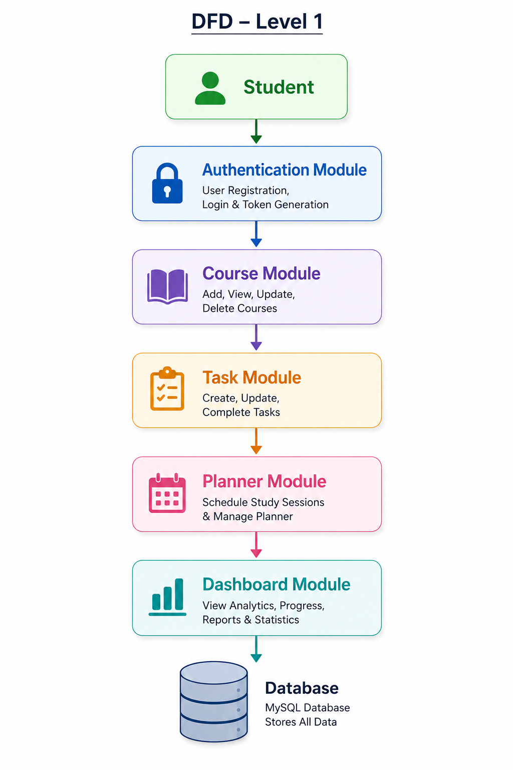

ER DIAGRAM

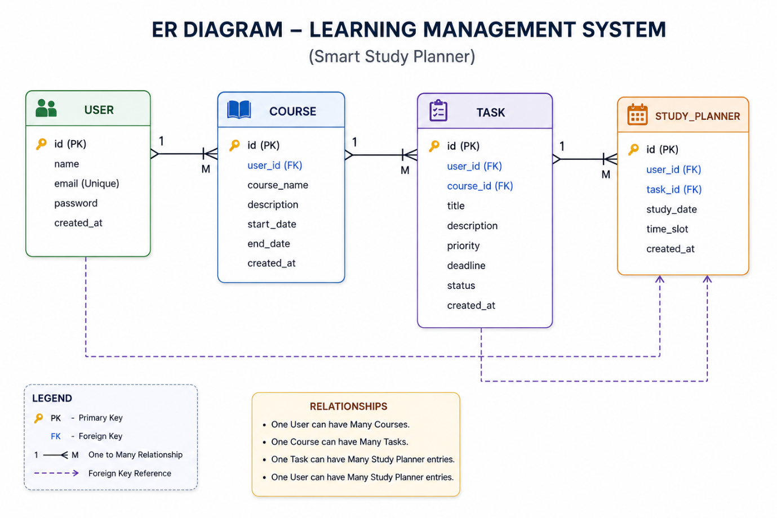

DATABASE DESIGN

USERS
Stores registered user information.
Fields:
- id
- name
- email
- password
- created_at

COURSES
Stores course information created by users.
Fields:
- id
- user_id
- course_name
- description
- start_date
- end_date

TASKS
Stores study tasks associated with courses.
Fields:
- id
- user_id
- course_id
- title
- description
- priority
- deadline
- status

STUDY_PLANNER
Stores scheduled study sessions.
Fields:
- id
- user_id
- task_id
- study_date
- time_slot

FUNCTIONAL REQUIREMENTS
Functional requirements define the features and operations that the system must perform.

FR-01 User Registration
The system shall allow new users to register using their name, email address, and password. The system shall validate user input before creating an account.

FR-02 User Login
The system shall authenticate registered users using email and password credentials. Upon successful authentication, a JWT token shall be generated for secure access.

FR-03 Course Management
The system shall allow users to:
- Add new courses
- View existing courses
- Update course details
- Delete courses

FR-04 Task Management
The system shall allow users to:
- Create study tasks
- Assign tasks to courses
- Set priorities (High, Medium, Low)
- Define deadlines
- Mark tasks as completed

FR-05 Study Planner
The system shall allow users to:
- Schedule study sessions
- Allocate time slots
- Organize daily study plans
- Track planned study activities

FR-06 Dashboard Analytics
The system shall display:
- Total number of courses
- Total tasks
- Completed tasks
- Pending tasks
- Task completion percentage
- Study progress statistics

FR-07 Secure Access Control
The system shall restrict access to protected resources using JWT authentication.

NON-FUNCTIONAL REQUIREMENTS
Non-functional requirements define system quality attributes.

Performance
- API response time should be less than 3 seconds.
- Database queries should be optimized.
- The system should handle multiple requests efficiently.

Security
- Passwords must be encrypted using hashing algorithms.
- JWT authentication should secure API endpoints.
- User data should be protected from unauthorized access.

Reliability
- The system should provide accurate results.
- Data should remain consistent during CRUD operations.
- Proper error handling should be implemented.

Scalability
- The architecture should support future expansion.
- Additional modules can be integrated without major changes.

Usability
- User interface should be simple and intuitive.
- Navigation should be user-friendly.
- Responsive design should support different screen sizes.

Maintainability
- Code should follow modular architecture.
- Documentation should be available for future enhancements.

Project Snapshots

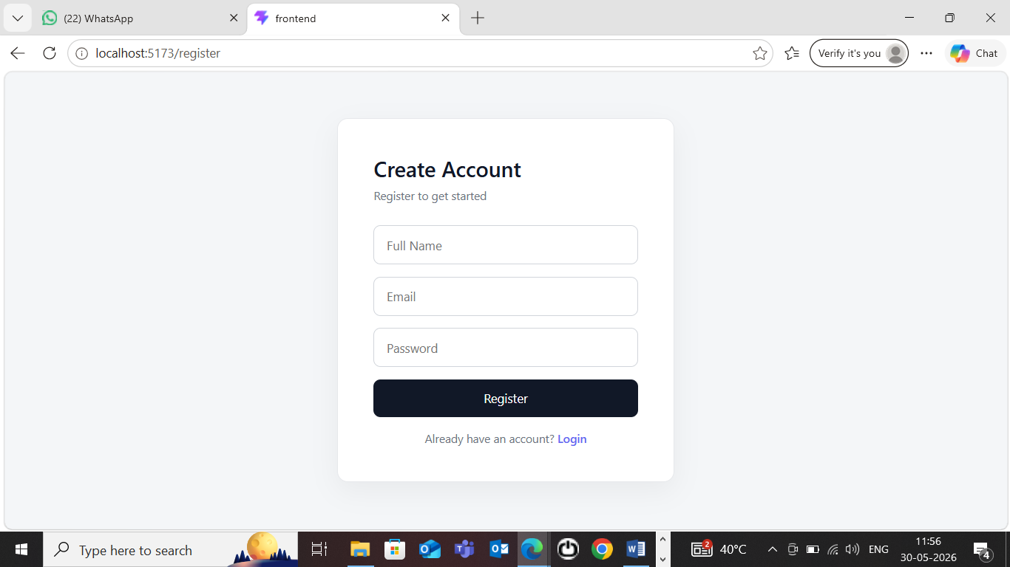
Registration/Sign Up Page

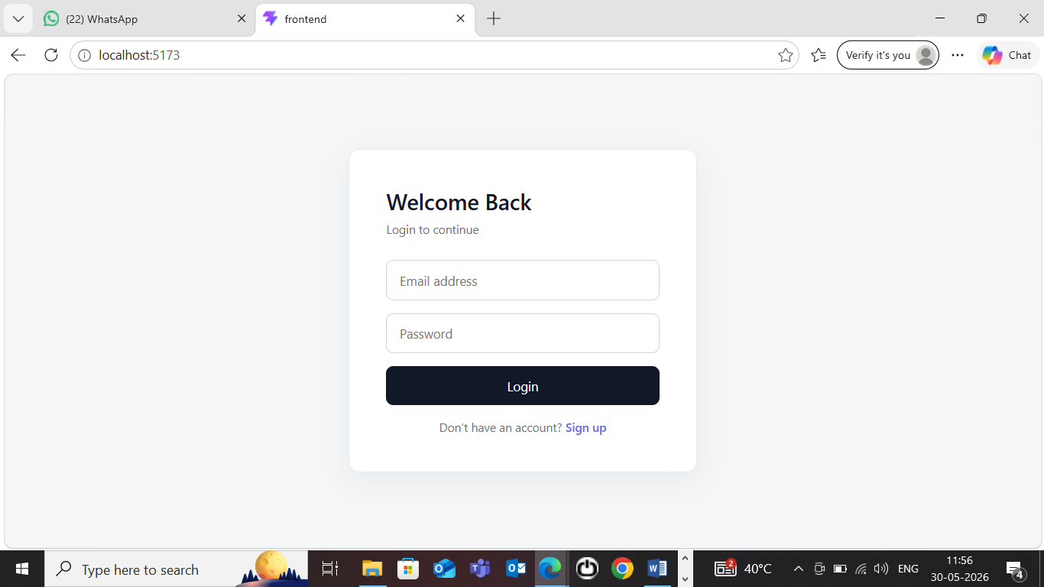
Login Page

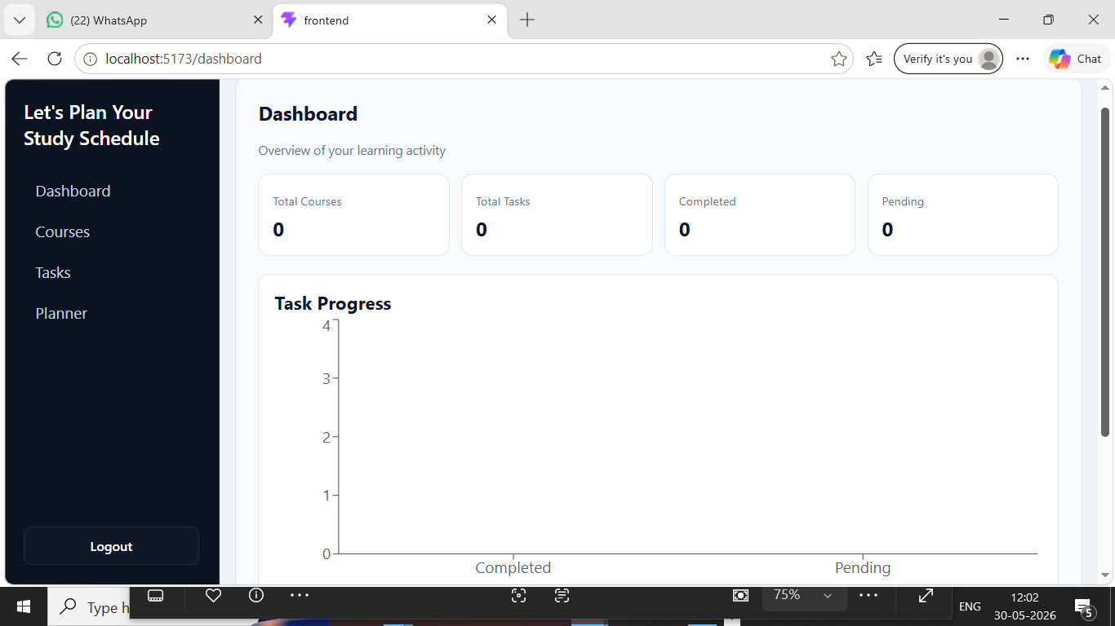
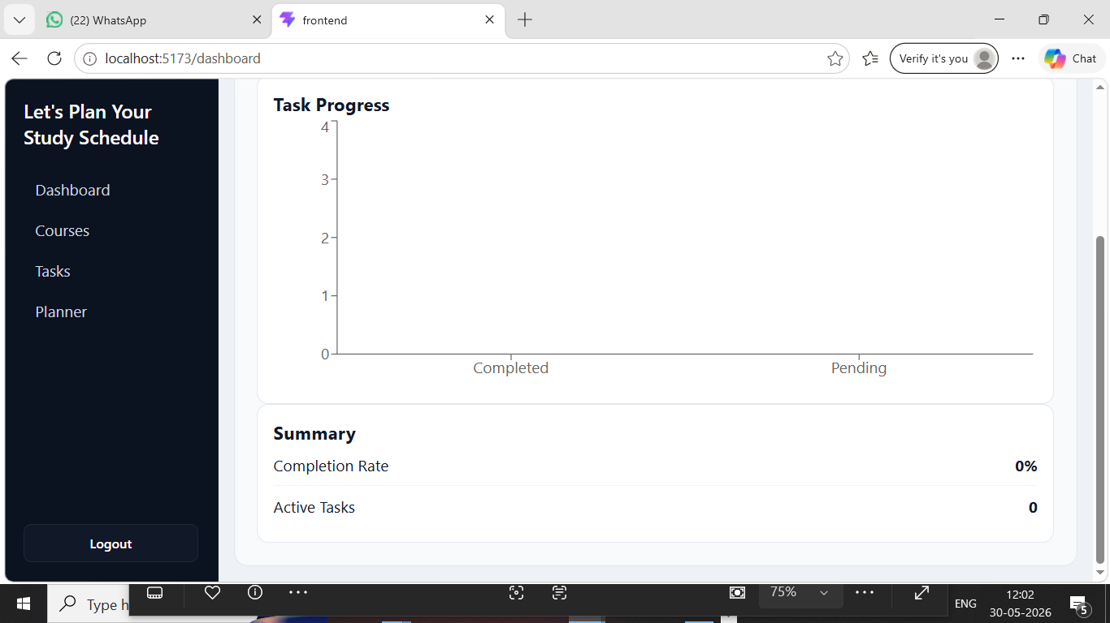
Dashboard Page View

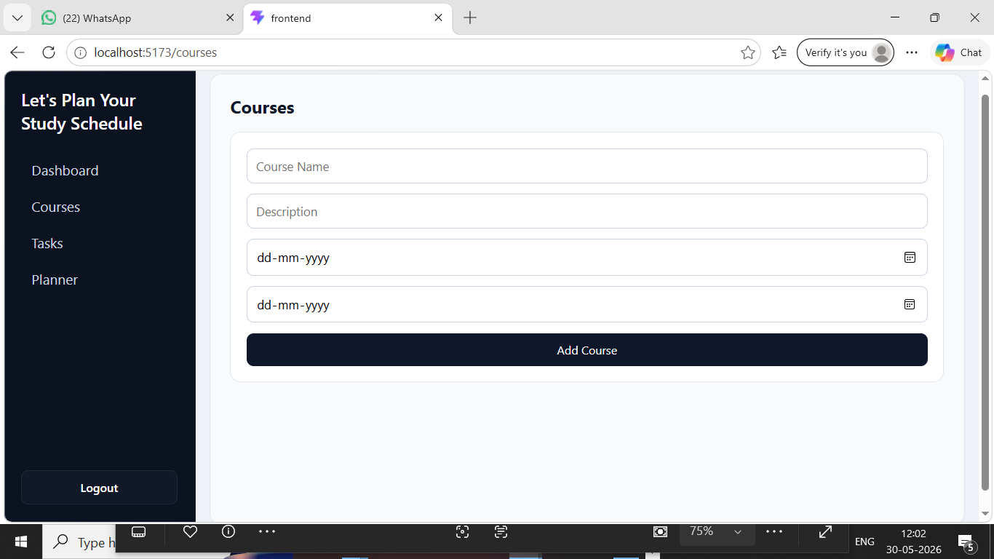
Courses Page View
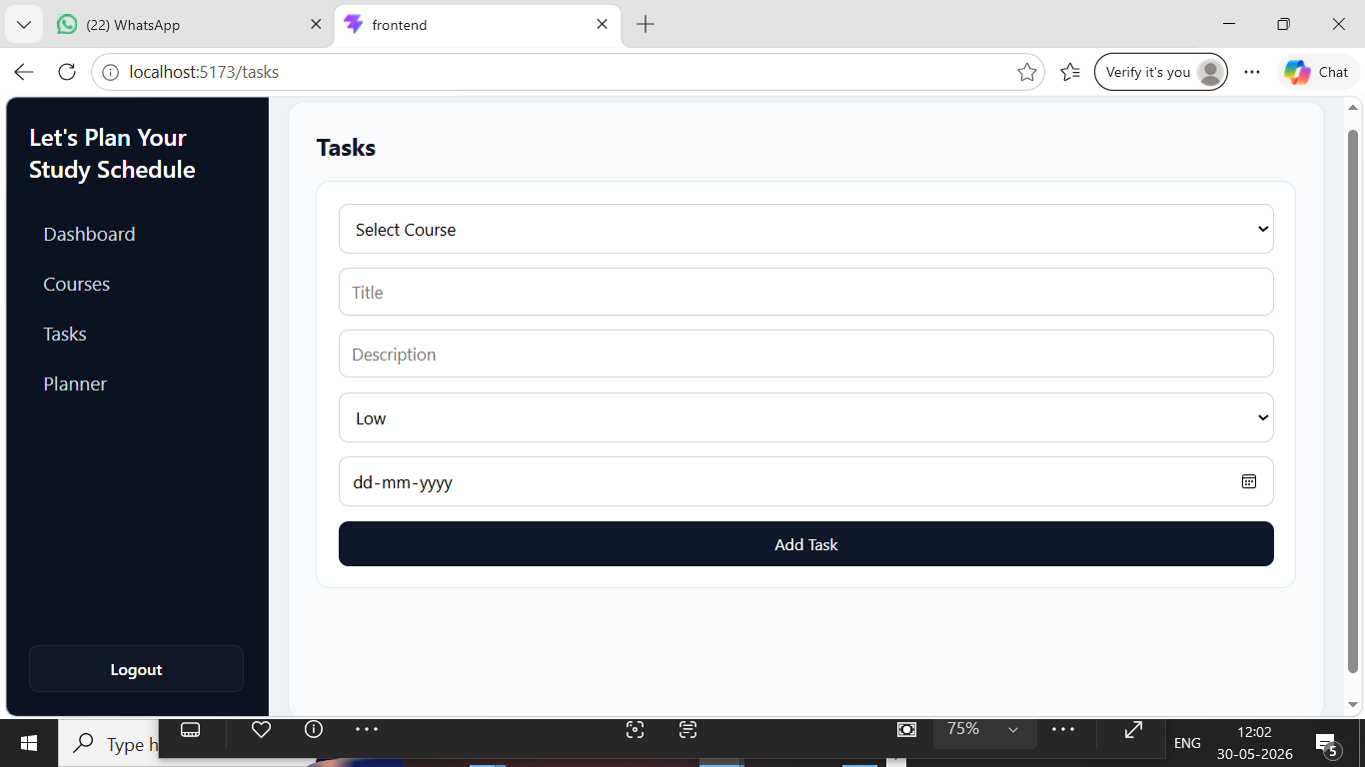
Tasks Page View

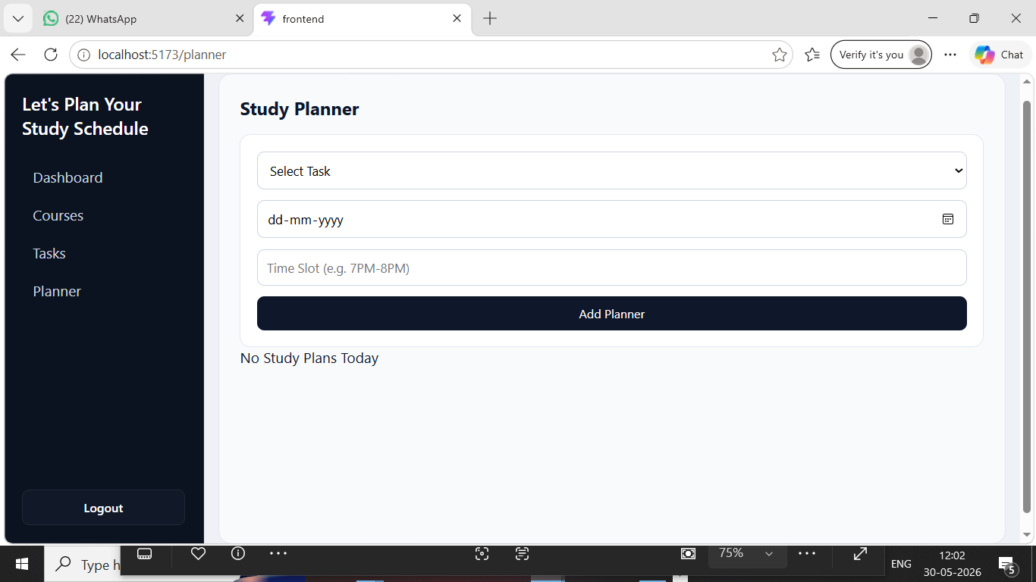
Study Planner Page View

MODULE DESCRIPTION

MODULE 1: AUTHENTICATION
Functions:
- User Registration
- User Login
- Password Hashing
- JWT Token Generation
- Authorization Control

MODULE 2: COURSE MANAGEMENT
Functions:
- Add Course
- View Courses
- Delete Course

MODULE 3: TASK MANAGEMENT
Functions:
- Create Tasks
- Assign Priority
- Set Deadlines
- Mark Tasks Completed

MODULE 4: STUDY PLANNER
Functions:
- Select Tasks
- Allocate Study Dates
- Assign Time Slots
- View Daily Schedule

MODULE 5: DASHBOARD ANALYTICS
Functions:
- Total Courses
- Total Tasks
- Completed Tasks
- Pending Tasks
- Completion Percentage
- Progress Visualization

API DESIGN
The system follows RESTful API architecture where the frontend communicates with the backend through HTTP requests.

Authentication APIs

Register User
Endpoint: POST /register
Purpose:
Creates a new user account.

Login User
Endpoint: POST /login
Purpose:
Authenticates the user and generates a JWT token.

Course APIs

Get All Courses
Endpoint: GET /courses
Purpose:
Fetches all courses associated with the logged-in user.

Create Course
Endpoint: POST /courses
Purpose:
Creates a new course.

Delete Course
Endpoint: DELETE /courses/{id}
Purpose:
Removes a selected course.

Task APIs

Get Tasks
Endpoint: GET /tasks
Purpose:
Retrieves all user tasks.

Create Task
Endpoint: POST /tasks
Purpose:
Creates a new task.

Complete Task
Endpoint: PUT /tasks/{id}/complete
Purpose:
Marks a task as completed.

Planner APIs

Create Planner Entry
Endpoint: POST /planner
Purpose:
Schedules study activities.

Get Planner Data
Endpoint: GET /planner/today
Purpose:
Retrieves today's study schedule.

Dashboard APIs

Dashboard Statistics
Endpoint: GET /dashboard
Purpose:
Returns analytics and progress statistics.

FRONTEND DESIGN
The frontend is developed using ReactJS and provides an interactive user interface.

Major Components

Authentication Pages
- Login Form
- Registration Form
- Form Validation

Dashboard
- Statistics Cards
- Progress Overview
- Analytics Visualization

Course Management Page
- Add Course Form
- Course List
- Delete Functionality

Task Management Page
- Task Creation Form
- Priority Selection
- Deadline Tracking
- Task Completion Control

Study Planner Page
- Daily Schedule View
- Time Slot Management
- Planner Tracking

Navigation Components
- Sidebar Menu
- Top Navigation Bar
- Protected Routes

State Management
React Hooks are used to manage application state and API responses.

BACKEND DESIGN
The backend is developed using FastAPI and follows REST API architecture.

Authentication Module
Responsibilities:
- User registration
- Login validation
- JWT token generation
- Password hashing

Course Module
Responsibilities:
- Course creation
- Course retrieval
- Course deletion

Task Module
Responsibilities:
- Task creation
- Task updates
- Task completion tracking

Study Planner Module
Responsibilities:
- Schedule creation
- Planner retrieval
- Study session organization

Dashboard Module
Responsibilities:
- Progress calculations
- Statistics generation
- Performance tracking

Database Layer
The database layer uses:
- MySQL
- SQLAlchemy ORM
- Relational schema design

SECURITY IMPLEMENTATION
The system implements JWT-based authentication for secure user access.
Security Features:
- Password Hashing using Bcrypt
- JWT Token Authentication
- Protected API Endpoints
- User-specific Data Access
- Secure Login Validation

TESTING
Test Case 1:
User Registration
Expected Result:
Account created successfully
Status:
PASS

Test Case 2:
User Login
Expected Result:
JWT Token Generated
Status:
PASS

Test Case 3:
Course Creation
Expected Result:
Course Added Successfully
Status:
PASS

Test Case 4:
Task Creation
Expected Result:
Task Added Successfully
Status:
PASS

Test Case 5:
Study Planner Creation
Expected Result:
Planner Added Successfully
Status:
PASS

Test Case 6:
Dashboard Analytics
Expected Result:
Correct Statistics Displayed
Status:
PASS

RESULTS AND OUTPUTS
The system was successfully developed and tested.

Registration Module
Users can successfully create accounts using valid credentials.

Login Module
Users can authenticate securely using JWT-based authentication.

Course Management
Users can add, view, and delete courses successfully.

Task Management
Users can create study tasks, assign priorities, and update task status.

Study Planner
Users can schedule study sessions and organize daily learning activities.

Dashboard Analytics
Users can monitor:
- Total Courses
- Total Tasks
- Completed Tasks
- Pending Tasks
- Progress Percentage

API Testing Results
All API endpoints were tested using Postman and returned expected responses.

Database Testing Results
CRUD operations were successfully performed on MySQL tables.

FUTURE ENHANCEMENTS
The current system can be extended with advanced features in future versions.

AI-Based Study Recommendations
The system can analyze user behavior and suggest personalized study plans.

Automated Schedule Generation
Study schedules can be automatically generated based on deadlines and workload.

Email Notifications
Reminder emails can be sent for upcoming deadlines and pending tasks.

Calendar Integration
Google Calendar and Outlook integration can be implemented.

Mobile Application
Android and iOS applications can be developed for mobile access.

Multi-Role Access
Separate roles can be added for:
- Administrator
- Faculty
- Student

Cloud Deployment
The application can be deployed on cloud platforms such as AWS, Azure, or Google Cloud.

Advanced Analytics
Machine learning techniques can be used to predict academic performance and study trends.
These versions are report-ready and suitable for a diploma/BCA/BSc/MCA final project submission.

CONCLUSION
The Learning Management System with Smart Study Planner successfully fulfills the objective of providing a centralized platform for academic planning and productivity management.
The integration of ReactJS, FastAPI, SQLAlchemy, JWT Authentication, and MySQL creates a secure, scalable, and efficient web application. The platform enables users to manage courses, organize tasks, schedule study activities, and monitor progress through analytical dashboards.
The project demonstrates practical implementation of modern full-stack web development technologies and serves as a strong foundation for future enhancements such as AI-based study recommendations, calendar synchronization, and mobile application support.

REFERENCES

Official Documentation
- React Documentation
- FastAPI Documentation
- MySQL Documentation
- SQLAlchemy Documentation
- JWT Documentation
- Axios Documentation
- Python Documentation
- Git Documentation
- GitHub Documentation

Development Tools Used
- Visual Studio Code
- Postman API Platform

Learning & Research Resources
- W3Schools Web Development Tutorials
- MDN Web Docs
- Stack Overflow Developer Community

AI-Assisted Development
- ChatGPT by OpenAI — Used for concept understanding, architecture discussions, debugging support, code explanation, documentation guidance, and project report preparation.

GitHub Repository
- GitHub Repository Link: https://github.com/aditi829/Learning-Platform-with-Smart-Study-Planner-LMS-.git

