
Student Campus Pulse Dashboard Project Documentation
Student Campus Pulse Dashboard: Interactive Student Satisfaction & Campus Analytics System


Start Date | End Date | Total Effort (hrs.) | Project Environment | Tools used
02/04/2026 | 30/04/2026 | 110 | - Python(Jupyter Notebook)  - Flask Backend  - HTML/CSS/JavaScript Frontend | • Python  • Pandas  • Numpy  • Openpyxl  • Jupyter Notebook  • Flask  • Flask-CORS  • HTML  • CSS  • JavaScript  • Chart.js  • VS Code

CERTIFICATE
This is to certify that the project report entitled “Student Campus Pulse Dashboard: Interactive Student Satisfaction & Campus Analytics System” is a genuine work carried out by [Aditi Patidar] as part of the project submission under the TCS ION Career Edge / TCS ION Program.
This project has been successfully completed in partial fulfillment of the requirements of the program launched by TCS ION. The work presented in this report is based on the candidate’s own efforts in data collection, data cleaning, analysis, backend development, frontend dashboard creation, and final project implementation.
To the best of our knowledge, this project report is an original piece of work and has been prepared according to the guidelines provided under the TCS ION project framework.
Project Title: Student Campus Pulse Dashboard: Interactive Student Satisfaction & Campus Analytics System
Submitted By: Aditi Patidar
Name of the Company: TCS ION
Name of Institute: Jawaharlal Institute of Technology Vidya Vihar Borawan(District:- Khargone)
Authorized Evaluator / Program Coordinator: TCS ION

TABLE OF CONTENTS-
- Acknowledgement
- Introduction
- Objective and Scope
- Problem Statement
- Existing Approaches
- Project Methodology
- Tools and Technologies Used
- System Architecture
- Implementation
- Data Analysis Findings Along with Dashboard Snapshot
- Challenges Faced
- Reflection on Project
- Recommendations
- Solutions Implemented
- Expected Outcomes
- Future Enhancement
- Conclusion
- Tech Stack Summary
- Project Workflow Summary
- Link to Executable File
- Research Q
- References

1. Acknowledgement
I would like to sincerely thank TCS ION for providing this industry project opportunity and practical learning platform. This project helped me apply data analytics, backend development, and frontend dashboard creation in a real-world problem-solving environment. I also express gratitude to my institute and mentors for their support.

2. Introduction
- Student satisfaction is an important factor in evaluating the quality of educational institutions.
- Colleges and universities collect student survey data related to academics, facilities, attendance, placement opportunities, and overall campus experience.
- Raw survey data is often messy, inconsistent, and difficult to analyse without proper cleaning and transformation.
- Manual analysis of large datasets is time-consuming and may not provide meaningful insights for decision-making.
- The Student Campus Pulse Dashboard project was developed to transform raw student survey data into an interactive analytics system.
- The project begins with collecting student survey data in Excel format containing multiple academic and satisfaction-related attributes.
- Python and Jupyter Notebook were used for data cleaning, pre-processing, missing value handling, duplicate removal, and data transformation.
- The cleaned dataset was then integrated with a Flask backend to create APIs for dynamic data retrieval and filtering.
- A responsive frontend dashboard was developed using HTML, CSS, JavaScript, and Chart.js for data visualization.
- The dashboard provides key performance indicators (KPIs), satisfaction trends, facility analysis, placement confidence, and correlation heatmaps.
- This project helps institutions identify patterns, strengths, and problem areas in student experiences.
- It supports data-driven decision-making for improving academic quality, campus facilities, and student welfare.
- The project demonstrates the practical integration of data analytics, backend development, and frontend visualization in solving real-world educational challenges.
- Overall, the Student Campus Pulse Dashboard serves as a comprehensive solution for analysing and monitoring student satisfaction effectively.

Bottom of Form

3. Objective and Scope

Objective:
- To analyse student satisfaction data using data analytics techniques
- To clean and transform raw Excel survey data
- To build a Flask backend for dynamic APIs
- To develop an interactive dashboard for visualization
- To support institutional decision-making through analytics

Scope:
This project can be used by:
- College administrators
- Placement departments
- Student welfare teams
- Academic management

4. Problem Statement
Educational institutions collect large amounts of survey data from students, but raw data often contains:
- Missing values
- Inconsistent formatting
- Duplicate records
- Incorrect data types
- Limited visualization
Without proper cleaning and visualization, deriving meaningful insights becomes difficult.
This project solves this problem by:
- Cleaning raw Excel survey data using Python.
- Transforming it into a structured format.
- Building a Flask API backend.
- Designing a frontend dashboard using HTML, CSS, JavaScript, and Chart.js.

5. Existing Approaches

Traditional Methods:
- Manual Excel analysis
- Static reports
- Basic charts

Limitations:
- Time-consuming
- No real-time filtering
- Limited insights
- Difficult decision-making

6. Project Methodology

Phase 1: Data Collection
- Source: Student survey Excel sheet
- Approx. dataset size: ~10,000 student records
- Data fields included:
  - student_id
  - academic_year
  - major
  - facility_rated
  - satisfaction_score
  - gender
  - attendance_percentage
  - study_hours_per_week
  - internet_quality
  - hostel_resident
  - faculty_rating
  - placement_confidence
  - feedback_text

Phase 2: Data Cleaning & Transformation (Python Jupyter Notebook)

Tools Used:
- Pandas
- NumPy
- OpenPyXL

Steps Performed:

6.2.1 Missing Value Handling
- Filled numerical missing values using mean/median
- Filled categorical missing values using mode
- Removed invalid rows where necessary

6.2.2 Data Type Correction
- Converted:
  - attendance_percentage → float
  - satisfaction_score → numeric
  - placement_confidence → numeric
  - faculty_rating → numeric

6.2.3 Standardization
- Standardized categories:
  - “male”, “Male ” → Male
  - “yes”, “YES” → Yes

6.2.4 Duplicate Removal
- Removed duplicate student_id records

6.2.5 Output
- Final cleaned dataset:
cleaned_data.xlsx

7. Tools and Technologies Used

Data Processing:
- Python
- Pandas
- NumPy

Backend:
- Flask
- Flask-CORS

Frontend:
- HTML
- CSS
- JavaScript
- Chart.js

8. System Architecture

8.1 Backend (Flask API)

Technologies:
- Python
- Flask
- Flask-CORS
- Pandas

Main Features:
- Dynamic filtering
- KPI generation
- Year-wise satisfaction
- Gender analysis
- Facility analysis
- Placement confidence distribution
- Hostel distribution
- Facility distribution
- Major-wise analysis
- Correlation heatmap

API Endpoints:
- /filters
- /kpi
- /yearly_satisfaction
- /gender_satisfaction
- /facility_satisfaction
- /placement_distribution
- /hostel_distribution
- /major_satisfaction
- /facility_distribution
- /correlation_heatmap

8.2 Frontend Dashboard

Technologies:
- HTML5
- CSS3
- JavaScript
- Chart.js
- Font Awesome

Dashboard Components:

KPI Cards:
- Total Students
- Average Satisfaction
- Average Attendance
- Average Study Hours

Charts:
- Line Chart: Academic year-wise satisfaction
- Bar Chart: Facility satisfaction
- Horizontal Bar: Gender satisfaction
- Horizontal Bar: Major satisfaction
- Bar Chart: Placement confidence
- Pie Chart: Hostel distribution
- Doughnut Chart: Facility distribution
- Heatmap: Correlation analysis

9. Implementation

Data Collection:
Messy student survey data

Processing:
- Cleaned missing values
- Standardized labels
- Exported final dataset

Backend:
Created APIs for:
- Filters
- KPIs
- Satisfaction trends
- Heatmap

Frontend:
Dashboard created with:
- Responsive layout
- Dynamic charts
- Filter integration

10. Data Analysis Findings Along with Dashboard Snapshots

10.1 Key KPIs

Total Students, Average Satisfaction, Average Attendance, Average study Hours

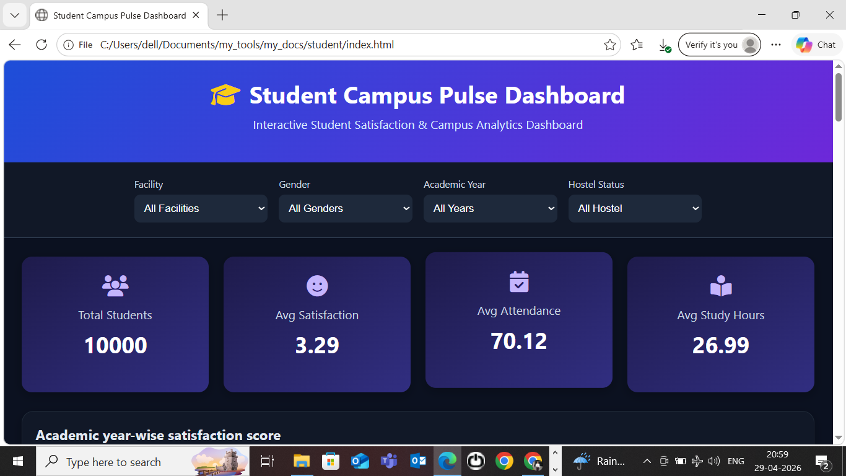

10.2 Key Filters

Facility, Gender, Academic year, Hostel Status

10.3 Key Insights:

i) Student Satisfaction:

What it shows:
- Compares satisfaction scores across 1st, 2nd, 3rd, and 4th year students.

Why it matters:
- Identifies whether satisfaction improves or declines over academic journey
- Helps detect issues faced by senior students

Example Use:
- If 4th year satisfaction is low → institution may improve placement or final-year support.
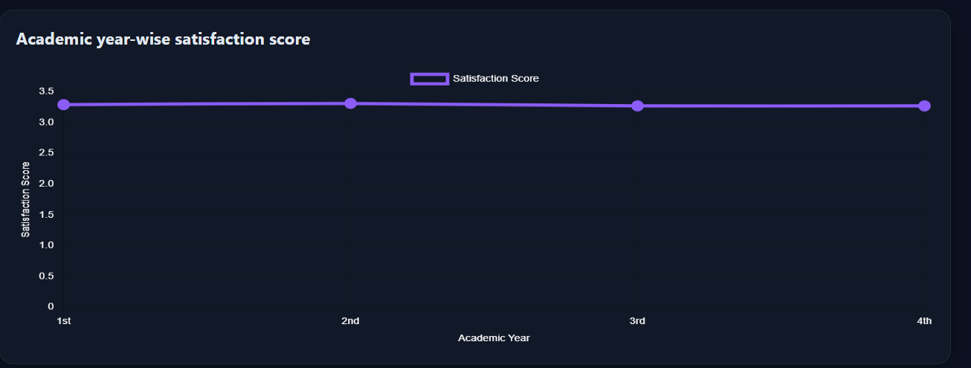

ii) Facility Performance:

What it shows:
- Average satisfaction score for facilities (Library, Hostel, Labs, Wi-Fi, etc.)

Why it matters:
- Identifies poorly rated campus facilities
- Helps prioritize infrastructure improvements

Example Use:
- Low hostel satisfaction → improve accommodation quality.
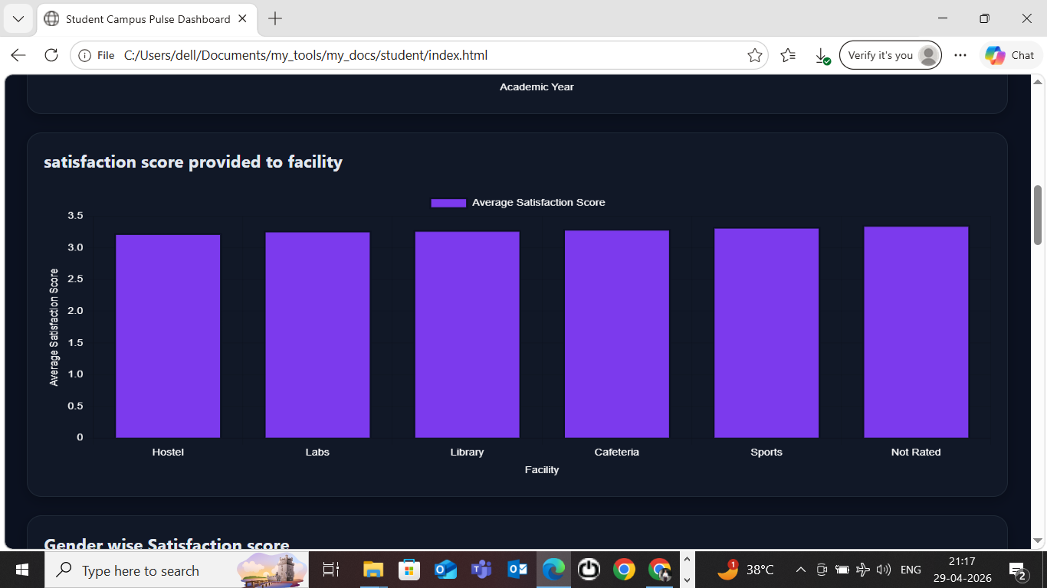

iii) Gender Wise Satisfaction Analysis:

What it shows:
- Comparison of satisfaction by gender

Why it matters:
- Reveals whether student experiences differ significantly
- Supports inclusive campus policies

Example Use:
- If female satisfaction is lower → evaluate safety/support systems.

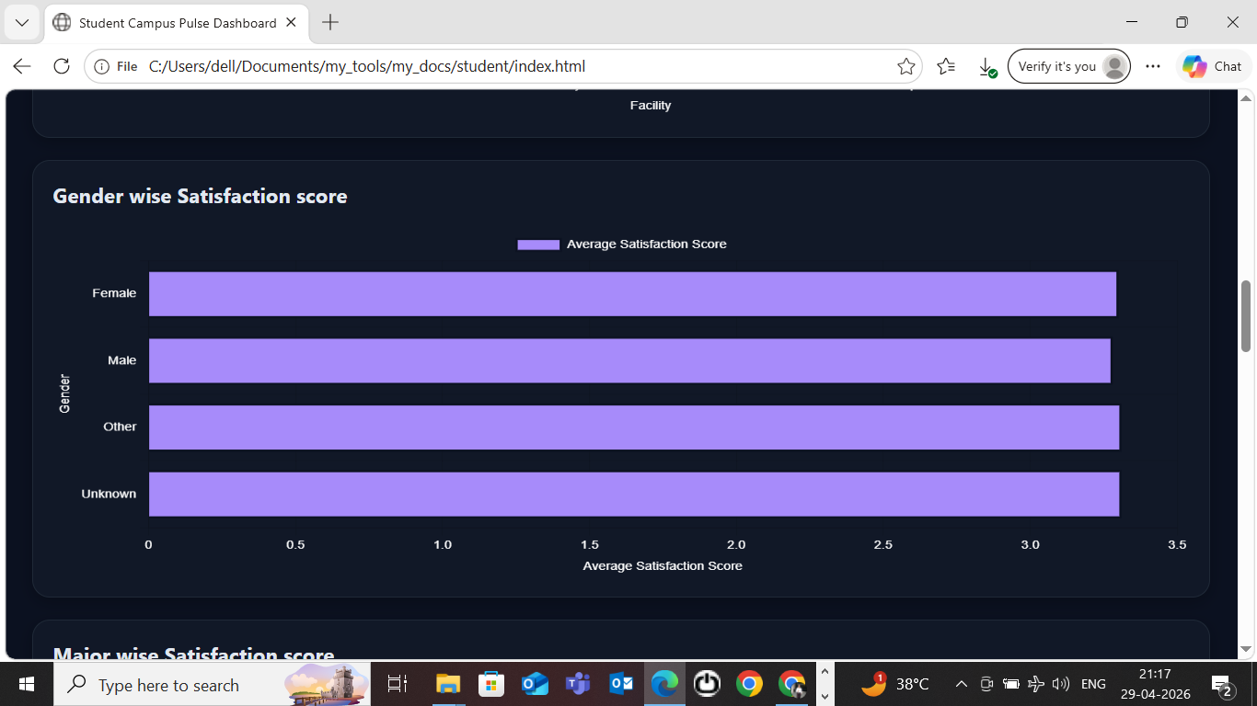

iv) Major-Wise satisfaction:

What it shows:
- Satisfaction across academic majors

Why it matters:
- Identifies department-specific concerns
- Helps academic planning

Example Use:
- Low satisfaction in Engineering → review curriculum or faculty support.

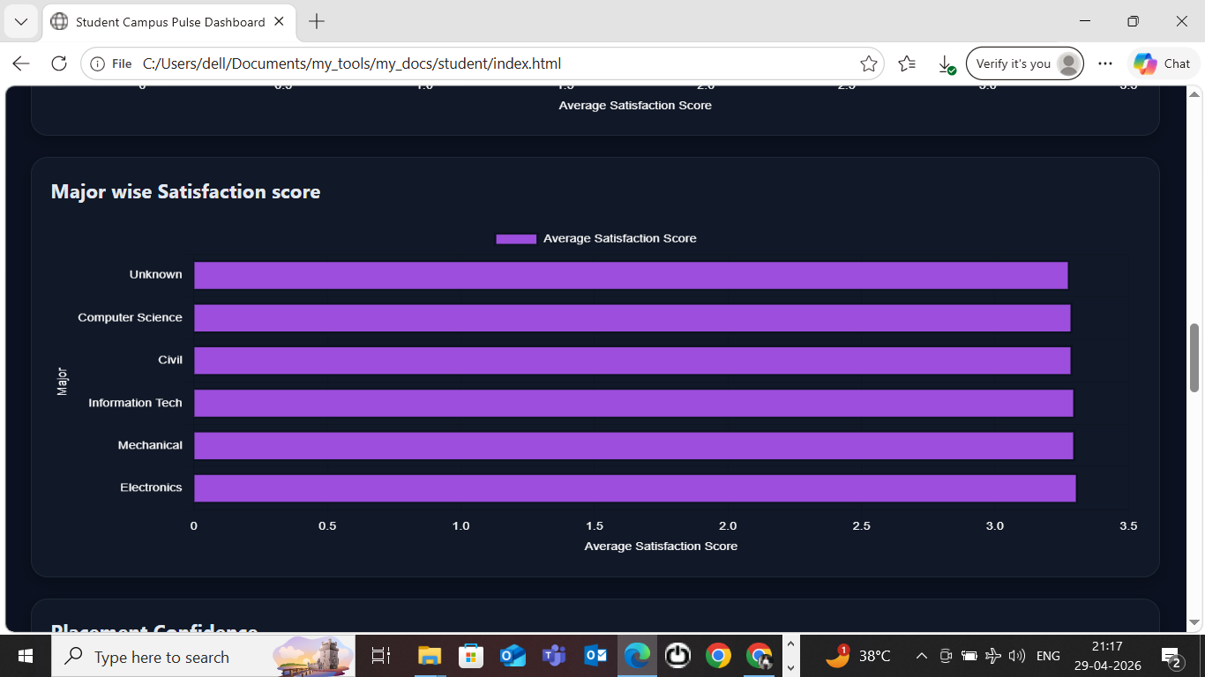

v) Placement Confidence:

What it shows:
- Student confidence in placement opportunities

Why it matters:
- Measures trust in career support
- Helps placement cell strategy

Example Use:
- Low placement confidence → increase industry tie-ups.

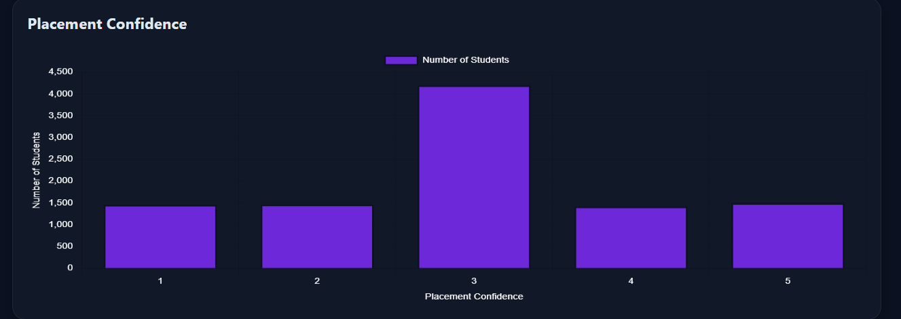

vi) Hostel Impact:

What it shows:
Hostel vs non-hostel student distribution

Why it matters:
- Useful for comparing residential student experiences
- Supports campus resource allocation

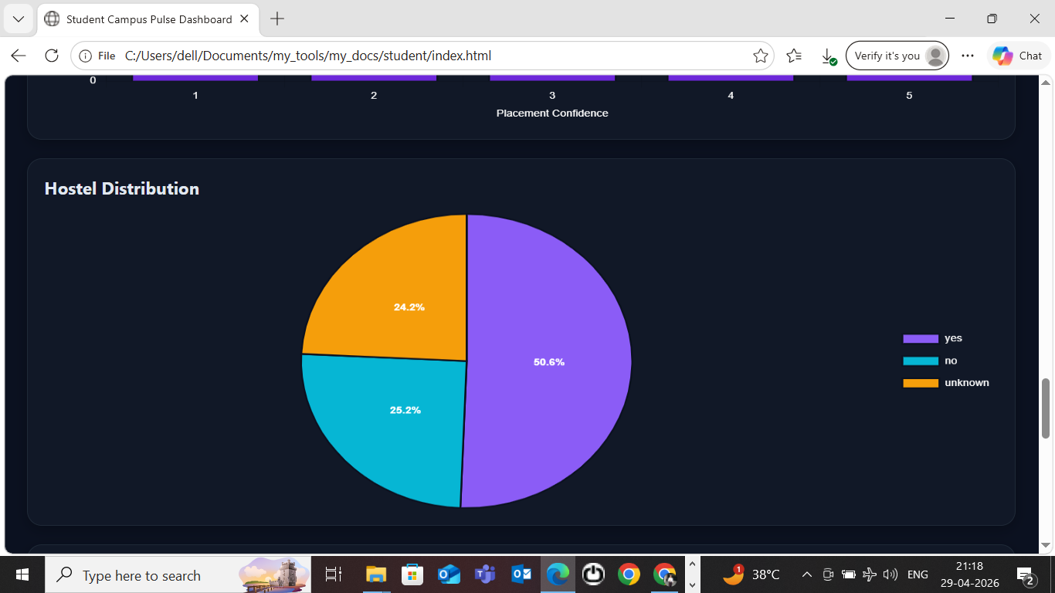

vii) Facility Distribution:

What it Shows:
- This chart shows how many students rated each campus facility, such as WiFi, Library, Hostel, or Labs.

Why it Matters:
- It helps identify which facilities are most used or important to students and supports better resource planning.

Example:
- If WiFi has the highest count, it means most students rated internet services, showing it is a key campus facility.

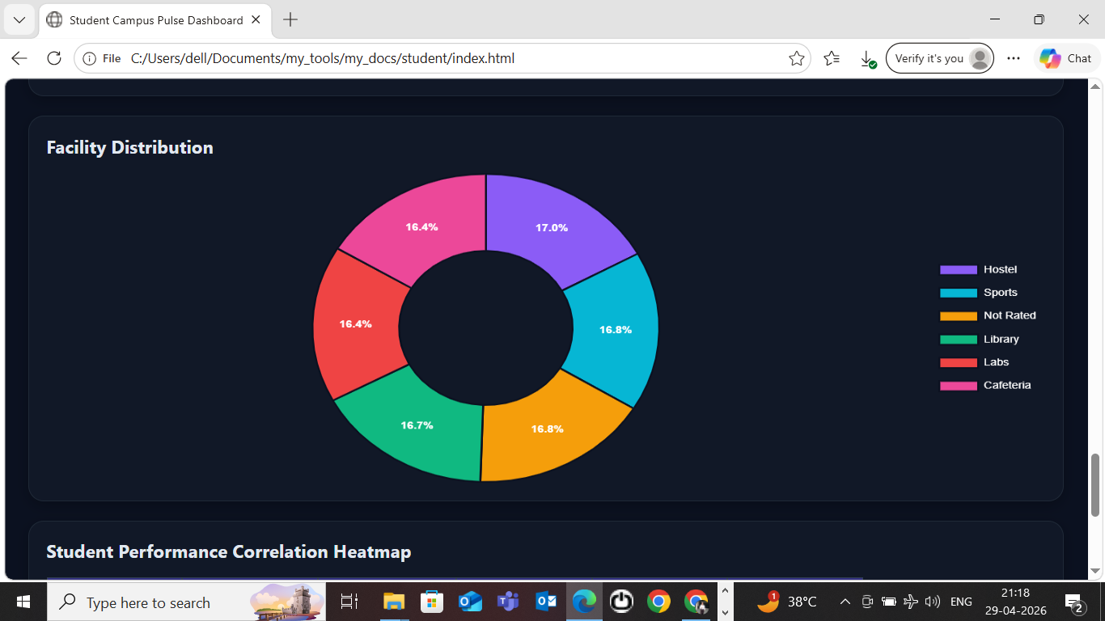

viii) Correlation Heatmap:

What it shows:
Relationship between:
- Satisfaction
- Attendance
- Study hours
- Faculty rating
- Placement confidence

Why it matters:
- Detects influential factors
- Supports predictive analysis

Example:
- High correlation between faculty rating and satisfaction → faculty quality strongly impacts student experience.

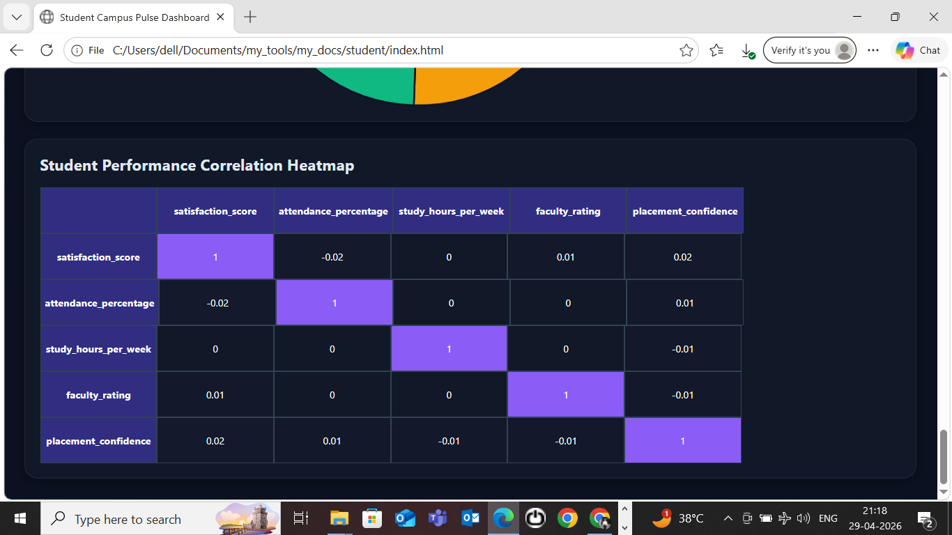

11. Challenges Faced
- Raw messy Excel data
- Missing values
- Inconsistent category labels
- Chart duplication issues
- API integration debugging
- Frontend responsiveness

12. Reflection on Project
This project improved my understanding of:
- Data cleaning
- API development
- Dashboard creation
- Data storytelling

13. Recommendations
- Improve low-rated facilities
- Strengthen placement support
- Monitor student trends regularly
- Integrate live feedback systems

14. User Manual

Step 1: Data Preparation
- Open Jupyter Notebook
- Load raw Excel file
- Perform:
  - Missing value treatment
  - Standardization
  - Data type correction
- Export:
cleaned_data.xlsx

Step 2: Backend Setup
- Save Flask code as:
app.py
- Place:
cleaned_data.xlsx in same directory
- Install dependencies:
pip install flask flask-cors pandas openpyxl
- Run:
python app.py
- Backend starts on:
http://127.0.0.1:5000

Step 3: Frontend Setup
- Save dashboard code as:
index.html
- Open in browser
- Ensure backend is running

Step 4: Using Dashboard

Filters:
- Facility
- Gender
- Academic Year
- Hostel Status

Features:
- Real-time filtering
- KPI updates
- Interactive charts
- Heatmap analysis

15. Expected Outcomes
- Better student satisfaction tracking
- Improved campus management
- Institutional decision support

16. Future Enhancements
- Login authentication
- Database integration (MySQL/MongoDB)
- Machine learning satisfaction prediction
- NLP sentiment analysis on feedback_text
- Power BI/Tableau integration
- Deployment on cloud (AWS/Render)

17. Conclusion

The Student Campus Pulse Dashboard successfully transforms raw student survey data into meaningful analytical insights through data cleaning, backend API development, and interactive frontend visualization. It serves as a practical educational analytics solution for institutions seeking to improve student experiences and operational effectiveness.

18. Tech Stack Summary
Layer | Technology
Data Cleaning | Python, Pandas
Data Storage | Excel
Backend | Flask
API Testing | Browser
Frontend | HTML, CSS, JS
Visualization | Chart.js

19. Project Workflow Summary
Raw Excel Data
↓
Data Cleaning (Jupyter Notebook)
↓
cleaned_data.xlsx
↓
Flask Backend APIs
↓
Frontend Dashboard
↓
Interactive Analytics & Insights

20. Link to Code and Executable File
- GitHub Repository Link:- https://github.com/aditi829/Student_Campus_Pulse_Dashboard.git

21. Research Questions and Responses

Q1: Which academic year has the highest satisfaction?

Q2: Which facility needs improvement?

Q3: Does faculty quality affect satisfaction?

22. References
- Pandas Documentation. (2026). Data Analysis and Manipulation Tools. https://pandas.pydata.org/
- Flask Documentation. (2026). Flask Web Framework. https://flask.palletsprojects.com/
- Chart.js Documentation. (2026). JavaScript Chart Library. https://www.chartjs.org/
- Openpyxl Documentation. (2026). Python Library for Excel Files. https://openpyxl.readthedocs.io/
- Font Awesome. (2026). Icon Toolkit. https://fontawesome.com/
- Python Software Foundation. (2026). Python Language Reference. https://www.python.org/
- W3Schools. (2026). HTML, CSS, JavaScript Tutorials. https://www.w3schools.com/
- Chatgpt. https://www.chatgpt.com

