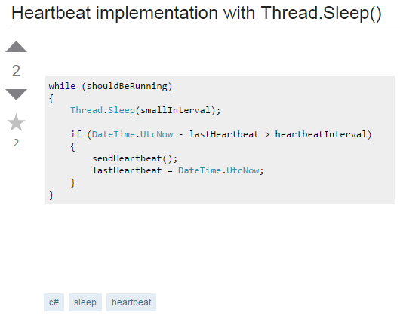

Now, it happens that when my application is going through some intensive CPU time (several minutes of heavy calculations in which the CPU is > 90% occupied), the heartbeats get delayed, even if smallInterval << heartbeatInterval. I have already tried setting the thread priority as AboveNormal - how can I improve my design to avoid such problems?

In my application I have an "heartbeat" functionality that is currently implemented in a long running thread in the following way (pseudocode):