**Android M Permissions Analysis**

**Instructions**

In order to use the tool, first open a terminal session and then go to the Desktop directory by entering the following command as soon as you open the terminal session:

$ cd Desktop/

**Important:** cd is a command that helps users navigate directories, we will assume knowledge about this command and other introduced com mands and their use from now on.

Once in the Desktop directory, the mperm/ directory can be found. Please, proceed to enter to this directory, until you reach the directory named MPermission. To list local directories within a given folder, enter:

$ ls -l

Once in the MPermission directory, a command with the syntax explained below can be entered in order to test the tool.

**$** python3 mperm.py -d [--decompile] apk_path # decompiles APK and moves it to sample_apk/ directory

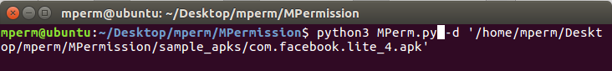

After the decompilation process is complete, proceed to run the analysis of the tool by entering a command with the syntax specified below. It is important to know that once an application has been decompressed, the decompressed folder will be found under the sample_apks/ folder with the same name as the original .apk file, followed by .uncompressed.

**$** python3 mperm.py -a [--analyze] decompiled_apk_path # analyze and prints source report / analysis report

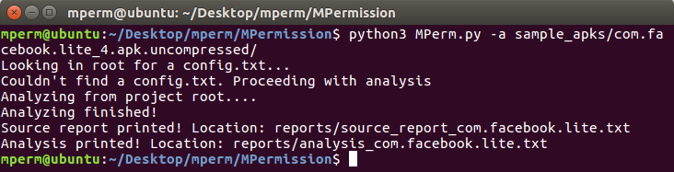

After the completion of the analysis, results can be found under the folder reports/ as a .txt file.