**# How to change the Password.**

Open the Lab machine and follow the steps:

Step1.  Login to your machine with your username and password.

Step2.  Press Ctrl + Alt + Del.

Step3.  Click on change the password.

Step4. You will be prompted to put old and new password.

Step5. Supply your old password, new password and retype new password and click Ok.

**# How to access printer from Lab:**

Step1: Open Start > All Programs > Accessories > Run

Step2: Enter \\print on the Run command

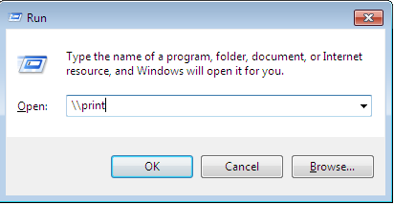

Step3: New window opens with the list of printers

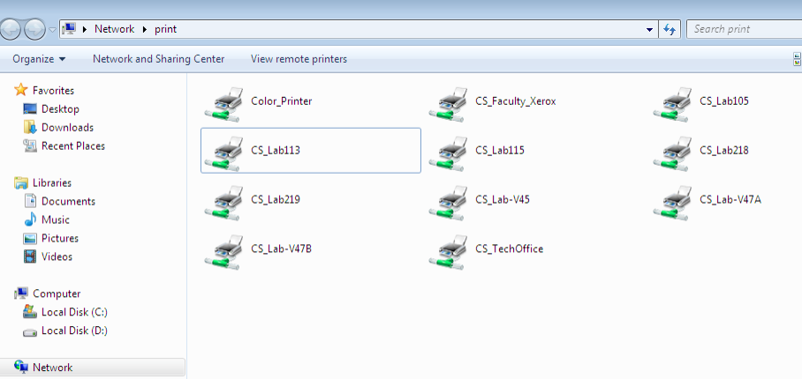

Step4: Check your “Lab Room” number and right click the corresponding printer name to add and click connect. Allow some time to complete the driver installation.

**# How to access the CS5 folder from the Lab:**

Step1: Open Start > All Programs > Accessories > Run

Step2: Enter \\cs5 on the Run Command

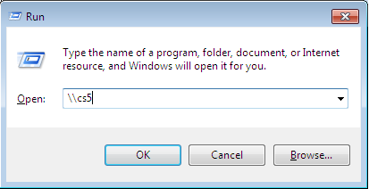

Step3: Supply Username and Password

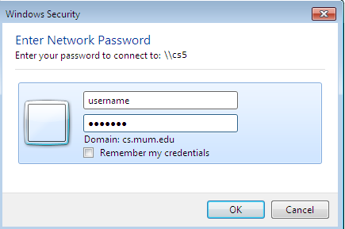

Step4: You are connected to cs5 folder.

**# How to access the CS5 folder from your dorm:**

Step1: Open Start > All Programs > Accessories > Run

Step2: Enter \\10.10.10.105 on the Run command

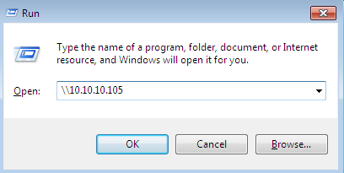

Step3: Supply username and password as follows:

Username: [98XXXX@cs.mum.edu](mailto:98XXXX@cs.mum.edu)

Enter your password and Click Ok.

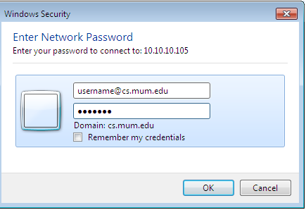

Step4: You are connected to CS5 folder.