
Department of Computer Science and Engineering
ALGORITHMIC PROBLEM-SOLVING HACKATHON (APSH 2026)
PROJECT DOCUMENTATION
Date: 03-10-2026 | Venue: 3rd Floor, A & B Blocks
Field | Details
Project Title | LokSahay: Disaster Relief, Coordinated by Algorithms
Team Name / Team No. | Team No. 2
Year / Semester / Section | II Year B.Tech / I Sem
Algorithm Paradigm Used | Greedy (priority-ordered allocation), supported by Graph shortest-path routing
Programming Language / Tools | Python, Flask API, NetworkX, SQLite
Faculty Mentor | K.Little Flower / Hemanth Kumar
Team Members
S.No | Name of the Student | Roll No. | Role
1 | Aditi Desai | 25MVCSER0632 | Team Lead
2 | Srishank Patel | 25MVCSER0649 | Prototype Planning
3 | Bhavani Prasad | 25MVCSER0607 | PPT and Documentation
4 | R. Manikanta | 25MVCSER0641 | UI/UX Designer

1. Problem Statement
During a disaster, relief is often available but coordination breaks down. Food, medicine, water, vehicles, roads and affected-area requests are spread across a network whose condition keeps changing. A useful plan must match limited supply to urgent demand and turn that match into a delivery decision that is actually feasible. LokSahay is an explainable system that allocates scarce relief supplies, vehicles and routes under urgency, capacity, accessibility and deadline constraints.
Inputs
Demand requests (affected area, population affected, resource type and quantity, urgency, deadline), supply inventories at multiple sources, the available vehicles with their capacities, and the road graph of the region.
Outputs
For every fulfilled request, a delivery recommendation containing the source, quantity, destination, vehicle, route, ETA, deadline and current status.
Constraints
• Inventory at each source is limited and shared across many requests.
• Each vehicle has a fixed carrying capacity.
• Roads can be blocked, so some routes become inaccessible.
• Supplies are scattered across multiple sources rather than held in one depot.
• Every delivery has a time window (deadline) that the route and vehicle must satisfy.
2. Objectives
LokSahay is designed to make urgency visible, use the available supply well, and keep every recommendation feasible. The project has four specific objectives:
• Prioritize need. Prioritize the areas with the greatest urgency, population impact and shortage so that the most critical needs are served first.
• Use supply well. Draw on scattered inventories without unnecessary waste or duplicate trips.
• Respect feasibility. Assign only those vehicles and routes that can carry the load and still meet the delivery deadline.
• Replan when reality changes. Recalculate the affected allocations whenever demand, inventory or road conditions change.
3. Proposed Approach
LokSahay follows a single decision loop that carries every request from submission to delivery. The coordinator dashboard sends requests to a Flask API, where Python services handle validation, scoring, allocation, vehicle assignment, route checks and status tracking. The loop passes through six visible stages:
• Coordinator Dashboard. Coordinators view requests, resources, allocations, routes, ETAs and delivery progress.
• Flask API. Receives requests and exposes the Python services that support the decision logic.
• Validation + Priority Engine. Validates each request and orders requests by urgency.
• Greedy Allocation Engine. Matches source, vehicle, destination and quantity for each request.
• NetworkX Route Analysis. Assesses the shortest feasible paths, travel time and access.
• SQLite state store. Prototype storage with indexed records for requests, sources, vehicles and allocations.
Why a greedy paradigm
The engine takes the highest-priority request first, picks the best feasible option available at that moment, updates the state and moves on. This suits disaster relief because the situation changes continuously and decisions must be made quickly; a plan that can be recomputed in step with the live network state is more useful than one that is optimal only for a frozen snapshot. Greedy allocation is also easy to explain, since each assignment can be traced to three things: urgency, feasibility and incremental cost.
Priority scoring
Requests are processed in descending order of priority, with earlier deadlines receiving precedence when appropriate. The score combines three configurable factors, and its weights remain configurable for the operating context. It is therefore not a hidden black box: its factors explain why one request is processed before another.
• Urgency: how immediate the need is.
• Impact: population affected and shortage.
• Pressure: accessibility and deadline risk.
Graph-based routing
Affected areas and verified resource locations are modelled as nodes and roads as weighted edges. Shortest-path analysis estimates distance and travel time, rejects options that are inaccessible or would break the deadline, and recalculates when a route is blocked. This makes feasibility visible instead of assumed.
4. Algorithm / Pseudocode
The allocation engine repeats the following five steps for each request, taken in priority order: validate, search sources, check transport, choose the best feasible option, and commit.
Step-by-step algorithm
• 1. Validate. Validate the request, source quantities, vehicle capacities and the deadline.
• 2. Search sources. Find the sources that carry the requested resource and still have usable inventory.
• 3. Check transport. Find vehicles and routes that can carry the allocation within the deadline.
• 4. Choose the best feasible option. Choose the feasible option with the lowest incremental distance or transport cost.
• 5. Commit and continue. Allocate, update inventory and vehicle capacity, record the route, and continue with the next request.
Pseudocode
ALLOCATE(requests, sources, vehicles, road_graph):
sort requests by priority score (descending);
ties: earlier deadline first
FOR each request r in sorted order:
IF NOT VALID(r, sources, vehicles): skip r
candidates = sources with resource(r) and inventory > 0
best = NONE
FOR each source s in candidates:
FOR each vehicle v able to carry the load:
path = SHORTEST_PATH(road_graph, s, destination(r))
IF path exists AND arrival_time(path) <= deadline(r):
cost = incremental distance / transport cost
IF best is NONE OR cost < best.cost:
best = (s, v, path, cost)
IF best is not NONE:
COMMIT: reduce inventory of best.s,
update capacity of best.v,
record route and ETA, set status = Assigned
ON CHANGE (demand, inventory or road blocked):
recompute affected allocations

Delivery status tracking
Once an allocation is committed, it moves through the following states: Assigned, Accepted, Picked Up, In Transit, Arrived and Delivered.
Explainability trail
Every assignment can be traced to its urgency, its feasibility and its incremental cost, so a coordinator can see exactly why a source, vehicle and route were chosen.
5. Complexity Analysis
Let D be the number of demand requests, S the number of supply sources, V the number of vehicles and E the number of edges in the road network. The cost is expressed in terms of the live network state rather than through unsupported performance claims.
Complexity | Best Case | Average Case | Worst Case
Time | O(D log D + E log V) | O(D log D + D(S + V) + E log V) | O(D log D + D(S + V) + E log V)
Space | O(D + S + V + E) | O(D + S + V + E) | O(D + S + V + E)
Justification
Sorting the requests into priority order costs O(D log D). For each request, the engine examines the candidate sources and vehicles, which contributes D(S + V). Shortest-path analysis on the road graph supports route feasibility and contributes E log V. The best, average and worst cases are the same in the stated model because each request is checked against the candidate sources and vehicles in every case. Space is O(D + S + V + E), the storage needed to hold the requests, sources, vehicles and road-network edges.
Reading the table: the priority order, the candidate checks and the route feasibility step each remain explicit in the expression.
6. Implementation
The prototype is organized into operational modules and execution/state modules, backed by a small set of data structures.
Operational modules
• Request and resource management: demand, supply, inventory and validation.
• Priority calculation: urgency and shortage ordering.
• Greedy allocation engine: source–vehicle–destination matching.
• Route analysis: weighted graph and shortest feasible path.
Execution and state
• Vehicle assignment: capacity and deadline checks.
• Tracking / status: Assigned, Accepted, Picked Up, In Transit, Arrived, Delivered.
• Data structures: lists/tables, dictionaries/maps, priority ordering and a weighted graph.
Core entities
• Request: demand plus urgency.
• Source: inventory available for each resource.
• Vehicle: carrying capacity.
• Route: weighted path between nodes.
Tools and platform
Python is used for the services, Flask for the API that receives requests, NetworkX for graph and route analysis, and SQLite as prototype storage with indexed records for requests, sources, vehicles and allocations.
7. Results and Test Cases
LokSahay is presented as a current prototype with explainable allocation, route feasibility and state tracking at its core. For each processed request the system produces a complete, traceable delivery decision.
Output of one test case
Given a request (affected area, resource type and quantity, urgency, deadline) together with source inventories, vehicles and the road graph, the system returns:
• the source chosen and the quantity allocated;
• the destination and the vehicle assigned;
• the route, the ETA and the deadline it was checked against;
• the delivery status, which advances from Assigned to Delivered.
Behaviour demonstrated
• Requests are served in priority order, with earlier deadlines getting precedence where appropriate.
• Options that are inaccessible or would miss the deadline are rejected during route analysis.
• When a route is blocked, or demand or inventory changes, the affected allocations are recalculated.
• Each assignment can be traced back to urgency, feasibility and incremental cost.
Screenshots
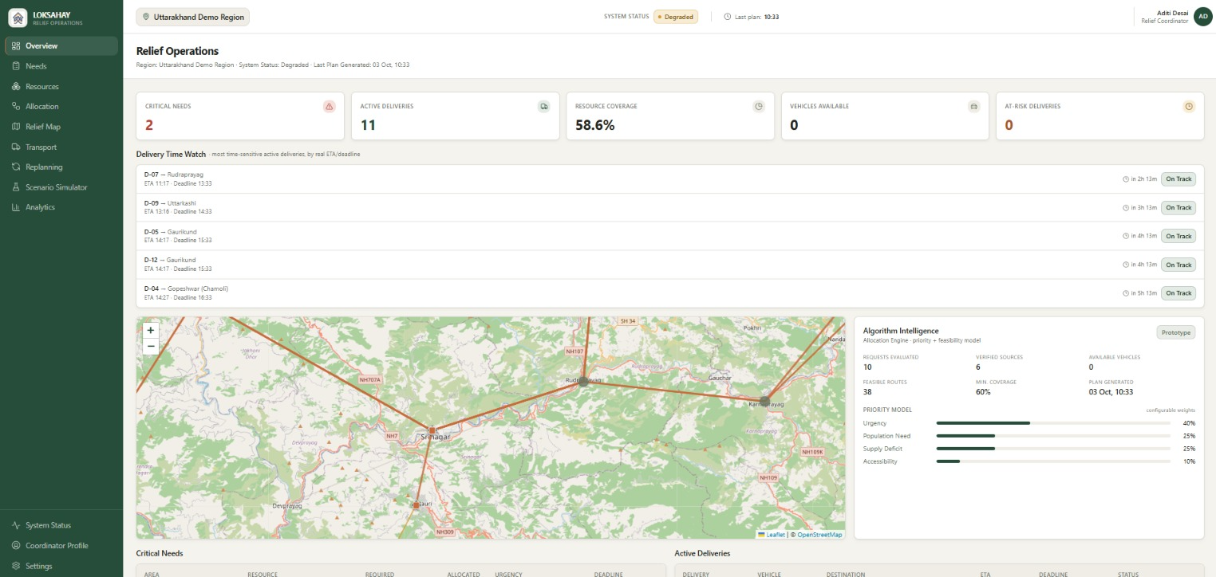
Figure 1: LokSahay Relief Operations dashboard (Uttarakhand demo region), showing critical needs, delivery time watch, relief map and the priority model.
8. Conclusion and Future Scope
LokSahay shows that disaster-relief coordination can be handled by an explainable algorithmic pipeline: validated requests are ordered by a configurable priority score, matched greedily to feasible sources and vehicles, checked against a road graph for accessibility and deadlines, and tracked through delivery. Because priority factors, feasibility checks and incremental cost are all visible, coordinators can see why each recommendation was made. The prototype also supports replanning when demand, inventory or road conditions change.
Future scope
• Tune the configurable priority weights for different disaster contexts and operating conditions.
• Move from prototype SQLite storage to a store suited to a larger live network, since replanning cost depends on the live network state (D, S, V and E).
• Extend the graph and routing layer with richer GIS and network data, as in the GIS and network-based disaster logistics literature.
9. References
[1] Government of India, Ministry of Home Affairs, "National Disaster Management Plan."
[2] National Disaster Management Authority, "Disaster-management guidelines and resources."
[3] Research literature on humanitarian logistics and disaster-relief resource allocation.
[4] Research literature on GIS and network-based disaster logistics.
[5] NetworkX Developers, "NetworkX documentation."
[6] Python Software Foundation, "Python documentation."

