MiniOmniDocs – Functional Requirements
Overview
MiniOmniDocs is a web‑based system that lets organization members store, browse, share, and annotate digital documents. The application provides a clean, modern dashboard for everyday users (Employees) and an administrative console for managers and system administrators. All interactions are performed through the browser; no command‑line or technical knowledge is required.
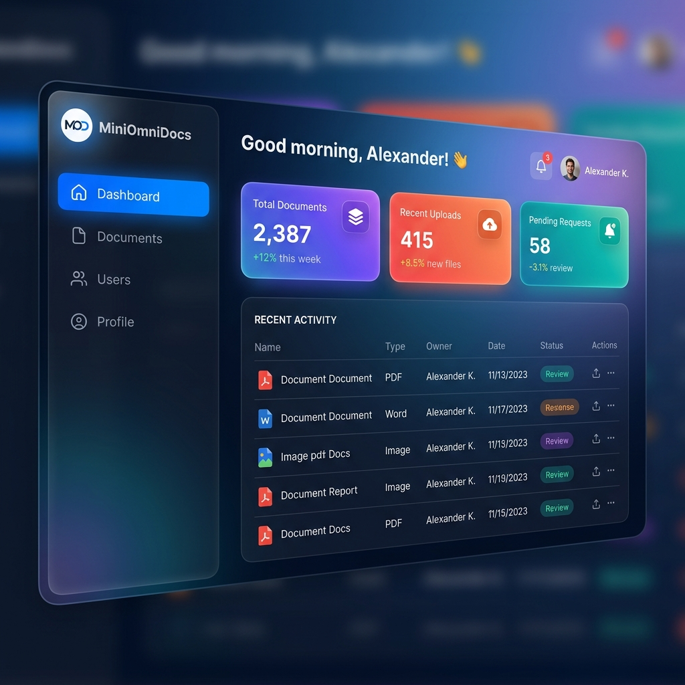
Figure 1: MiniOmniDocs Dashboard UI mockup

User Roles
- Employee – Upload documents, view own and shared documents, request access to restricted files, add personal annotations, download files they have permission to see.
- Manager – All Employee capabilities plus approve/deny access requests, view audit logs, manage user accounts (create, edit, deactivate), and delete any annotation.
- Administrator – Full system control: configure database, define role policies, monitor system health. (optional future extension)

Functional Features
- Dashboard (Home) – Welcome header, navigation, responsive layout.
- Document Management – Upload, view list, search/filter, download, delete (Manager only), view details.
- Access Permissions – Request access, approve/deny, revoke access.
- Annotations – Add, view, delete own, delete any (Manager).
- User Management – Create, edit, deactivate/reactivate users, search users.
- Audit Log – Automatic recording of critical actions, viewable and exportable by Manager.
- Profile Page – Shows user info, change password, recent activity.
- Error Handling & Feedback – Consistent toast notifications for successes and failures.

Typical User Journeys
- Employee – Upload & Share a Document: Log in → Dashboard → Upload → Confirmation toast → Document appears in list → Share with colleagues.
- Employee – Request Access & Annotate: Browse → Request Access → Manager approves → Notification → Open document → Annotate → Comment appears.
- Manager – Approve Requests & Manage Users: Dashboard → Pending Requests → Approve/Deny → User notified; Users page → Add User → Assign role.

Non‑Functional Expectations (User‑Facing Perspective)
- Intuitive UI – All actions reachable within two clicks.
- Realtime Feedback – Toast notifications after each operation.
- Responsive Design – Works on desktop and tablet.
- Accessibility – Color contrast, keyboard navigation, ARIA labels.
- Security Awareness – No exposure of raw passwords or DB details.

Glossary
- Document – Any uploaded file (PDF, DOCX, image, etc.).
- Annotation – Textual comment attached to a document.
- Permission Request – Formal ask by an Employee to view a restricted document.
- Manager – User with elevated rights to approve requests and administer accounts.

Feature Snapshots & Step‑by‑Step Guides
Figure 1: MiniOmniDocs Dashboard UI – premium glass‑morphism layout.

Dashboard Usage Steps
- Log in with your credentials; you are taken to the Dashboard home page.
- View the greeting header and three stats cards showing total documents, recent uploads, and pending access requests.
- Use the side navigation bar to jump to other sections such as Documents, Users, or Profile.
- Hover over any card for a brief tooltip; click a card to drill down into that area (e.g., click the "Pending Requests" card to open the request list).
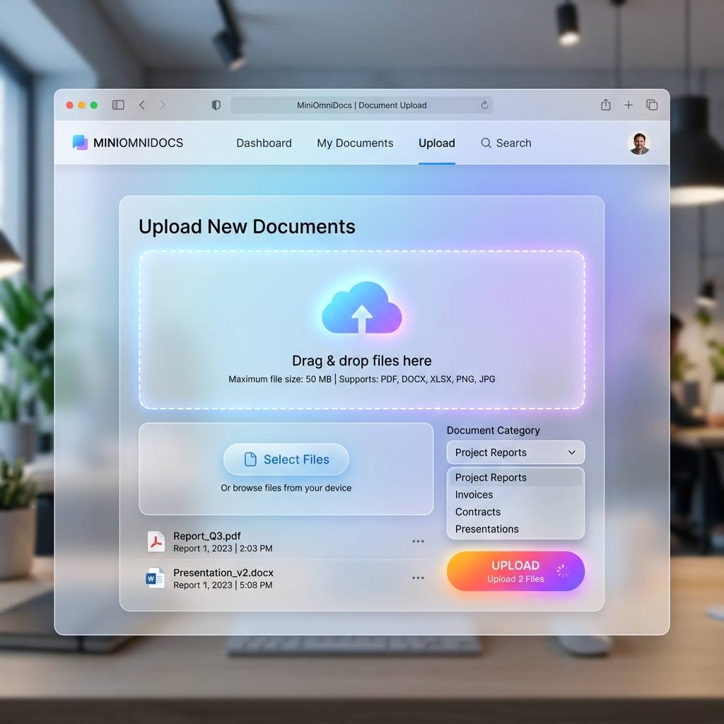
Figure 2: Document Upload Page – drag‑and‑drop area with cloud icon and bright Upload button.

Document Upload Steps
- Navigate to the "Documents" section via the side menu.
- Click the "Upload" button to open the upload dialog.
- Drag a file onto the highlighted area **or** use the "Browse" button to select a file.
- Optionally enter a category or description for the file.
- Press the bright "Upload" button; a toast confirms successful upload and the file appears in the document list.

