Project Title:
MNIST Digit Classification Using Neural Networks
Submitted To:
Naviotech Solution Pvt. Ltd
Submitted By:
Rajlaxmi panikar
Internship Domain:
Artificial Intelligence / Machine Learning
Date:
March 2026

2. Abstract
This project focuses on the classification of handwritten digits using a Neural Network model. The MNIST dataset, which consists of 70,000 grayscale images of handwritten digits (0–9), is used to train and evaluate the model. A Deep Learning approach using TensorFlow and Keras is implemented in Google Colab. The model successfully achieves high accuracy in recognizing digits. This project demonstrates the practical implementation of machine learning concepts in image classification tasks.

3. Introduction
Handwritten digit recognition is one of the fundamental problems in computer vision and pattern recognition. It is widely used in real-world applications such as postal mail sorting, bank cheque processing, and digitizing handwritten forms.
In this project, a Neural Network model is developed to automatically recognize handwritten digits using the MNIST dataset. The implementation is carried out using Python and TensorFlow in Google Colab.

4. Problem Statement
To develop a machine learning model capable of accurately classifying handwritten digits (0–9) from grayscale images using the MNIST dataset.

5. Objectives
- To understand the concept of Neural Networks.
- To implement image classification using Deep Learning.
- To train a model using the MNIST dataset.
- To evaluate model performance using accuracy metrics.
- To deploy and test the model for digit prediction.

6. Dataset Description
The MNIST dataset contains:
- 60,000 training images
- 10,000 testing images
- Image size: 28 × 28 pixels
- Grayscale images
- 10 output classes (digits 0–9)
Each image is labeled with the correct digit.

7. System Requirements
Hardware Requirements
- Computer/Laptop
- Internet connection
Software Requirements
- Python
- TensorFlow
- NumPy
- Matplotlib
- Google Colab

8. Methodology
The following steps were followed:
- Import required libraries.
- Load MNIST dataset.
- Normalize pixel values (0–255 to 0–1).
- Build Neural Network model.
- Compile the model.
- Train the model.
- Evaluate the model.
- Predict digit from test dataset.

9. Model Architecture
The Neural Network consists of:
- Input Layer (Flatten)
- Hidden Layer 1 (128 neurons, ReLU activation)
- Hidden Layer 2 (64 neurons, ReLU activation)
- Output Layer (10 neurons, Softmax activation)
The Softmax function is used to convert outputs into probability values.

10. Training Process
The model is trained using:
- Optimizer: Adam
- Loss Function: Sparse Categorical Crossentropy
- Epochs: 5
The loss function used is:
$$L=-∑ylog⁡(\hat{y})$$
This function measures the difference between actual and predicted values.

11. Results
After training, the model achieved approximately:
- Accuracy: 97% – 99%
The model successfully predicts handwritten digits from test images.
Screenshots of:
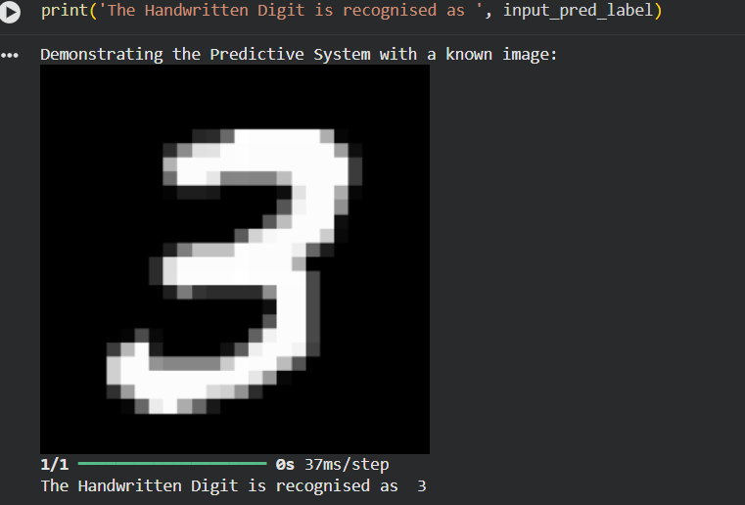.

12. Applications
- Bank cheque reading
- Postal code recognition
- Digitizing handwritten forms
- Automated data entry systems

13. Advantages
- High accuracy
- Fast training
- Easy implementation using TensorFlow
- Scalable for larger datasets

14. Limitations
- Works best on clean handwritten digits
- Accuracy may reduce for unclear handwriting
- Requires sufficient training data

15. Future Scope
- Improve accuracy using Convolutional Neural Networks (CNN)
- Deploy as a web application
- Extend for character recognition (A–Z)
- Integrate with real-time camera input

16. Conclusion
The MNIST Digit Classification project successfully demonstrates the implementation of a Neural Network for image classification. The model achieves high accuracy and effectively predicts handwritten digits. This project enhances understanding of Deep Learning concepts and practical implementation using TensorFlow in Google Colab.

17. References
- TensorFlow Documentation
- MNIST Dataset
- Python Documentation

