Hello Professor, I tried this new uml diagram. I found this format on google which said industries uses this kind of format in real world.

**Erecycler**

**Class Diagram:**

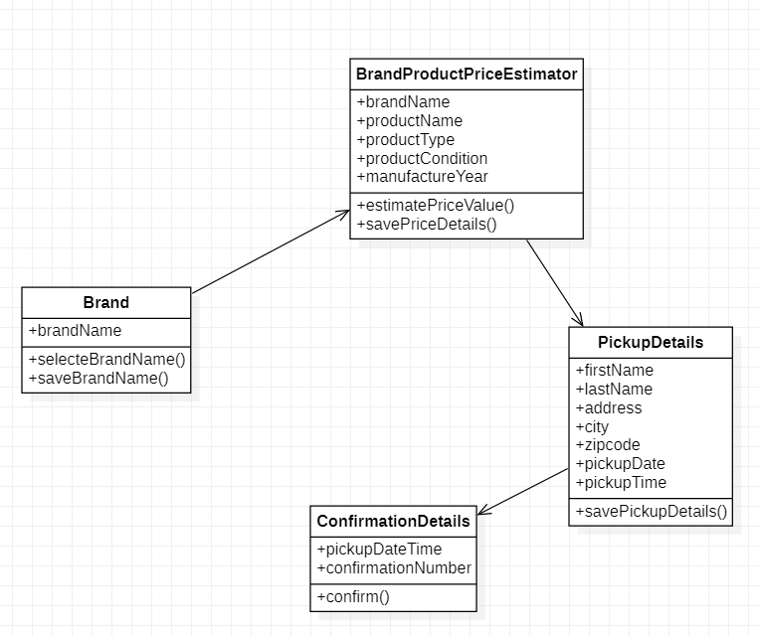

**Use-case diagram:**

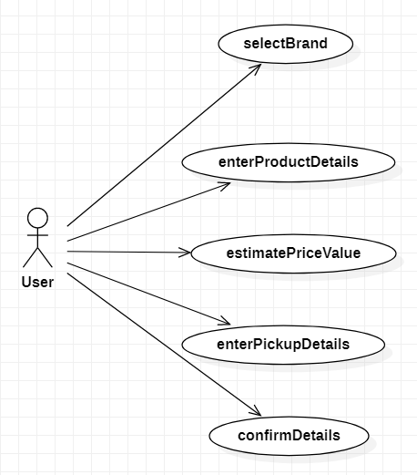

**Sequence Diagram:**

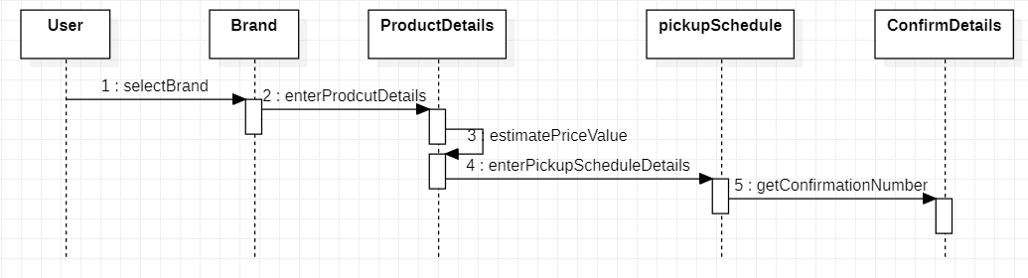

**Activity Diagram:**

